**Solution of Que:2**

Link to the .tf files: <https://drive.google.com/drive/folders/14qxkb7_qkfj_JhgICdKd8jvk_6Ab69PK?usp=sharing>

Screenshots:

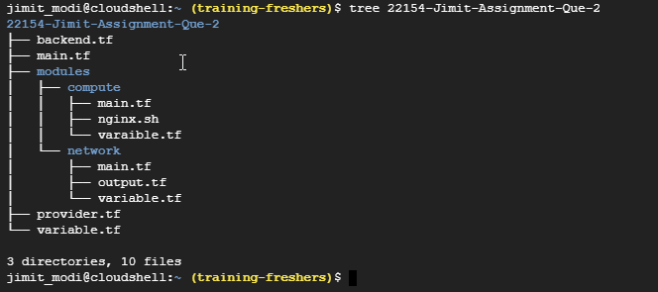

$ terraform init

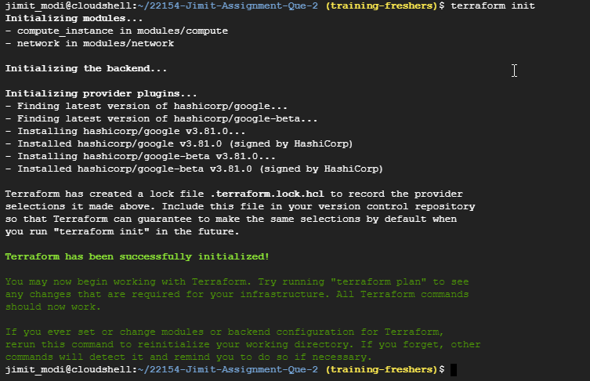

$ terraform plan

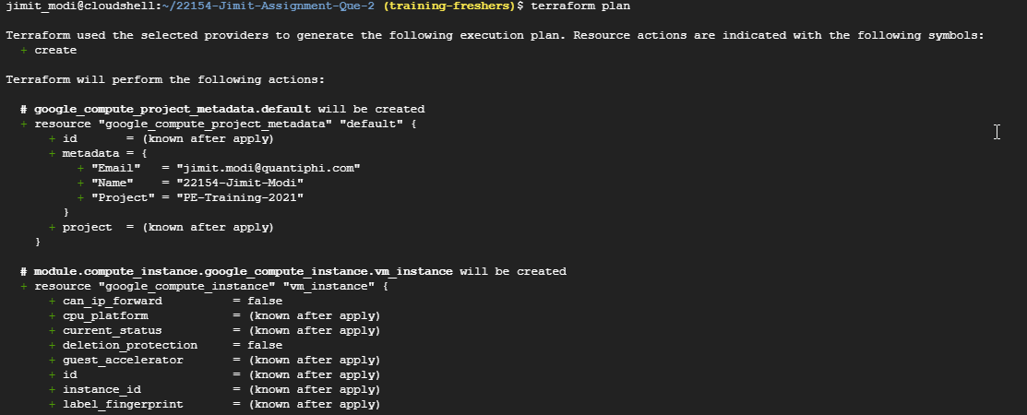

.

.

.

.

.

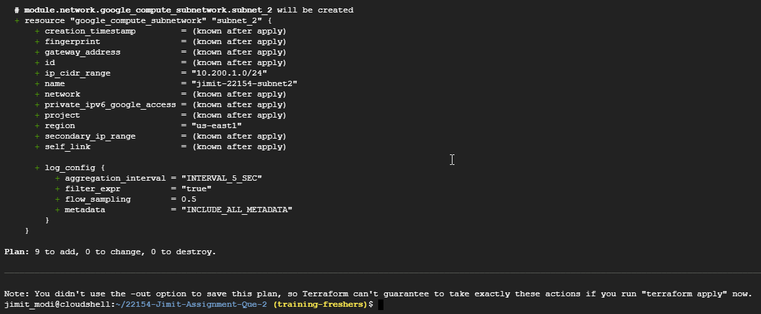

$ terraform apply --auto-approve

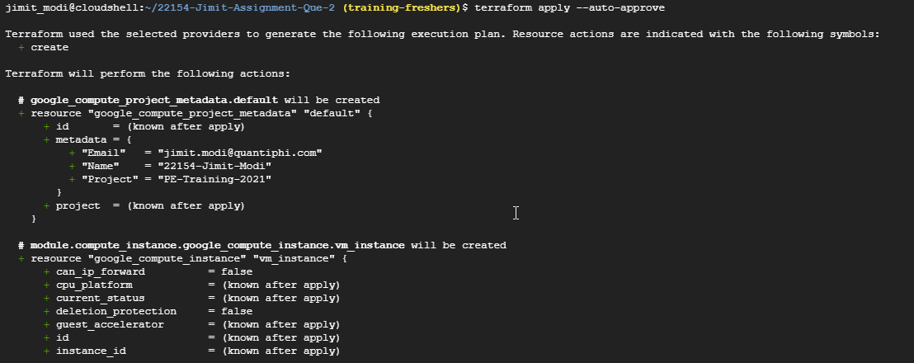

.

.

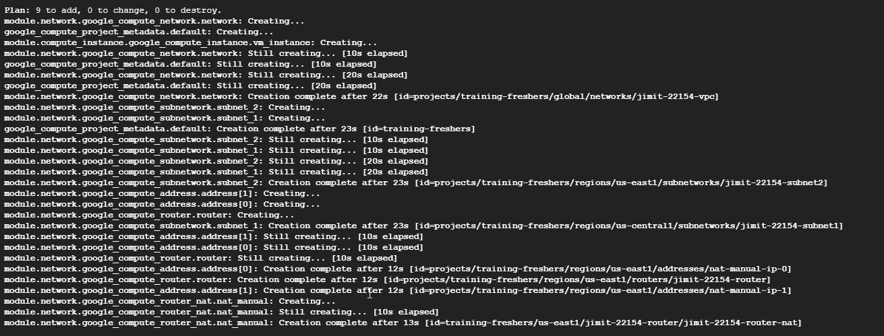

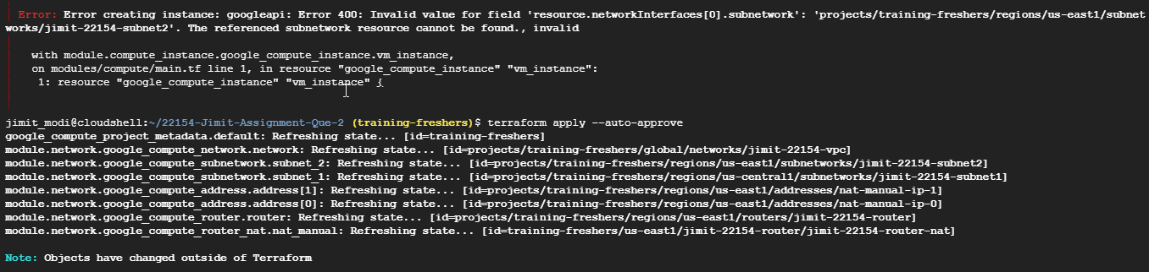



$ gcloud compute instances get-serial-port-output jimit-22154-instance --zone us-east1-c --start=124000

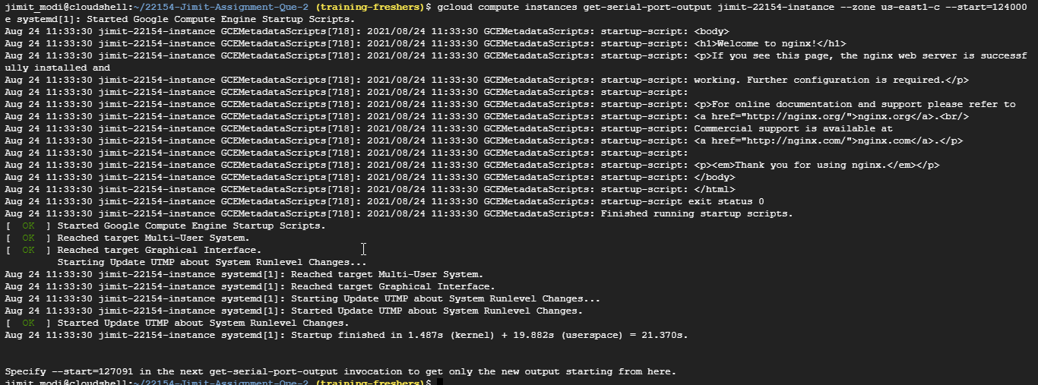

Console view of Compute Instance :

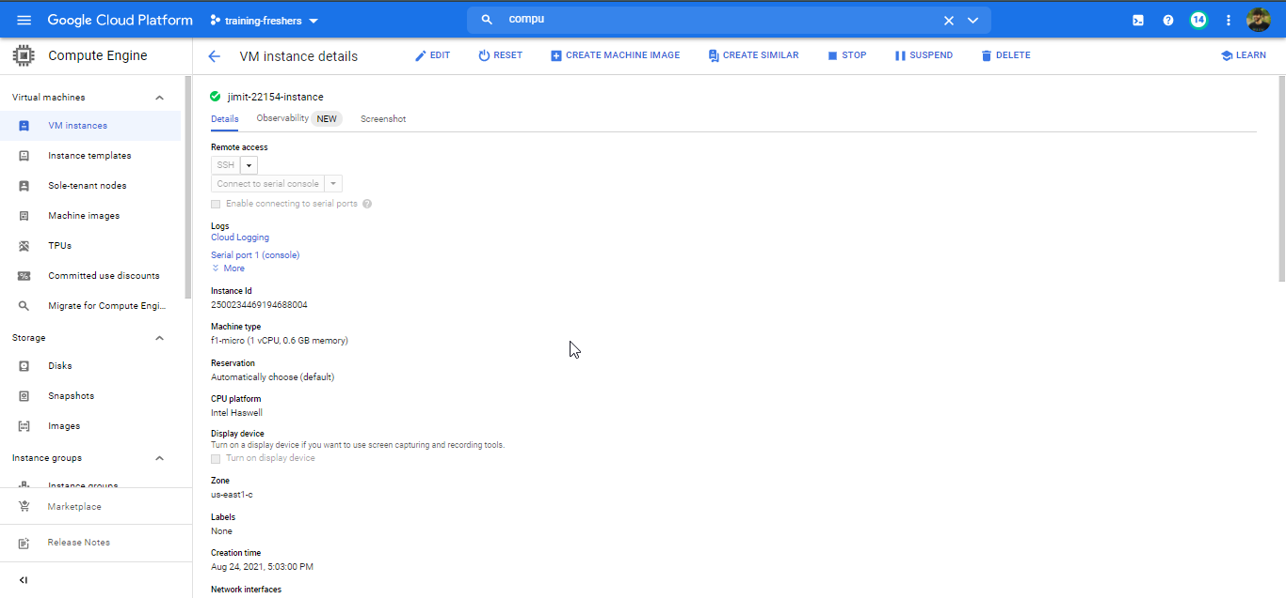

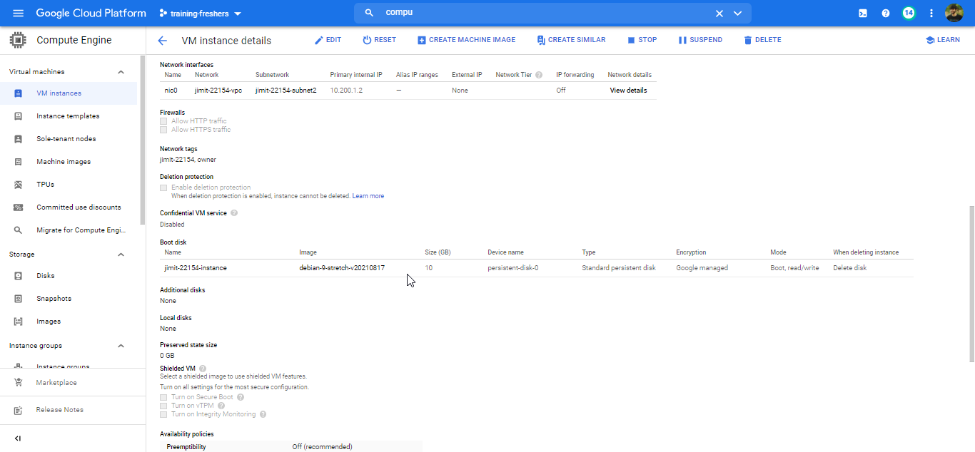

Console view of VPC and Subnets:

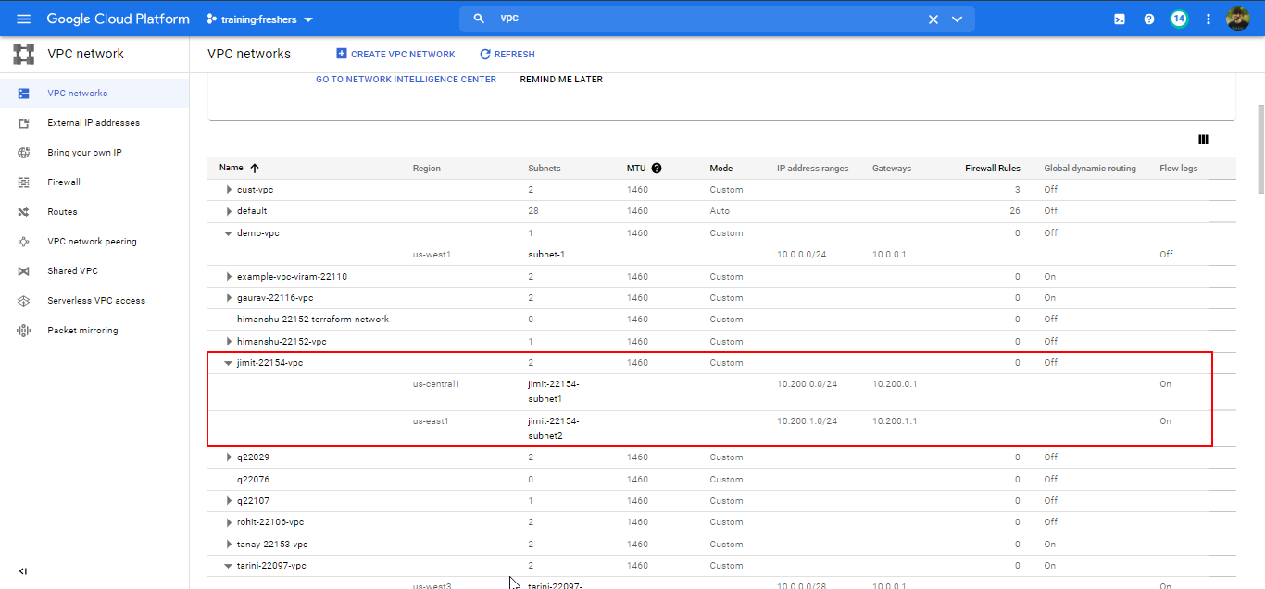

**Solution to Que:3**

Link to the .tf files: <https://drive.google.com/drive/folders/1Ep3OWTEeVmQFYqrkcD0ABSlfg8Jgl-Vc?usp=sharing>

Screenshots:

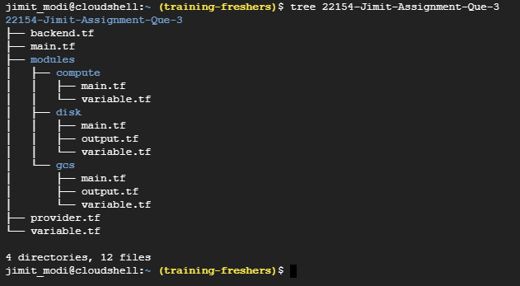

$ terraform init

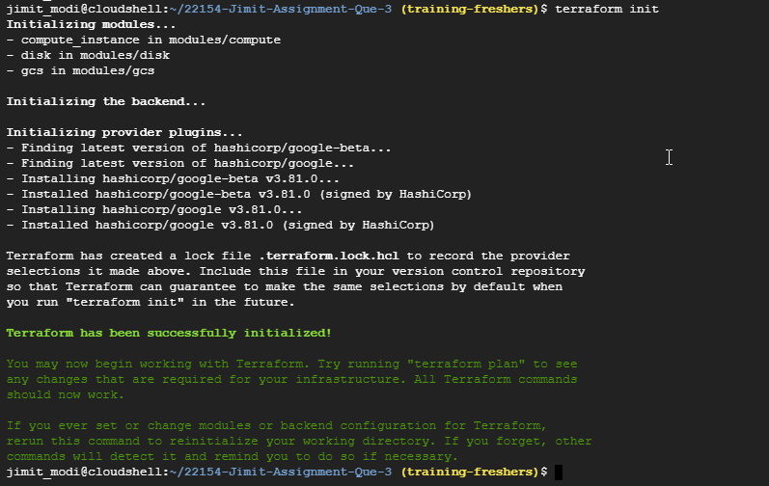

$ terraform plan

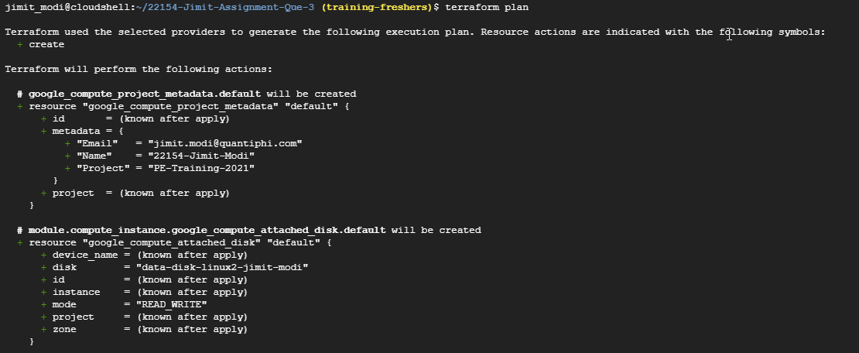

.

.

.

.

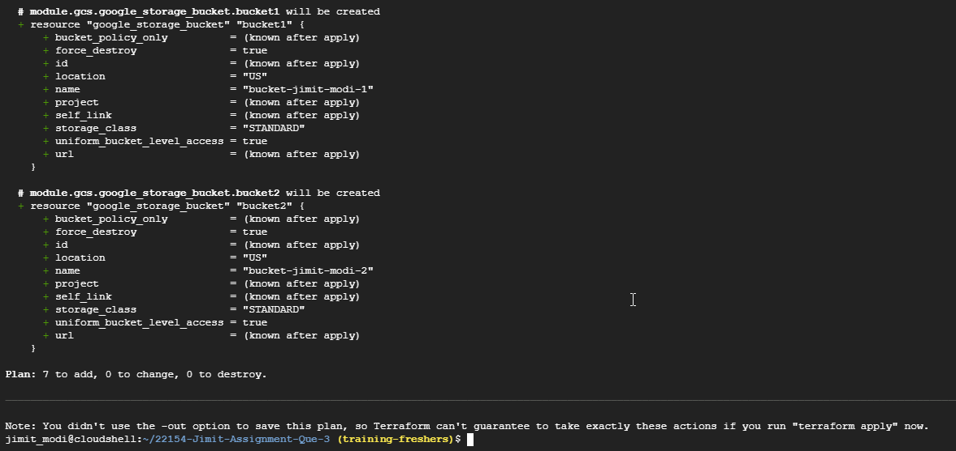

$ terraform apply --auto-approve

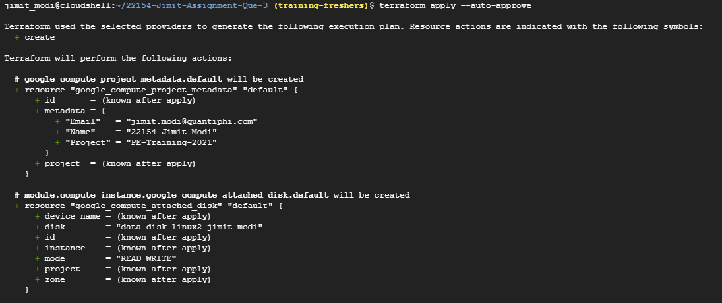

.

.

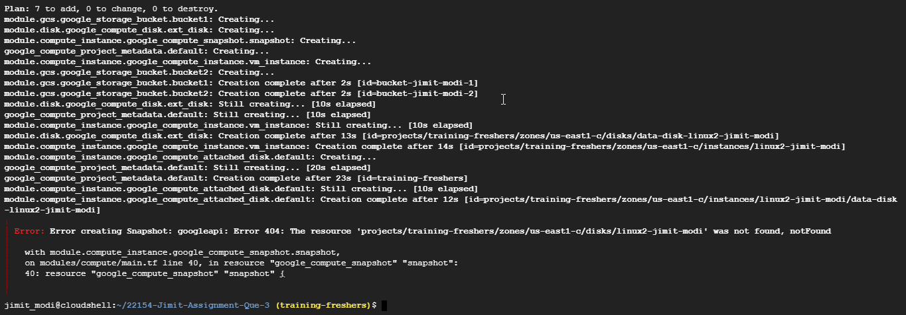

.

.

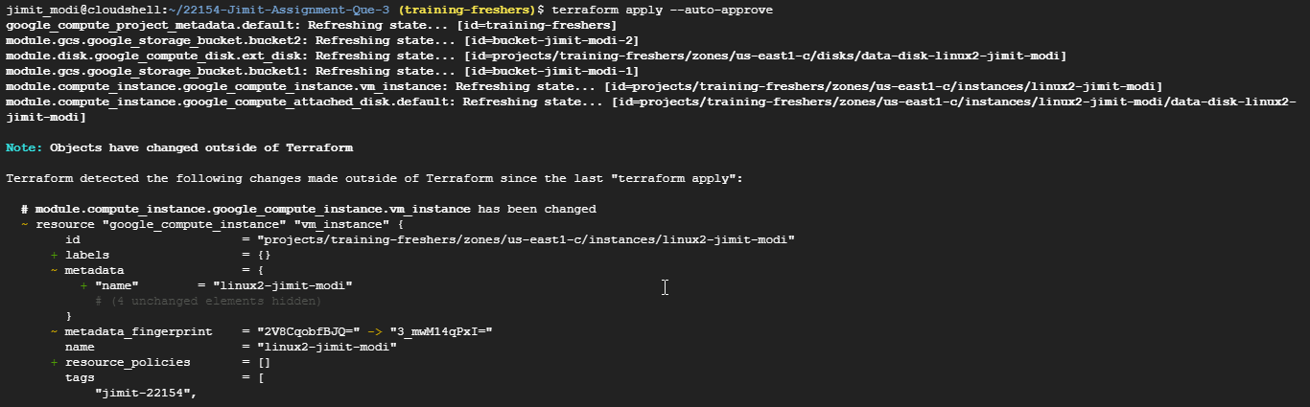

.

.

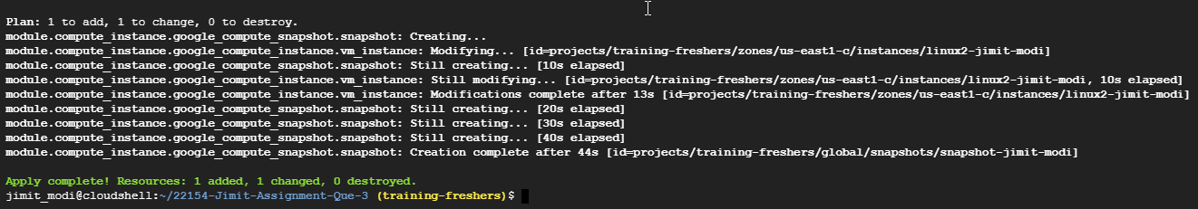

Console Views:

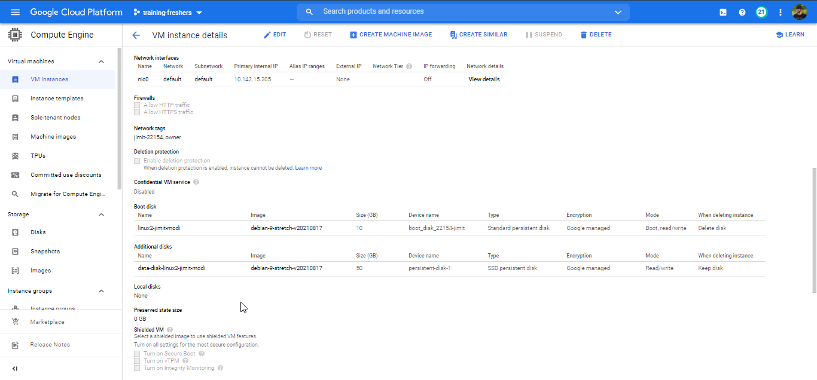

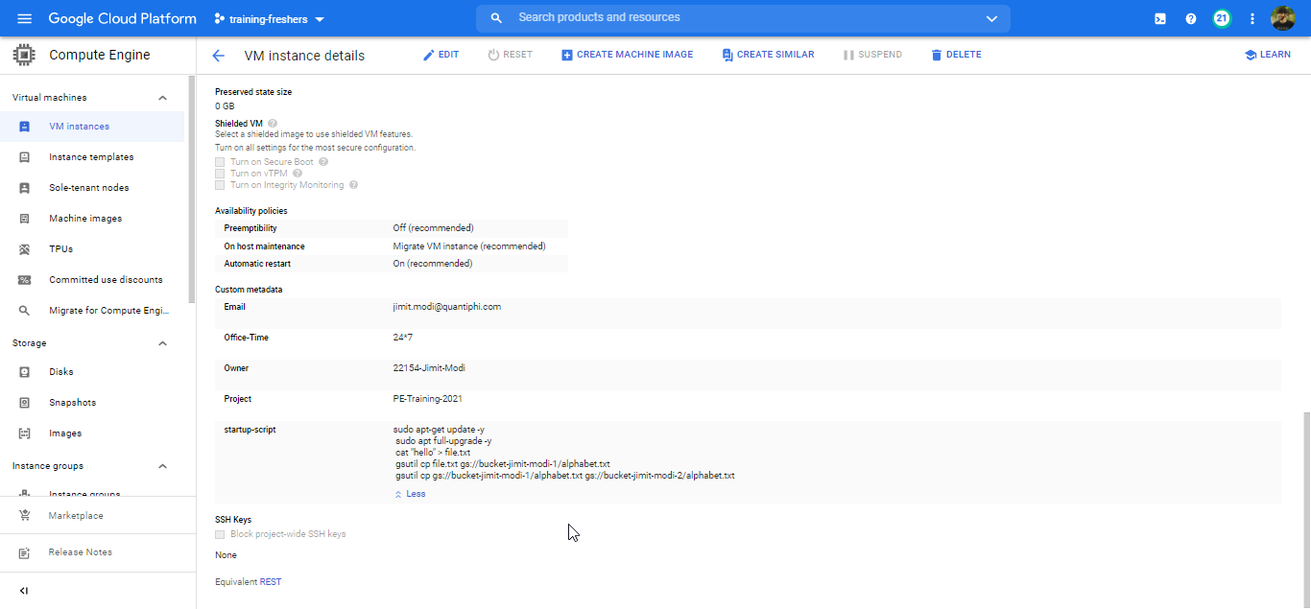

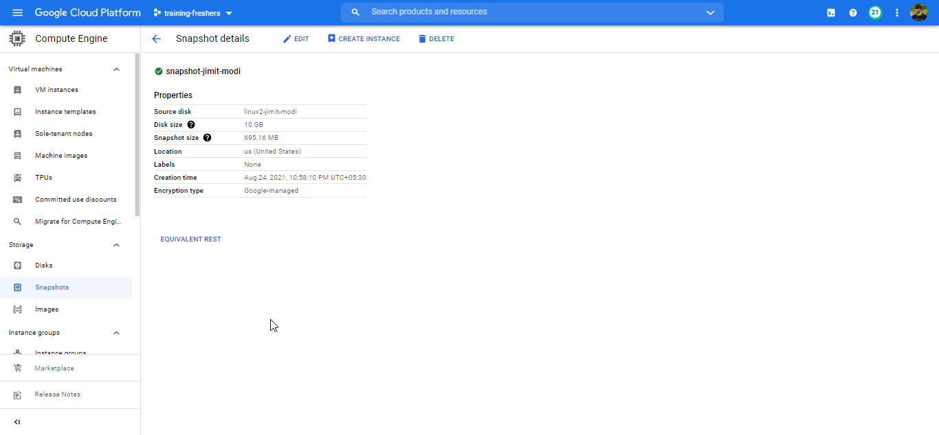

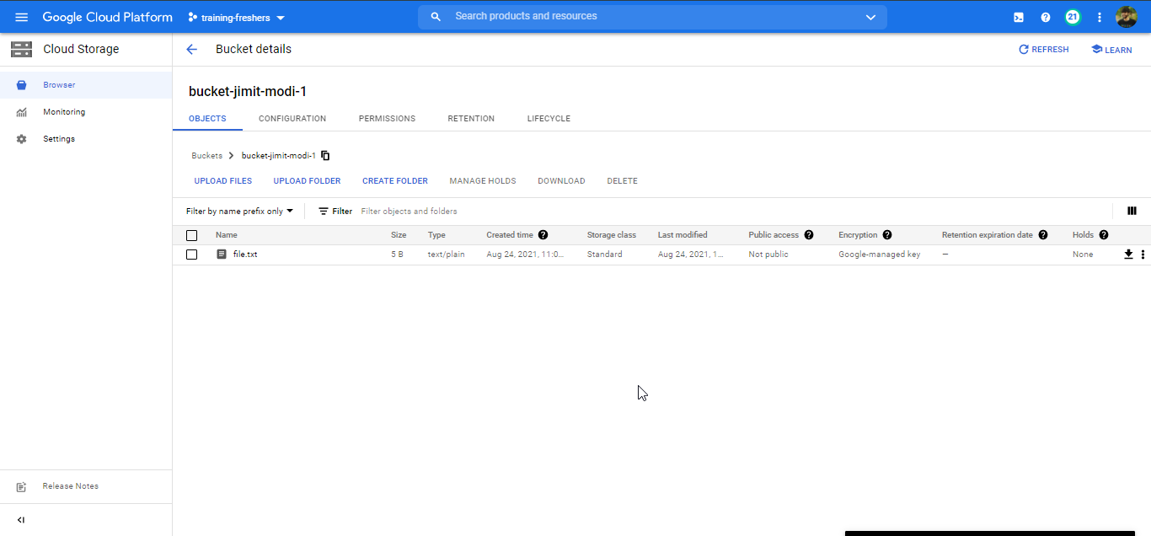

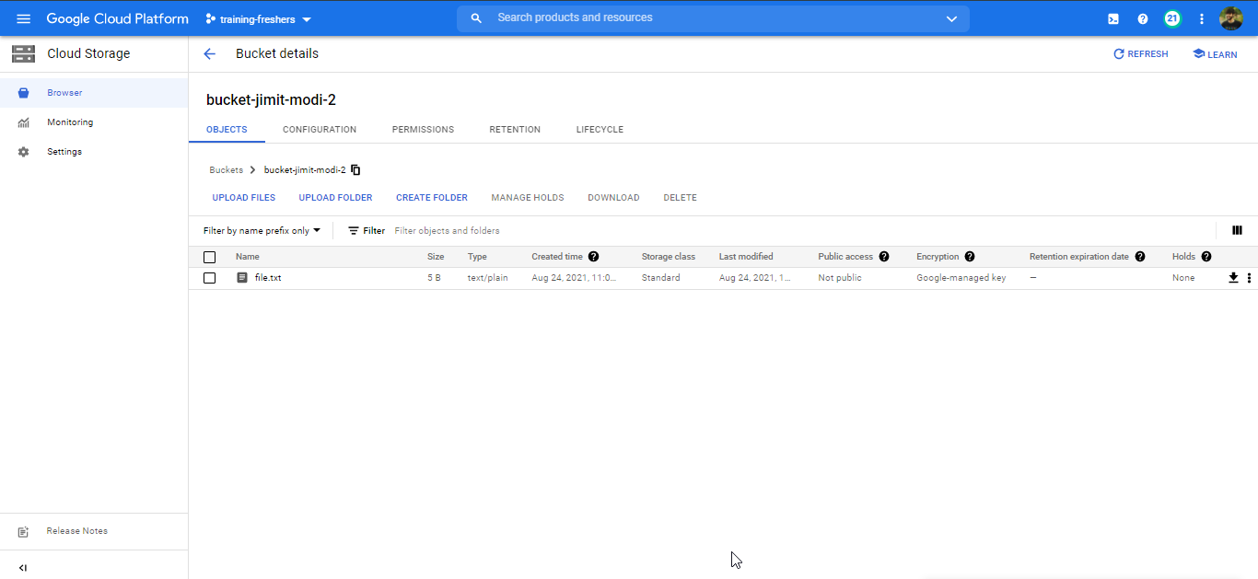

**Solution to Que:4**

Link to the .tf files: <https://drive.google.com/drive/folders/1oU04GedHIYS_BrN-ZQLe-L2fCtG-yDvq?usp=sharing>

Screenshots:

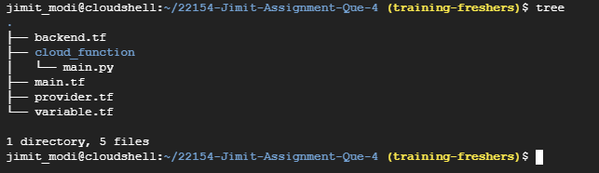

$ terraform init

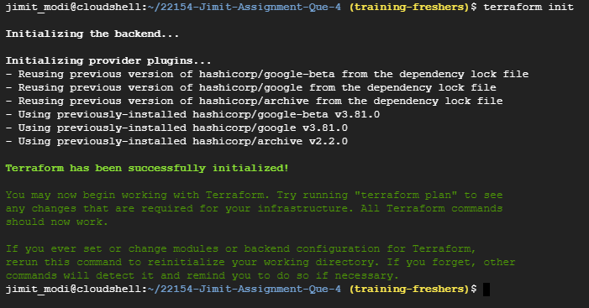

$ terraform plan

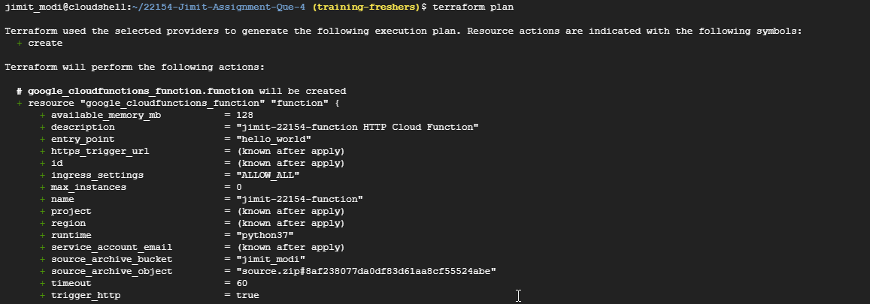

.

.

.

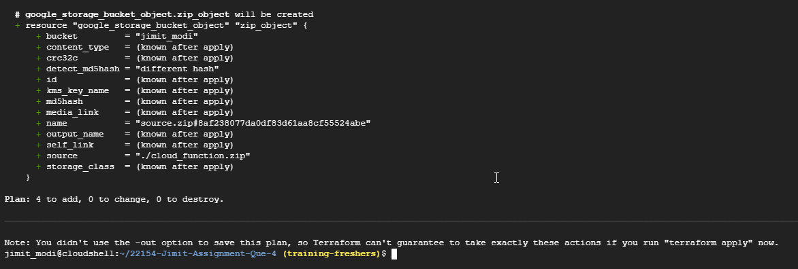

$ terraform apply --auto-approve

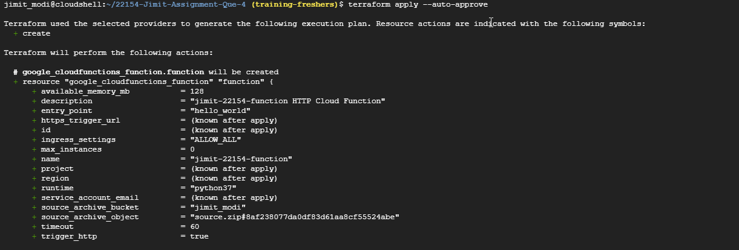

.

.

.

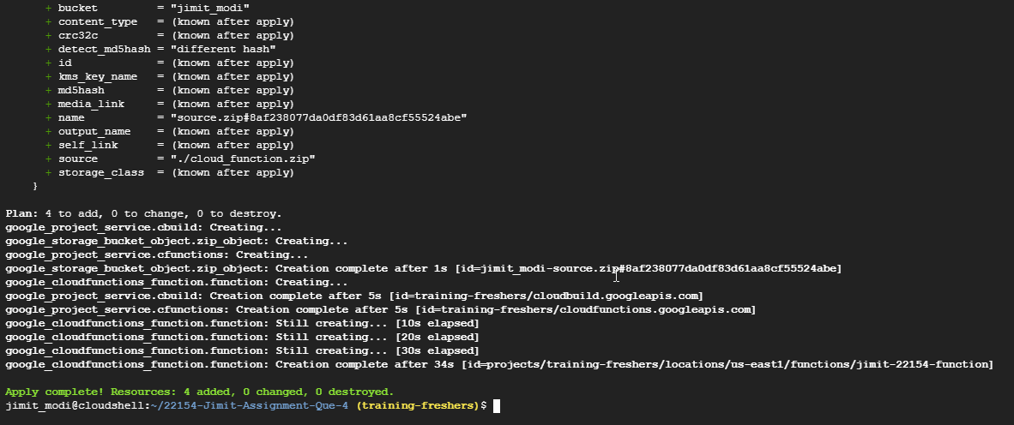

Viewing function in console:

