**INDEX**

|  |  |  |
| --- | --- | --- |
| **SL.NO** | **PROGRAMS** | **PAGE NO** |
| 1 | GO Program to Check Whether a Number is Even or Odd. | 1-2 |
| 2 | GO program to display of standard arithmetic operators with 2 integer values. | 3 |
| 3 | GO Program to Find LCM and GCD of given two numbers. | 4-5 |
| 4 | GO Program to find the index of first occurrence of a substring. | 6 |
| 5 | GO Program to get first and last element of slice in Golang. | 7 |
| 6 | GO Program to get total number of characters in a string. | 8 |
| 7 | GO Program to print full Pyramid using STAR | 9 |
| 8 | GO program for implementation of Binary Search. | 10 |
| 9 | GO program for implementation of Linear Search. | 11 |
| 10 | GO Program to Generate Multiplication Table | 12 |
| 11 | GO Program to Add Two Matrix Using Multi-dimensional Arrays. | 13-14 |
| 12 | GO Program to Calculate Area of Rectangle and Square. | 15 |
| 13 | GO Program to Check Whether a Number is Palindrome or Not. | 16-17 |
| 14 | GO program to implementation of Tower of Hanoi Algorithm. | 18-19 |
| 15 | GO Program to print the ascii code for each letter in the alphabet. | 20 |
| 16 | GO Program to read file line by line to string. | 21 |
| 17 | GO Program to take user input and addition of two strings | 22 |
| 18 | GO Program to Get current date and time in various format in golang. | 23-24 |
| 19 | GO program with example of Array Reverse Sort Functions for integer and strings | 25 |
| 20 | GO Program to replace substrings in a string. | 26 |

**1. GO Program to Check Whether a Number is Even or Odd.**

package main import "fmt" func main() { fmt.Println("Enter number:") var n int fmt.Scanln(&n) if n%2==0 {

fmt.Println(n,"is Even number")

}else{ fmt.Println(n,"is odd number")

}

}

**Output: -**

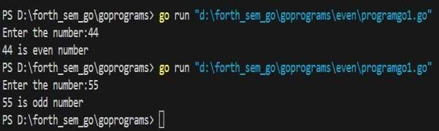

1. **GO program to display of standard arithmetic operators with 2 integer values.**

package main import "fmt" func main() {

fmt.Println("1 + 2 = ", 1+2) fmt.Println("5 * 2 = ", 5*2) fmt.Println("10 - 2 = ", 10-2) fmt.Println("10 / 2 = ", 10/2) fmt.Println("10 % 2 = ", 10%2)

}

**Output: -**

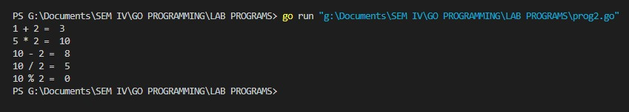

1. **GO Program to Find LCM and GCD of given two numbers.**

package main import "fmt" func lcm(temp1 int,temp2 int){ var lcmnum int=1 if temp1>temp2 { lcmnum=temp1

} else {

lcmnum=temp2

} for {

if lcmnum%temp1==0&& lcmnum%temp2==0 { fmt.Printf("LCM of %d and %d is %d",temp1,temp2,lcmnum) break

}

lcmnum++

} return }

func gcd(temp1 int,temp2 int) { var gcdnum int for i:=1;i<=temp1 && i<=temp2;i++ { if temp1%i==0 && temp2%i==0 { gcdnum=i

}

}

fmt.Printf("GCD of %d and %d is %d",temp1,temp2,gcdnum) return }

func main() { var n1,n2,action int

fmt.Println("Enter two positive integers:") fmt.Scanln(&n1) fmt.Scanln(&n2) fmt.Println("Enter 1 for LCM and 2 for GCD") fmt.Scanln(&action) switch action { case 1:lcm(n1,n2) case 2:gcd(n1,n2)

}

}

**Output: -**

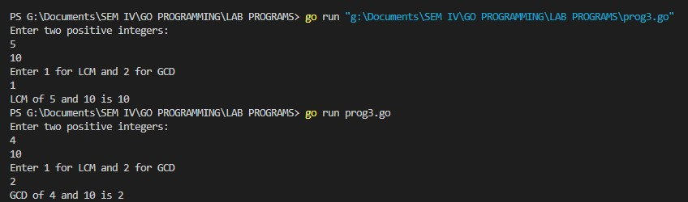

**4. GO Program to find the index of first occurrence of a substring.**

package main import ( "fmt"

"strings"

)

func main() { str := "the cat in the hat" i := strings.Index(str, "hat") fmt.Println(i)

var str2 string str2="The cat in the hat" j:=strings.Index(str2,"in") fmt.Println(j)

}

**Output: -**

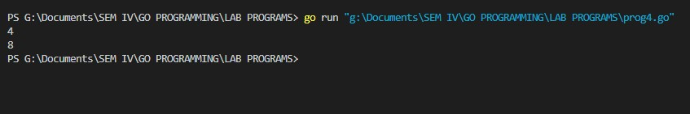

**5. GO Program to get first and last element of slice in Golang.**

package main import "fmt" func main() { intSlice := []int{1, 2, 3, 4, 5} fmt.Println("slice: ", intSlice)

last := intSlice[len(intSlice)-1] fmt.Println("last element: ", last)

first := intSlice[:1] fmt.Println("first element: ", first)

remove := intSlice[:len(intSlice)-1] fmt.Println("remove last: ", remove)

}

**Output: -**

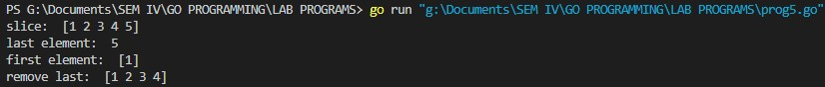

1. **GO Program to get total number of characters in a string.**

package main import "fmt" func main(){ str:="Hemanth Kumar" fmt.Println(str) len:=len(str) fmt.Println(len)

}

**Output: -**

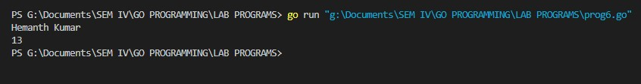

1. **GO Program to print full Pyramid using STAR.**

package main import "fmt" func main() { var rows int var k int=0 fmt.Print("Enter number of rows:") fmt.Scanln(&rows) for i:=1;i<=rows;i++ { k=0 for space:=1;space<=rows-i;space++ { fmt.Print(" ") } for { fmt.Print("*") k++ if k==2*i-1{ break } } fmt.Println("")

}

}

**Output: -**

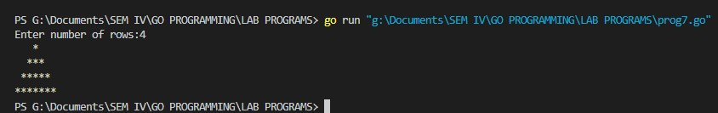

1. **GO program for implementation of Binary Search.**

package main import "fmt" func binarySearch(needle int,haystack []int)bool { low:=0 high:=len(haystack) for low<=high { median:=(low+high)/2 if haystack[median]<needle { low=median+1

} else { high=median-1

} }

if low==len(haystack)||haystack[low]!=needle { return false } return true } func main() {

items:=[]int{1,2,9,20,31,45,63,70,100} fmt.Println(binarySearch(100,items))

}

**Output: -**

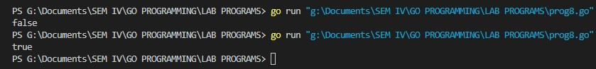

1. **GO program for implementation of Linear Search.**

package main import "fmt" func linearSearch(datalist []int,key int)bool { for _,item:=range datalist { if item==key { return true

} } return false } func main() { items:=[]int{95,78,56,84,25,35,15,26} fmt.Println(linearSearch(items,96))

}

**Output: -**

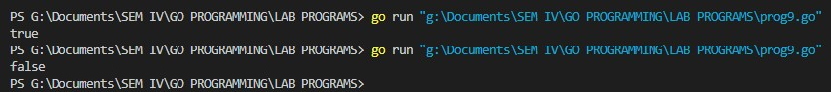

1. **GO Program to Generate Multiplication Table.**

package main import "fmt" func main() { var n int fmt.Print("enter the integer number:") fmt.Scanln(&n) i:=1 for { if i>10 { break } fmt.Println(n,"X",i,"=",n*i) i++ }

}

**Output: -**

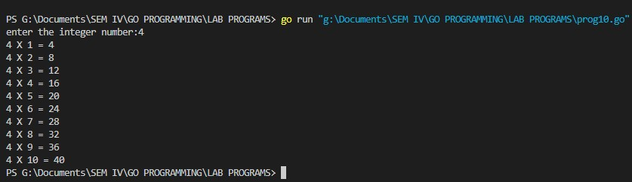

1. **GO Program to Add Two Matrix Using Multi-dimensional Arrays**.

package main import "fmt" func main() { var matrix1 [100][100]int var matrix2 [100][100]int var sum [100][100]int var row,col int

fmt.Println("Enter number of rows:") fmt.Scanln(&row) fmt.Println("Enter number of cols:") fmt.Scanln(&col) fmt.Println()

fmt.Println("==========matrix1==========") fmt.Println() for i:=0;i<row;i++ { for j:=0;j<col;j++ {

fmt.Printf("Enter the element for matrix1 %d%d:",i+1,j+1) fmt.Scanln(&matrix1[i][j])

} } fmt.Println()

fmt.Println("==========matrix2==========") fmt.Println() for i:=0;i<row;i++ { for j:=0;j<col;j++ {

fmt.Println("Enter the element for matrix2 %d%d:",i+1,j+1) fmt.Scanln(&matrix2[i][j])

} for i:=0;i<row;i++ { for j:=0;j<col;j++ { sum[i][j]=matrix1[i][j]+matrix2[i][j]

}

fmt.Println()

fmt.Println("==========Sum of Marix==========")

fmt.Println() for i:=0;i<row;i++ { for j:=0;j<col;j++ { fmt.Printf("%d",sum[i][j]) if j==col-1 { fmt.Println("")

}

}

}

}

**Output: -**

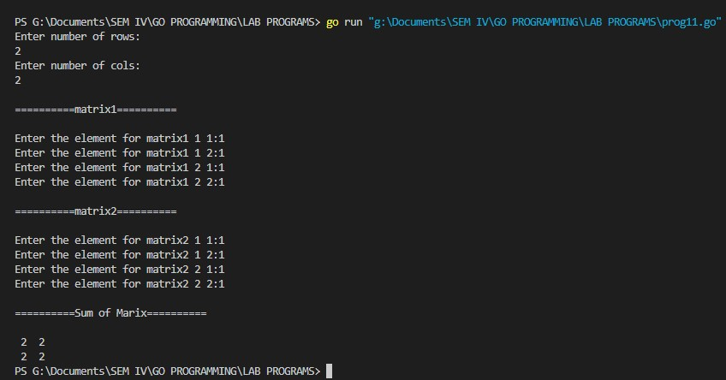

**12. GO Program to Calculate Area of Rectangle and Square.**

package main import "fmt" var area int func main() { var l,b int fmt.Println("Enter length of rectangle:") fmt.Scanln(&l)

fmt.Println("Enter the bredth of rectangle:") fmt.Scanln(&b) area=l*b

fmt.Println("Area of rectangle:",area) fmt.Println("Enter length of square:") fmt.Scanln(&l) area=l*l fmt.Println("Area of square:",area)

}

**Output: -**

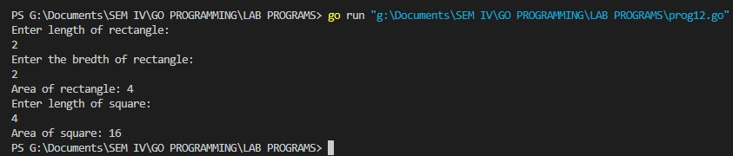

**13. GO Program to Check Whether a Number is Palindrome or Not.**

package main import "fmt" func main() {

var number,remainder,temp int var reverse int=0 fmt.Println("Enter any positive integer:") fmt.Scanln(&number) temp=number

for {

remainder=number%10 reverse=reverse*10+remainder number/=10

if number==0 { break } }

if temp==reverse {

fmt.Printf("%d is a palindrome",temp)

} else { fmt.Printf("%d is not a palindrome",temp)

}

}

**Output: -**

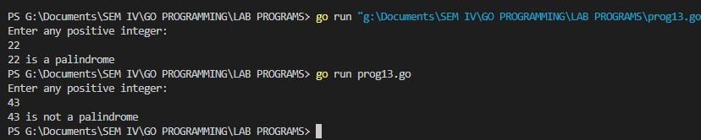

**14. GO program to implementation of Tower of Hanoi Algorithm.**

package main import "fmt" type solver interface { play(int) } type towers struct {

}

func(t*towers)play(n int) { t.moveN(n,1,2,3) }

func(t*towers)moveN(n,from,to,via int){ if n>0 {

t.moveN(n-1,from,via,to)

t.moveM(from,to)

t.moveN(n-1,via,to,from)

} }

func(t*towers)moveM(from,to int) { fmt.Println("move disk from rod",from,"to rod",to)

} func main() { var t solver t=new(towers) t.play(4)

}

**Output: -**

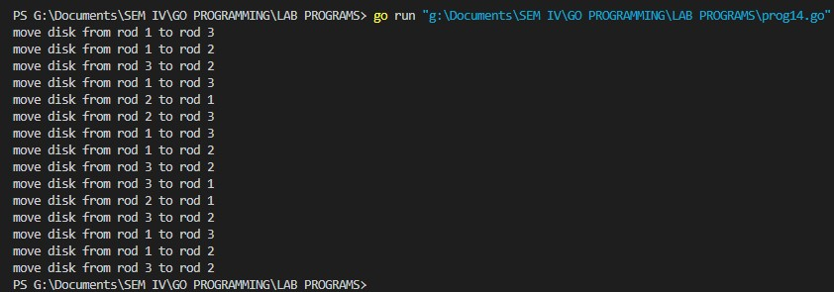

1. **GO Program to print the ascii code for each letter in the alphabet.**

package main import "fmt" func main() {

var str="abcdefghijklmnopqrstuvwxyz" for _,c:=range str { fmt.Println(c)

}

}

**Output: -**

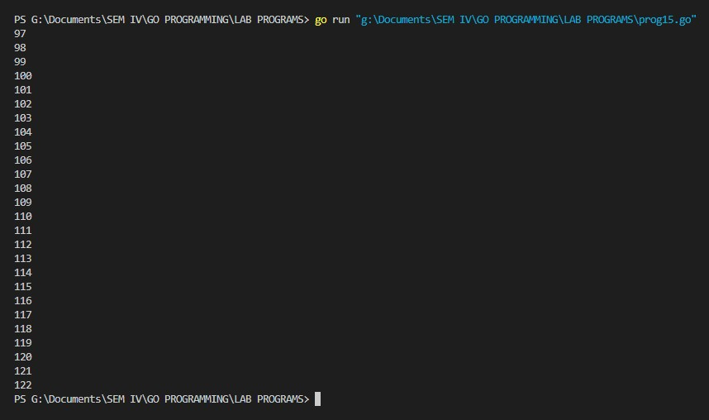

1. **GO Program to read file line by line to string.**

package main import ( "bufio"

"fmt"

"log"

"os"

)

func main() { file,err:=os.Open("kotlin.txt") if err!=nil {

log.Fatalf("failed opening file:%s",err)

} scanner:=bufio.NewScanner(file) scanner.Split(bufio.ScanLines) var txtlines []string for scanner.Scan() { txtlines=append(txtlines,scanner.Text())

} file.Close()

for _, eachline := range txtlines { fmt.Println(eachline)

}

}

**Output: -**

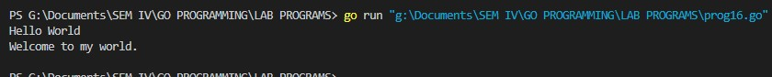

**17. GO Program to take user input and addition of two strings.**

package main import "fmt" func main() {

fmt.Println("Enter first string:") var first string fmt.Scanln(&first) fmt.Println("Enter second string:") var second string fmt.Scanln(&second) fmt.Println(first+second)

}

**Output: -**

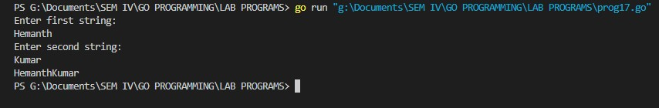

**18.GO Program to Get current date and time in various format in golang.**

package main import ( "fmt"

"time"

)

func main() { currentTime:=time.Now()

fmt.Println("Current Time in String:",currentTime.String()) fmt.Println("MM-DD-YYYY:",currentTime.Format("01-02-2006")) fmt.Println("YYYY-MM-DD:",currentTime.Format("2006-01-02")) fmt.Println("YYYY.MM.DD:",currentTime.Format("2006.01.02 15:04:05")) fmt.Println("YYYY#MM#DD {Special Character}:",currentTime.Format("2006#01#02")) fmt.Println("YYYY-MM-DD hh:mm:ss :",currentTime.Format("2006-01-02 15:04:05")) fmt.Println("Time with MicroSeconds:",currentTime.Format("2006-01-02

15:04:05.000000")) fmt.Println("Time with NanoSeconds:",currentTime.Format("2006-01-02

15:04:05.000000000")) fmt.Println("ShortNum Month:",currentTime.Format("2006-1-02")) fmt.Println("LongMonth:",currentTime.Format("2006-January-02")) fmt.Println("ShortMonth:",currentTime.Format("2006-Jan-02")) fmt.Println("Short Year:",currentTime.Format("06-Jan-02")) fmt.Println("LongWeekDay:",currentTime.Format("2006-01-02 15:04:05 Monday")) fmt.Println("ShortWeekDay:",currentTime.Format("2006-01-02 Mon")) fmt.Println("ShortDay:",currentTime.Format("Mon 2006-01-2"))

fmt.Println("Short Hour Minute Second:",currentTime.Format("2006-01-02 3:4:5")) fmt.Println("Short Hour MInute Second:",currentTime.Format("2006-01-02 3:4:5 PM")) fmt.Println("Short Hour Minute Second:",currentTime.Format("2006-01-02 3:4:5 pm")) }

**Output: -**

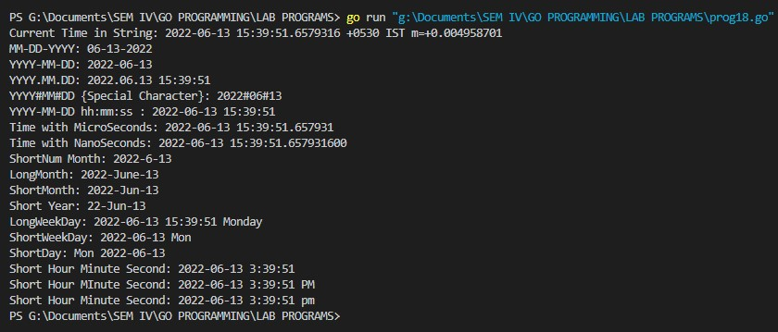

**19.GO program with example of Array Reverse Sort Functions for integer and strings.**

package main import ( "fmt"

"sort"

)

func main() {

fmt.Println("Integer reverse sort") num:=[]int{50,40,60,9,80} sort.Sort(sort.Reverse(sort.IntSlice(num))) fmt.Println(num)

fmt.Println()

fmt.Println("Strings reverse sort") text:=[]string{"Japan","UK","Germeny","Australia","NewYork"} sort.Sort(sort.Reverse(sort.StringSlice(text))) fmt.Println(text)

}

**Output: -**

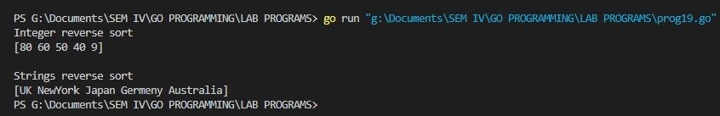

**20. GO Program to replace substrings in a string.**

package main import ( "fmt"

"strings"

)

func main() { str1:="A cat is a cat is a cat is a cat" fmt.Println(str1)

str2:=strings.Replace(str1,"cat","dog",1) fmt.Println(str2)

str3:=strings.Replace(str1,"cat","dog",2) fmt.Println(str3)

str4:=strings.Replace(str1,"cat","dog",-1) fmt.Println(str4)

}

**Output: -**

