CONDENSING UNIT TECHNICAL DATA | 

ZZMODEL
_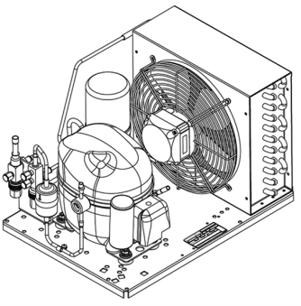 |  |  |  |  |  | ENGINEERING CODE |  |  |  |  |  |   REFRIGERANT
 |  |  |  |  |  | BOM |  |  |  |  |  | Refrig_name
 |  |  |  |  |  | POWER SUPPLY |  |  |  |  |  | APPLICATION
 |  |  |  |  |  | Power Supply |  |  |  |  |  | Applic_type
 |  |  |  |  |  | MOTOR TYPE |  |  |  |  |  | STANDARD
 |  |  |  |  |  | Motor_type |  |  |  |  |  | Standard_name
 |  |  |  |  |  |   COOLING CAPACITY |  |  |  |  |  | EFFICIENCY
 |  |  |  |  |  | R_CAPACITY_0 |  |  |  |  |  | R_COP_0


DATA

GENERAL DATA
Model |  |  | ZZMODEL
ELECTRICAL DATA
Locked Rotor Amperage (LRA) |  |  | LRA_val
Rated Load Amperage (RLA) |  |  | RLA_val
Maximum Overcurrent Protection (MOP) |  |  | MOP_val
Minimum Current Ampacity (MCA) |  |  | MCA_val
ACCESSORIES
Dryer |  | Dryer_desc |  | Dryer_code
Sightglass |  | Sight_desc |  | Sight_code
Discharge valve |  | Dis_desc |  | Dis_code
Suction valve |  | Suc_desc |  | Suc_code
CONDENSING COMPONENTS
Compressor |  | Comp_desc |  | Comp_code
Condenser |  | Cond_desc |  | Cond_code
Refrigerant |  |  | Refrig_name
Expansion Device |  |  | EXP_Device
Fan Blade Diameter |  |  | Blade_diameter
Fan Kit |  | Fankit_desc |  | Fankit_code

MECHANICAL DATA
Air Flow |  |  | Air_flow
Height |  |  | Height_val
Receiver |  |  | Receiver_volume
Shaﬅ Power |  |  | Shaft_power
Weight |  |  | Weight_val
Width |  |  | Width_val
Length |  |  | Length_val

PERFORMANCE

TESTED CONDITIONS
Tested Refrigerant |  |  |  |  |  | Refrig_name
Tested Application |  |  |  |  |  | Applic_Type
Tested Standard |  |  |  |  |  | Standard_name
RATED POINTS
 | Ambient  Temperature  °C |  | Evaporating  Temperature  °C |  | Cooling  Capacity  W |  | Eﬃciency  W/W |  | Power  Consumption  W
 | R_Ta |  | R_Te |  | R_CAPACITY |  | R_COP |  | R_CONSUMPTION
Test Condition: Subcooling 3 K, Return Gas 32 ºC.

PERFORMANCE CURVE |  |  |  |  |  |  | Ambient Temperature 25ºC
 | Evaporating  Temperature  °C | Cooling  Capacity  W |  | Eﬃciency  W/W |  | Power  Consumption  W
 | Te1-1 | CAP1-1 |  | COP1-1 |  | CON1-1
 | Te1-2 | CAP1-2 |  | COP1-2 |  | CON1-2
 | Te1-3 | CAP1-3 |  | COP1-3 |  | CON1-3
 | Te1-4 | CAP1-4 |  | COP1-4 |  | CON1-4
 | Te1-5 | CAP1-5 |  | COP1-5 |  | CON1-5
Test Condition: Subcooling 3 K, Return Gas 32 ºC.
PERFORMANCE CURVE |  |  |  |  |  |  | Ambient Temperature 32ºC
 | Evaporating  Temperature  °C | Cooling  Capacity  W |  | Eﬃciency  W/W |  | Power  Consumption  W
 | Te2-1 | CAP2-1 |  | COP2-1 |  | CON2-1
 | Te2-2 | CAP2-2 |  | COP2-2 |  | CON2-2
 | Te2-3 | CAP2-3 |  | COP2-3 |  | CON2-3
 | Te2-4 | CAP2-4 |  | COP2-4 |  | CON2-4
 | Te2-5 | CAP2-5 |  | COP2-5 |  | CON2-5
Test Condition: Subcooling 3 K, Return Gas 32 ºC.
.

PERFORMANCE CURVE |  |  |  |  |  |  | Ambient Temperature 43ºC
 | Evaporating  Temperature  °C | Cooling  Capacity  W |  | Eﬃciency  W/W |  | Power  Consumption  W
 | Te3-1 | CAP3-1 |  | COP3-1 |  | CON3-1
 | Te3-2 | CAP3-2 |  | COP3-2 |  | CON3-2
 | Te3-3 | CAP3-3 |  | COP3-3 |  | CON3-3
 | Te3-4 | CAP3-4 |  | COP3-4 |  | CON3-4
Test Condition: Subcooling 3 K, Return Gas 32 ºC.

ENVELOPE
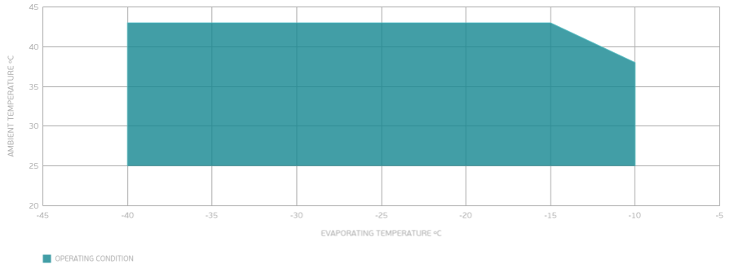

EXTERNAL DIMENSIONS
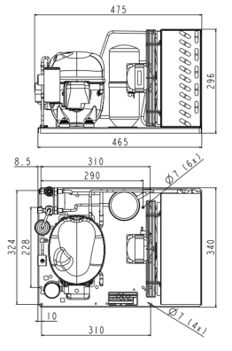

WIRING DIAGRAM
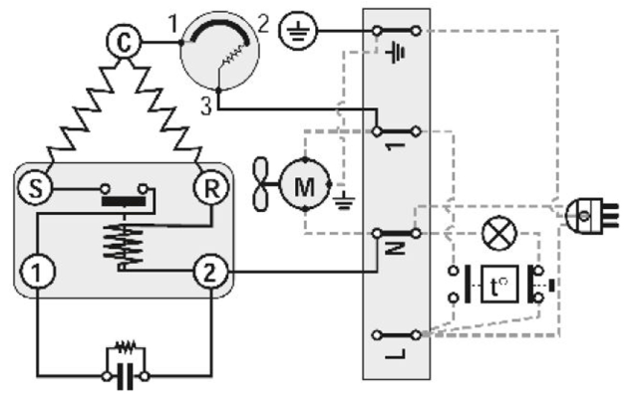

embraco.com Fri, Jul 25, 25, 10:00:40 +0000 GMT

