-- 1

SELECT m.pizza_name, m.price, p.name AS pizzeria_name, pv.visit_date

FROM menu m

JOIN person_visits pv ON m.pizzeria_id = pv.pizzeria_id

JOIN person p ON pv.person_id = p.id AND p.name = 'Kate'

WHERE m.price BETWEEN 800 AND 1000

ORDER BY m.pizza_name, m.price, p.name; 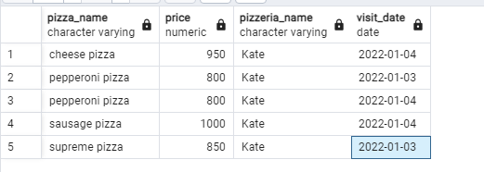

-- 2

SELECT id

FROM menu

WHERE id NOT IN (SELECT DISTINCT menu_id FROM person_order)

ORDER BY id;  
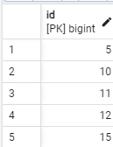

-- 3

SELECT m.pizza_name, m.price

FROM menu m

LEFT JOIN person_order po ON m.id = po.menu_id

WHERE po.id IS NULL

ORDER BY m.pizza_name, m.price;  
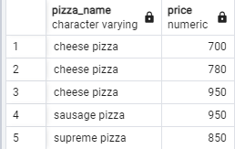

-- Exercise 4

SELECT DISTINCT p.name AS pizzeria_name

FROM pizzeria p

JOIN person_visits pv ON p.id = pv.pizzeria_id

JOIN person pe ON pv.person_id = pe.id

ORDER BY p.name;  
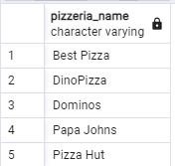  
-- Exercise 5

SELECT p.name AS pizzeria_name

FROM pizzeria p

JOIN person_visits pv ON p.id = pv.pizzeria_id

JOIN person pe ON pv.person_id = pe.id

GROUP BY p.name

HAVING COUNT(DISTINCT pe.gender) = 2

ORDER BY p.name;  
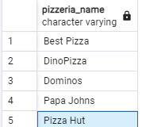

-- Exercise 7

SELECT m1.pizza_name, m1.price, m1.pizzeria_id AS pizzeria_id1,

m2.pizzeria_id AS pizzeria_id2

FROM menu m1

JOIN menu m2 ON m1.pizza_name = m2.pizza_name

WHERE m1.price = m2.price AND m1.pizzeria_id <> m2.pizzeria_id

ORDER BY m1.pizza_name;  
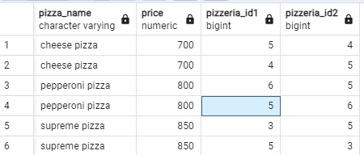

-- Exercise 8

INSERT INTO menu (id, pizzeria_id, pizza_name, price)

VALUES (19, 2, 'greek pizza', 800);

SELECT * FROM menu;

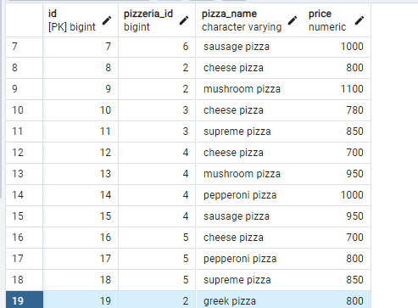

-- Exercise 9

INSERT INTO menu (id, pizzeria_id, pizza_name, price)

VALUES ((SELECT MAX(id) + 1 FROM menu), (SELECT id FROM pizzeria WHERE name = 'Dominos'), 'sicilian pizza', 900);

SELECT * FROM menu;

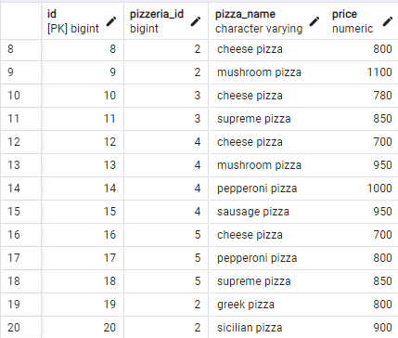

-- Exercise 12

UPDATE menu SET price = price * 0.9 WHERE pizza_name = 'greek pizza';

SELECT * FROM menu;

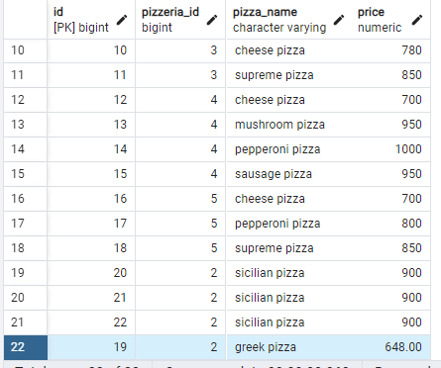

-- Exercise 14

-- Delete orders from Exercise #12 based on order date

DELETE FROM person_order WHERE menu_id = (SELECT id FROM menu WHERE pizza_name = 'greek pizza') AND order_date = '2022-02-25';

-- Delete "greek pizza" from the menu

DELETE FROM menu WHERE pizza_name = 'greek pizza';

SELECT * FROM person_order