Data Guide
WETLAND EVALUATION TOOL
January 2026

Wetland Layers:

Surface Water:
The layer depicts the monthly extent of flooding within the wetland and riparian systems. Layers represent averaged conditions from 2014 to 2020 to estimate wetland hydrology under current climate scenarios. Areas of darker blue represent more open or deeper water, while more transparent shades are characteristic of shallow areas and/or areas interspersed with emergent vegetation (Figure 1). Surface water models include public and private lands, including agricultural land-use practices associated with wetland habitats.

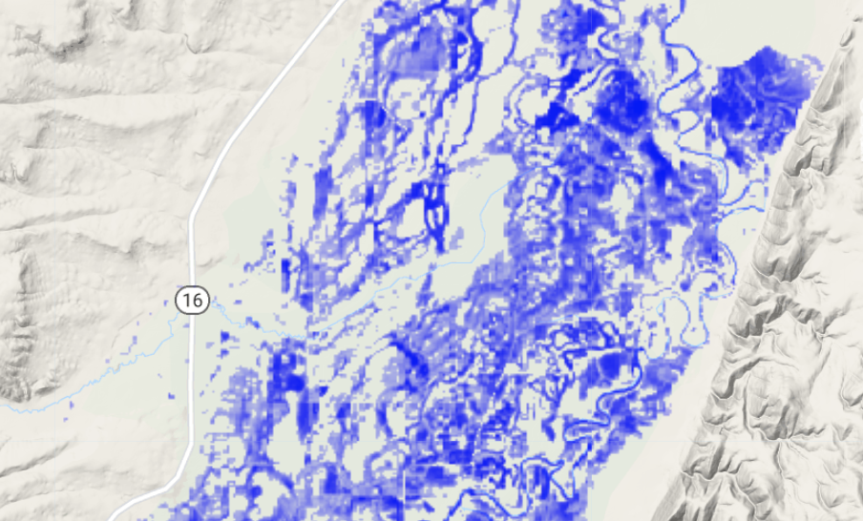
Figure 1. Surface water layer - areas of darker blue represent more open or deeper water, while more transparent shades represent shallow areas and/or areas interspersed with emergent vegetation.

Values are measured as the proportion (0-1) of water contained within a pixel (30x30 m).

Methods and additional information on surface water modeling can be found in the Supplementary Materials from a 2023 paper from Donnelly et al. "Beneficial ‘inefficiencies’ of western ranching: Flood-irrigated hay production sustains wetland systems by mimicking historic hydrologic processes"
Hydroperiod:
Layers depict the monthly extent of wetland surface water classified by its annual duration of flooding, commonly defined as ‘hydroperiod.’ The duration of flooding is calculated as an average of conditions from 2014 to 2020 to depict near-term conditions. Hydroperiods are defined as; temporary (pink - flooded < 2 months), seasonal (seasonal - flooded >2 and <9 months ), or semi-permanent (blue - flooded > 9 months) following a classification scheme similar to Cowardin (1979). Classes can provide important ecological context to wetland function and vegetative structure associated with specific wildlife habitat values.
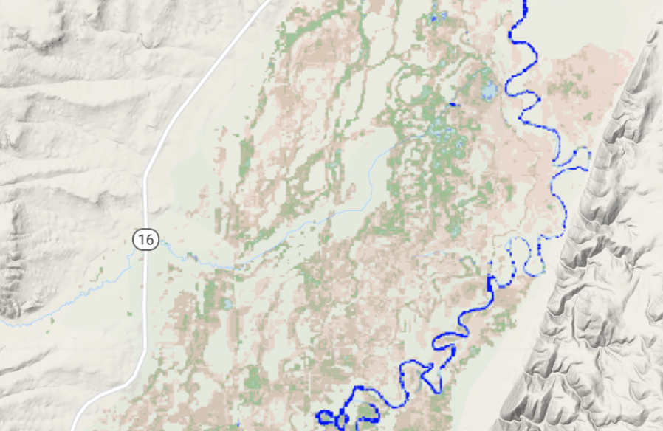Figure 2. Hydroperiod layer - hydroperiods represent wetland classes defined by Cowardin (1979) as; temporary (pink - flooded < 2 months), seasonal (seasonal - flooded >2 and <9 months ), or semi-permanent (blue - flooded > 9 months).
It is important to note that hydroperiods can be split when flooding is separated by drying in the same year. This pattern is naturally rare but can be associated with flood-irrigated agriculture when water is applied during the growing season and again in the fall post-harvest. Similarly, moist soil management on wildlife refuges can result in staggered flood events that stimulate plant growth. These actions can result in false hydroperiods when a site is classified as a seasonal wetland (total flooded months >2 and <9) but functions ecologically as a temporary (flooded < 2 months) split over multiple periods.
The value represented is the length of inundation; units are months of inundation.

Resilience:
Layers depict seasonal (spring, summer, fall, winter) wetland surface water trends from 1984 to 2020. Areas of wetland drying are shown in red, with darker shades representing consistently drier conditions associated with shorter or less frequent periods of inundation. Areas that have become wet more often or for longer periods are shown in blue, with darker shades indicating consistently wetter conditions. Areas of white represent stable conditions. All wetland trends are relative to local patterns, meaning that a site that is rarely inundated but has experienced abnormal flooding events in recent years will be depicted as trending wetter despite relatively dry conditions otherwise.
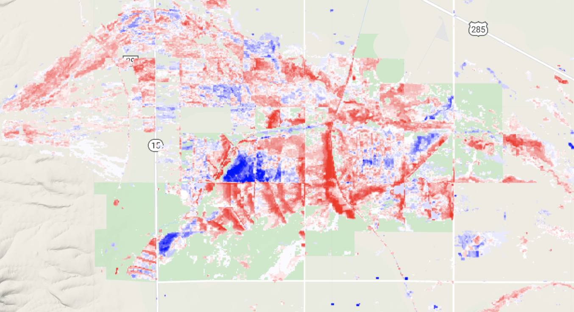
Figure 3. Resilience layers - areas of wetland drying are shown in red with darker shades representative of consistently drier conditions. Areas that have trended wetter are shown in blue with darker shades indicating consistently wetter conditions.

Common uses of the resiliency layer include:
Screening tool for conservation easement programs seeking to ensure investments prioritize protections of climate-resilient wetlands - i.e., wetlands that show positive or neutral trends in wetland surface water conditions over time.

Restoration tool that allows users to focus on areas of wetland drying to target on-the-ground examination of their restoration potential.

Values range from -1 to 1, with values <1=drying and >1=wetter. Values at or near 0 are considered stable.
Users should be aware that the interpretation of wetland resiliency trends can be complex as patterns are frequently influenced by multiple factors that include: hydrology, climate, irrigation practices, irrigation infrastructure, and water use laws. Local knowledge of these factors is necessary when determining cause.
For more information about WET or supporting research, please contact Teagan Hayes.
e teagan.hayes@iwjv.org
c 920-979-9009

