Fs=22050; F0=440; F1=880; D=1;

t=linspace(1/Fs,D,Fs*D); x0=sin(2*pi*F0*t); x1=sin(2*pi*F1*t); soundsc(x0,Fs); soundsc(x1,Fs)

plot_spectrum(x0,Fs,'single tone @ 440 Hz', [0.15, 0.17]);

plot_spectrum(x1,Fs,'single tone @ 880 Hz', [0.15, 0.17]);

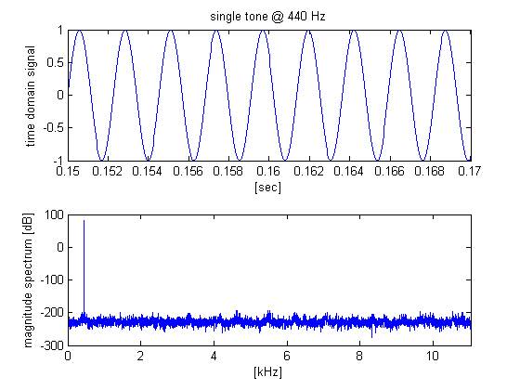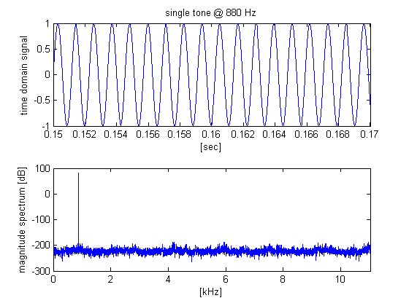

*Published with MATLAB® R2014a*