CST8912 – Cloud Solution Architecture
Contents

Introduction: 2
Prerequisites: 2
Objectives: 2
Findings: 3
Step 1: 3
Step 2: 4
Step 3: 6
Step 4: 8
Step 5: 9
Step 6: 10
Step 7: 13
Takeaways and Analysis: 14
References: 15

Graded Lab Activity #3

Introduction:
As part of this lab, we examine how to manage and configure Azure Storage accounts. We focus on important tasks like configuring blob access tiers, enabling secure file sharing using shared access signatures (SAS), and selecting redundancy choices. Likewise, we also use lifecycle management to automate data transfer among various storage levels according to preset rules.
The following activities are done hands-on in the lab exercises:
- Initiating a geo-redundant storage account (GRS).
- Adjusting blob access levels and storage redundancy.
- File uploading, access control management, and container creation.
- Providing temporary, secure access to storage resources by generating SAS tokens.
- putting lifecycle management guidelines into practice to automate data transfer.

Prerequisites:
Any sample file can be selected for this lab from the link given below:
https://people.sc.fsu.edu/~jburkardt/data/csv/csv.html

Objectives:
- Define and list the essential architectural elements required to satisfy the functional needs of various application scenarios.
- Implement highly available solutions by gaining a profound understanding of cloud service models, such as IaaS, PaaS, and SaaS.
- Understand how to use Shared Access Signatures (SAS) and learn how to design and oversee a highly scalable, secure cloud storage solution.

Findings: The findings of this lab can be summarized in following steps:
Step 1: This step involves selecting geo-redundant storage keeping networking and data protection settings as they are and creating a storage account under the student subscription and resource group "CST8912-demo" for area Canada Central.
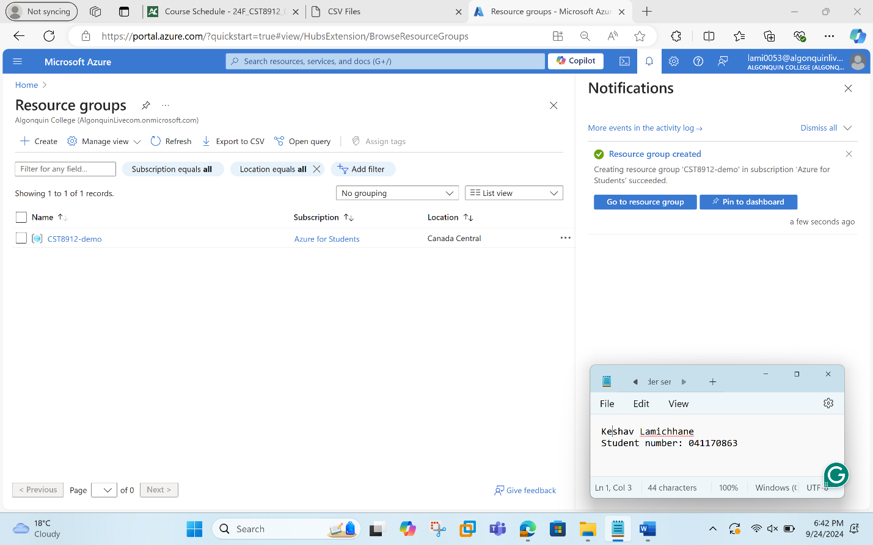
In the next step, we created the storage named lab2test8912 with the following details:
Subscription: Select your student subscription.
Resource group: Select or create a new one named "CST8912-demo."
Storage account name: lab2test8912
Region: Select "Canada Central."
Performance: Standard.
Redundancy: Geo-redundant storage (GRS).
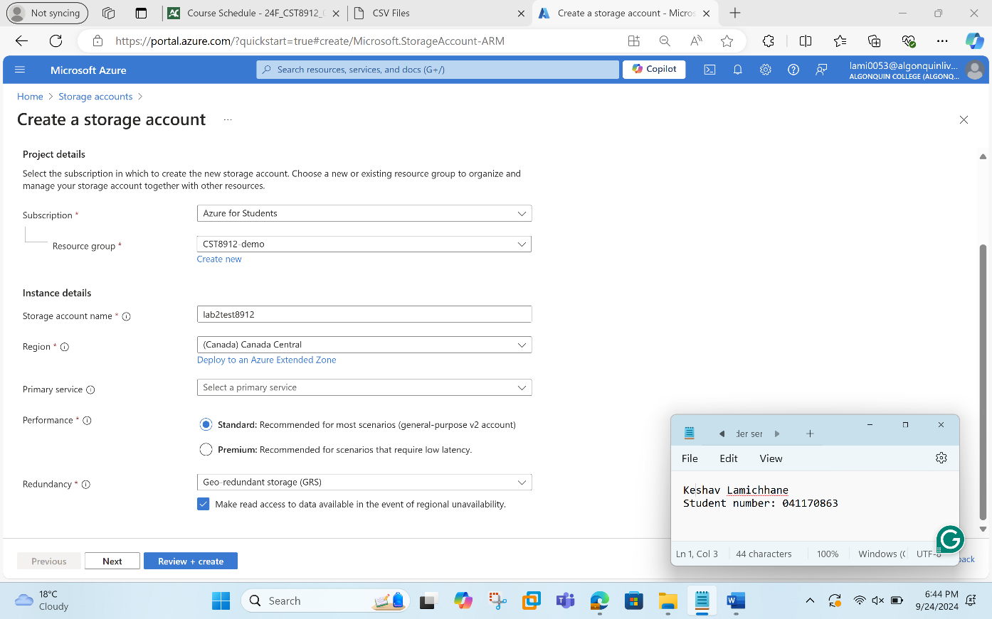

Step 2: In this step, we navigate to the "Storage accounts" service and click on lab2test8912. In the left-hand menu under "Data management," we change the redundancy to local redundant storage and also change the blob access tier to cool.
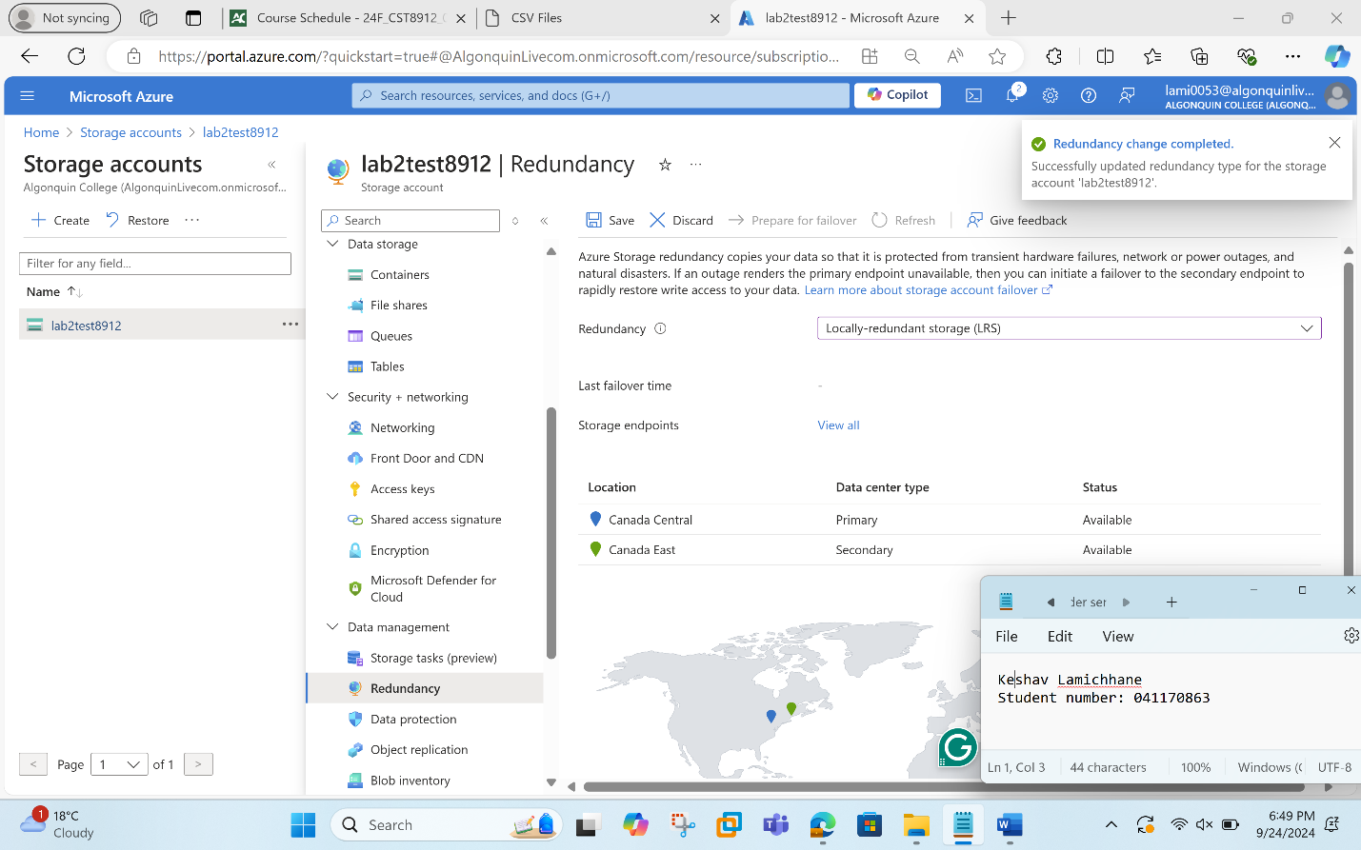
Under the "Settings" section, click "Configuration." And in the "Blob access tier" section, change the default to "Cool”.
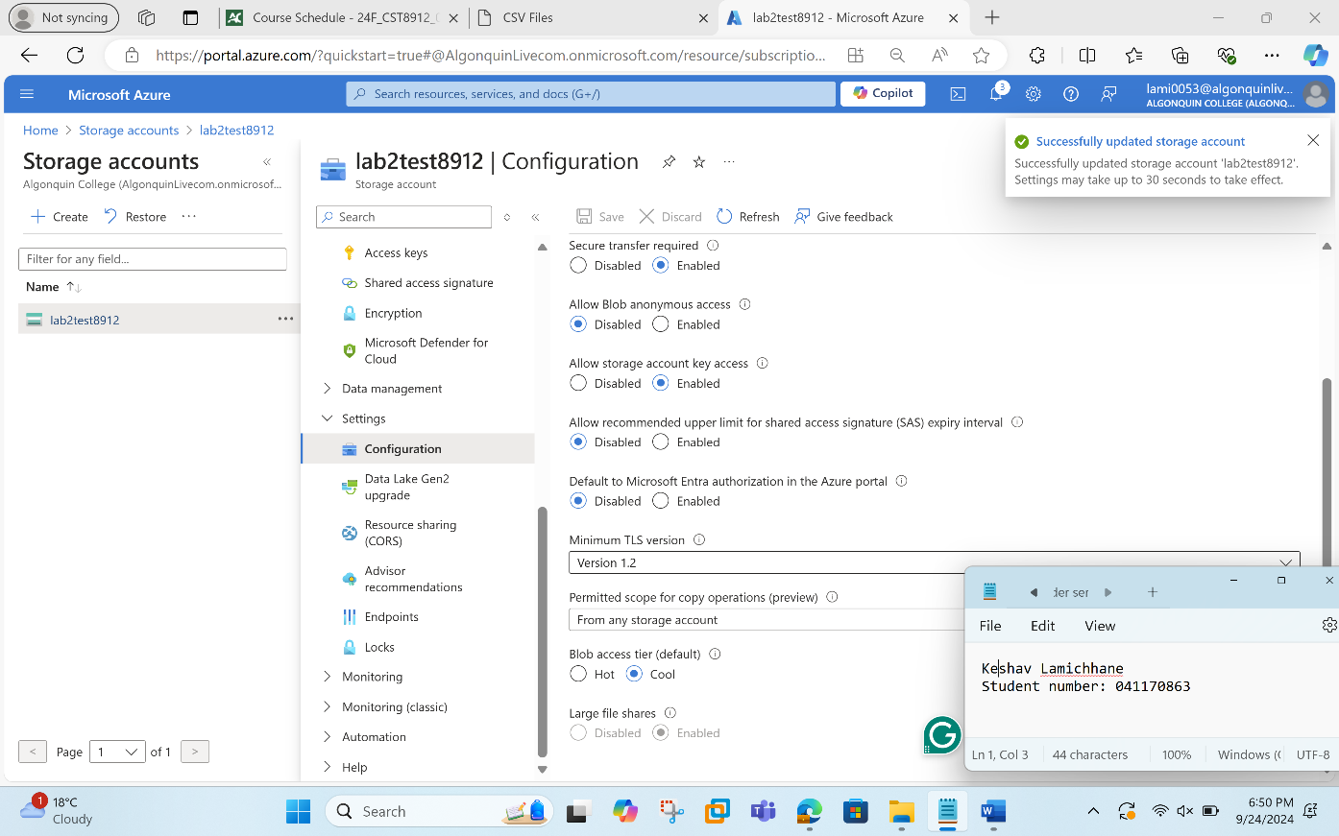
Step 3: In this step, we will be creating container named as labtestcontainer8912 and set the access to public and click create.
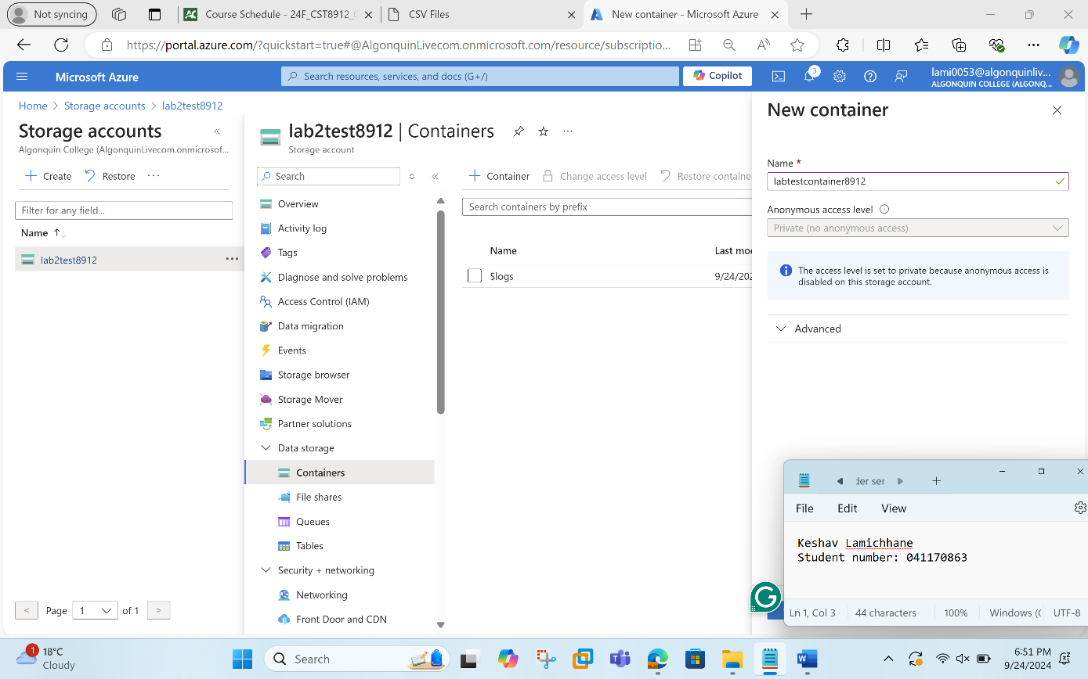
Next step is to upload a blob. For this, click on upload section of container created so far. The sample file for uploading can be downloaded from the link provided in the lab instructions.
Once uploading is done,
- Change "Access tier" to "Hot."
- Select the destination folder "sampletest8912."
- Click "Upload."
The following screenshot clarifies the step:
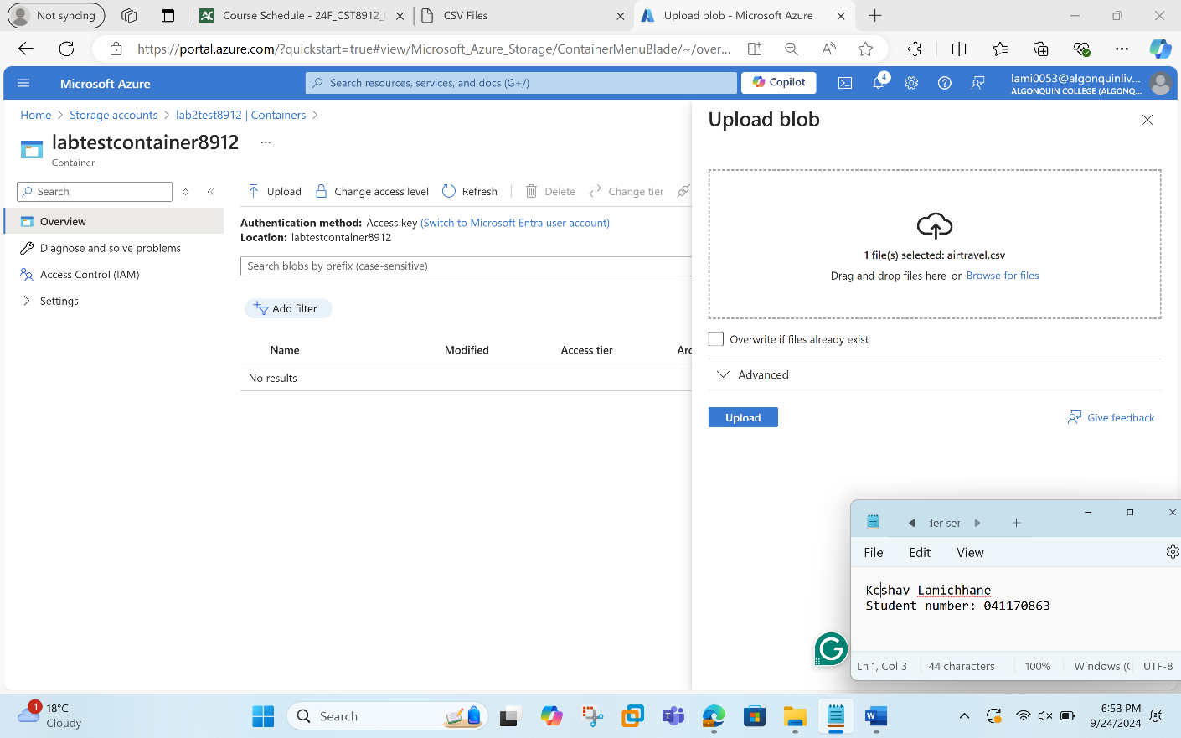

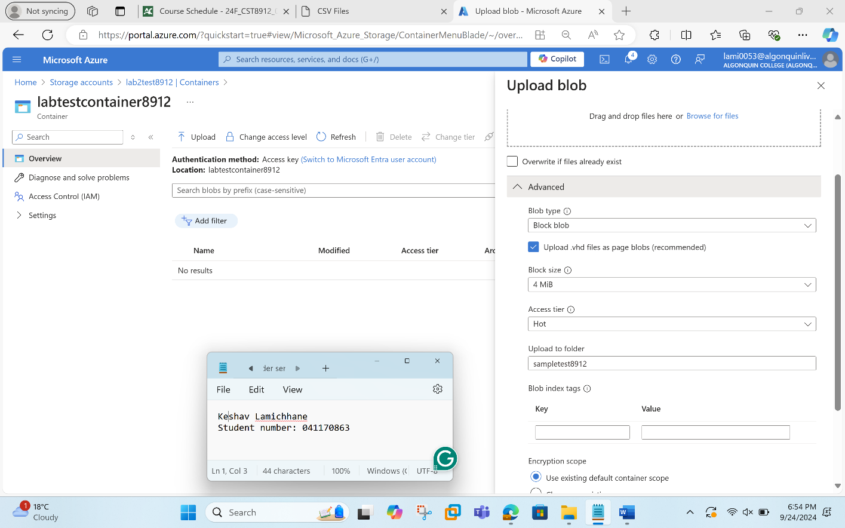

Step 4: In this step, we see the configuration options of the container and copy the URL to open that in a new private window of the browser.
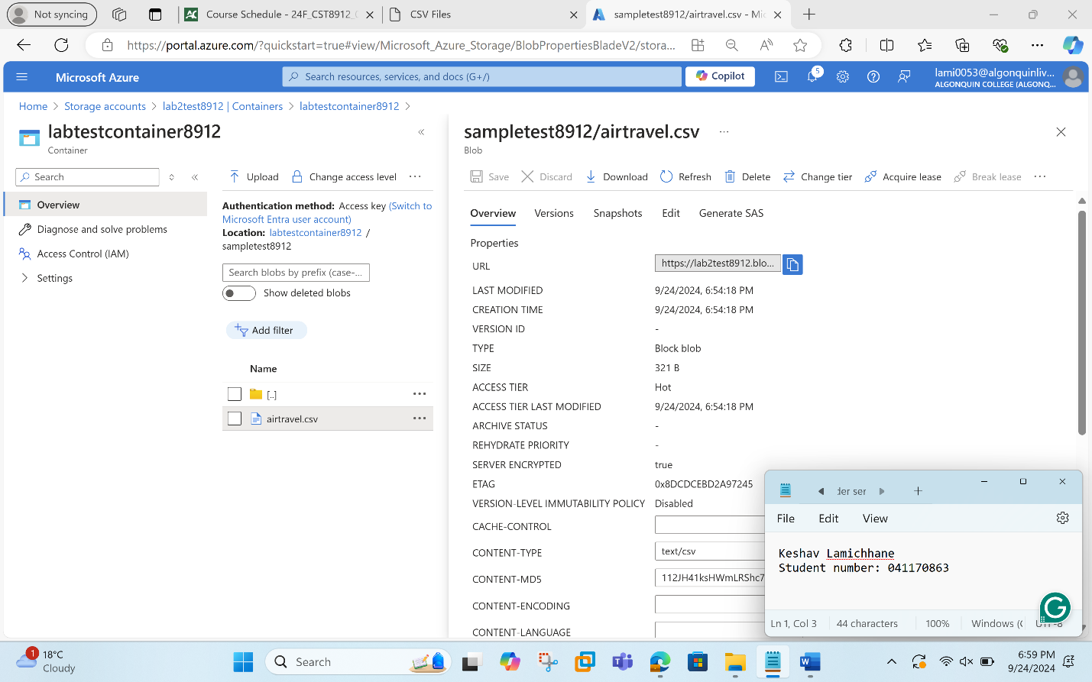
The url won’t work since the container has been assigned private access and cannot be accessed by the public. We will receive a "Resource not found" error, indicating the blob is not publicly accessible.
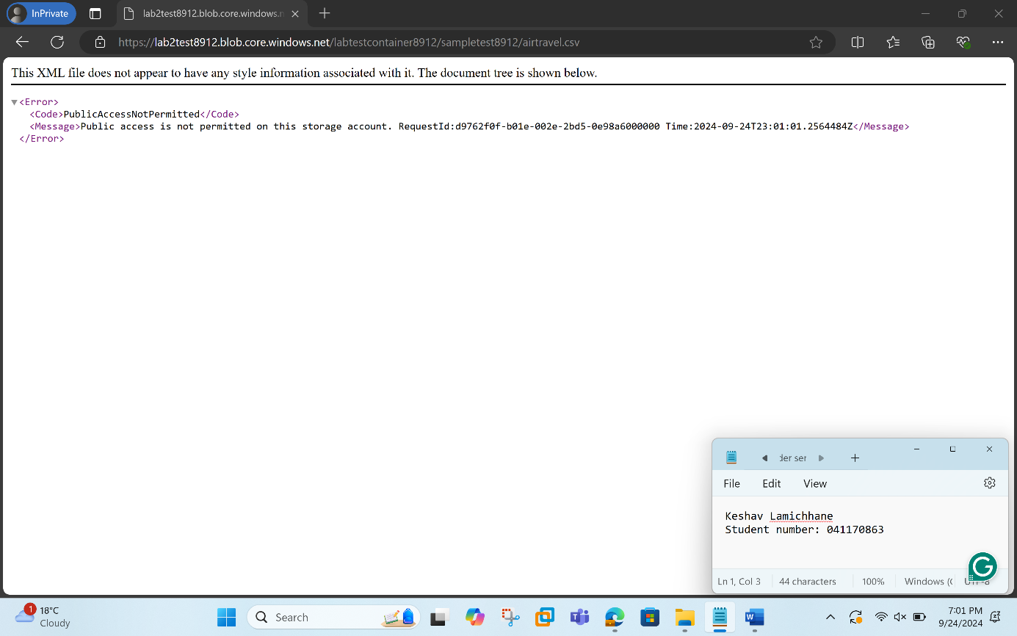
Step 5: Now, we need to create SAS token and then try again pasting the blob SAS URL on the private window.
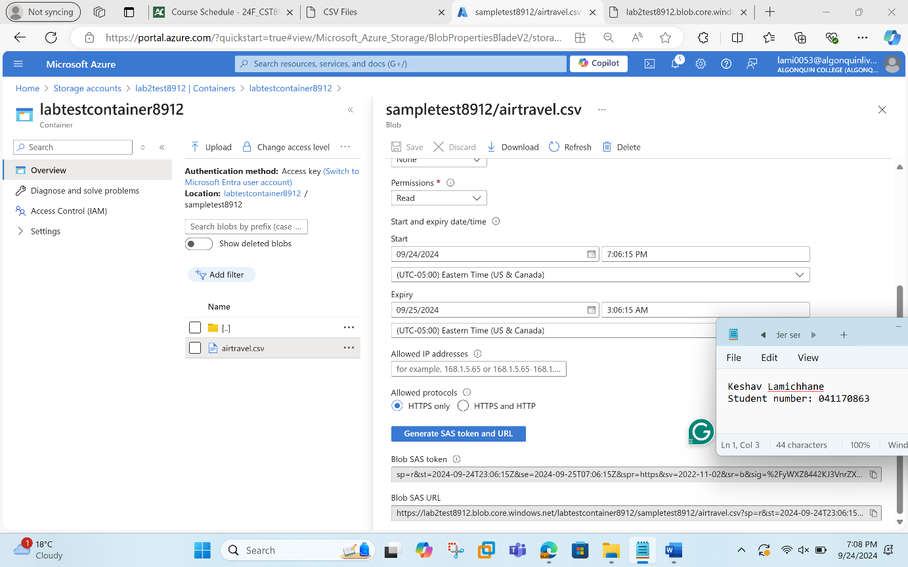
The file should now be accessible. As soon as you paste the link, the download will occur, and you can access the file.
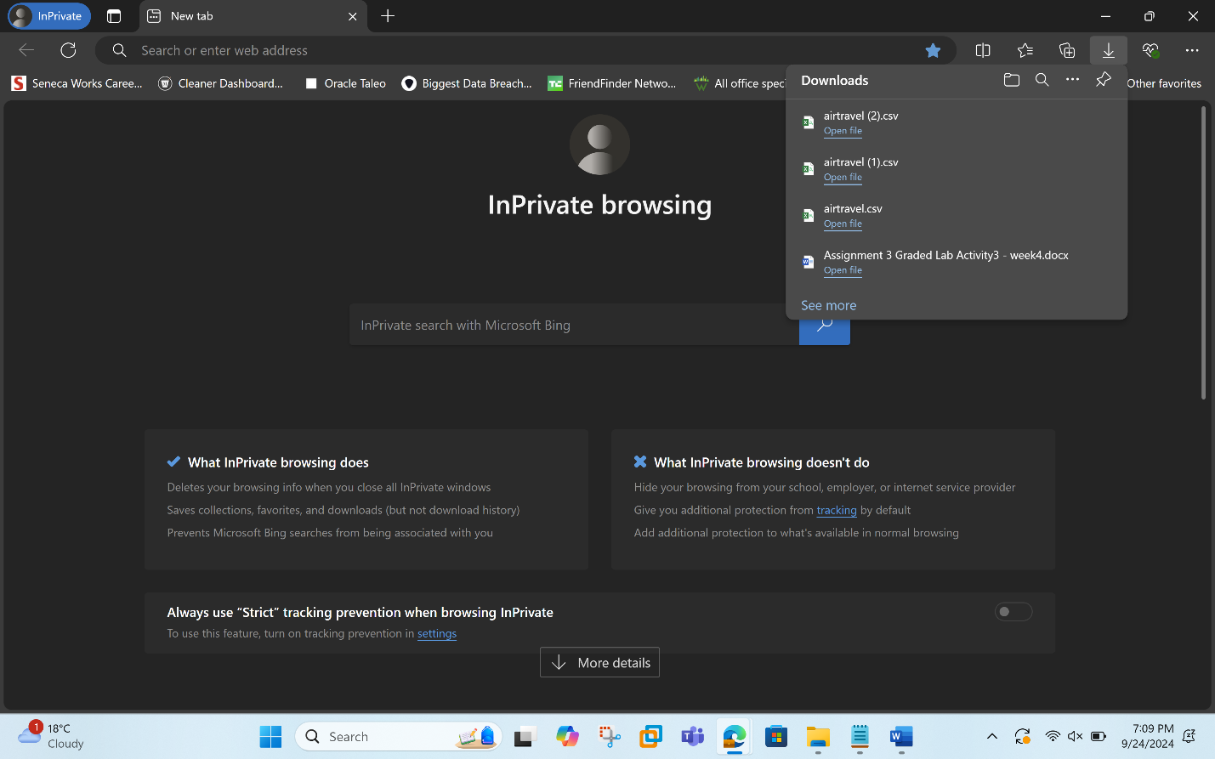
Step 6: In this step, we perform the lifecycle management with the following setting:
Configure Lifecycle Management:
- Go back to the storage account's main page.
- Under "Data management," select "Lifecycle Management."
- Click "+ Add rule."
- Give the rule name as myrule8912.
- Set the "Rule scope" to "Limit blobs with filters."
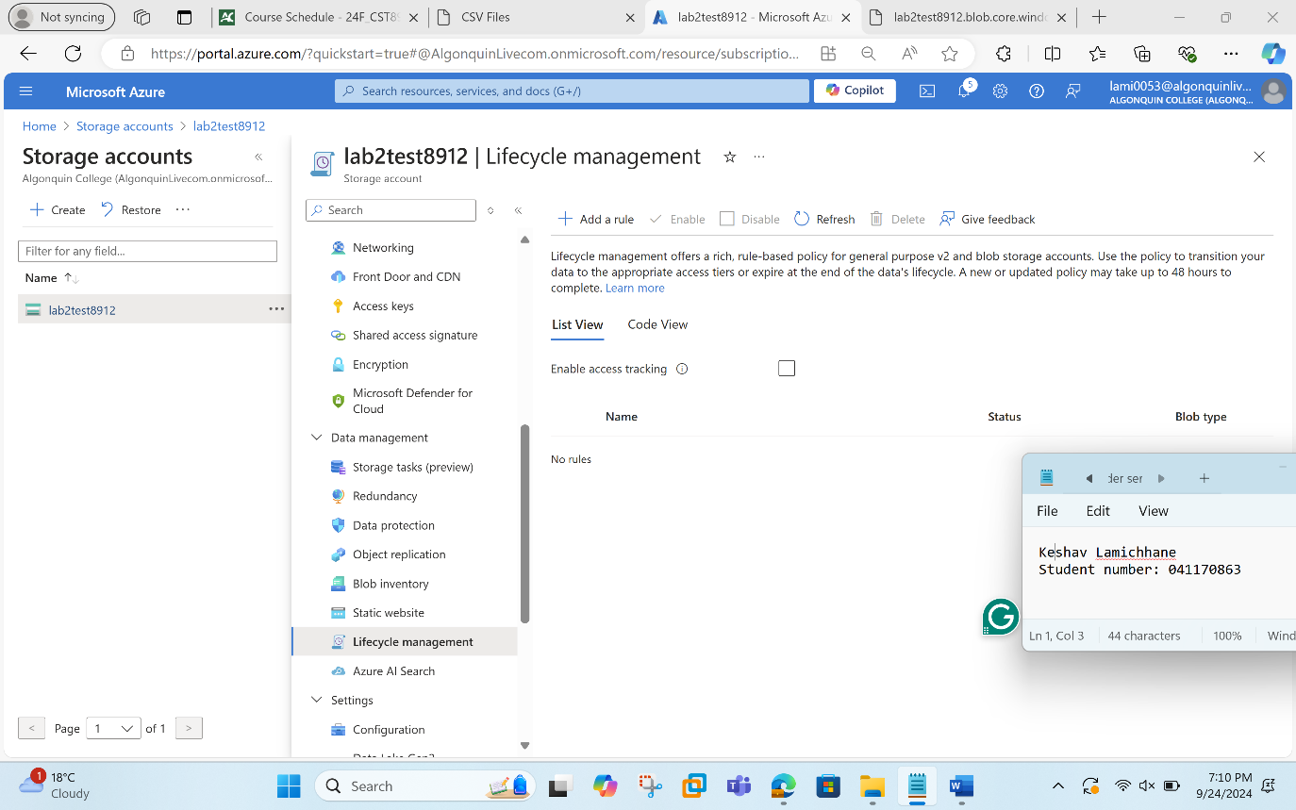
- For the condition, set "Base blobs last modified" to 15 days and click on "Action," and select move to cool storage and finally save it.
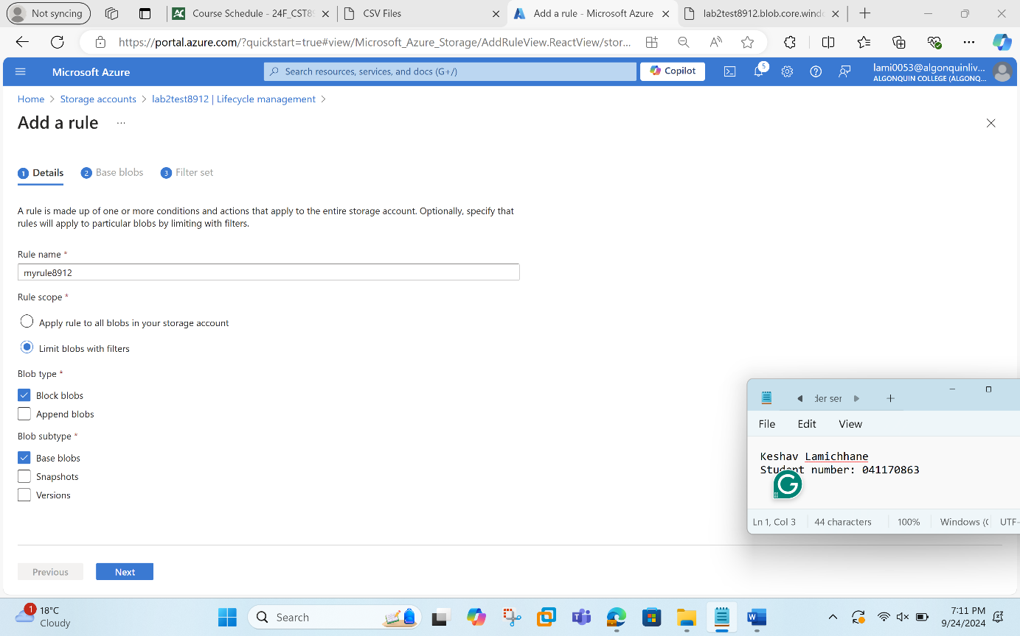

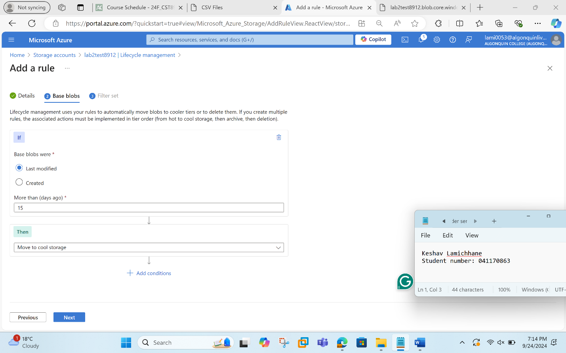
Lifecycle management rule created is shown below:
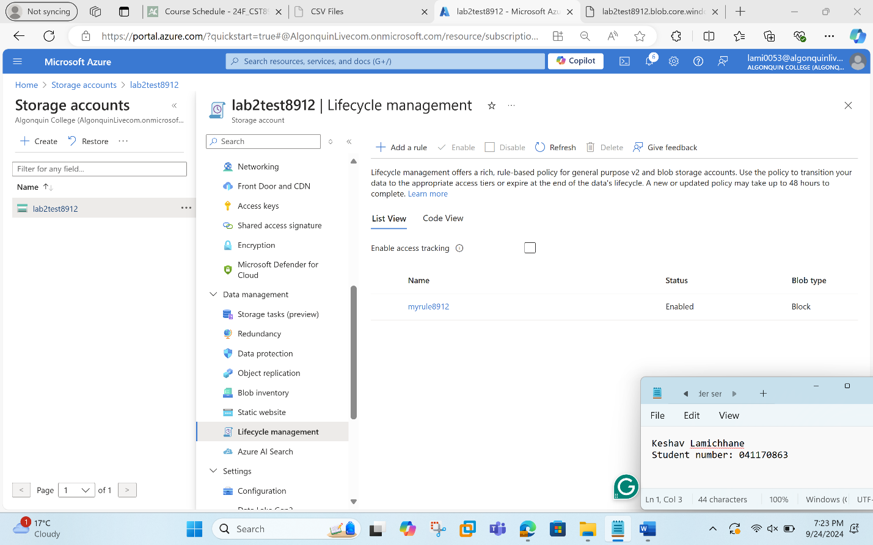
Step 7: This step concludes the lab. For proper cost management and resource management, we will be deleting the resources created so far for this lab.
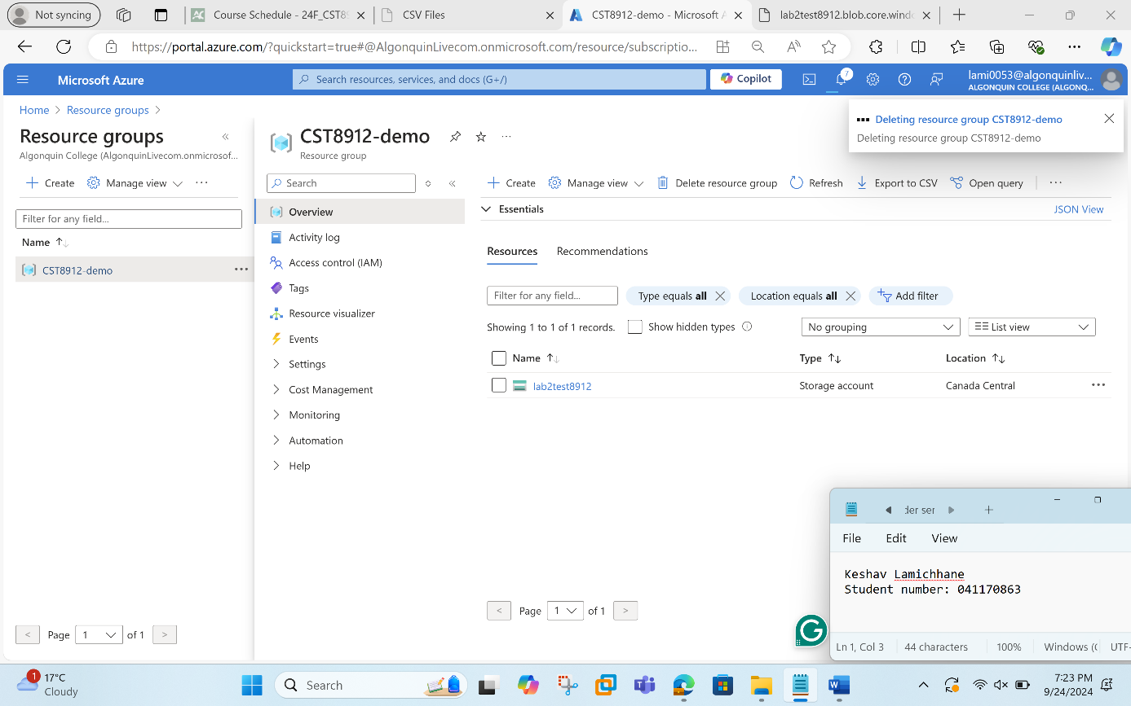

Takeaways and Analysis:
- Gained knowledge of setting up and creating Geo-Redundant Storage (GRS).
- Modified the blob access levels and storage account settings.
- Designed and oversaw containers with suitable access restrictions.
- Understood SAS tokens that have been generated for safe, transient resource access.
- Lifecycle management was put into practice to automate data movement.
- Understood resource cleanup as a key component of cost control.
- Gained practical knowledge of the key components of Azure storage.
These lessons learned will be useful in the design and management of safe, highly accessible, and reasonably priced cloud storage solutions for next projects or practical uses.

References:
Azure Storage Accounts - How to Create new Storage Accounts. (n.d.). Www.youtube.com. https://www.youtube.com/watch?v=sI2ahWX8RH8
‌CBT Nuggets. (2023, January 19). How to Generate Shared Access Signatures with Azure Storage Accounts. YouTube. https://www.youtube.com/watch?v=0PX1eW1sCGg
‌Digital Cloud Training. (2021, August 26). Amazon S3 Access Control - IAM Policies, Bucket Policies and ACLs. YouTube. https://www.youtube.com/watch?v=xFzJw6wJ8eY
‌Cloud Sprint. (2022, November 30). EP 12 : Google Cloud Storage Tutorial | Configure Object Lifecycle & Versions. YouTube. https://www.youtube.com/watch?v=DviqTrRZJ44
‌

