**Setting up environment to work with VxSDK Java sample** (*Currently supported in 32bit only)

Java sample comprises of two projects – one C++ JNI wrapper project for communicating with VxSDK libraries and Java UI application communicates with JNI wrapper libraries.

* CPPJni wrapper project in Visual C++

Dev Environment:

* Visual Studio 2013
* JDK 1.8 (32 or 64 bit)*

Steps to build the project:

* Add reference to VxSDK include files, MediaController project include files and Java JDK include file paths at “C++/General/Additional Include Directories” in project properties page.

For eg:

*VxSdk\Include;*

*MediaController\Include*

*C:\Program Files (x86)\Java\jdk1.8.0_66\include\win32;*

*C:\Program Files (x86)\Java\jdk1.8.0_66\include;*

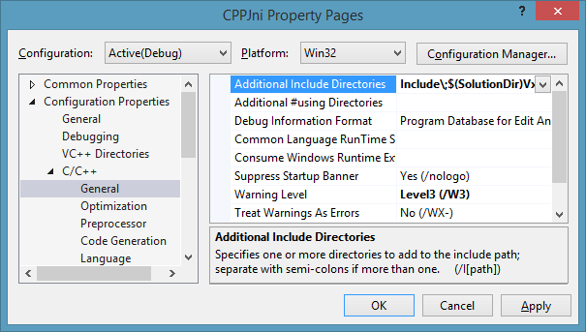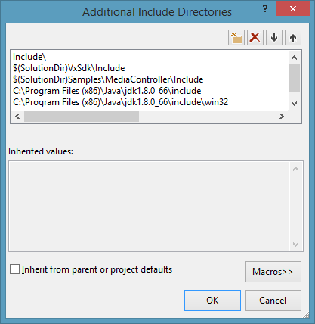

* Add reference to VxSDK and MediaController library paths under “Linker/General/Additional Library Directories” in project properties page.

For eg:

*VxSdk\Bin\;*

*MediaController\Bin\x86\Debug;*

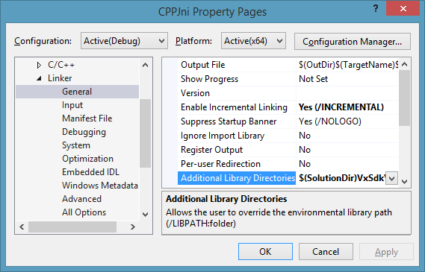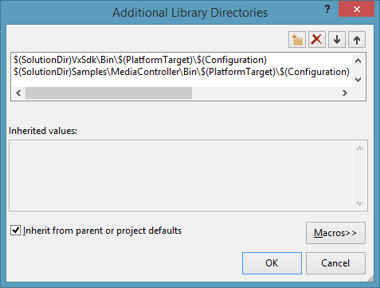

* Link VxSDK and MediaController libs to project via “Linker/Input/Additional Dependencies” in project properties page.

For eg:

*VxSdkd.lib;*

*MediaControllerd.lib;*

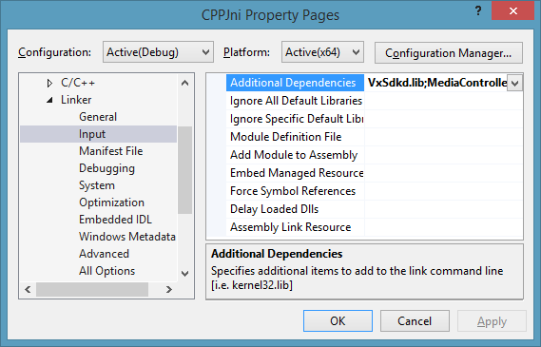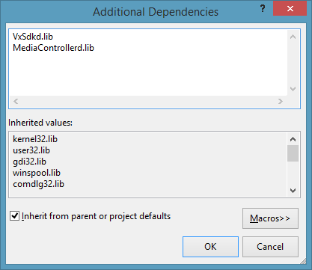

* Java UI Project

Dev Environment:

* Java Eclipse Luna
* JRE 1.8 (32 or 64 bit)*
* WindowBuilder plugin for Eclipse Luna

Steps to build the project:

* Check and configure the JRE in the project based on the JRE installed on your system by following below steps:
  + From the Java sample properties page, select “Java Build Path”-> “Libraries”
  + Ensure JRE System library pointed to the one installed in the system by “Edit”ing the JRE System library .
  + “Installed JREs” will list out the JREs that is installed and also add one.

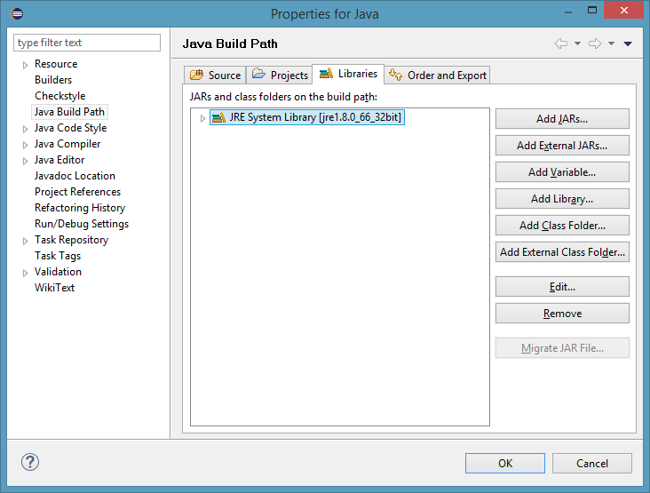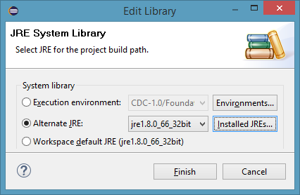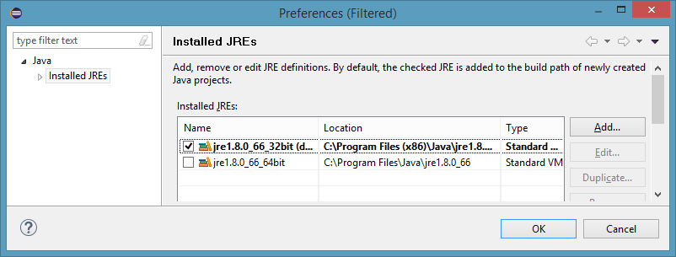

* Before building the project, make sure CPPJni project is built against the same platform as that of selected JRE type in above step. Ie. If you chose 32 bit JRE, then CPPJni should build in 32bit platform.
* Also based on the configuration to run with, make sure CPPJni and dependent libraries are ready with that configuration.
* Final thing is to make sure “libs” folder inside the project root folder contains the libraries (CPPJni, VxSDK, MediaController and GStreamer(bin and lib)) as per the selected configuration and platform.

For eg: to Debug  the Java sample, libs folder should look like this.

