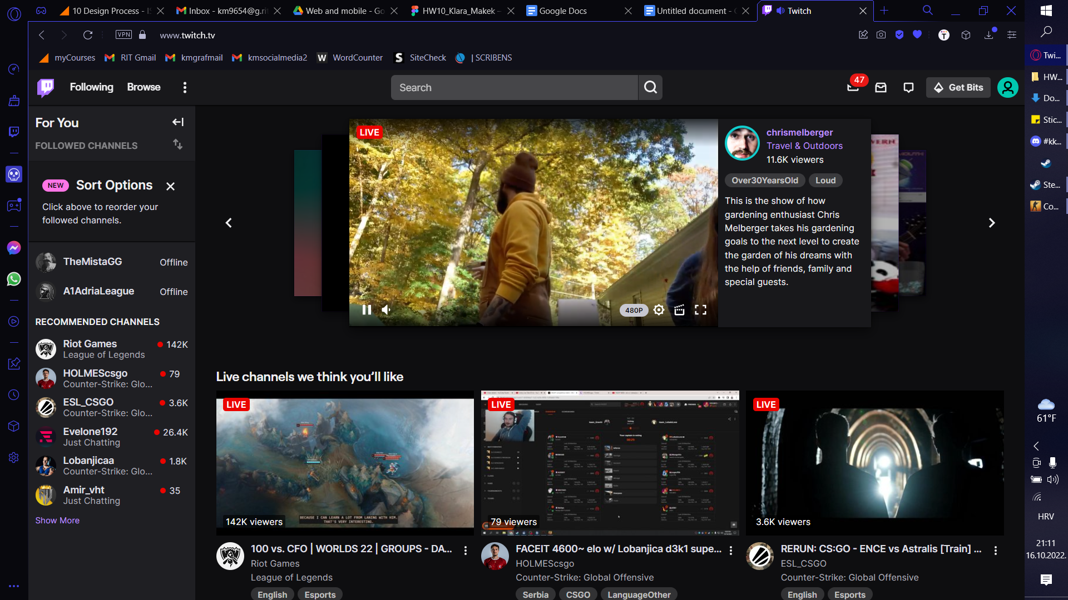

<https://www.twitch.tv>

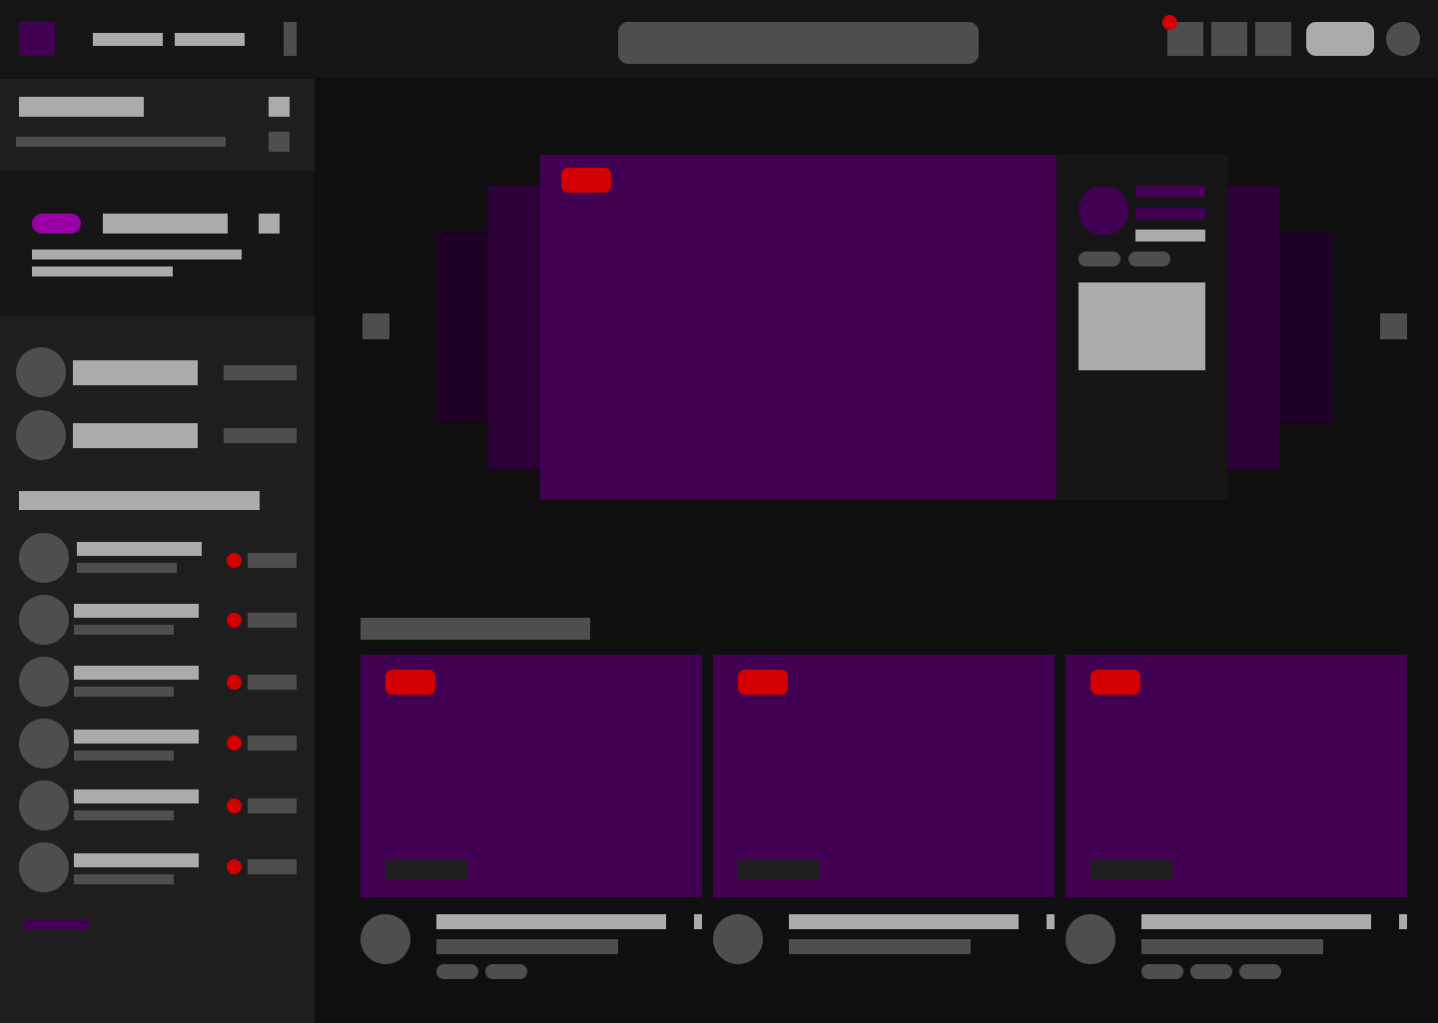

https://www.figma.com/file/QdsKGBPZ63z38b4RSDwYYJ/HW10_Klara_Makek?node-id=1%3A2

* What does your eye see first? What is the “hook”?

Well the hook is definitely the video of the stream that starts to play the moment the side loads.

* Where does the eye go next? Where does it go last?

My eye goes to the sidebar second and then the second stream grid under the main one, my eye last goes on the navbar.

* How does the design help the eye flow through the page?

When we scroll the sidebar doesn't move so our eyes are mostly focused on the weriarity of the streams.

* Is there a hidden grid or alignment?

There is nice and neat alignment of the sidebar content.

* How does color create an impact or movement?

Multiple colors of the video streams can be a little distracting but they do the job of getting your attention.The lighter color of the sidebar does attract your eyes.

* Does the design help carry the essence and mood of the site?

Yes, the dark team helps to relax the eyes while you watch streams and the highlights get your attention in time.