|  |  | **Information Sciences and Technologies**  **Golisano College of Computing and Information Sciences** |
| --- | --- | --- |

HW09 Design: Analyzing Web Sites

# Overview

So, you've been web surfing for quite some time now, and you've undoubtedly found some pages that you like and others that you don't like. Sometimes, it's not so easy to really explain why. You now have a new vocabulary with which to describe your thoughts.

# A. Site Evaluation

1. Follow these both links in any browser:

[**https://www.rit.edu/**](https://www.rit.edu/) **and** [**https://www.croatia.rit.edu/**](https://www.croatia.rit.edu/)

1. Examine these sites, at least the first page and a couple of links to sub-pages (sub-pages must be part of the same site).
2. Summarize your opinions for both sites and the reasoning behind them on:
   1. Alignment:

The first page has OK alignment. It’s mostly centered but some places stretch from left to right and there is somewhat of a balance.

The second page home page is almost completely from left to right but sub sites are centered.

* 1. Proximity:

The first page is too cramped on one side, and on the other, empty space is too broth. There is no balance and your eyes get lost very easily.

The second page home page has almost no empty space and it seems cramped but it's not so “in your face” as the first one. Sub pages do have margins and empty spaces which is good and it has a nice flow so your eyes don't get lost.

* 1. Repetition:

The first page had good repetition of colors and repetition of “blocks” of content like news and “Faces of RIT” is good.

The second page also has good repetition of color and “blocks” of content. Sub pages have repetition of the element of separation which gives nice composition.

* 1. Contrast:

The first page has a nice contrast. Things almost can’t get confused with each other.

The second page home page has a lot of colors but the contrast is oke. On the sub pages you can get a little confused.

* 1. Use of color:

Color of both pages is in the same color palette and it’s nice to distribute along the site. But pictures and their color ruin the over feeling.

* 1. Use of typography:

The first page has only 2 fonts and one of them is only used one, as I see it, and that is oke. Color of the text and the headers are different which is good. Fonts look a little different in navigation, content and footer.

The second page has only 1 font and it gives nice relaxation for the eyes. That font looks a little different in navigation, content and footer .Color of the text and the headers are different which is good.

1. Make a conclusion and explain your opinions on the design of both sites. Each student must post his/her thoughts individually.

The first page is overall nice but to me it has too many colors and the mix of centered and left-right alignment is confusing. The content appears too big and cluttered because of the size. Repetition helps a little to keep you on the track altho animations can lead your eyes away. The font could be better but it’s nicely used. The site could be better. Content is nicely spread and it can be read with any problem.

The second page home page could use a lot of redoing. It’s so cluttered and there is no empty space. But sub pages are much better than the home page. Home page and sub pages are related but don’t share the same feeling. Font is nice and usage is balanced. Color is nicely used and balanced, pictures are alright, they almost have the same color palette as the site. Content is nicely spread and it can be read with any problem.

B. Personal Class Page

Your home page is found at *solace.ist.rit.edu/~abc1234/index.html*. Pick a color scheme for your own class page and describe it below. Describe your current, existing color scheme (it's probably very bland). In fact, do a screenshot and embed it below. Describe briefly how you would like to redesign this page in terms of what colors you would like to use for each element.

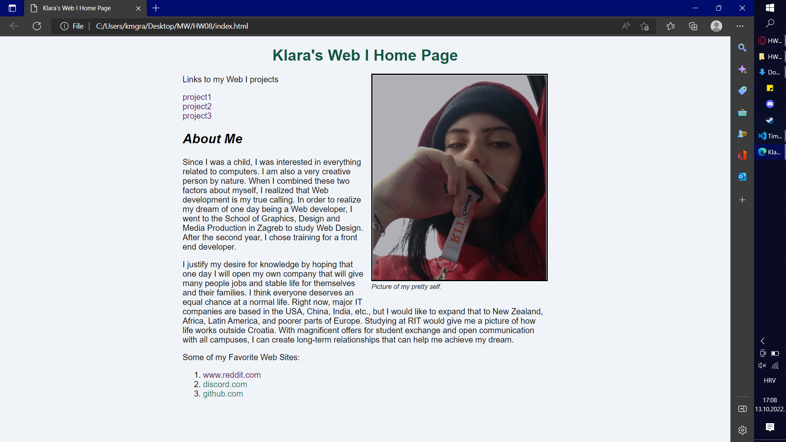

My color scheme consists of 4 related colors. My background color is light blue, almost ghostly white which makes black text pop out. For h1 i used green, and i used the same green for unclicked links. For hover over links I used light blue and for clicked links I used purple.

Going forward I would use dark gray for the text so it doesn't look so sharp. I would change the green to a little more light color for the h1 and for the links would leave this color.

Now, use the space below to sketch an improved layout for your page. Find a wireframe design tools or, alternatively, hand draw a design on a sheet of paper, scan or photograph it with your smart phone and embed it below.

I would like to stretch the content to have some balance with content and empty space. Would “box”related things(links, social, fav’ pages links) and put the emphasis on them so they look more appealing. Separate the navigation, heder, content and footer so it has nice aye flow.

# 

# Submission

When completed, upload this document to the Assignment dropbox HW09 Design using filename ***HW09-YourName.docx***.

HW09 Design: Analyzing Web Sites

**Name: Klara Makek**

| **Criteria** |
| --- |
| A.3 C.R.A.P. Analysis |
| A.4 Conclusion of site analysis |
| B. Personal home page shown as graphic or photo |
| B. Current color scheme for personal home page described |
| B. Discussion of an improved color scheme. |
| B. Improved layout for personal home page site discussed |
| B. Graphic of the improved personal home page included |