CMPUT 291-Assignment1

Lecture 1:00 – 2:00 pm MWF

Group Members:

Klark Bliss (Lab D10),

Justin Daza (Lab D03),

Siddhant Khanna(Lab D05),

Collaborators: None

Part 2:

CREATE TABLE Follows(

started CHAR(8),

follower CHAR(20),

followee CHAR(20),

PRIMARY KEY(follower, followee),

FOREIGN KEY (followee) REFERENCES Users,

FOREIGN KEY (follower) REFERENCES Users);

CREATE TABLE Users(

uid CHAR(20),

name CHAR(20),

email CHAR(20),

city CHAR(20),

timeZone CHAR(5),

PRIMARY KEY(uid));

CREATE TABLE Verified(

vdate DATE,

uid CHAR(20),

PRIMARY KEY(uid),

FOREIGN KEY(uid) REFERENCES Users

ON DELETE CASCADE);

CREATE TABLE Protected(

uid CHAR(20),

PRIMARY KEY(uid),

FOREIGN KEY(uid) REFERENCES Users

ON DELETE CASCADE);

CREATE TABLE CreatesLists(

name CHAR(12),

creator CHAR(20) NOT NULL,

PRIMARY KEY(name, creator),

FOREIGN KEY(creator) REFERENCES Users,

ON DELETE CASCADE);

CREATE TABLE Includes(

name CHAR(12),

uid CHAR(20),

PRIMARY KEY(name,uid),

FOREIGN KEY(name) REFERENCES Lists,

FOREIGN KEY(uid) REFERENCES Users);

CREATE TABLE WritesTweets(

tdate DATE,

uid CHAR(20) NOT NULL,

text CHAR(140),

PRIMARY KEY(tdate, uid),

FOREIGN KEY(uid) REFERENCES Users,

ON DELETE CASCADE);

CREATE TABLE Retweets(

op CHAR(20),

uid CHAR(20),

tdate DATE,

rdate DATE,

PRIMARY KEY(tdate, op, uid),

FOREIGN KEY(tdate,op) REFERENCES tweets,

FOREIGN KEY(uid) REFERENCES Users);

CREATE TABLE hashtags(

term CHAR(20),

PRIMARY KEY(term));

CREATE TABLE URLs(

longURL CHAR(40),

sortURL CHAR(20),

PRIMARY KEY(shortURL));

CREATE TABLE mentionsU(

uid CHAR(20),

tdate DATE,

url CHAR(20),

PRIMARY KEY(tdate,uid,url),

FOREIGN KEY(tdate,uid) REFERENCES Tweets,

FOREIGN KEY(url) REFERENCES URLs);

CREATE TABLE mentionsH(

uid CHAR(20),

tdate DATE,

term CHAR(20),

PRIMARY KEY(tdate,uid,term),

FOREIGN KEY(tdate,uid) REFERENCES Tweets,

FOREIGN KEY(term) REFERENCES hashtags);

CREATE TABLE replto(

originalId CHAR(20),

o_date DATE,

replyId CHAR(20),

r_date DATE,

PRIMARY KEY(r_date, replyId),

FOREIGN KEY(r_date, replyId) REFERECES Tweets,

FOREIGN KEY(o_date, originalId) REFERECES Tweets);

Part 1 – Individual Diagrams:

Diagram Creator: Klark Bliss

Reviewed by: Justin Daza

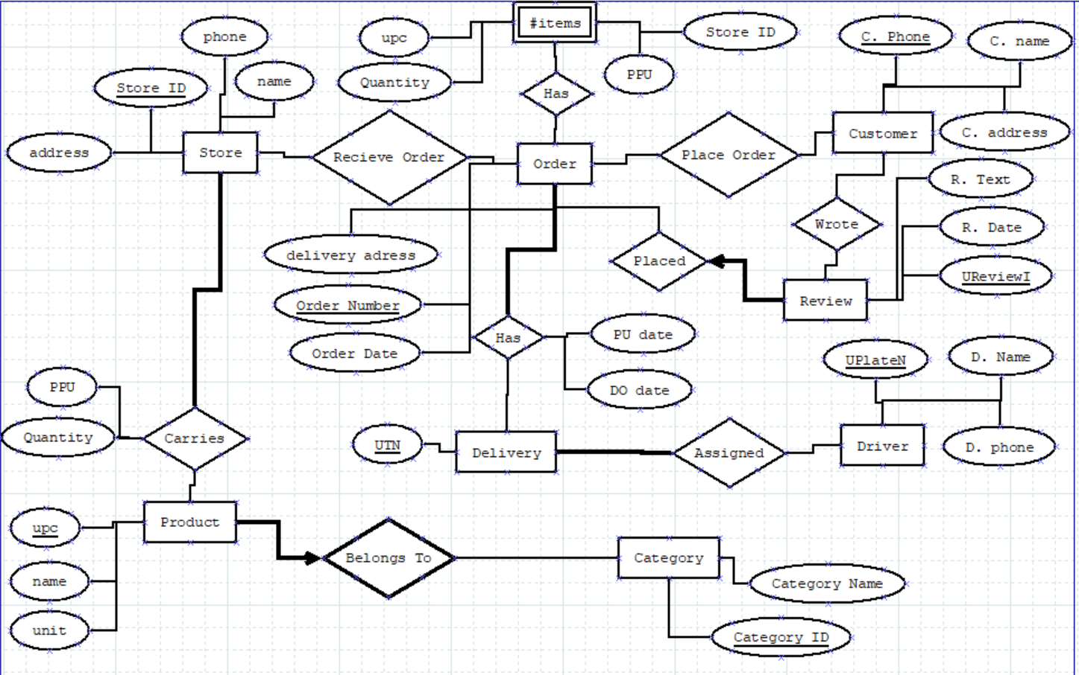

Comments:

Item Entity:

- Makes sense that it should be a weak entity of Order.

- Not sure if creating Store ID Attribute is a good way to show store association

- There should be a relationship with Product and Store based on the database specifications.

- Missing bijective constraint since it is a weak entity

- Quantity and PPU attributes should be attached to the ‘Has’ relationship

Confused about the connection going on here. Assume that it’s connected to Order.

Wrote & Place Order Relationship:

* These relationships aren’t necessary given the database specifications. Review should only have a relationship with Order.
* Should have a participation constraint on the Review side of the relationship

Review Entity:

- Reviews are part of the order so it would make sense to label this as a "weak entity".

Diagram Creator: Siddhant Khanna

Reviewed by: Klark Bliss

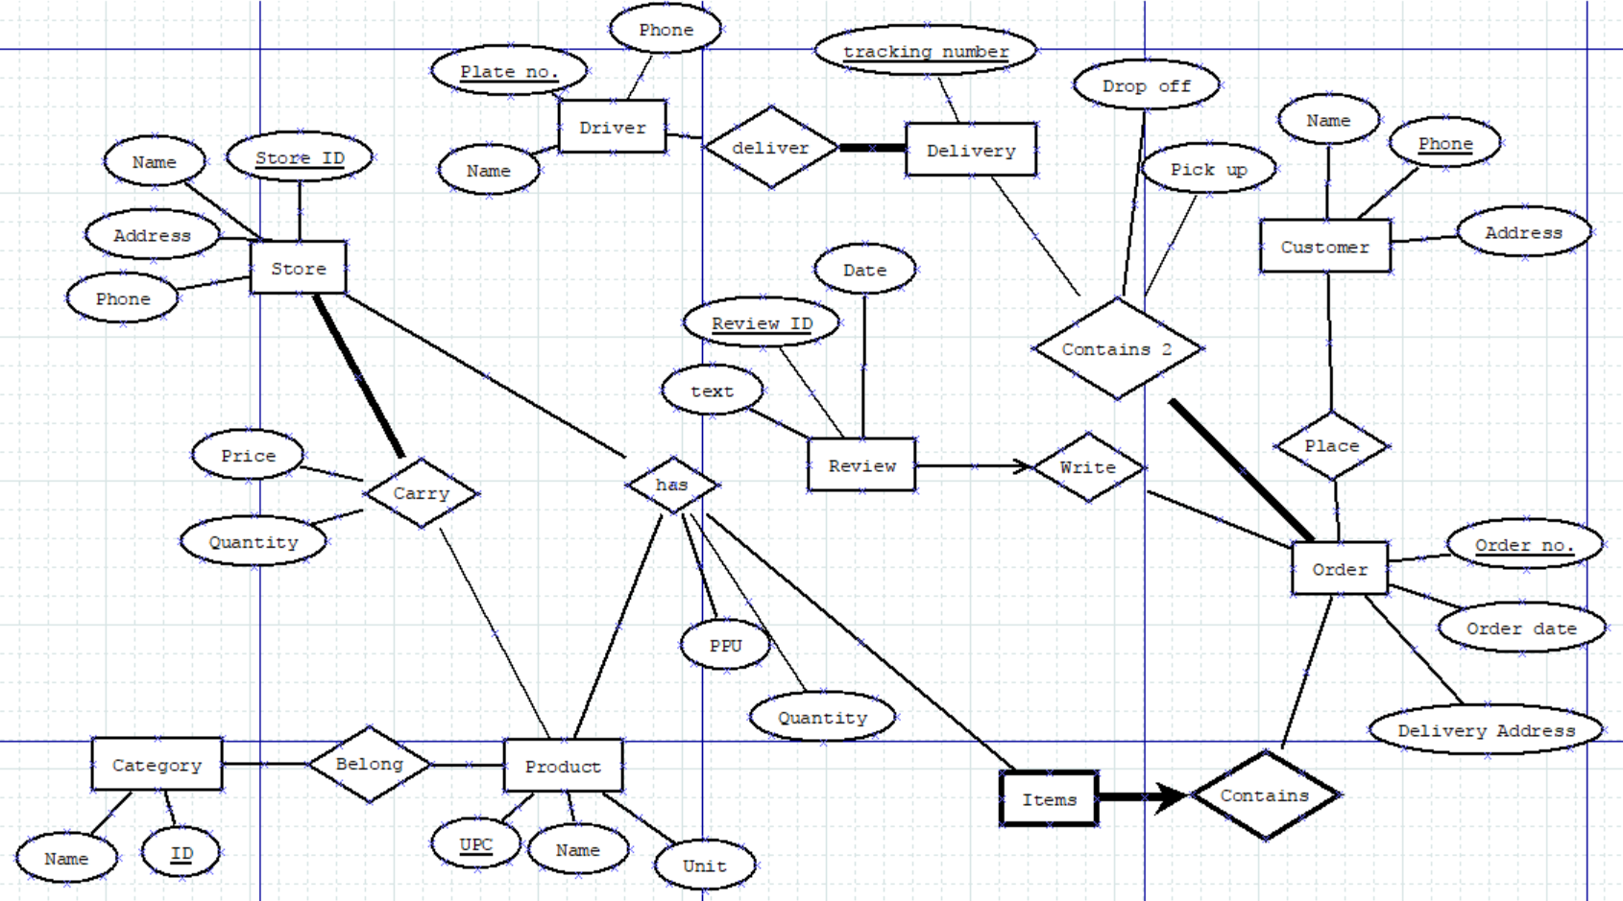

Comments:

* The store entity has all the correct attributes and I agree with store ID

as the key

* I agree with the Customer entity
* I agree with the Product entity
* I think Product might be weak entity of category because consider the

Scenario where a store deletes a category then there would be no need

To hold onto the products in that category either. Furthermore the

Phrasing belongs to makes it seem like category is the superclass to product

* Plus, there should be a participation constraint 1…N from product to the

Relationship “Belong”. Because while you can have a category with no items

In it meaning you are waiting for a shipment you can’t have a product in the

Store and have it not belonged to a category

* I agree with the relationship setup between product, store, and the

participation constraint going from store to carry

* I agree with the relationship between customer and order.
* Items should have a participation constraint not a bijection constraint since

There can be more than one item

* The ternary relationship between store, product and items makes it unclear

What items is the weak entity to. If you keep the ternary relationship have

A bijective constraint going to has. If you change it so that there are three

Binary relationships have a bijective constraint on the relation going from

Items to product.

* I agree with the delivery entity and its relationship to the order entity
* I agree with the driver entity and its relationship to the delivery entity
* I agree with the review entity and its relationship to the order entity

And its [0,1] (intersect natural numbers) constraint

Part 1 – Group Diagram Solution:

