dbt Learning Program
Week 1 Recap & Week 2 Guide
Building a Star Schema Data Warehouse with dbt

This guide walks through everything covered in Week 1 and introduces the new concepts for Week 2, with diagrams for each major idea. The goal is not just to finish the tasks and get a passing grade — it's to actually understand why each step matters, because that understanding is what carries over into every future project you touch, long after these specific tables are forgotten.
Read it top to bottom before opening the code. It will take longer than skimming straight to the task list, but it will save you far more time than it costs once you hit something unexpected.

What's Inside
- Part 1 — Week 1 Recap: the star schema, the RAW → STAGE → DEV rule, what you built, and how it all connects
- Part 2 — Week 2 Guide: fact tables, incremental models, and snapshots, explained with analogies and diagrams
- Part 3 — Walkthrough of all three Week 2 tasks with code
- Part 4 — Mistakes to Avoid, Word List, and Quick Quiz

Part 1 — Week 1 Recap: Staging & Dimensions
Week 1 was about getting raw data into the warehouse and making it trustworthy. Before you touch Week 2, make sure the ideas below feel solid — everything in Week 2 builds directly on top of them, and the fact table you're about to build will break in confusing ways if these foundations aren't clear.

The Big Picture: What Are We Building?
Over the course of this program, you're building a Star Schema — a way of organizing data into two kinds of tables. Think of a retail company: someone needs a list of every customer and every product (things that mostly stay the same), and separately, a record of every sale that ever happened (things that pile up constantly). A star schema keeps those two kinds of information apart on purpose:
- Dimension Tables (the "What"): Descriptive data about entities — customers, products, stores. These rarely change and answer "who or what is this?"
- Fact Tables (the "How much"): Transactional events — orders, and the individual items sold within them. These grow every single day and answer "how much happened, and when?"
Week 1 built the dimensions. Week 2 builds the fact table that connects to all of them — you'll see exactly how they link together in the diagram below.

The Data Flow Rule
There is one rule that governs the entire project, and it's worth memorizing before anything else:
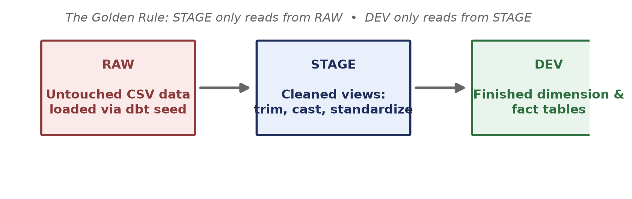
Figure 1 — Data only ever flows one direction: RAW → STAGE → DEV.
- RAW: The raw seed data — CSV files loaded exactly as they arrived, with no cleanup at all. If a name has extra whitespace or a date is stored as text, it stays that way here.
- STAGE: One view per source that trims whitespace, fixes casing, and casts data types correctly. This is the only layer allowed to read from RAW.
- DEV: The finished dimension and fact tables that the rest of the business would actually query and build reports on. DEV reads only from STAGE — never directly from RAW.
Why this matters: if every model pulled straight from RAW, any inconsistency in the source data — a stray space, mismatched casing, a null field — would leak into every downstream table, and you'd have to fix the same bug in ten different places. By funneling everything through one clean STAGE layer, a fix in one staging model propagates to everything built on top of it.

What You Actually Built in Week 1

1. Seeds
You ran dbt seed to load 5 raw CSV files into the RAW schema — this is the starting point for every model that follows. Nothing downstream can exist until this step succeeds.

2. Five Staging Models
One SQL view per source table, each doing basic cleanup: trimming text, standardizing casing, casting types, and defaulting nulls to sensible values. None of them do any business logic yet — that's intentional. STAGE is purely about making the data trustworthy, not about calculating anything.
- stg_customers — cleaned names, lowercase email, cast signup_date
- stg_products — trimmed names, prices cast to numeric, is_active cast to boolean
- stg_orders — lowercase/trimmed status, cast order_date, shipping_fee defaulted to 0
- stg_order_items — quantity/prices cast to correct numeric types, discount_pct defaulted to 0
- stg_stores — trimmed text, region uppercased, cast opened_date

3. Three Dimension Tables
Built in models/dev/, each referencing its staging model — never a seed directly:
- dim_customers — customer_id, full_name, email, phone, country, city, signup_date
- dim_products — descriptive columns plus unit_margin (list_price − cost_price)
- dim_stores — store_id, store_name, city, country, region, opened_date

How the Staging Models Connect
It helps to see the relationships as a picture rather than a list. Here's how the five staging models you built reference each other:
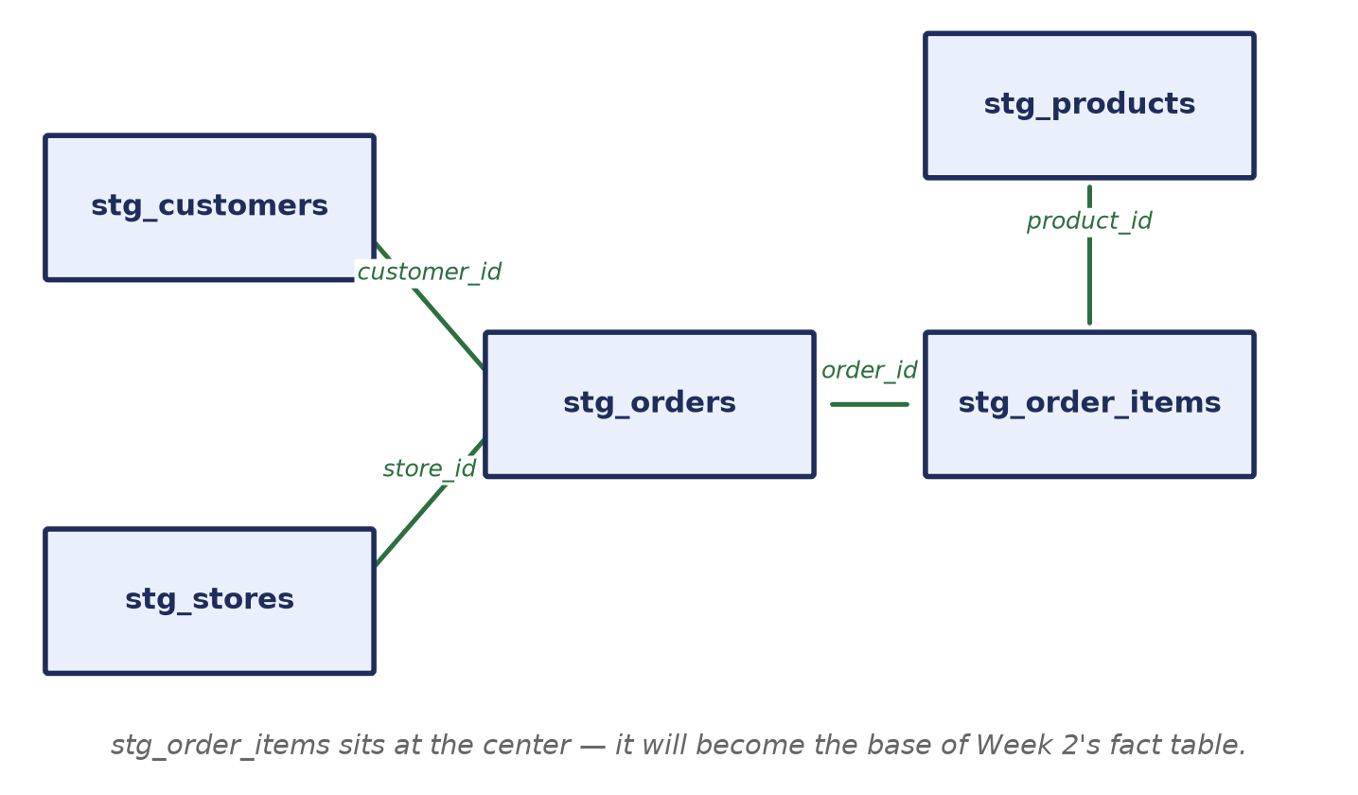
Figure 2 — stg_order_items is the connective tissue between orders, products, customers, and stores.
Notice that stg_order_items sits in the middle and touches almost everything. That's not a coincidence — it's the line-level detail that Week 2's fact table is built directly from. Every foreign key you see in this diagram (customer_id, store_id, product_id, order_id) is a thread that Week 2 will pull together into one table.

Self-Check Before Moving On
If any of these feel shaky, it's worth revisiting the Week 1 material before starting Week 2:
- Can you explain, in one sentence, why STAGE exists as a separate layer instead of building dimensions straight from RAW?
- Do you know the difference between a dimension table and a fact table?
- Can you trace how a customer_id flows from stg_customers into dim_customers?

Part 2 — Week 2: The Incremental Fact & Snapshots
Budget: roughly 2 hours. This week has three parts, and they build on each other in order — build the fact table first, then make it incremental, then add the snapshot. Don't skip ahead; Task 2.2 assumes Task 2.1 already works, and Task 2.3 is independent but easiest to understand once the first two clicks.

What's New This Week (In Plain Terms)

The Fact Table
A fact table is where the transactional detail lives — one row per real-world event. This week that event is a single line item within an order. You'll join three staged models together (orders, order items, and products) to produce one row per order_item_id, enriched with the financial numbers: revenue, cost, and margin.
Analogy: if dim_customers and dim_products are like the entries in an address book and a product catalog, fct_order_items is like the receipt tape from a cash register — a long, ever-growing list of individual line items, each one pointing back to "who bought it," "what was bought," and "where."

Incremental Materialization
So far, every model you've built gets fully rebuilt from scratch every time you run dbt run. That's fine for small dimension tables with a few hundred rows, but a fact table can have millions of rows — rebuilding all of them every single run wastes time and compute, and that cost only grows as the business grows.
An incremental model changes this: on the first run it builds the full table as usual, but on every run after that, it only processes and appends the new rows. Think of it as the difference between re-writing an entire book every time you add a sentence, versus just adding the new sentence to the end of the last page.
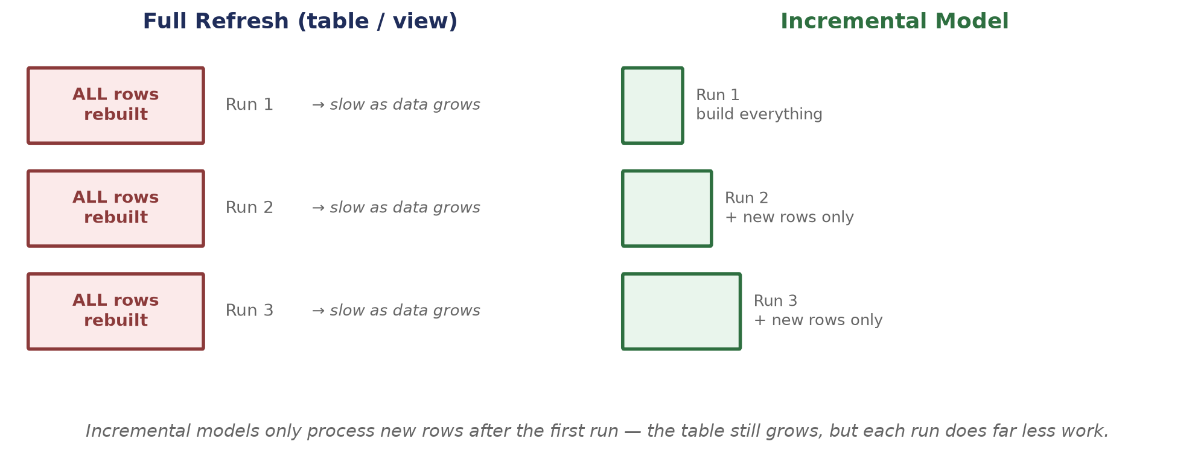
Figure 3 — A full refresh reprocesses everything every run; an incremental model only processes what's new.

Snapshots
Some values change over time — a product's price goes up, a product gets discontinued. Normally, an UPDATE just overwrites the old value and it's gone forever: if you query the table today, you have no way to know what the price used to be last month. A snapshot is dbt's way of taking a timestamped picture of a table every time it runs, so you can look back later and answer questions like "what was this product's price on the day this order was placed?" This is often called tracking slowly changing dimensions, and it's a very common real-world requirement — finance and analytics teams frequently need to reconstruct history, not just see the current state.
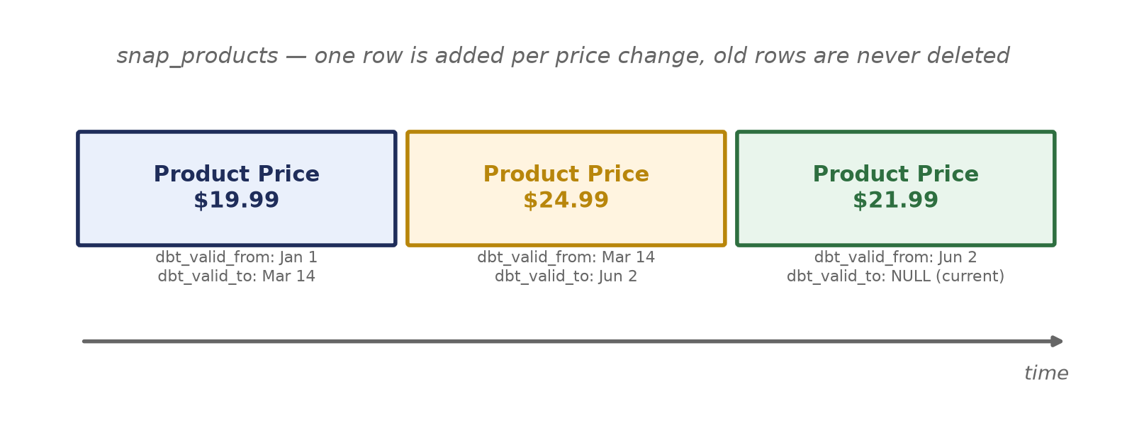
Figure 4 — Every price change creates a new row instead of overwriting the old one, so history is preserved.

How the Fact Table Connects to Week 1's Dimensions
Now that both halves exist, here's the complete picture — the star shape a Star Schema is named for, with one fact table in the middle and dimension tables radiating out around it:
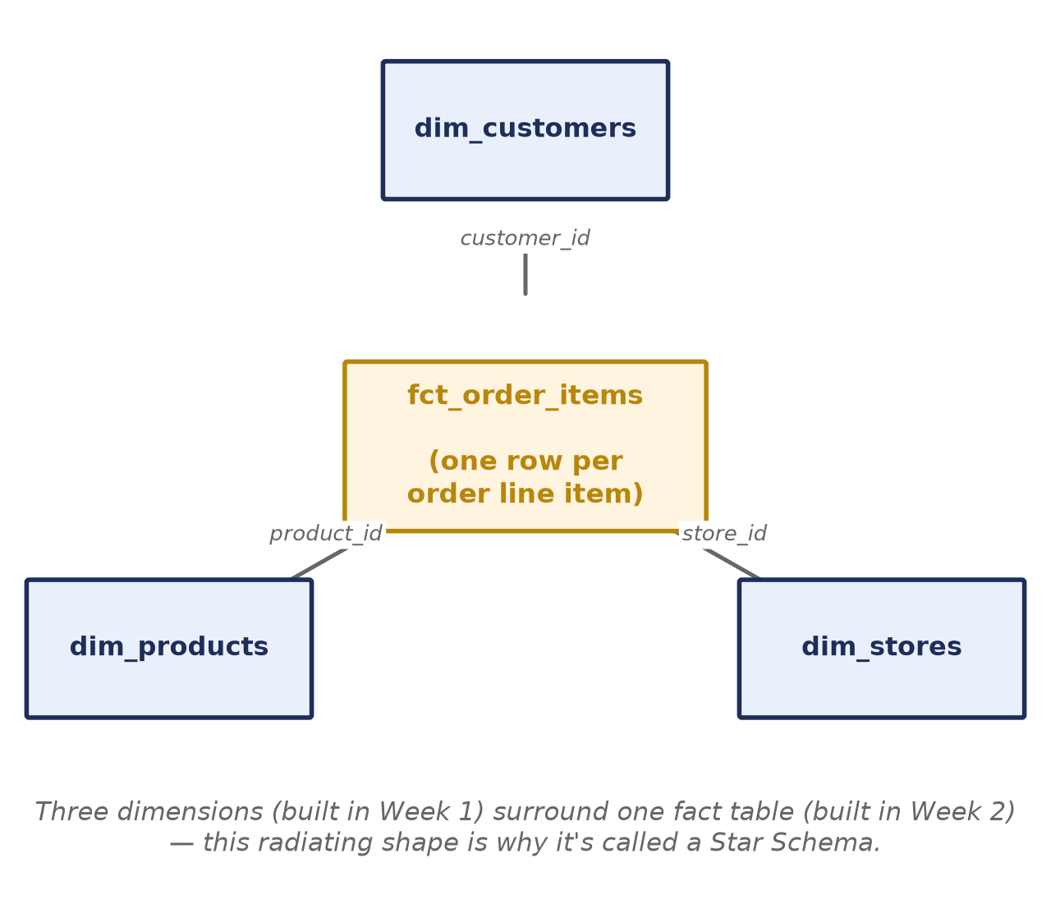
Figure 5 — fct_order_items in the center, connected to all three dimensions built in Week 1.
- dim_customers connects to fct_order_items via customer_id
- dim_products connects to fct_order_items via product_id
- dim_stores connects to fct_order_items via store_id
Once this is in place, someone could ask a question like "what was total margin by region last quarter?" and answer it by joining fct_order_items to dim_stores — that's the entire point of building the warehouse this way.

Part 3 — Task Walkthrough

Task 2.1 — Build the Line-Level Fact (40 pts)
Create models/dev/fct_order_items.sql. Grain: one row per order_item_id — this means no aggregation, just one clean joined row per line item. If you find yourself using GROUP BY in this model, you've gone one step too far; aggregation belongs in later reporting models, not here.
Join stg_order_items → stg_orders (to pull in customer_id, store_id, order_date, order_status) and stg_order_items → stg_products (to pull in cost_price). Both joins should be on the staged models, consistent with the RAW → STAGE → DEV rule from Part 1.
Measures to calculate:
- gross_amount = quantity × unit_price
- discount_amount = quantity × unit_price × discount_pct / 100
- net_amount = quantity × unit_price × (1 − discount_pct / 100)
- total_cost = quantity × cost_price
- margin = net_amount − total_cost
Reading these left to right: gross_amount is the sticker-price total before any discount. discount_amount is how much was shaved off. net_amount is what the customer actually paid. total_cost is what it cost the business to fulfill that line. margin is what's left over — the number a business actually cares about most.
Deliverable: fct_order_items.sql that runs successfully and produces the expected number of rows.

Task 2.2 — Make the Fact Incremental (30 pts)
Convert fct_order_items into an incremental model using this config block at the top of the file:
{{ config(
materialized='incremental',
unique_key='order_item_id'
) }}

Then add a filter so re-runs only process rows that don't exist yet:
{% if is_incremental() %}
where order_item_id > (select coalesce(max(order_item_id), 0) from {{ this }})
{% endif %}

Why this works: {{ this }} refers to the table itself as it currently exists in the warehouse. On the very first run the table doesn't exist yet, so is_incremental() is false and the whole filter block is skipped — dbt builds everything from scratch, same as before. On every run after that, is_incremental() is true, so the where clause kicks in: dbt looks inside {{ this }} for the highest order_item_id already sitting in the table, and only pulls in source rows with an order_item_id higher than that. In other words, the subquery answers "where did I leave off?" and the where clause says "only give me what's newer than that." coalesce(..., 0) just handles the edge case of an empty table by falling back to 0 instead of returning null.
This particular filter works because order_item_id is an ever-increasing number — every new row is guaranteed to have a higher ID than every row that came before it. That assumption won't always hold. A common alternative is to filter on a timestamp column instead, such as updated_at, which also lets you pick up rows that were edited after the fact and not just brand-new ones:
{% if is_incremental() %}
where updated_at > (select coalesce(max(updated_at), '1900-01-01') from {{ this }})
{% endif %}

Which one should you use? an incrementing ID (like order_item_id) is simpler and is a good fit when rows are only ever inserted, never edited. An updated_at timestamp is the better choice when source rows can be modified after creation, since it re-picks-up any row whose data changed — something an ID-based filter would silently miss. For this task, either approach is acceptable; the ID version shown above is the simplest one to reason about.

Test it with these three commands, in order:
dbt run --select fct_order_items --profiles-dir . # first build
dbt run --select fct_order_items --profiles-dir . # second run adds 0 rows
dbt run --select fct_order_items --full-refresh --profiles-dir . # rebuild from scratch

Confirming it worked: the second run should add zero new rows since nothing changed in the source data — that's your proof the incremental filter is doing its job. If it adds all the rows again, the filter isn't wired correctly.

Deliverable: the incremental fct_order_items.sql.

Task 2.3 — Snapshot Product Prices (30 pts)
Create snapshots/snap_products.sql to track changes to list_price and is_active in raw_products over time.
{% snapshot snap_products %}
{{
config(
target_schema='RAW',
unique_key='product_id',
strategy='check',
check_cols=['list_price', 'is_active']
)
}}
select * from {{ ref('raw_products') }}
{% endsnapshot %}

Run it with:
dbt snapshot --profiles-dir .

The strategy='check' setting tells dbt to watch the columns listed in check_cols. Whenever list_price or is_active changes for a given product_id, dbt closes out the old row (setting dbt_valid_to to the current timestamp) and inserts a new one (with a fresh dbt_valid_from) — so you end up with a full history instead of a single overwritten value, exactly like Figure 4 above.
To see it in action: change a price in the seed CSV, re-run dbt seed, then run dbt snapshot again. You should see a new version of that row appear in snap_products, with the old row's dbt_valid_to now filled in.
Deliverable: a working snap_products.sql, producing a snapshot table with dbt_valid_from / dbt_valid_to columns.

Grading Your Work
Once all three tasks are complete, run:
python scripts/grade_assignment.py --week 2

Fix any items marked with an X and re-run the grader until everything passes.

Part 4 — Mistakes to Avoid, Word List, and Quick Quiz

Mistakes to Avoid
- Referencing raw_orders or raw_products directly for cost_price, unit_price, etc. — always join through the STAGE layer, never a seed, to stay consistent with the RAW → STAGE → DEV rule from Week 1.
- Forgetting the is_incremental() filter — without it, the model still technically works, but it rebuilds everything every run and defeats the entire purpose of Task 2.2.
- Using strategy='timestamp' instead of strategy='check' for the snapshot — check is correct here since we're watching specific columns for any change, not comparing an updated_at timestamp that may not exist in the source.
- Mixing up gross_amount and net_amount — gross is before the discount is applied, net is after. This is a very common source of numbers being "slightly off but not obviously wrong."
- Running dbt run without --full-refresh after changing the SQL logic of an incremental model — schema or logic changes may need a full refresh to apply cleanly to already-built rows.

Word List
Term | Meaning
Dimension table | A table of descriptive, mostly-static attributes about an entity (customer, product, store).
Fact table | A table of transactional events, one row per occurrence, that references dimension tables via foreign keys.
Grain | What one row of a table represents. The grain of fct_order_items is "one order line item."
Materialization | How dbt physically builds a model in the warehouse — as a view, a table, or incrementally.
Incremental model | A materialization that only processes new or changed rows after the first run, instead of rebuilding everything.
Snapshot | A dbt feature that records the history of a changing table by adding new rows instead of overwriting old ones.
Slowly changing dimension (SCD) | A general data-warehousing term for tracking how a dimension's attributes change over time — snapshots are dbt's tool for this.
ref() | The Jinja function used inside a model to reference another dbt model, so dbt can build things in the right order.

Quick Quiz
Answer these before moving on to Week 3 — if any answer doesn't come quickly, go back and re-read that section rather than guessing.
- Why can't fct_order_items reference raw_products or raw_orders directly?
- What does is_incremental() evaluate to on the very first run of a model, and why?
- What's the difference between gross_amount and net_amount?
- If a product's is_active flag changes from true to false, what happens in snap_products — does the old row get deleted, updated, or something else?
- Which column in fct_order_items connects it to dim_stores?

Questions or stuck on something? Reach out before spending too long on one blocker — the goal this week is understanding incremental models and snapshots, not just getting green checkmarks from the grader.

