Curl -v <https://odetocode.com/odetocode.jpg>

Request

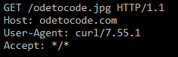

Response

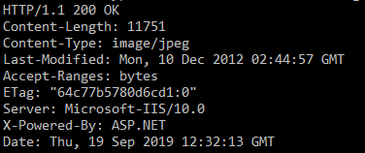

Curl -o http-easy.html http://www.jmarshall.com/easy/ http/

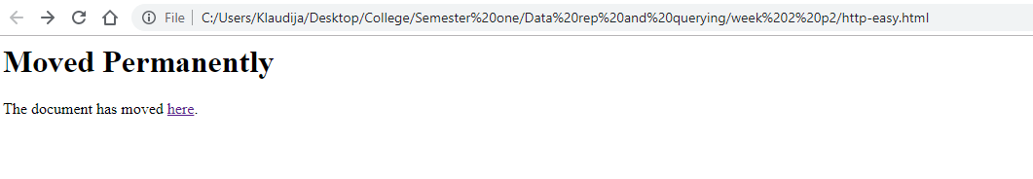

Reason: curl doesn’t change http to https itself, instead includes the correct link as part of the page

Curl -o duckduckgo.html http://www.duckduckgo. com

