Rao Nauman

[Company name]  [Company address]

lab-9

**Q1. What is the IP address and TCP port number used by the client computer (source) that is transferring the file to gaia.cs.umass.edu? To answer this question, it’s probably easiest to select an HTTP message and explore the details of the TCP packet used to carry this HTTP message, using the “details of the selected packet header window” (refer to Figure 2 in the “Getting Started with Wireshark” Lab if you’re uncertain about the Wireshark windows.**

**Solution:**

Ip address=s128.119.245.12,

Port number=1161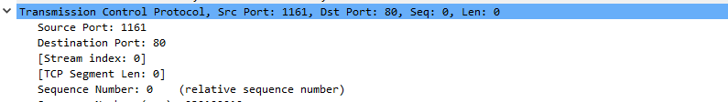

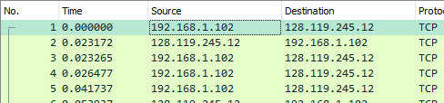

**Q2. What is the IP address of gaia.cs.umass.edu? On what port number is it sending and receiving TCP segments for this connection?**

**Solution:**

ip address of **gaia.cs.umass.edu=**128.119.245.12

sending port=80





**Q3. What is the IP address and TCP port number used by your client computer (source) to transfer the file to gaia.cs.umass.edu?**

Solution:

Ip= 192.168.18.120

Port= 51173

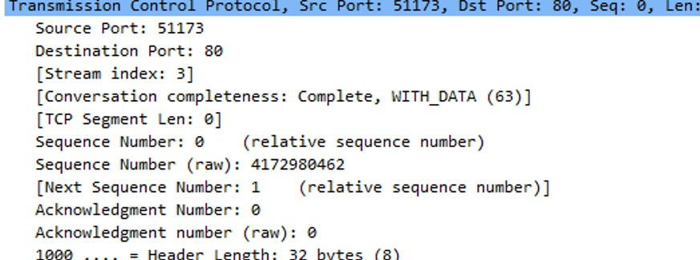

**Q4. What is the sequence number of the TCP SYN segment that is used to initiate theTCP connection between the client computer and gaia.cs.umass.edu? What is it in the segment that identifies the segment as a SYN segment?**

The Sequence Number is set as 0 .it is the initiating the TCP connection. The SYN Flag is set to 1 which identifies this segment to be a SYN segment.

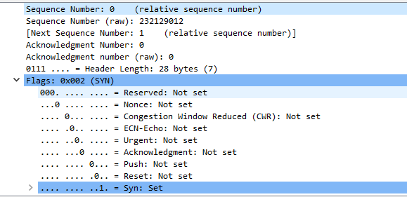

**Q5. What is the sequence number of the SYNACK segment sent by gaia.cs.umass.edu to the client computer in reply to the SYN? What is the value of the Acknowledgement field in the SYNACK segment? How did gaia.cs.umass.edu determine that value? What is it in the segment that identifies the segment as a SYNACK segment?**

The sequence of the SYNACK segment sent by gaia is 0. The Value in the Acknowledgement field is 1. Since the initial sequence number was 0, 0+1 = 1. The SYN and ACK flags are set to be 1, identifying this segment as a SYNACK segment.

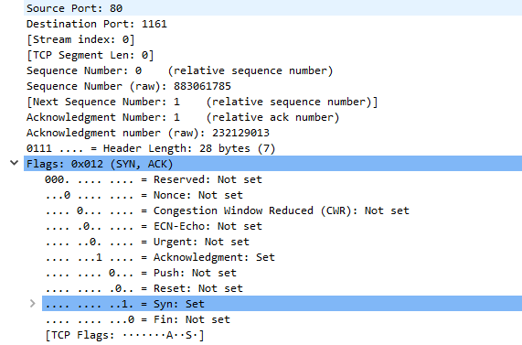

**Q6. What is the sequence number of the TCP segment containing the HTTP POST command? Note that in order to find the POST command, you’ll need to dig into the packet content field at the bottom of the Wireshark window, looking for a segment with a “POST” within its DATA field.**

According to packet tracer, the sequence number for the segment containing the POST command is 1

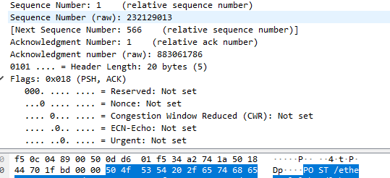

**Q7. Consider the TCP segment containing the HTTP POST as the first segment in the TCP connection. What are the sequence numbers of the first six segments in the TCP connection (including the segment containing the HTTP POST)? At what time was each segment sent? When was the ACK for each segment received? Given the difference between when each TCP segment was sent, and when its acknowledgement was received, what is the RTT value for each of the six segments? What is the EstimatedRTT value (see Section 3.5.3, page 242 in text) after the receipt of each ACK? Assume that the value of the EstimatedRTT is equal to the measured RTT for the first segment, and then is computed using the EstimatedRTT equation on page 242 for all subsequent segments.**

**Solution:**

6 Segments

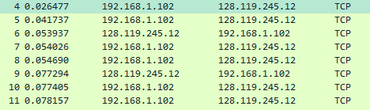

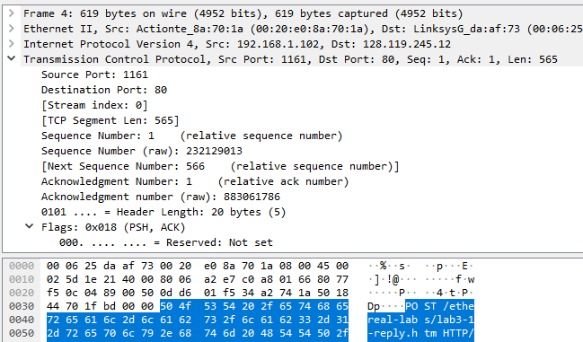

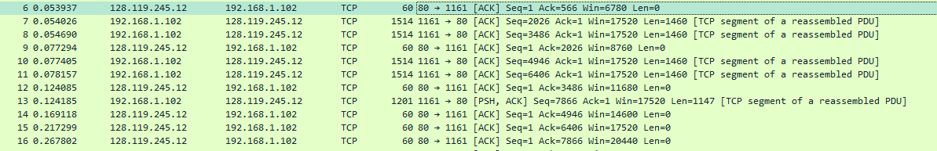

First 6 segments are packets no.: 4, 5, 7, 8, 10, 11

First 6 acknowledgement segments are: 6, 9, 12, 14, 15, 16

Segment No. Sequence No. Sent time ACK received time RTT

1 1 0.026477 0.053937 0.027460

2 566 0.041737 0.077294 0.035557

3 2026 0.054026 0.124085 0.070059

4 3486 0.054690 0.169118 0.114428

5 4946 0.077405 0.217299 0.139894

6 6406 0.078157 0.267802 0.189645

EstimatedRTT = 0.875 * EstimatedRTT + 0.125 * SampleRTT

**Estimated RTT after ACK of segment 1:**

Estimated RTT = RTT for segment 1 = 0.027460

**Estimated RTT after ACK of segment 2:**

Estimated RTT = 0.875*0.027460 + 0.125*0.035557 = 0.028472125

**Estimated RTT after ACK of segment 3:**

Estimated RTT = 0.875*0.028472125 + 0.125*0.070059 = 0.03367048438

**Estimated RTT after ACK of segment 4:**

Estimated RTT = 0.875*0.03367048438 + 0.125*0.114428 = 0.04376517383

**Estimated RTT after ACK of segment 5:**

Estimated RTT = 0.875*0.04376517383 + 0.125*0.139894 = 0.0557812771

**Estimated RTT after ACK of segment 6:**

Estimated RTT = 0.875*0.0557812771 + 0.125*0.189645 = 0.07251424246

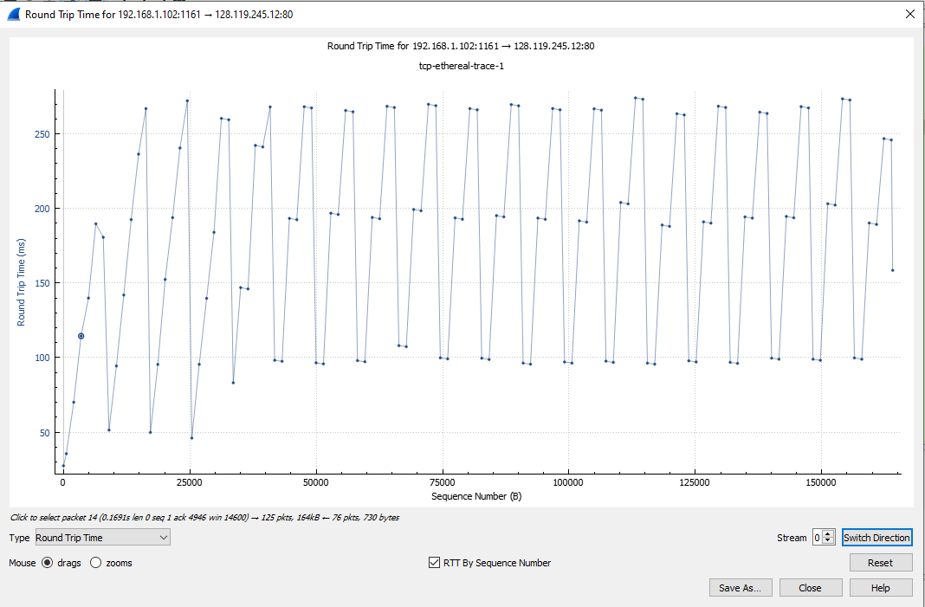

**Q8. What is the length of each of the first six TCP segments?**

Segments Length

1 565

2 1460

3 1460

4 1460

5 1460

6 1460

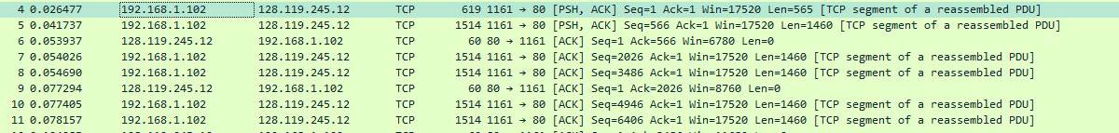

**Q10. Are there any retransmitted segments in the trace file? What did you check for (in the trace) in order to answer this question?**

. No, there are no retransmitted segments in this trace file. There are two ways to find retransmitted packets. **(i)**. Packet tracer tells you if a packet is retransmitted. **(ii)**. By plotting a time-sequence graph, we can see that if there is a point where the sequence number drops, then a packet has been retransmitted, but as you can see in the graph below, sequence numbers are continuously increasing.

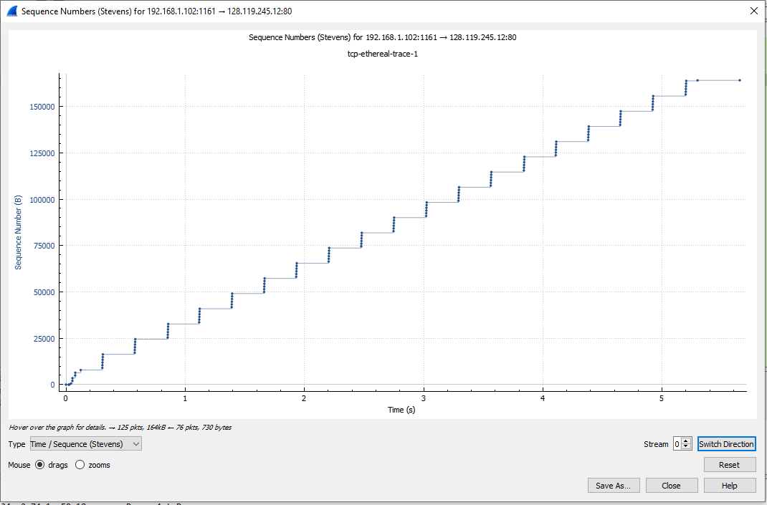

**Q11. How much data does the receiver typically acknowledge in an ACK? Can you identify cases where the receiver is ACKing every other received segment (see Table 3.2 on page 250 in the text).**

By subtracting the acknowledgment numbers between 2 messages, we can know how much data has been received. An example of acknowledging every other segment is given below and the data received between this is (2026-566) = 1460.

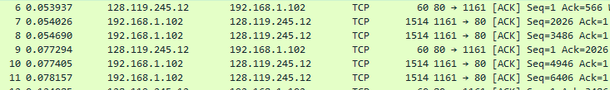

**Q12. What is the throughput (bytes transferred per unit time) for the TCP connection? Explain how you calculated this value.?**

The size of the gia.txt file is 152,138 bytes. The time taken to download the file is the time for the first TCP segment - time for the last ACK segment. So, download time = 5.455830 - 0.026477 = 5.429353. The throughput is total bytes/total time taken = 152,138/5.429353 = 28021.3867 bytes/second.





**Q13. Use the Time-Sequence-Graph(Stevens) plotting tool to view the sequence number versus time plot of segments being sent from the client to the gaia.cs.umass.edu server. Can you identify where TCP’s slow start phase begins and ends, and where congestion avoidance takes over? Comment on ways in which the measured data differs from the idealized behavior of TCP that we’ve studied in the text**



The slow start phase starts from 0 seconds and lasts till about 0.17 seconds. There is no congestion avoidance seen here since the size of the segments remains the same throughout.

**Q14. Answer each of two questions above for the trace that you have gathered when you transferred a file from your computer to gaia.cs.umass.edu**