Rao Nauman

[Company name]  [Company address]

lab-5 home-udp

**Question 1:**

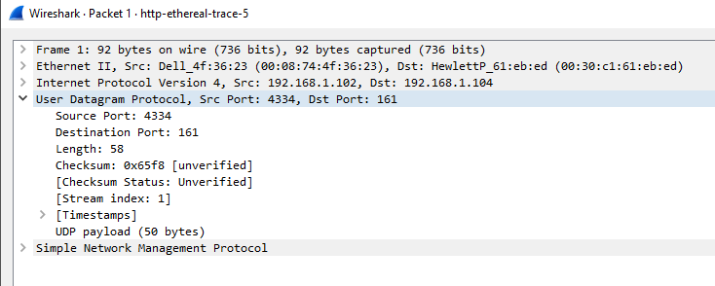

**Question 2:**

Each UDP header is 16 hexadecimal characters long; 16 hexa = 64 bits = 8 bytes.

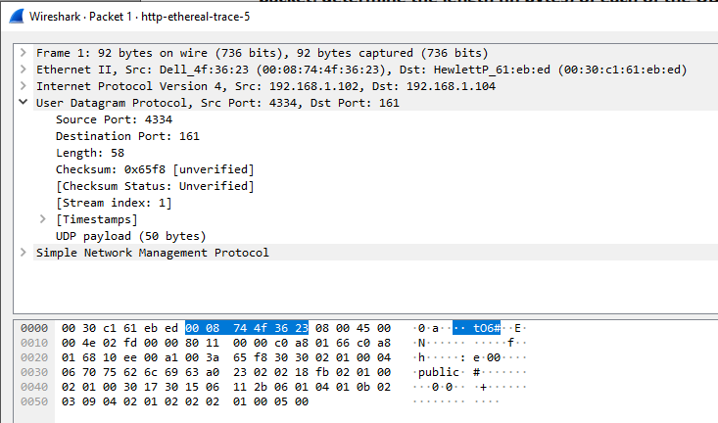

**Question 3;**

The value in the length field is the size, in bytes, of the entire segment (header+payload). We

do not need to specify header length separately because all UDP headers are of the same size.

My captured packet shows length = 58 and payload = 50; 58 - 8 = 50 bytes.



**Question 4:**

The maximum size of a UDP payload is (2^16 -1) and we also need to deduct an extra 8 bytes

for the header. So, the maximum size of the payload can be 65527 byte.

**Question 5:**

The largest possible port number is (2^16 - 1) which is equal to 65535

**Question 6:**

The protocol number for UDP is 11 in hexadecimal which is equal to 17 in decimal. (F = 15; 10  
= 16, 11 = 17)

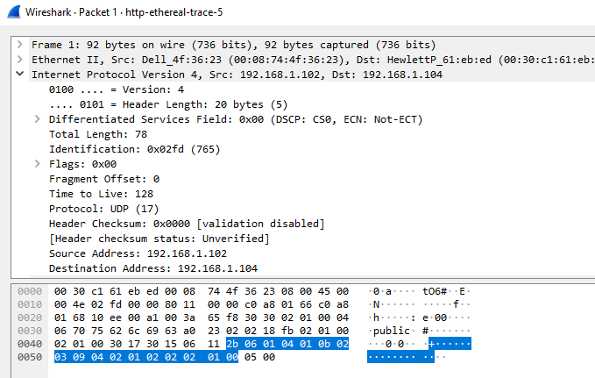

**Question 7:**

Packet 1: Source Port: 4334, Destination Port: 161

