Rao Nauman

[Company name]  [Company address]

ASSIGNMENT-1

**QUESTION-1:**

MariaDB [employees]> select *

-> from employees

-> where lower(last_name like "%a%" or last_name like "%e%" or last_name like "%i%" or last_name like "%o%" or last_name like "%u%") limit 15;

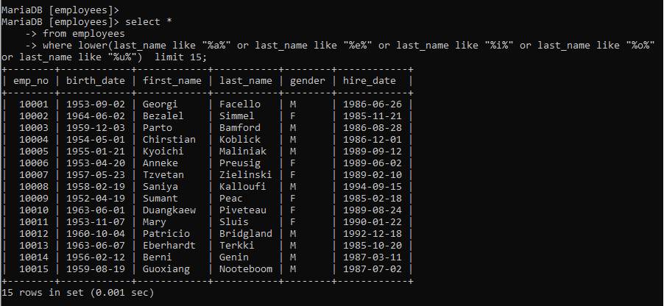

**QUESTION-2:**

SELECT GENDER , COUNT(GENDER) FROM EMPLOYEES GROUP BY GENDER ;

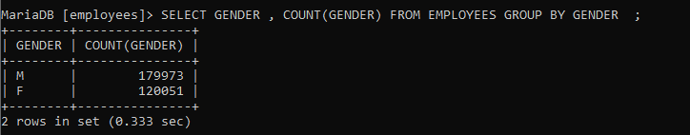

**QUESTION-3:**

select emp_no, sum(salary) as total_SALARY from salaries where emp_no in (10001,401829) group by emp_no;

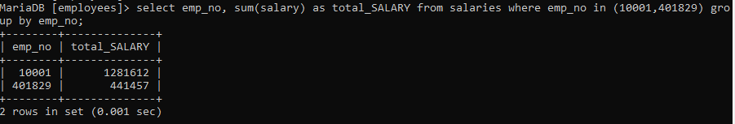

**QUESTION-4:**

select emp_no, first_name, last_name, salary from employees natural join salaries where salary = (select min(salary) from salaries);

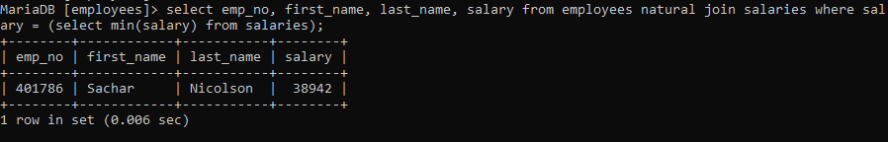

**QUESTION-5:**

SELECT EMP_NO , FIRST_NAME , LAST_NAME ,COUNT(DEPT_NO) FROM EMPLOYEES NATURAL JOIN DEPT_EMP GROUP BY EMP_NO HAVING COUNT(DEPT_NO)>=2 LIMIT 10 ;

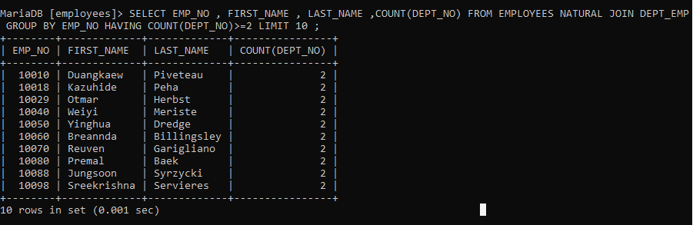

**QUESTION:6**

MariaDB [employees]> SELECT emp_no , first_name , last_name , salary

-> FROM employees natural join salaries

-> ORDER BY salary DESC

-> LIMIT 1,2;

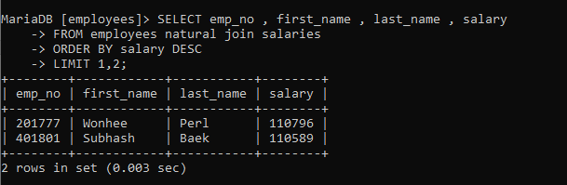

**Question:7**

SELECT DISTINCT EMP_NO , FIRST_NAME , LAST_NAME , DEPT_NAME FROM EMPLOYEES JOIN DEPT_EMP USING(EMP_NO) JOIN DEPARTMENTS USING(DEPT_NO) LIMIT 11;

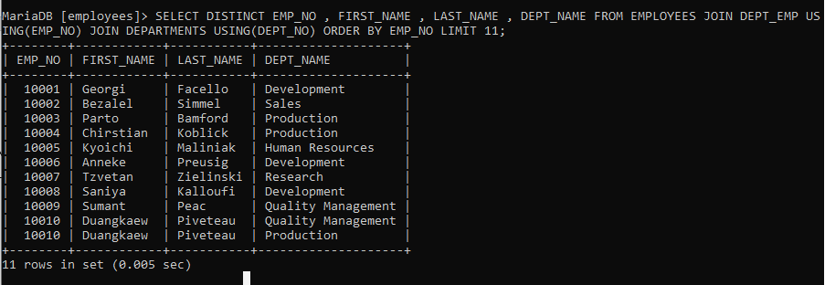

**QUESTION : 8**

SELECT emp_no , first_name , last_name , salary

-> FROM employees natural join salaries

-> ORDER BY salary DESC

-> LIMIT 2,1;

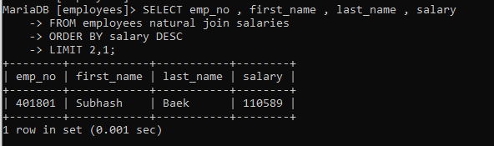

**QUESTION:9**

**select * from dept_emp where emp_no = "10004"**

**delete from employees where emp_no = "10004"**

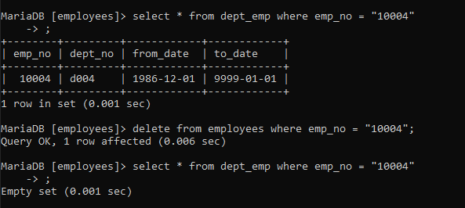

**QUESTION : 10**

delete from employees where hire_date > '1999-12-31';



**QUESTION 11:**

**UPDATE TITLES SET TITLE="PROJECT MANAGER" WHERE EMP_NO=10004;**

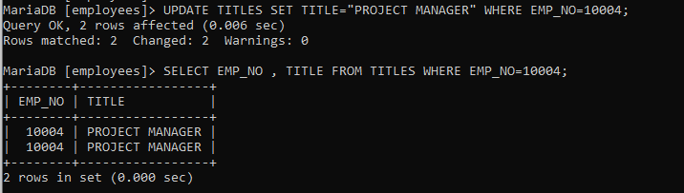

**QUESTION : 12**

**ALTER TABLE DEPARTMENTS**

**-> MODIFY COLUMN DEPT_NAME varchar(60) not null ;**

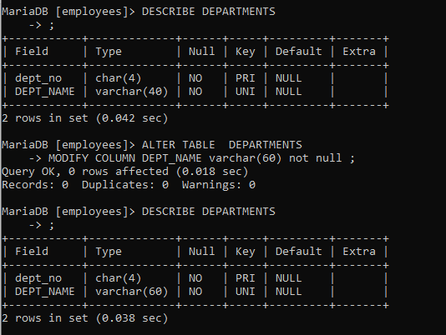

**QUESTION 13:**

alter table salaries

-> change salary payslip int(11) not null;

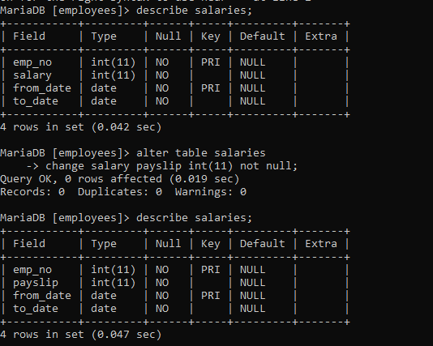

**QUESTION 14:**

alter table titles rename to job_description; 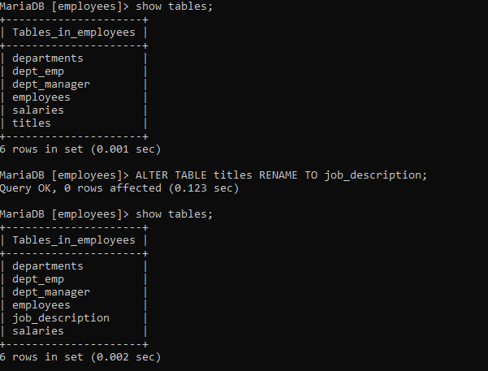

**QUESTION 15**

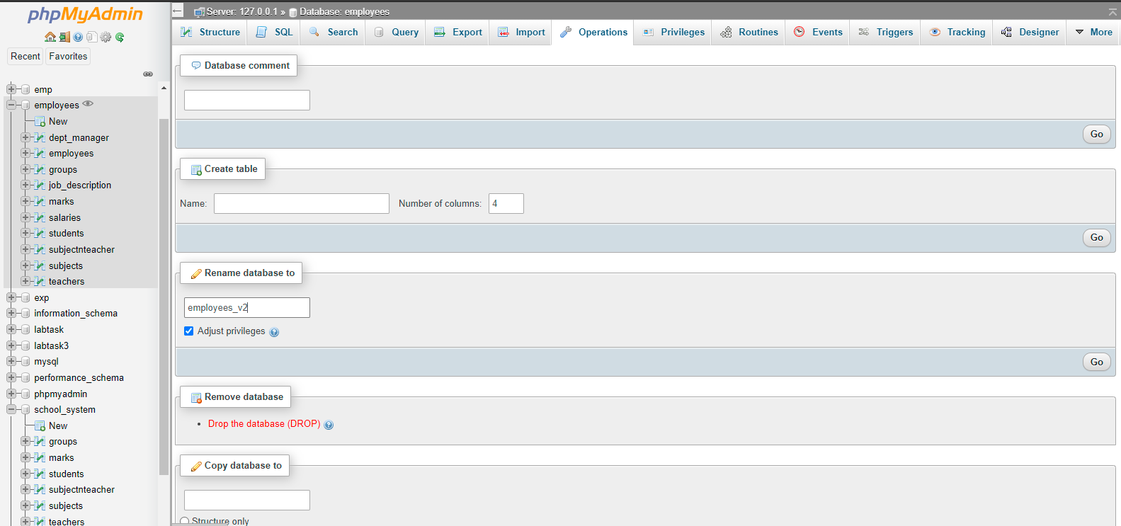

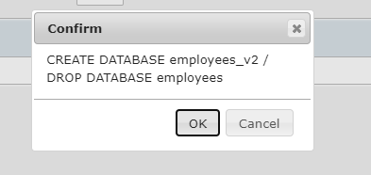

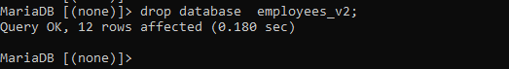

**Part-2:**

DROP DATABASE IF EXISTS school_system;

CREATE DATABASE IF NOT EXISTS school_system;

USE school_system;

SELECT 'CREATING DATABASE STRUCTURE' as 'INFO';

DROP TABLE IF EXISTS groups,

subjects,

teachers,

subjectnteacher,

students,

marks;

create table groups(

group_id int not null,

name varchar(40) not null,

PRIMARY KEY(group_id)

);

create table subjects (

subject_id int not null,

title varchar(40) not null,

PRIMARY KEY(subject_id)

);

CREATE TABLE teachers(

teacher_id INT NOT NULL,

first_name VARCHAR(16) NOT NULL,

last_name VARCHAR(16) NOT NULL,

PRIMARY KEY(teacher_id)

);

CREATE TABLE students (

student_id INT NOT NULL,

first_name VARCHAR(14) NOT NULL,

last_name VARCHAR(16) NOT NULL,

group_id INT NOT NULL,

FOREIGN KEY (group_id) REFERENCES groups (group_id) ON DELETE CASCADE,

PRIMARY KEY (student_id)

);

CREATE TABLE marks(

mark_id INT NOT NULL,

student_id INT NOT NULL,

subject_id INT NOT NULL,

date DATE NOT NULL,

mark INT NOT NULL,

FOREIGN KEY (student_id) REFERENCES students (student_id) ON DELETE CASCADE,

FOREIGN KEY (subject_id) REFERENCES subjects (subject_id) ON DELETE CASCADE,

PRIMARY KEY(mark_id)

);

CREATE TABLE subjectnteacher(

subject_id INT NOT NULL,

teacher_id INT NOT NULL,

group_id INT NOT NULL,

FOREIGN KEY (subject_id) REFERENCES subjects (subject_id) ON DELETE CASCADE,

FOREIGN KEY (teacher_id) REFERENCES teachers (teacher_id) ON DELETE CASCADE,

FOREIGN KEY (group_id) REFERENCES groups (group_id) ON DELETE CASCADE

);

show tables;

