Rao Nauman

[Company name]  [Company address]

office-365

Step1: sign up to office 365

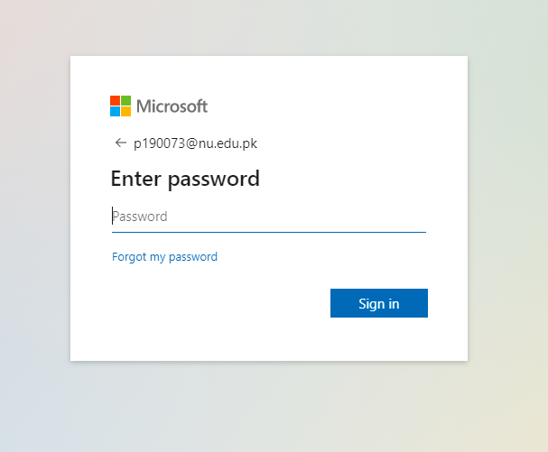

Step 2: login succesfull now head to azure for student

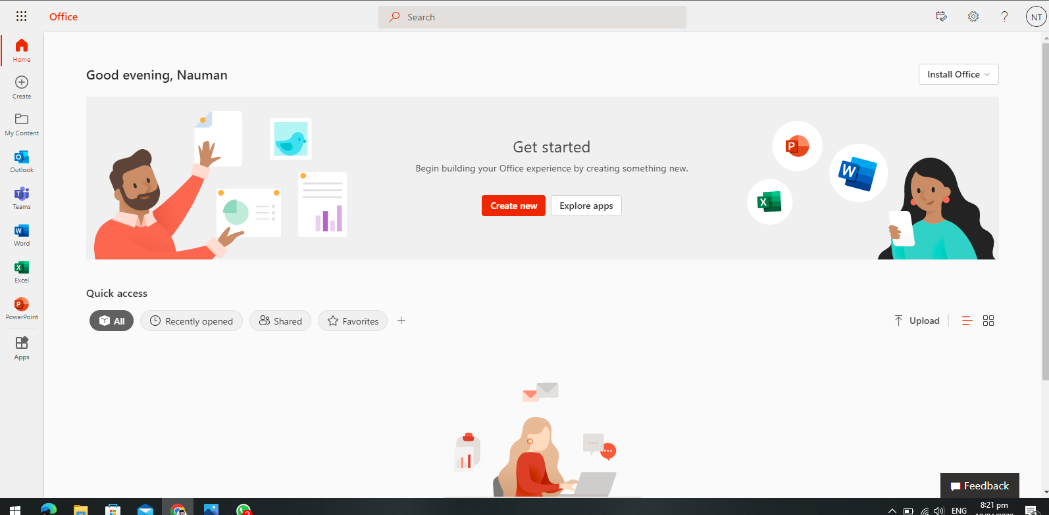

Step 3: signup on azure as students

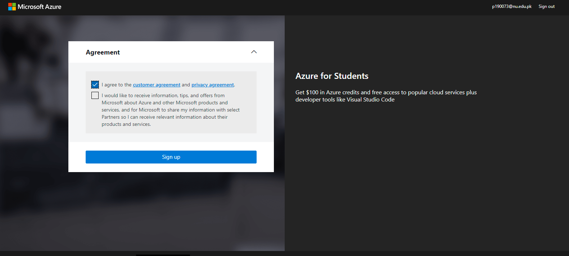

Step 4: account successfully created

