one single image:  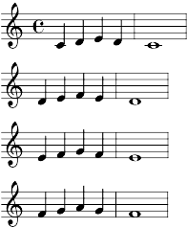 | separate images (system-by-system):  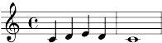  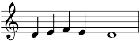  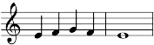  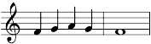

no additional spacing: | 2mm space below paragraph:

