HICODE Analysis Platform
Frontend Feature Guide
Hierarchical Inductive Coding — Web Interface
Version date: 2026-06-16
Screenshots captured from a local mock run (doctor_reviews_50 + built-in fixtures)

Table of Contents

1. Product Overview & Layout
HICODE is an inductive-coding analysis platform for researchers. A user uploads or connects a text corpus and enters a research question; the system then filters the text by embedding similarity to the question, generates descriptive labels for each text with an LLM, clusters those labels hierarchically into themes, and presents the themes, associated texts, and statistical visualizations in the interface.
The frontend is a single-page app: the entire analysis flow lives on one page, organized as a three-step set of cards, in a two-column layout — a left navigation sidebar and a right main content area.
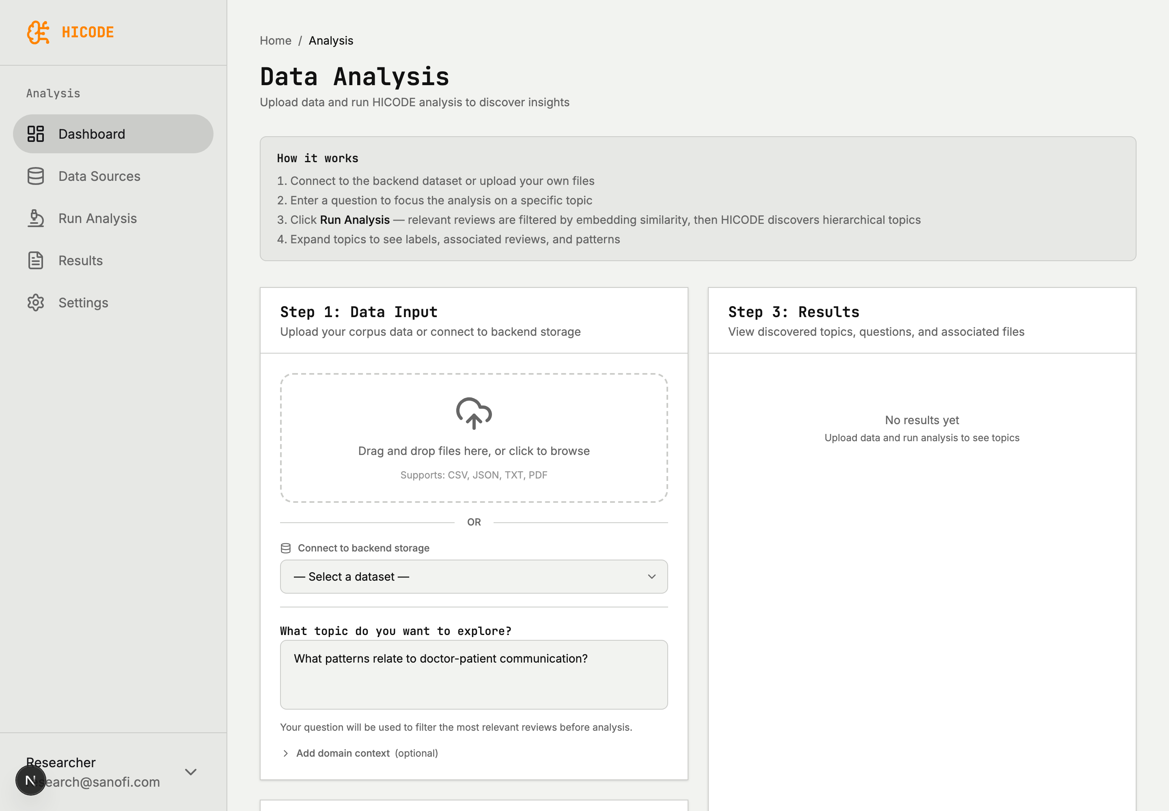
Figure 1 — Overall layout (left sidebar + Data Analysis main page)
Tech stack: Next.js 16 · React 19 · Tailwind CSS 4 · Recharts · lucide-react. The backend is FastAPI, with the API base set via NEXT_PUBLIC_API_URL.

2. Navigation (Sidebar)
The sidebar has a brand area at the top (HICODE) and a user area at the bottom (currently hard-coded as Researcher / research@sanofi.com). Under the “Analysis” group are five navigation entries. At present these entries only toggle a local highlight state and are not yet wired to page routing — the main content area always shows the Data Analysis page. The table below describes each entry’s intended function and current status.
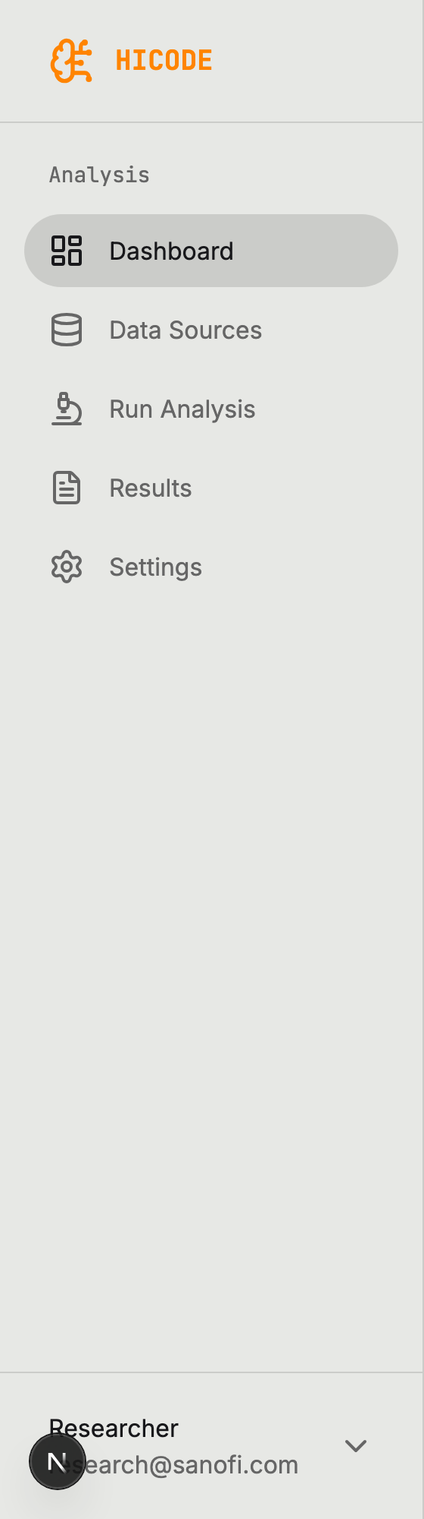
Figure 2 — Sidebar navigation
Entry | Intended function | Current status
Dashboard | Platform home/overview: recent analysis jobs, key metrics, quick links | Not implemented (highlight only)
Data Sources | Data source management: browse/connect backend datasets, view uploaded files | Not implemented (connect lives inside Step 1)
Run Analysis | Run analysis: the current three-step main flow | Implemented (current main page)
Results | Results hub: review historical analysis results and themes | Not implemented (results shown only in Step 3 panel)
Settings | Settings: model selection, API key, language, theme, etc. | Not implemented

3. Main Page (Data Analysis)
The header shows the breadcrumb “Home / Analysis”, the title “Data Analysis”, a four-step “How it works” guide, and a red error bar on failure. The body is a two-column layout: data input + run on the left, results on the right, organized as three cards.

Step 1 — Data Input
Two mutually exclusive data sources are offered: upload files, or connect to a backend dataset.
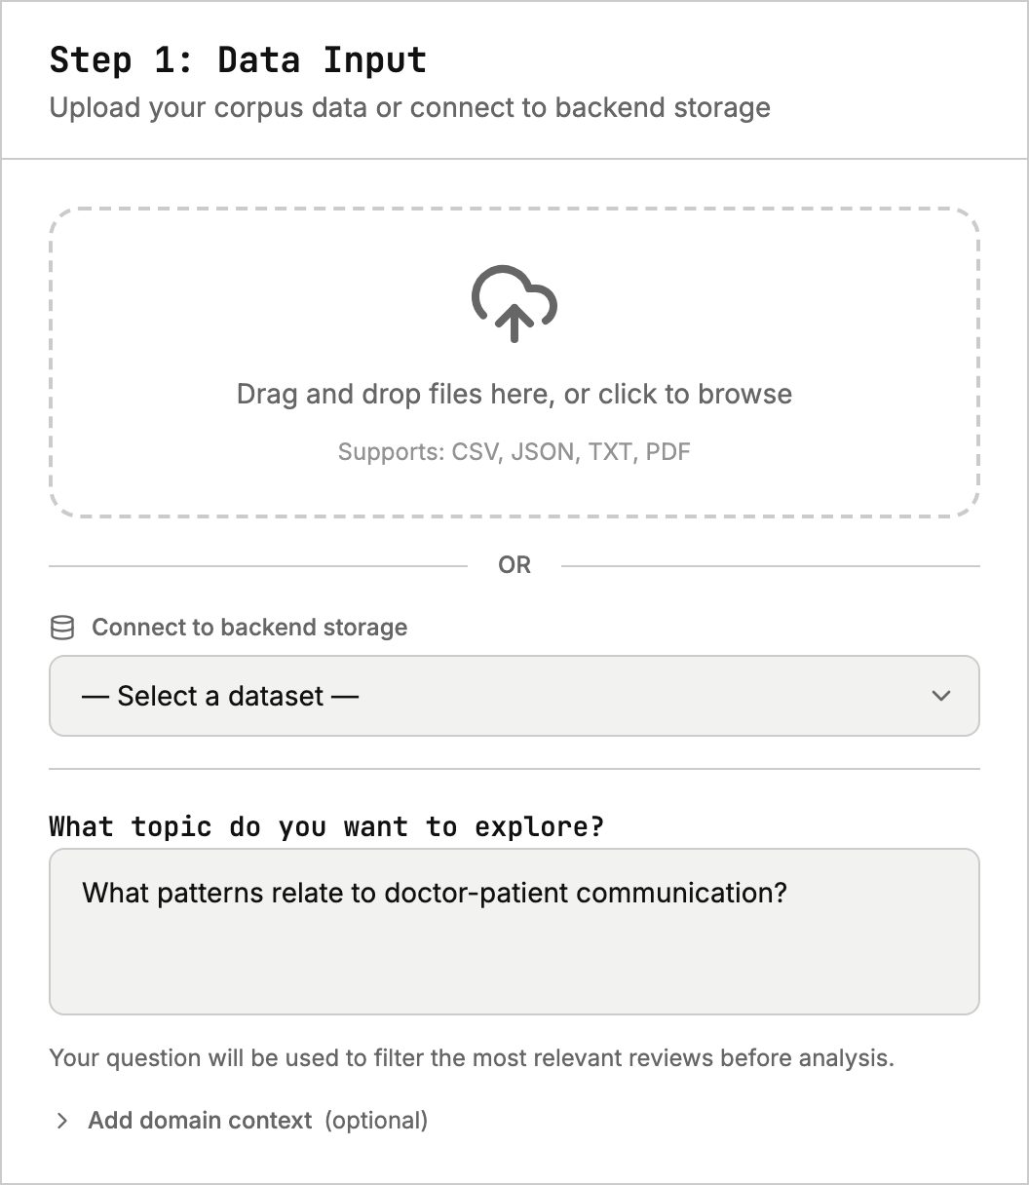
Figure 3 — Step 1: upload files / connect a backend dataset / enter the research question
- Upload files: drag-and-drop or click to upload, multiple files supported; accepts CSV / JSON / TXT / PDF (filtered by extension). Selected files can be removed individually.
- Connect a backend dataset: on mount the dropdown is auto-populated with available datasets shown as “name (N docs)”; if the backend is unreachable it shows “Could not reach backend.”
- Research question: the “What topic do you want to explore?” field is used to filter the most relevant texts by embedding similarity before analysis.
- Domain context (optional, collapsible): background or domain knowledge fed into the system prompt to steer label generation; ignored if left empty.
After a backend dataset is selected, the card switches to a green “connected” badge showing the dataset name and document count, and clears any uploaded files:
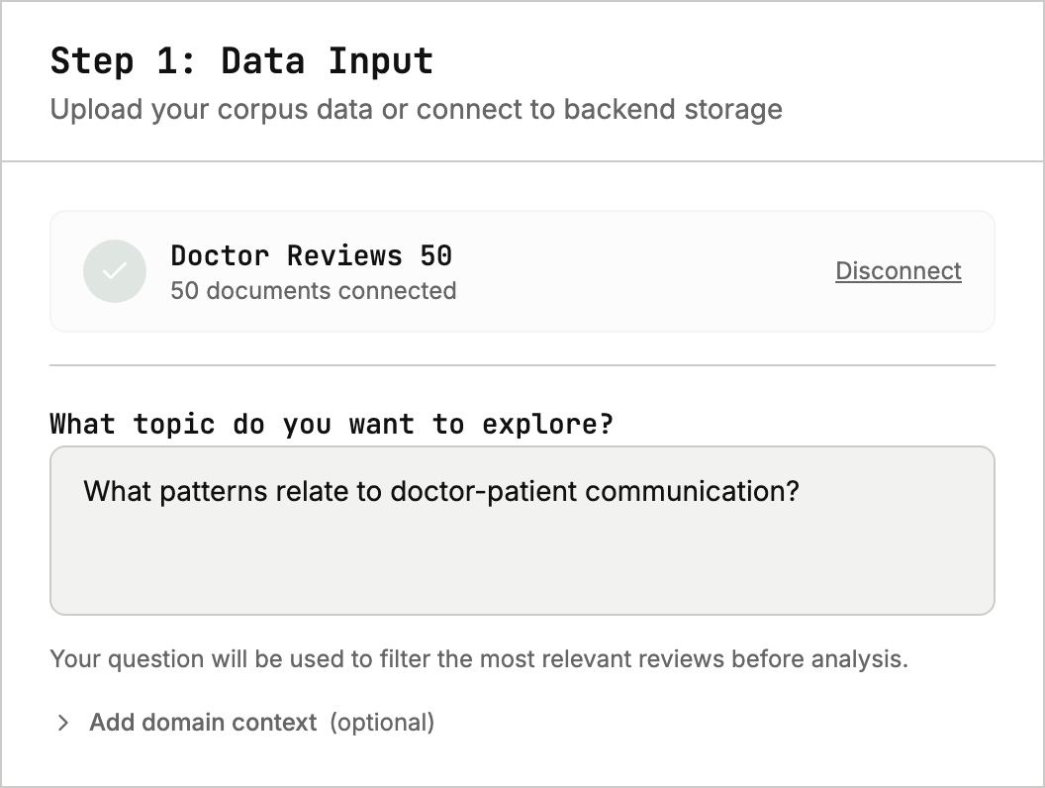
Figure 4 — Step 1: connected-dataset state

Step 2 — Run Analysis
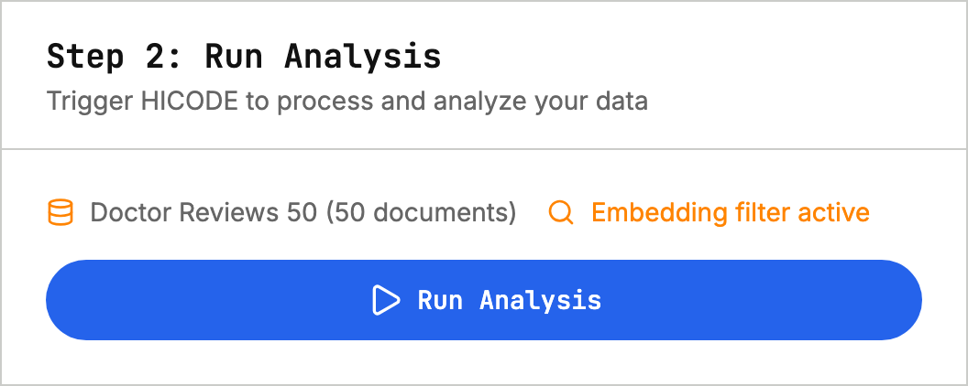
Figure 5 — Step 2: run info and the Run Analysis button
- Info row shows the dataset name + document count (for uploaded files, an estimated “~N documents”).
- When the question is non-empty, an Embedding filter active marker is shown.
- During analysis a spinner and live progress text (from the backend job status) are shown; the button is disabled when there is no data or while analyzing.
Run logic: uploaded files are first parsed via POST /api/upload; then POST /api/analyze starts a job (with documents or datasource_id, query, coding_goal, background, model_name — default gpt-4o-mini); GET /api/status/{job_id} is then polled every 2 s, up to 10 minutes, and the results render on completion.

Step 3 — Results
Before any run, an empty state “No results yet” is shown. Once results exist, the top is a summary bar (number of themes, total documents, count filtered by relevance, labels generated), followed by a collapsible “Filtered Reviews” section, and then four view tabs.
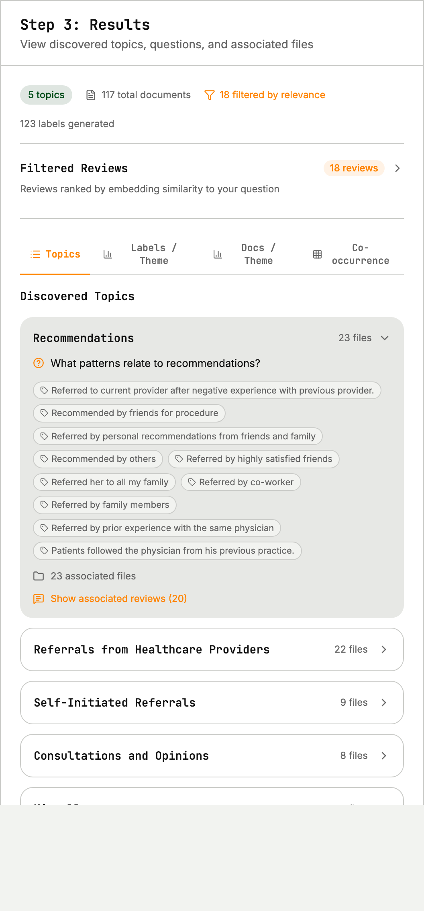
Figure 6 — Step 3: summary bar + Filtered Reviews + Topics (default view, first theme expanded)
Topics view: a list of themes with the first expanded by default; expanding a theme reveals its research questions, label cloud, associated file count, and the collapsible original associated reviews.

Figure 7 — Original “associated reviews” under an expanded theme
Filtered Reviews: a list of reviews ranked by embedding similarity, each showing the document ID, text, and an “NN% match” similarity score.

Figure 8 — Expanded “Filtered Reviews”: reviews ranked by similarity

4. Result Visualizations
The results area switches between four views via the tab bar; the latter three are chart visualizations, and a tab is automatically disabled (greyed out) when its data is missing.

4.1 Labels / Theme — Label-prevalence bar chart
A horizontal bar chart showing how many raw labels rolled up into each theme, sorted descending; six recycling colors, auto-fitting row height, and value-on-hover.
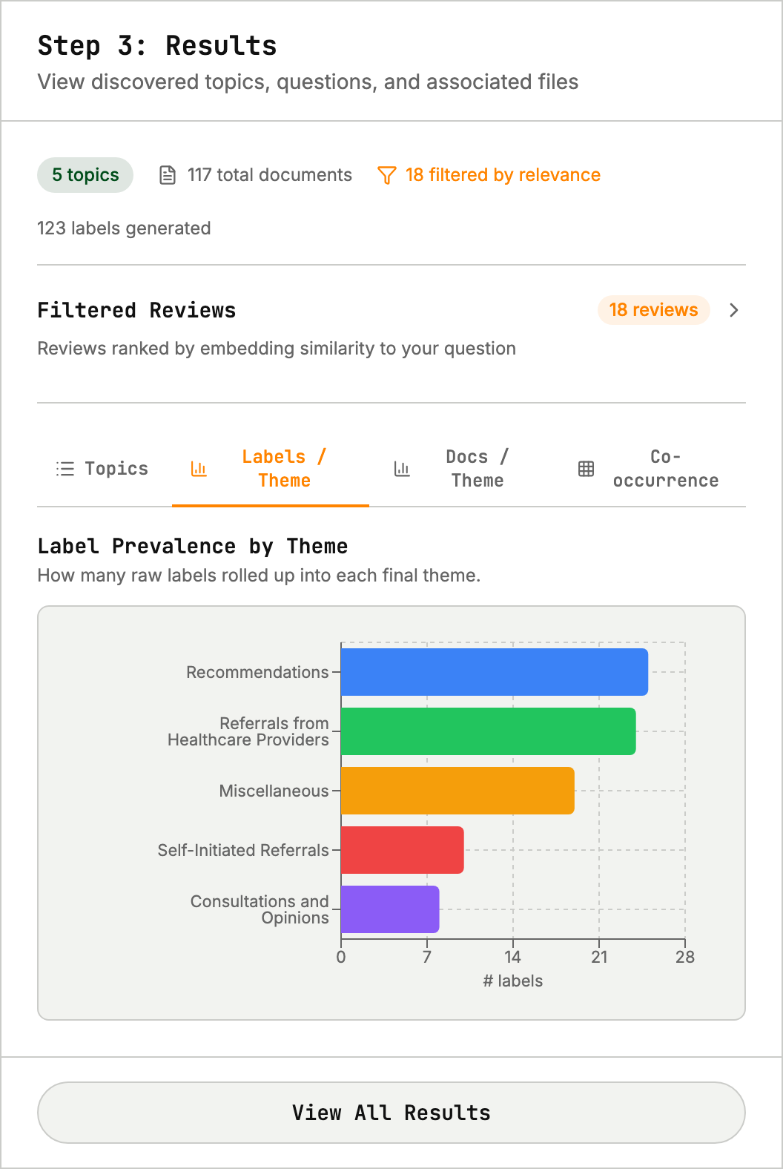
Figure 9 — Labels per Theme: raw-label count per theme

4.2 Docs / Theme — Document-prevalence bar chart
The same bar-chart component, showing how many distinct documents contain each theme (a document tagged with three themes counts once for each).
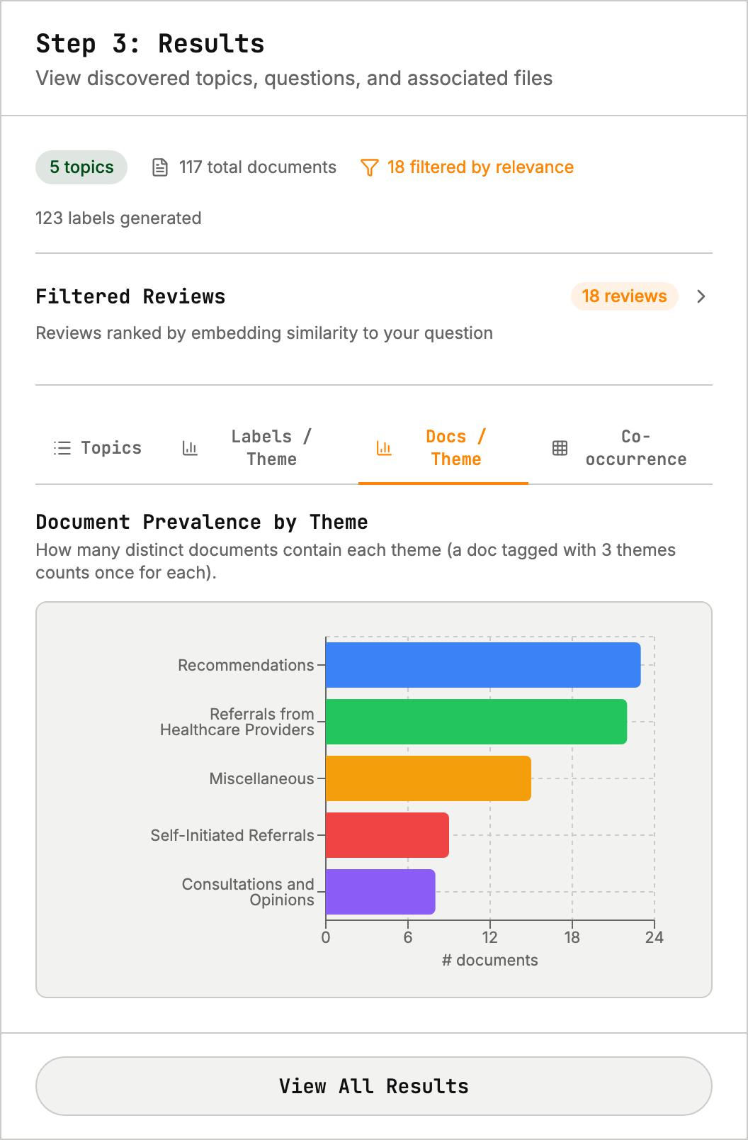
Figure 10 — Docs per Theme: document count per theme

4.3 Co-occurrence — Theme co-occurrence heatmap
A hand-drawn SVG upper-triangular matrix; each cell is the number of documents containing both themes. Color ramps from light to deep blue, the diagonal is masked, a color-scale legend sits at the bottom, and hovering shows “Theme A ↔ Theme B: N”. When all values are zero it shows “No co-occurrences detected.”
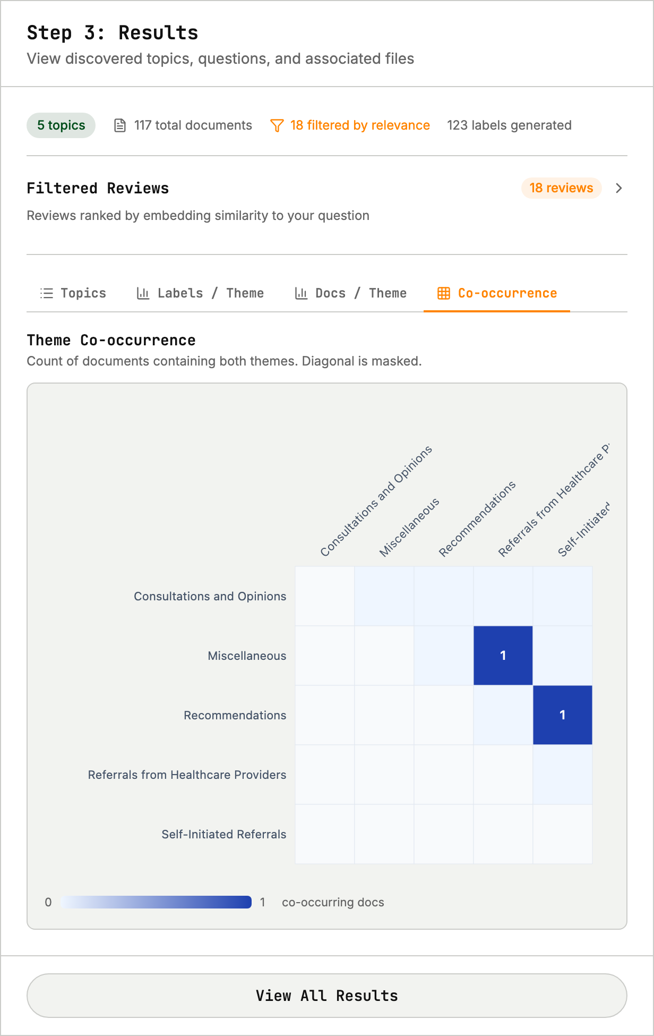
Figure 11 — Co-occurrence: theme co-occurrence heatmap

Visualization data contract
The following fields come from the backend’s AnalysisResult (see src/types/analysis.ts):
Field | Purpose
themesOrdered | Theme order for the matrix / axes
themeLabelCounts | Bar chart: raw-label count per theme
themeDocCounts | Bar chart: document count per theme
coOccurrenceMatrix | Heatmap: N×N symmetric matrix, diagonal = 0
filteredReviews[] | Filtered reviews and their similarity score
totalLabels | Number of unique labels generated

