|  |  |  |
| --- | --- | --- |
| Doc. Id.: | **Moddy-UM** | |
| Title: | **Moddy System Simulator User Guide** | |
| Issue: | 1.0 | |
| Valid for Moddy Version | 1.0.0 | |
| Date of Issue: | 2017-01-30 | |
| Author(s): | Klaus Popp |  |

Contents

1 Objective 4

1.1 Identification 4

1.2 Definitions 4

1.3 Abbreviations 4

2 Introduction 5

2.1 What is Moddy 5

2.2 Why another Simulator? 5

2.3 Quick Start 6

2.3.1 Model Structure 6

2.3.2 Model Behavior 7

2.3.3 Ports and Messages 7

2.3.4 Timers 8

2.3.5 Running Simulator 8

2.3.6 Visualizing Results 9

2.3.6.1 Sequence Diagram 9

2.3.6.2 Trace Table 10

3 Detailed User Guide 12

3.1 Core Simulator 12

3.1.1 Initializing the Simulator 12

3.1.2 Simulation Time 12

3.1.2.1 Time Unit 12

3.1.2.2 Setting the Time Unit for Trace Outputs during Simulation 12

3.1.2.3 Current Simulation Time 12

3.1.3 Parts 13

3.1.3.1 simPart Constructor Parameters 13

3.1.3.2 simPart Methods Called on Start and End of Simulation 14

3.1.3.3 Nested Parts 14

3.1.4 Message Communication 15

3.1.4.1 Creating Ports 15

3.1.4.2 Binding Ports 16

3.1.4.3 Sending Messages 17

3.1.4.4 Receiving Messages 17

3.1.4.5 Messages 18

3.1.5 Timers 20

3.1.5.1 Creating Timers 20

3.1.5.2 Starting and Stopping Timers 21

3.1.5.3 Timer Expiration Callback 21

3.1.6 Annotations 21

3.1.7 State Indications 22

3.1.8 Running the Simulation 23

3.2 Sequential Program Simulation 23

3.2.1 Program Model 24

3.2.2 Communication between Moddy Programs and other Moddy Parts 25

3.2.3 Buffering Input Ports 25

3.2.3.1 Sampling Input Ports 25

3.2.3.2 Queing Input Ports 27

3.2.4 Program Timers 29

3.2.5 System Calls for Sequential Programs 29

3.2.6 Concurrent Program Execution/RTOS Simulation 30

3.2.7 vSimpleProg and vThread 32

3.3 Result Visualisation 33

3.3.1 Sequence Diagram Generation 33

3.3.2 Trace Table Generation 33

3.3.3 Structure Graph Generation 33

4 Installation 35

4.1 Installing Eclipse 35

4.2 Install Python 35

4.3 Installing PyDev 35

4.4 Installing svgwrite 35

4.5 Installing GraphViz 35

4.6 Installing moddy 36

Objective

Identification

This document describes the moddy system simulator.

Definitions

Definitions

|  |  |
| --- | --- |
| **Term** | **Definition** |
| Simulation Time | The current virtual time seen by the model during simulation |

Abbreviations

1. Abbreviations

|  |  |
| --- | --- |
| **Abbreviation** | **Description** |
|  |  |

Introduction

## What is Moddy

Moddy is a simulator to model and analyze the timing behavior of systems consisting of objects that communicate via messages. The objects are called “parts” in Moddy, to be consistent with the term SysML uses in internal block diagrams.

Moddy was written to analyze complex systems in the concept phase to validate the suitability of the concept. Moddy cannot prove that your concept will work, but it can help you to determine very quickly that it WILL NOT work. In this case, you will have to change your concept and analyze it again.

You describe the structure and the behavior of your model via a program written in “python” language.

After the simulation run, Moddy can produce a number of result files, that you will analyze to evaluate whether the model behaves as expected. These result files are

* A sequence diagram
* An event trace
* A structure graph (block diagram)

Further result files, such as wave forms may be added in the future.

Moddy’s Simulator is a classic “Descrete Event simulator”. From Wikipedia <https://en.wikipedia.org/wiki/Discrete_event_simulation>:

*A discrete-event simulation (DES) models the operation of a system as a discrete sequence of events in time. Each event occurs at a particular instant in time and marks a change of state in the system. Between consecutive events, no change in the system is assumed to occur; thus the simulation can directly jump in time from one event to the next.*

## Why another Simulator?

I was looking for a simulator that

* Supports Quick Model generation: Meaning: Modelling shall be doable by non-programmers in an intuitive and easy-to-remember way
* Is suitable to model communication between objects
* Can visualize those communication at least in form of sequence diagrams
* Is open source or at least affordable

simPy is a python Discrete Event simulator. However, it seems complicated and non-intuitive to use. It uses python “generator functions” for threads, which (to me) seems not suitable. Furthermore it lacks visualization of results.

Mathlab simEvents is powerful, but expensive. It is difficult to use, focusing on statistical analysis and cannot generate sequence diagrams.

Also had a look at Rhapsody SysML.

## Quick Start

The following chapter describes the basic functions of Moddy by using the example “1_hello” tutorial model.

In a Moddy model, a system is composed of “Objects” that communicate with other parts through messages.

In the “hello” tutorial, we simulate a conversation between two people, “Bob” and “Joe”, therefore “Bob” and “Joe” are the two parts used in the model.

### Model Structure

The structure of the system is modelled via parts, ports and bindings between ports.

In the “hello” tutorial, we have two parts, Bob and Joe. Each part has an output port (mouth) and an input port (ears).

To simulate the time that Bob and Joe need for thinking, we create also a timer for both.

To model the behavior of Bob, we define a class “Bob”, which creates the ports and timers:

class **Bob**(simPart):

def **__init__**(*self*, sim, objName):

# Initialize the parent class

super().__init__(sim=sim, objName=objName)

# Ports

*self*.createPorts(*'in'*, [*'ears'*])

*self*.createPorts(*'out'*, [*'mouth'*])

# Timers

*self*.createTimers([*'thinkTmr'*])

*self*.reply = *""*

…

The main program creates an instance of Bob and Joe like this

simu = sim()

bob = Bob( simu, *"Bob"* )

joe = Joe( simu, *"Joe"* )

To allow Joe to hear what Bob says, we “bind” the ears of Joe to the mouth of Bob and vice versa. A binding is always initiated from the output port; you call the output port’s bind function and specify the input port that shall be bound:

bob.mouth.bind(joe.ears)

joe.mouth.bind(bob.ears)

Moddy can also output the structure of the model. After you created the structure, call:

# Output model structure graph

moddyGenerateStructureGraph(simu, *'1_hello_structure.svg'*)

This is the resulting structure graph:

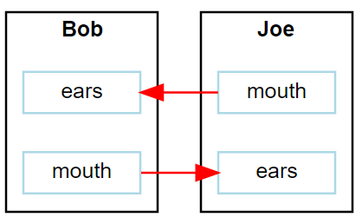

### Model Behavior

To model the behavior of parts, your model:

* Sends messages to other parts
* Reacts on received messages from other parts
* Reacts on timer events

This means, the simulator calls the model code only whenever such an event occurs.

For example, Bobs behavior will be modelled as follows:

class **Bob**(simPart):

…

def **earsRecv**(*self*, port, msg):

if msg == *"Hi, How are you?"*:

*self*.reply = *"How are you?"*

else:

*self*.reply = *"Hm?"*

*self*.thinkTmr.start(1.4)

*self*.setStateIndicator(*"Think"*)

def **thinkTmrExpired**(*self*, timer):

*self*.setStateIndicator(*""*)

*self*.mouth.send(*self*.reply, 1)

### Ports and Messages

A message is send always from an “Output Port” to an “Input Port”.

A part can have many Ports to communicate with other parts.

A message is send via the sending port’s send() method:

*self*.mouth.send(*self*.reply, 1)

In this example, self.reply is the message; here it is a string.

The second parameter defines the flight time, i.e. how long it takes until the message arrives at the input port.

On the receiver side, the part that owns the input port must define a “receive function”, which gets passed the message just received:

def **earsRecv**(*self*, port, msg):

if msg == *"Hi, How are you?"*:

*self*.reply = *"How are you?"*

else:

*self*.reply = *"Hm?"*

*self*.thinkTmr.start(1.4)

*self*.setStateIndicator(*"Think"*)

Note: This receive routine must be called always <portName>Recv.

### Timers

A part can have many timers to control its own behavior.

A timer is stopped by default.

You start the timer via timer.start(timeout).

You stop (cancel) the timer via timer.stop()

You can restart an already running timer via timer.restart(timeout).

def **thinkTmrExpired**(*self*, timer):

*self*.setStateIndicator(*""*)

*self*.mouth.send(*self*.reply, 1)

Note: The expiration routine must be called always <timerName>Expired.

### Running Simulator

After the parts and bindings were created, the simulator can run:

# let simulator run

simu.run(stopTime=12.0)

Here we stop the simulator after 12 seconds. If no limit is given, the simulator would run until no more events to execute.

On the python console, the simulator outputs the simulation trace:

TRC: 0.0s >MSG Bob.mouth(OutPort) // req=0.0s beg=0.0s end=1.0s dur=1.0s msg=[Hi Joe]

SIM: Simulator 0.9.0 starting

TRC: 1.0s <MSG Joe.ears(InPort) // req=0.0s beg=0.0s end=1.0s dur=1.0s msg=[Hi Joe]

TRC: 1.0s ANN Joe(Block) // got message Hi Joe

TRC: 1.0s T-START Joe.thinkTmr(Timer) // 2.0s

TRC: 1.0s STA Joe(Block) // Think

TRC: 3.0s T-EXP Joe.thinkTmr(Timer)

TRC: 3.0s STA Joe(Block) //

TRC: 3.0s >MSG Joe.mouth(OutPort) // req=3.0s beg=3.0s end=4.5s dur=1.5s msg=[Hi, How are you?]

TRC: 4.5s <MSG Bob.ears(InPort) // req=3.0s beg=3.0s end=4.5s dur=1.5s msg=[Hi, How are you?]

TRC: 4.5s T-START Bob.thinkTmr(Timer) // 1.4s

TRC: 4.5s STA Bob(Block) // Think

TRC: 5.9s T-EXP Bob.thinkTmr(Timer)

TRC: 5.9s STA Bob(Block) //

TRC: 5.9s >MSG Bob.mouth(OutPort) // req=5.9s beg=5.9s end=6.9s dur=1.0s msg=[How are you?]

TRC: 6.9s <MSG Joe.ears(InPort) // req=5.9s beg=5.9s end=6.9s dur=1.0s msg=[How are you?]

TRC: 6.9s ANN Joe(Block) // got message How are you?

TRC: 6.9s T-START Joe.thinkTmr(Timer) // 2.0s

TRC: 6.9s STA Joe(Block) // Think

TRC: 8.9s T-EXP Joe.thinkTmr(Timer)

TRC: 8.9s STA Joe(Block) //

TRC: 8.9s >MSG Joe.mouth(OutPort) // req=8.9s beg=8.9s end=10.4s dur=1.5s msg=[Fine]

TRC: 10.4s <MSG Bob.ears(InPort) // req=8.9s beg=8.9s end=10.4s dur=1.5s msg=[Fine]

TRC: 10.4s T-START Bob.thinkTmr(Timer) // 1.4s

TRC: 10.4s STA Bob(Block) // Think

TRC: 11.8s T-EXP Bob.thinkTmr(Timer)

TRC: 11.8s STA Bob(Block) //

TRC: 11.8s >MSG Bob.mouth(OutPort) // req=11.8s beg=11.8s end=12.8s dur=1.0s msg=[Hm?]

SIM: Simulator stopped at 11.8s

### Visualizing Results

#### Sequence Diagram

Moddy can generate a sequence diagram from the simulation results. At the moment, the sequence diagram is generated as a scalable vector graphics (SVG), either pure or embedded in HTML.

After simulation run, the following code generates the sequence diagram:

moddyGenerateSequenceDiagram( sim=simu,

fileName=*"1_hello.html"*,

fmt=*"svgInHtml"*,

excludedElementList=[],

timePerDiv = 1.0,

pixPerDiv = 30)

This is the result:

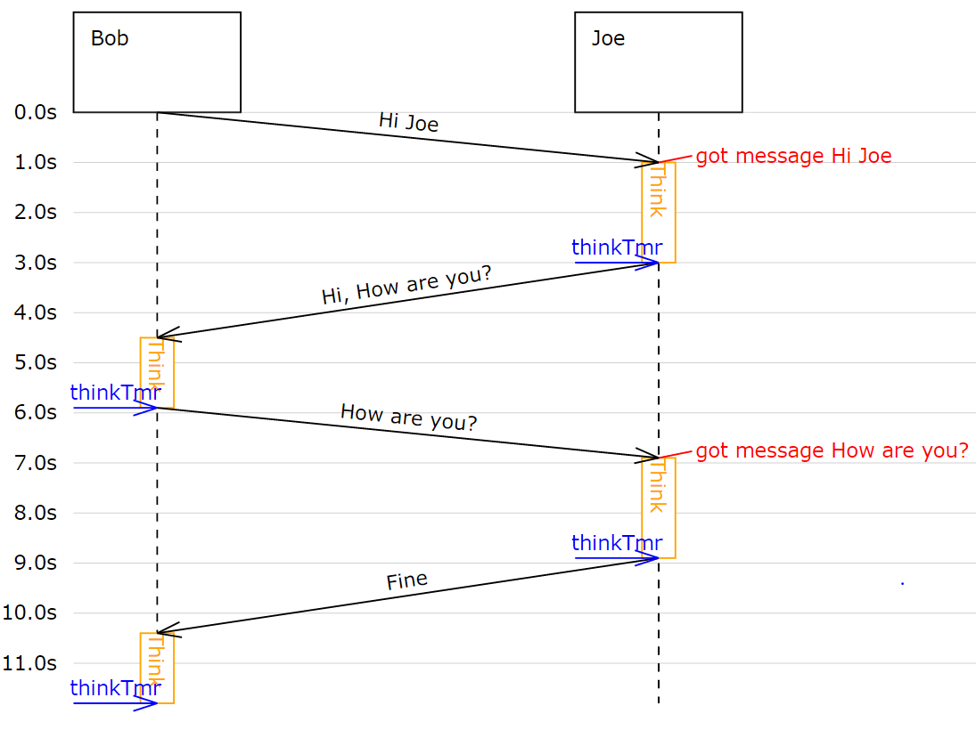

Notes:

* The black arrows are messages
* The blue arrows are timer expiration events
* The orange boxes are visualized “states” or “activities” that were generated by the model via setStatusIndication().
* The red messages are annotations that were generated by the model via addAnnotation()

#### Trace Table

Moddy can also generate a table in form of a .csv (comma separated value file). This is how to generate it:

moddyGenerateTraceTable(simu, *'1_hello.csv'* )

This would be the result when open in Excel:



# Detailed User Guide

Core Simulator

### Initializing the Simulator

The simulator is the first class you must instantiate. The simulator constructor has no arguments:

from moddy import *

simu = sim()

The “simu” variable has to be passed to the parts.

Note: It is not foreseen to instantiate the simulator more than once.

### Simulation Time

The simulator time is the virtual time seen by the model while the simulation is running.

#### Time Unit

Moddy’s simulation time unit is seconds, i.e. the value 1.0 means one second. Because the simulator uses a floating point type for the simulation time, any time unit can be used by the model.

The globals “ms” (=1E-3), “us” (=1E-6) and “ns” (=1E-9) can be used conveniently to specify short times. Example:

n2.toArmPort.send(*'down'*, 1*ms)

The 1*ms passes the value (1*1E-3) = 0.001 to the send function.

#### Setting the Time Unit for Trace Outputs during Simulation

To define the time unit for simulation outputs, use

simu.setDisplayTimeUnit( unit )

where unit can be “s”, “ms”, “us” or “ns”.

This setting affects only the trace outputs during the simulation run:

TRC: 8.9s STA Joe(Block) //

TRC: 8.9s >MSG Joe.mouth(OutPort) // req=8.9s beg=8.9s end=10.4s dur=1.5s msg=[Fine]

It does not affect the Sequence diagram time unit or the csv table output

#### Current Simulation Time

The simulator provides a time() method which can be used by parts to determine the current simulation time. The time returned is the current simulation time in seconds.

Within a part you access the time() function through

self._sim.time()

### Parts

Parts are the component of the system that communicate to each other. They are the base elements to form the structure of a model.

You create a part by creating an instance of a class derived from simPart. This derived class contains the model code implementing the behavior of the part:

* The parts initialization code
* The port receive methods
* The timer expired methods
* Optionally: Methods that are executed at the beginning and the end of the simulation (better place it in method startSim())

Here is a simple example of a part class derived from simPart.

For Python beginners: The “self” variable that is used in ever method is the reference to the own part (comparable with “this” in C++).

from moddy import *

class **Bob**(simPart):

def **__init__**(*self*, sim, objName):

# Initialize the parent class

super().__init__(sim=sim, objName=objName)

# Ports

*self*.createPorts(*'in'*, [*'ears'*])

*self*.createPorts(*'out'*, [*'mouth'*])

# Timers

*self*.createTimers([*'thinkTmr'*])

*self*.reply = *""*

def **earsRecv**(*self*, port, msg):

if msg == *"Hi, How are you?"*:

*self*.reply = *"How are you?"*

else:

*self*.reply = *"Hm?"*

*self*.thinkTmr.start(1.4)

*self*.setStateIndicator(*"Think"*)

def **thinkTmrExpired**(*self*, timer):

*self*.setStateIndicator(*""*)

*self*.mouth.send(*self*.reply, 1)

#### simPart Constructor Parameters

Each part must initialize the simPart’s constructor.

class **simPart**(simBaseElement):

*"""Simulator block"""*

def **__init__**(*self*, sim, objName, parentObj = None ):

The parameters are:

* sim: The simulator instance
* objName: The name of the part
* parentObj: The parent part (for example the “car” if the current part is “engine”). If this parameter is omitted, “no parent” is assumed.

Example:

class **Bob**(simPart):

def **__init__**(*self*, sim, objName):

# Initialize the base class

super().__init__(sim=sim, objName=objName)

#### simPart Methods Called on Start and End of Simulation

Optionally, a part may define Methods that are called at the start or end of simulation.

def **startSim**(*self*):

*'''Called from simulator when simulation begins'''*

def **terminateSim**(*self*):

*'''Called from simulator when simulation stops.*

*Terminate block (e.g. stop threads)'''*

If present, the startStim() method is called at the start of the simulation (i.e. at simulation time 0). The simulator calls the startSim() method of all parts at the beginning of its run() method, in the order the parts have been created. The typical actions in the startSim() routine are

* starting timers
* sending initial messages

If present, the terminateSim() method is called by the simulator when the simulation is terminated, in the order the parts have been created. Typical actions of terminateSim() are

* stopping threads
* closing files

#### Nested Parts

You can model parts that are composed of other parts. For example, the part “engine” may be part of the part “car”.

To model this, you use the simPart constructors “parentObj” argument.

class **Engine**(simPart):

def **__init__**(*self*, sim, objName, car):

# Initialize the base class

super().__init__(sim=sim, objName=objName, parentObj=car)

…

class **Car**(simPart):

def **__init__**(*self*, sim, objName):

# Initialize the base class

super().__init__(sim=sim, objName=objName)

self.engine = Engine(sim, ‚engine‘, self)

Note: The part hierarchy has no relevance for the simulator. The part hierarchy however is displayed in the structure graph, trace output and in the sequence diagrams.

### Message Communication

Parts can communicate only via messages that are sent from an output port to an input port. More about messages in chapter 3.1.5 “Messages”.

Output ports can only send messages, they cannot receive.

Input ports can only receive messages, they cannot send.

There is also an IO Port, but this is nothing else as an object containing one input and one output port.

In general, a message that is sent via an output port, is received after the “flight Time” at the input port. The flight time simulates the transmission time of the message.

#### Creating Ports

All ports of a part must be explicitly created by a part. This is usually done in the constructor (__init__ method) of the part owning the port. Note that a port is always owned by exactly one part.

There are two ways to create ports:

Using the low level methods:

* newInPortI()
* newOutPort()
* newIOPort()

Example:

class **Bob**(simPart):

def **__init__**(*self*, sim, objName):

...

self.ears = self.newInputPort( ‘ears’, self.earsRecv )

This creates a new input port with the name ‘ears’ and assigns the method earsRecv() as the callback method. The resulting port object is assigned to the part variable ‘ears’.

The creation of an IO port is similar:

self.myIOPort1 = self.newIOPort( ‘ioPort1’, self.ioPort1Recv )

An output port has no receive callback method:

self.myOutPort1 = self.newOutoutPort( ‘outPort1’ )

To reduce the amount of typing, you can call the higher level function createPorts().

class **Bob**(simPart):

def **__init__**(*self*, sim, objName):

...

*self*.createPorts(*'in'*, [*'ears'*])

This essentially does exactly the same as the low level function above. It creates a new port object, creates a new part variable self.ears and assigns the callback method “earsRecv”.

This means that your callback function MUST always be named <portName>Recv.

You can also create multiple ports with one call:

*self*.createPorts(*'in'*, [*'inPort1', 'inPort2', 'inPort3'*])

Output ports and IO ports can be created with the same method:

*self*.createPorts(*'out'*, [*'outPort1', 'outPort2', 'outPort3'*])

*self*.createPorts(*'io'*, [*'ioPort1', 'ioPort2', 'ioPort3'*])

Usually, you will always use the high level method, unless you need to create several input ports that have the same receive method.

#### Binding Ports

Before a message can be sent between parts, someone must bind the output port of one object to the input port of another object.

Note: Input and output ports that shall be bound must belong to different parts!

This binding is done normally by the main program. If you have parts that are composed of other parts, then the internal bindings within the top level part are done in the top level parts constructor.

To bind an input port to an output port, you call the output ports bind method:

bob.mouth.bind(joe.ears)

You can bind several input ports to one output board to simulate multicast transfer.

bob.mouth.bind(joe.ears)

bob.mouth.bind(john.ears)

bob.mouth.bind(paul.ears)

You cannot bind several output ports to one input port!

You can also bind IO ports to each other. In this case the output port of the first IO port is bound to the input port of the second port and vice versa. It doesn’t matter on which IO port you call the bind method.

class **myPart**(simPart):

def **__init__**(*self*, sim, objName):

...

*self*.createPorts(*'io'*, [*'ioPort1'*])

part1 = myPart( simu, *‘part1’* )

part2 = myPart( simu, *‘part2’* )

part1.ioPort1.bind( part2.ioPort1 )

If you need to bind an IO port to a normal input and normal output port, you can do it like this:

Consider part1 has an ioport called “ioPort1” and part2 has one input port “inPort1” and an output port “outPort1”:

part1.ioPort1._outPort.bind( part2.inPort1 )

part2.outPort1.bind( part1.ioPort1._inPort )

#### Sending Messages

A message between two parts is sent via an output port’s send routine:

send( msg, flightTime )

Where

* msg is the message you want to send (More about messages in chapter 3.1.5 “Messages”)
* flightTime is the transmission time of the message; i.e. how long it takes until the message arrives at the input port. flightTime must be a positive value in seconds. flightTime can be 0; in this case, the message arrives without delay at the bound input ports.

The send method has no return value.

What happens if you call the send method on a port which is already sending a message (meaning: the flight time of one or more previous messages has not elapsed)?

In this case, the output port queues the pending messages one after each other. When a messages flight time has elapsed, the next message from the queue is sent. This simulates the behavior of a serial transmission.

[??? SeqDiag}

#### Receiving Messages

When a message is received on an input port, the input ports callback method is called. This receive method must be provided by the model, usually in the class derived from simPart.

When you have created the port with createPorts(), the method is called <portName>Recv:

class **Bob**(simPart):

def **__init__**(*self*, sim, objName):

...

*self*.createPorts(*'in'*, [*'ears'*])

def **earsRecv**(*self*, port, msg):

if msg == *"Hi, How are you?"*:

*self*.reply = *"How are you?"*

else:

*self*.reply = *"Hm?"*

*self*.thinkTmr.start(1.4)

The receive callback method gets passed two parameters:

* port is the input port on which the message was received. You can use this to find out which port received the message in case you have assigned the same receive method to multiple ports
* msg is the message just received

The receive callback method does not return a value.

Note that you get a copy of the message sent by the caller, so you can modify or even delete the message content without affecting the sender or other receivers of the message. More specifically, msg is a “deep copy” of the original message; this means that also objects that are referenced in the message can be copied.

The usual task of receive callback method is to start timers or to send messages to other objects.

#### Messages

What type of data can be transferred between output and input ports?

Generally, any valid python object can be a Moddy message, such as:

* Numbers, e.g. 1.0
* Strings, e.g. ‘abc’
* Lists, e.g. [‘abc’, 1.0, 2]
* User defined classes

Moddy does not force any specific type to be used as a message. However, the model must be written in a way that the receiver understands the messages the sender might generate.

Here is an example of a user defined that is used as a Moddy message. It simulates the behaviour of “Fail Safe over EtherCAT”:

class **FsoeMsg**:

def **__init__**(*self*, addr, seq, data ):

*self*.addr = addr # FSoE Address

*self*.seq = seq # sequence number

*self*.data = data # FSoE Payload

To send such a message, you could call from a part’s method:

*self*.outPort1.send( FsoeMsg(self.fsoeAddr, seq, ‘TESTDATA’, msgFlightTime)

Restriction: Do NOT include a reference to the simulator instance, parts, ports or timers into the user defined messages! This may cause an exception when sending such messages (because it causes endless recursion while trying to make a deep copy of the message).

##### Message Content Display

How are message contents displayed in sequence diagrams and trace tables?

Moddy calls the object’s __str__() method. This method should generate a user readable string with the message content.

For the built-in classes, python defines the __str__() method. For user defined classes, you must implement it:

class **FsoeMsg**:

...

def **__str__**(*self*):

return *"FSoE @%d#%d %s"* % (*self*.addr, *self*.seq, *self*.data)

Example output: “FSOE @2#3 ‘ABC’” -> meaning: FSOE message to slave 2, sequence 3, with data ‘ABC’.

##### Checking Message Types

If the receiver wants to check if the received message is of the correct type, he can use the python type() method, here are some examples:

if type(msg) is int:

…

if type(msg) is float:

…

if type(msg) is str:

…

if type(msg) is list:

…

if type(msg) is FsoeMsg:

…

##### Message Colors

You can influence the color in which messages are displayed in the sequence diagram.

By default, the messages are drawn in “black”.

You can assign a color to an output port, e.g.

**myOutPort.setColor**(*"green"*)

In this case, all messages sent via this output ports are drawn in green.

You can even assign different colors to individual messages. To do so, create a member “msgColor” inside a (user defined) message:

class **FsoeMsg**:

def **__init__**(*self*, addr, seq, data, msgColor=None ):

*self*.addr = addr # FSoE Address

*self*.seq = seq # sequence number

*self*.data = data # FSoE Payload

if msgColor is not None: *self*.msgColor = msgColor

If the msgColor member exists, this message will get the define msgColor.

### Timers

Timers are – beside messages - another way of triggering actions in a part.

Typically, timers are used to

* Trigger periodic actions
* Provide timeout for message reception

A timer is started and stopped from a part’s methods. When the timer expires, an “expiration callback” method is called within the part-

#### Creating Timers

A part can have any number of timers.

All timers of a part must be explicitly created by a part. This is usually done in the constructor (__init__ method) of the part owning the timer. There are two ways to create timers:

Using the low level method newTimer():

Example:

class **Bob**(simPart):

def **__init__**(*self*, sim, objName):

...

self.thinkTmr = self.newTimer( ‘thinkTmr’, self.thinkTmrExpired )

This creates a new timer with the name ‘thinkTmr’ and assigns the method thinkTmrExpired() as the callback method. The resulting timer object is assigned to the part variable ‘thinkTmr’.

To reduce the amount of typing, you can call the higher level function createTimers().

class **Bob**(simPart):

def **__init__**(*self*, sim, objName):

...

*self*.createTimers([*'thinkTmr'*])

This essentially does exactly the same as the low level function above. It creates a new timer object, creates a new part variable self.thinkTmr and assigns the callback method “thinkTmrExpired”.

This means that your callback function MUST always be named <timerName>Expired.

You can also create multiple timers with one call:

*self*.createTimers([*'tmr1', 'tmr2'*])

#### Starting and Stopping Timers

Each timer has two states: Started and Stopped.

You start a timer with start() or restart().

*self*.thinkTmr.start(2)

*self*.thinkTmr.restart(2)

Both expect the timer’s expiration time, relative to the current simulation time, in seconds (in the examples above: 2 seconds). They do not return a value.

The start() method throws an exception if you use it on a timer which is already started. The restart() method starts a timer with the specified time regardless of the timers state. Both methods bring the timer into the started state.

You stop a timer with stop() method(). It brings the timer into the stopped state. In other words, you cancel the timer.

*self*.thinkTmr.stop()

#### Timer Expiration Callback

When a timer expires, the timer’s callback method is called. This callback method must be provided by the model, usually in the class derived from simPart.

When you have created the port with createTimers(), the method is called <timerName>Expired:

class **Bob**(simPart):

def **__init__**(*self*, sim, objName):

...

*self*.createTimers([*'thinkTmr'*])

def **thinkTmrExpired**(*self*, timer):

*self*.mouth.send(*self*.reply, 1)

The timer expired callback gets passed the *timer* parameter, which is the timer object that has expired. You can use this to find out which timer expired in case you have assigned the same callback methods to multiple timers.

The callback method does not return a value.

The usual task of receive callback method is to re-start this timer, start other timers or to send messages to other objects.

### Annotations

The model can add annotations to the output (i.e. sequence diagrams and trace tables) to visualize special events in the model.

You add an annotation by calling the simPart’s addAnnotation() method:

class **Joe**(simPart):

def **earsRecv**(*self*, port, msg):

*self*.addAnnotation(*'got message '* + msg)

In a sequence diagram, an annotation is displayed on the part’s life line at the current simulation time:



Annotation

The addAnnotation() method expects a string as its argument. It must be a single-line string. No special characters such as newline are allowed.

### State Indications

To visualize a part’s state or to indicate which activity the part is currently performing, you can use state indications. For this, you call the part’s setStateIndicator() method:

class **Bob**(simPart):

…

def **earsRecv**(*self*, port, msg):

...

*self*.setStateIndicator(*"Think"*)

def **thinkTmrExpired**(*self*, timer):

*self*.setStateIndicator(*""*)

The first parameter to setStateIndicator() is *text*:

* A non-empty string indicates the start of a new state or activity. The text is displayed in sequence diagrams in vertical direction.
* An empty string ends the state or activity



State Indicator

The second, optional parameter to setStateIndicator is *appearance*. With this parameter, you can control the colors of state indicator. If present, it must be a python dictionary like this:

{*'boxStrokeColor'*:*'black'*, *'boxFillColor'*:*'green'*, *'textColor'*:*'white'*}

Where:

* boxStrokeColor: is the color of the status box’s border
* boxFillColor: is the color of box body
* textColor: is the color of the text

Color names are according to the SVG specification, see <http://www.december.com/html/spec/colorsvg.html> for an overview.

If the appearance argument is omitted, it defaults to:

{*'boxStrokeColor'*:*'orange'*, *'boxFillColor'*:*'white'*, *'textColor'*:*'orange'*}

### Running the Simulation

After the instantiation of the simulator, the creation of the parts, ports and the binding of the ports, you can run the simulation:

# let simulator run

simu.run(stopTime=12.0, maxEvents=100 , enableTracePrinting=True)

This will run the simulation until one of the following conditions are met:

* *stopTime* has been reached
* The simulator has processed a maximum number of event *maxEvents.* If this argument is omitted, it defaults to 10000
* The simulator has no more events to execute
* An exception was raised (either by the model or the simulator)

With enableTracePrinting, you can control whether the simulator prints each event while executing.

Sequential Program Simulation

With the message and timer callbacks explained before, you can model already everything.

However, when you want to model a sequential execution, it can be quite cumbersome to do this with the event based mechanism. For example if you want to model the execution of a software program like this

* Get inputs (from Moddy messages), takes 100µs
* Calculate, takes 1ms
* Set outputs, takes 200µs

With the event based mechanism, you would need a state machine in the timer’s callback routine, which is not easy to understand.

So Moddy allows an alternative way to model those sequential programs, simply called “Programs” in the following.

To create a “program”, your Part must be a subclass of either *vThread* or *vSimpleProg*. (More about the difference between them later).

### Program Model

class **Client**(vSimpleProg):

def **__init__**(*self*, sim):

super().__init__(sim=sim, objName=*"Client"*, parentObj=None)

*self*.createPorts(*'QueingIO'*, [*'netPort'*])

def **runVThread**(*self*):

while True:

*self*.wait(1.2*ms)

*self*.netPort.send(*'test'*, 100*us)

*self*.busy(100*us, *'TX1'*, whiteOnBlue)

*self*.netPort.send(*'test1'*, 100*us)

*self*.busy(100*us, *'TX2'*, whiteOnRed)

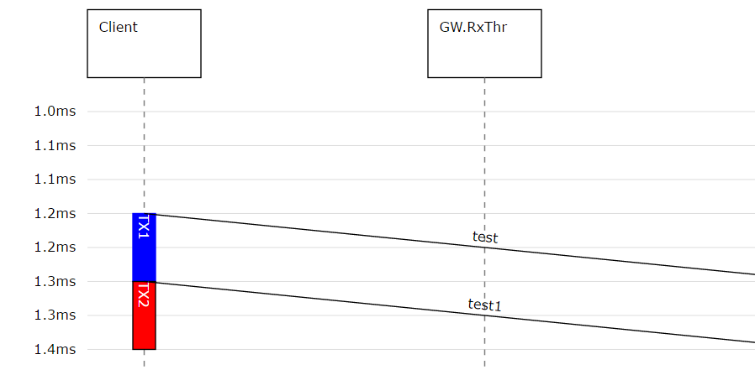

In the above example, you see a very simple sequential program.

Moddy parts derived from vThread or vSimpleProg must implement a method *runVThread*. This method contains your sequential program model.

It is called at the start of the simulation time (simulation time 0).

The *runVThread* method is not supposed to exit/return, that’s why they contain an endless loop.

The *runVThread* method can control the timing of the program via “system calls”:

* **wait()** – delays the program execution for a specified time or until an event occurred, indicating that the program is idle. No status box is shown on the sequence diagram life line while a program is waiting
* **busy()** – delays the program execution for the specified time. A user defined status box (e.g. ‘TX1’ in the example above occurs) is shown on the life line while the program is busy.

### Communication between Moddy Programs and other Moddy Parts

Like normal Moddy parts, Moddy Programs shall communicate with other parts only via Moddy messages.

To send messages, a Moddy program can use standard output ports. There is no difference to other parts

But a standard input port executes a callback method. It cannot tell the program that a message has been received (other than setting a global variable). For this reason, Moddy provides “buffering ports”.

### Buffering Input Ports

A buffering port buffers received messages in the part’s local memory and eventually wakes up the program.

There are two types of buffering ports

* **Sampling Port:** A sampling port is used if the receiver is only interested in the most recent message.
  + A sampling port buffers only the last received message.
  + A read from the sampling buffer does *not* consume the buffered message
* **Queing Port:** A queing port is used if the receiver wants to get all messages.
  + A queing port buffers all messages in a fifo queue. The queue depth is infinite.
  + A read from the buffer consumes the first message

*Note: The term “Queing” is misspelled in this documentation and in the code. It should be “Queuing”. For now, I leave it as it is.*

A program reads a message from a buffering ports via the *readMsg()* method. It can check the number of messages in the buffer through the *nMsg()* method.

A program can wait for new message using the wait() method. The exact behavior depends on the type of buffer port (Sampling or Queing) and will be explained in the following.

#### Sampling Input Ports

Recall from previous chapter:

* A sampling port buffers only the last received message.
* A read from the sampling buffer does *not* consume the buffered message

A sampling input port is created with the createPorts() method, usually from the program’s constructor:

*self*.createPorts(*'SamplingIn'*, [*'inP1'*])

The *readMsg()* method on a sampling input port returns the most recent message received. If no message at all was received, it returns either the “default” (if provided) or raises a BufferError exception. If you call *readMsg()* and now new message has arrived since the last *readMsg()* call, you get the same message again.

The *nMsg()* method returns 0 if no message was received at 0, or 1 otherwise.

A program can call *wait()* so that is woken up if a message arrives on the port:

*self*.wait(20, [*self*.inP1])

A sampling input port wakes up a waiting with *every* message that arrives.

The following snippet demonstrates the use of a sampling port.

myThread1 is a program that has a sampling input port “inP1”, while stimThread is firing messages to that port.

class **myThread1**(vSimpleProg):

def **__init__**(*self*, sim ):

super().__init__(sim=sim, objName=*'Thread'*, parentObj=None)

*self*.createPorts(*'SamplingIn'*, [*'inP1'*])

def **showMsg**(*self*):

msg = *self*.inP1.readMsg(default=*'No message'*)

*self*.addAnnotation(msg)

def **runVThread**(*self*):

cycle=0

while True:

cycle += 1

*self*.showMsg()

*self*.busy(18,cycle, busyAppearance)

*self*.showMsg()

*self*.busy(14,cycle, busyAppearance)

*self*.wait(20,[*self*.inP1])

class **stimThread**(vSimpleProg):

def **__init__**(*self*, sim ):

super().__init__(sim=sim, objName=*'Stim'*, parentObj=None)

*self*.createPorts(*'out'*, [*'toT1Port'*])

def **runVThread**(*self*):

count=0

while True:

count+=1

*self*.wait(15)

*self*.toT1Port.send(*'hello%d'* % count,5)

This would result in the following sequence diagram:

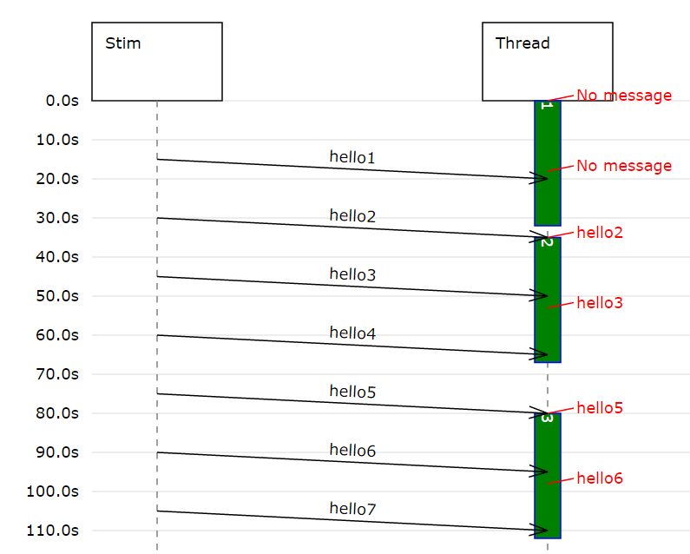

#### Queing Input Ports

Recall from previous chapter:

* A queing port buffers all messages in a fifo queue. The queue depth is infinite.
* A read from the buffer consumes the first message

A queing input port is created with the createPorts() method, usually from the program’s constructor:

*self*.createPorts(*'QueingIn',* [*'inP1'*])

The *readMsg()* method on a sampling input port returns the first message of the queue. If no message is in the queue, it raises a BufferError exception.

The *nMsg()* method returns the number of messages in the queue (0 if none).

A program can call *wait()* so that is woken up when a the *first message an empty queue* arrives on the port:

*self*.wait(20, [*self*.inP1])

Note: Call wait() only on empty queing ports, otherwise the program will not be woken up (because the wakeup happens only at empty->non-empty transitions)!

The following snippet demonstrates the use of a queing port.

myThread1 is a program that has a queing input port “inP1”, while stimThread is firing messages to that port.

class **myThread1**(vSimpleProg):

def **__init__**(*self*, sim ):

super().__init__(sim=sim, objName=*'Thread'*, parentObj=None)

*self*.createPorts(*'QueingIn'*, [*'inP1'*])

def **getAllMsg**(*self*):

lstMsg = []

while True:

try:

msg = *self*.inP1.readMsg()

lstMsg.append(msg)

except BufferError:

break

*self*.addAnnotation(lstMsg)

def **runVThread**(*self*):

cycle=0

while True:

cycle += 1

*self*.busy(33, cycle, busyAppearance)

*self*.getAllMsg()

*self*.wait(20, [*self*.inP1])

*self*.getAllMsg()

class **stimThread**(vSimpleProg):

def **__init__**(*self*, sim ):

super().__init__(sim=sim, objName=*'Stim'*, parentObj=None)

*self*.createPorts(*'out'*, [*'toT1Port'*])

def **runVThread**(*self*):

count=0

while True:

count+=1

*self*.wait(15,[])

*self*.toT1Port.send(*'hello%d'* % count,5)

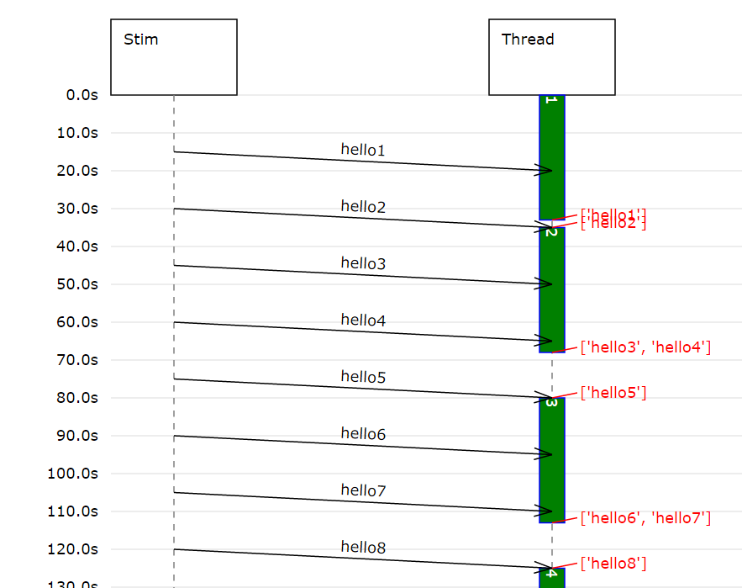

### Program Timers

???

### System Calls for Sequential Programs

In the previous chapters, the system calls *wait()* and *busy()* were already briefly introduced. Now in more detail:

**wait()** delays the program execution for a specified time or until an event occurred.

The model is indicating with *wait()* that the program is idle. Therefore no status box is shown on the sequence diagram life line while a program is waiting.

**wait**(timeout, evList=[])

Where

* *timeout* is the timeout. If None, wait forever. A timeout value of 0 is invalid.
* *evList* is the list of events to wait for. Events can be must be an instance from one of the classes vtSamplingInPort, vtQueuingInPort, or vtTimer. If evList is empty (or omitted), waits for timeout unconditionally.

*wait()* returns a string:

- 'ok' if one of the events has been triggered (it does not tell you which one)

- 'timeout' if timeout

**busy()** – delays the program execution for the specified time.

The model is indicating with *busy()* that the program is performing some operation. Therefore, a user defined status box appears on the life line while the program is busy.

**busy**(time, status, statusAppearance={})

Where:

* *time* is the busy time.
* *status* is the status text shown on the sequence diagram life line
* *statusAppearance* defines the decoration of the status box in the sequence diagram. See chapter 3.1.7

*busy()* returns always the string ‘ok’.

### Concurrent Program Execution/RTOS Simulation

Moddy comes with a simulation of a simple RTOS (real time operating system) scheduler. With this feature, you can model SW threads that run concurrently on a single CPU core.

The scheduler has the following features:

* 16 thread priorities - 0 is highest priority
* Priority based scheduling. Low prio threads run only if no higher thread ready.
* Threads with same priority will be scheduled round robin (when one of the same prio threads releases the processor, the next same prio thread which is ready is selected)

First, you create the scheduler object:

sched= vtSchedRtos(sim=simu, objName=*"sched"*, parentObj=None)

Then you add the threads (subclasses of vThread) that shall be scheduled by the scheduler:

t1 = myThread1(simu)

t2 = myThread2(simu)

t3 = myThread3(simu)

sched.addVThread(t1, prio=0)

sched.addVThread(t2, prio=1)

sched.addVThread(t3, prio=1)

Example snippet:

class **myThread1**(vThread):

def **__init__**(*self*, sim ):

super().__init__(sim=sim, objName=*'hiThread'*, parentObj=None)

def **runVThread**(*self*):

print(*" VtHi1"*)

*self*.busy(50,*'1'*,busyAppearance)

print(*" VtHi2"*)

*self*.wait(20,[])

print(*" VtHi3"*)

*self*.busy(10,*'2'*,busyAppearance)

print(*" VtHi4"*)

*self*.wait(100,[])

print(*" VtHi5"*)

*self*.wait(100,[])

while True:

print(*" VtHi5"*)

*self*.busy(10,*'3'*,busyAppearance)

*self*.wait(5,[])

class **myThread2**(vThread):

def **__init__**(*self*, sim ):

super().__init__(sim=sim, objName=*'lowThreadA'*, parentObj=None)

def **runVThread**(*self*):

print(*" VtLoA1"*)

*self*.busy(50,*'1'*,busyAppearance)

print(*" VtLoA2"*)

*self*.wait(20,[])

print(*" VtLoA3"*)

*self*.busy(20,*'2'*,busyAppearance)

print(*" VtLoA4"*)

*self*.busy(250,*'3'*,busyAppearance)

class **myThread3**(vThread):

def **__init__**(*self*, sim ):

super().__init__(sim=sim, objName=*'lowThreadB'*, parentObj=None)

def **runVThread**(*self*):

print(*" VtLoB1"*)

*self*.busy(50,*'1'*,busyAppearance)

print(*" VtLoB2"*)

*self*.wait(20,[])

print(*" VtLoB3"*)

*self*.busy(100,*'2'*,busyAppearance)

print(*" VtLoB4"*)

*self*.busy(250,*'3'*,busyAppearance)

simu = sim()

sched= vtSchedRtos(sim=simu, objName=*"sched"*, parentObj=None)

t1 = myThread1(simu)

t2 = myThread2(simu)

t3 = myThread3(simu)

sched.addVThread(t1, 0)

sched.addVThread(t2, 1)

sched.addVThread(t3, 1)

Resulting in the following sequence diagram:

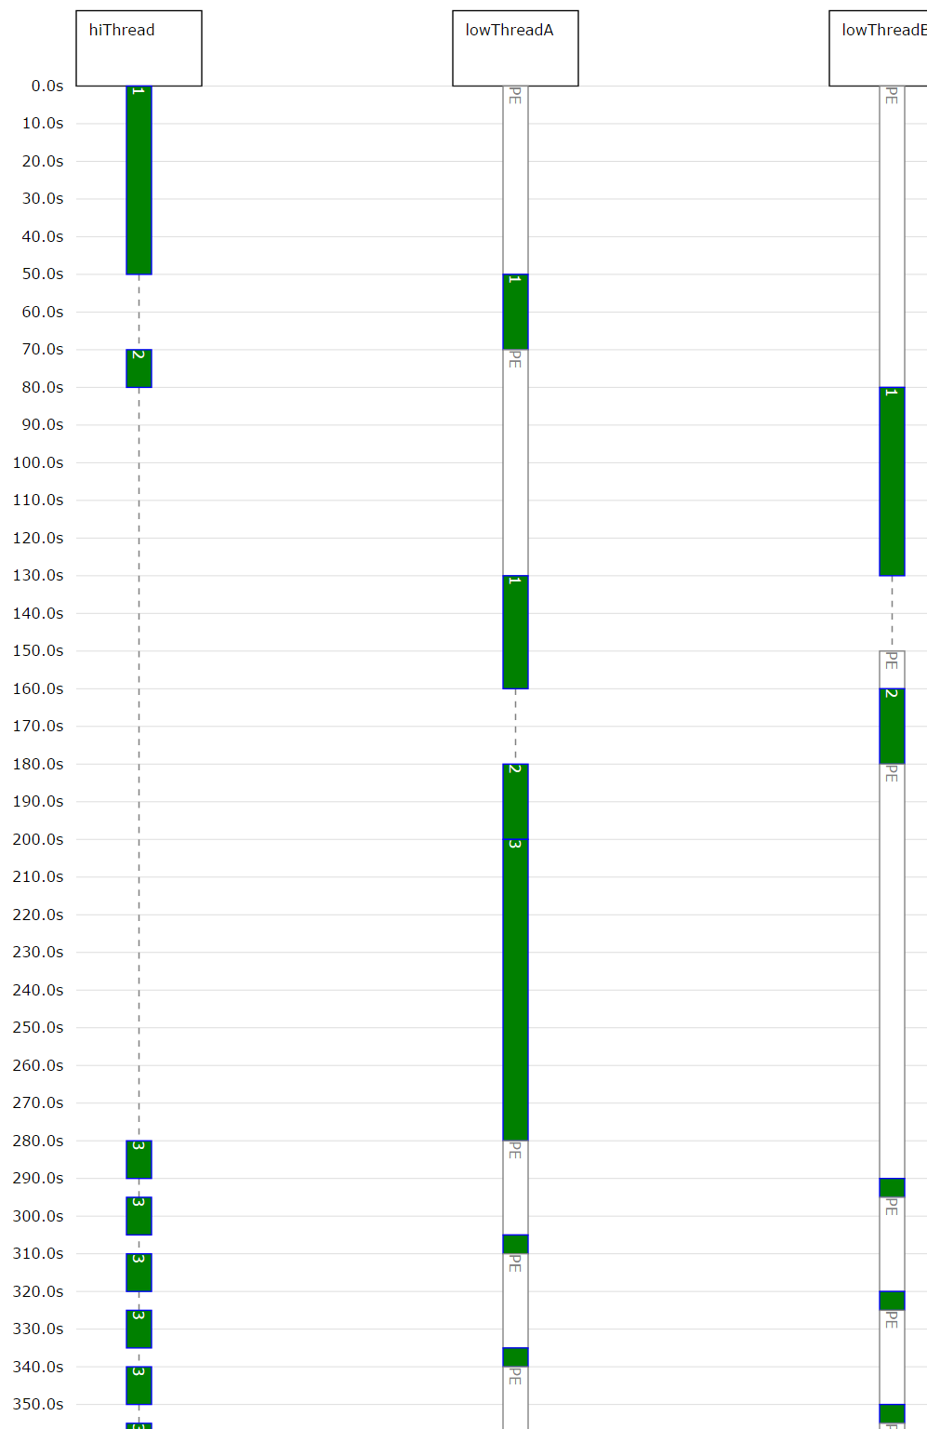

Note: The “PE” status indicator tells you that the thread is “preempted”, i.e. it would be ready to run, but it has to wait for the CPU resource, because a higher thread is busy.

### vSimpleProg and vThread

vSimpleProg is a specialization of vThread. vSimpleProg uses an exclusive scheduler for the program, so there are no concurrent threads.

vThreads must be explicitly assigned to a scheduler.

Result Visualisation

### Sequence Diagram Generation

See moddy/svgSeqD/**moddyGenerateSequenceDiagram**

[???]

Notes:

* Raw SVG files (.svg) can be edited by Inkskape or MS Visio.
* Raw SVG files can be displayed in browser, but browser cannot scroll, use SVG embedded in HTML when you want to display svg in browser

### Trace Table Generation

See moddy/traceToCsv/**moddyGenerateTraceTable**

[???]

### Structure Graph Generation

See moddy/traceToCsv/**moddyGenerateStructureGraph**

[???]

Example of a structure graph:

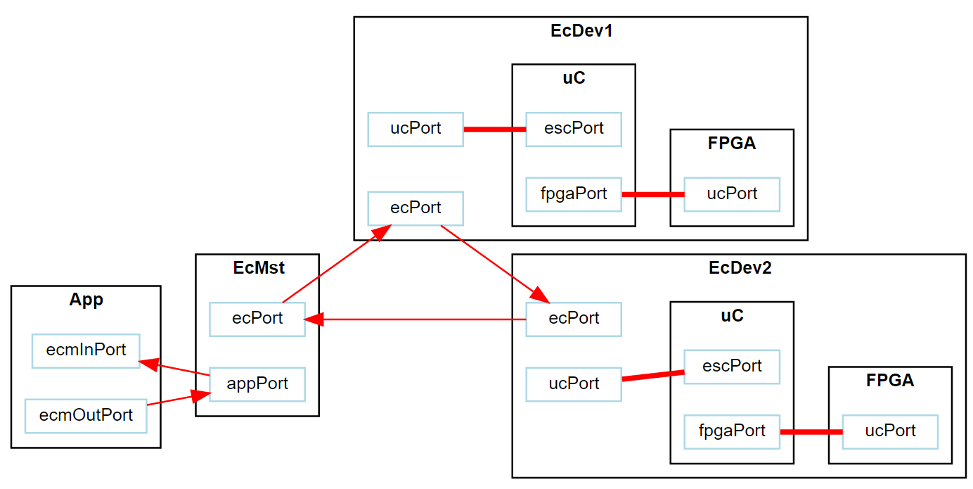

# Installation

Tested with python 3.5.2 and 3.6 under Windows 10, Eclipse Neon/pyDev

Required libraries: svgwrite https://pypi.python.org/pypi/svgwrite , tested with svgwrite 1.1.9

Required tools: GraphViz, tested with Version 2.38

## Installing Eclipse

Download & Install Eclipse from <https://eclipse.org/downloads/>

## Install Python

Download & Install Python from <https://www.python.org/downloads/>

During install, click checkbox “add python to PATH”

## Installing PyDev

In Eclipse, select Help->Install new Software and enter <http://www.pydev.org/updates> for both Name and location

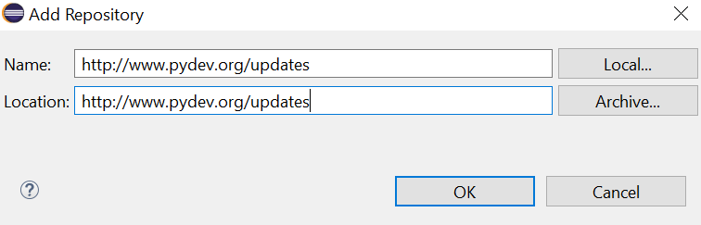

Select “pyDev” and follow the installation instructions

## Installing svgwrite

Open Windows command line.

From the command line, call

pip install svgwrite

## Installing GraphViz

Install GraphViz from

<http://www.graphviz.org/Download..php>

Then ensure that the bin/ subdirectory of the GraphViz installation is in your PATH.

## Installing moddy

Note: This may change. It is not optimized yet.

Clone moddy from GitHub.

From eclipse, select File->Import. Then General->File System. Select the directory where you cloned moddy to.

Go to Project->Preferences.

Select PyDev – Interpreter = 3.x

Select PyDev – PYTHONPATH – Source Folders -> Add Source Folder /$(PROJECT_DIR_NAME)/src

Try to run the tutorial:

Right click in Package Explorer to “moddy/src/tutorial/1_hello.py”.

Select “Run As”->”Python Run”

The console log should end with

…

Drawing ANN events

saved 1_hello.html as svgInHtml

saved 1_hello.csv as CSV