System Architecture
Customer Insights Segment Sankey
Draft segment preview and member analysis with Dynamics 365, Dataverse, Azure, and Microsoft Fabric
Document | Value
Version | 1.2
Date | August 20, 2026
Status | As-built architecture with operational and security notes
Audience | Architecture, development, operations, security, and product owners
Primary format | Microsoft Word; diagrams additionally editable in Excalidraw
Note: Secrets and API keys are deliberately not part of this document.

1. Management Summary 4
1.1 Key Architecture Decisions 4
1.2 Current Functional Scope 4
2. System Context 4
2.1 Participating Platforms and Responsibilities 5
2.2 User Interactions 5
2.3 High-Level Deployment and Infrastructure Mapping 5
2.4 Request Flow: Custom API, Plugin, Azure, and Fabric 6
3. Logical Architecture 7
3.1 Client Components 8
3.2 Dataverse Components 8
3.3 Azure API Components 8
3.4 Fabric Components 9
4. Data Architecture 9
4.1 Data Sources 9
4.2 Automatic Dependency Resolution 9
4.3 SQL Compilation 9
4.4 Stage Semantics 10
5. Count Evaluation Flow 10
5.1 Example of a Verified Result 10
6. Members View Flow 11
6.1 Paging Approach 11
6.2 Supported Fields 11
7. Security Architecture 11
7.1 Identities and Authentication 12
7.2 Data Protection and Permissions 12
7.3 Token Security 12
7.4 Security Risks and Mitigations 13
8. Physical Deployment 13
8.1 Dataverse 13
8.2 Azure 13
8.3 Microsoft Fabric 14
9. Operations and Monitoring 14
9.1 Availability Dependencies 14
9.2 Typical Incident: Capacity Inactive 14
9.3 Logging and Error Principles 15
9.4 Performance 15
10. Scaling and Limits 15
10.1 Scaling Characteristics 15
10.2 Known Limits 15
10.3 Target State for High Load 16
11. Quality Assurance and Verified State 16
11.1 Acceptance Criteria 16
12. Deployment and Change Process 16
12.1 Azure API 17
12.2 Dataverse Plugin and Custom APIs 17
12.3 Web Resources 17
12.4 Rollback 17
13. API Contracts 17
13.1 Dataverse Count API 17
13.2 Dataverse Members API 17
13.3 Azure API Protection 17
14. Source Code and Artifact Overview 18
14.1 Included Diagram Sources 18
15. Glossary 18
16. Open Operational Recommendations 19

1. Management Summary
The solution extends the draft segment editor of Dynamics 365 Customer Insights – Journeys with an interactive Sankey preview. For each cumulative filter stage it calculates the member count, visualizes inflows and outflows, and enables drill-down into the contacts still contained, removed, or added.
The actual set evaluation takes place entirely in Microsoft Fabric. The Dataverse plugin reads and validates the draft MQL, builds a typed abstract syntax tree, and hands it to a secured ASP.NET Core API. This API compiles profile, relationship, consent, behavioral, and set operations into parameterized Fabric SQL CTEs.
For the overview, only aggregated COUNT_BIG values leave Fabric. For member drill-down, Fabric returns at most 50 contact IDs per page; Dataverse then adds the visible fields in the context of the signed-in user. This preserves record- and field-level security.

1.1 Key Architecture Decisions
- Fabric is the sole engine for segment sets and set operations.
- Dataverse remains the system of record for draft MQL, metadata, and security-checked contact data.
- Journeys events and required Dataverse tables are provisioned in a shared Serving Lakehouse.
- The browser UI never receives an API key or large ID sets.
- Short-lived, encrypted tokens bind the member query to segment, stage, filter, sorting, and continuation.
- Errors are reported explicitly; a count of 0 is only shown after a successful evaluation.

1.2 Current Functional Scope
Area | Implementation
Segment logic | PROFILE, relationships, consent, interaction, nested/static segments
Set operations | INTERSECT, UNION, and EXCEPT
Visualization | Cumulative Sankey stages, removed and added bubbles, result
Members | Search, field filters, sorting, 50-item keyset paging, contact navigation
Security | Dataverse security trimming, field-level security, server-side API key, managed identity
Scaling | Counts independent of profile count; no 250,000 ID limit

2. System Context
The segment designer operates exclusively within the Customer Insights model-driven app. A command opens a Dynamics side pane. The pane calls global Dataverse Custom APIs, which coordinate Dataverse and the Azure/Fabric evaluation.
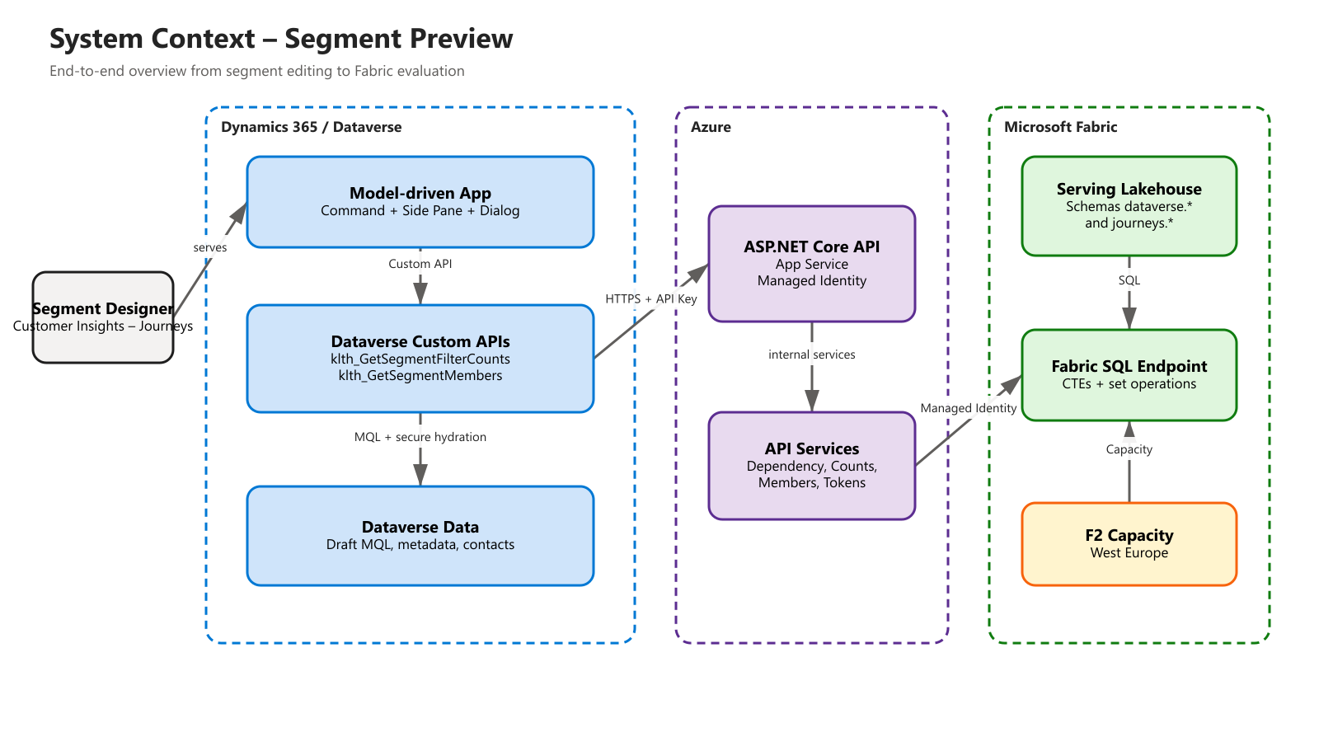
Figure 1: System context and key platform boundaries

2.1 Participating Platforms and Responsibilities
Platform | Responsibility
Dynamics 365 Customer Insights – Journeys | Segment editor, draft MQL, user interaction
Dataverse | Segment definition, metadata, environment variables, contacts, and security model
Azure App Service | Secured segment engine and integration endpoints
Microsoft Fabric | Serving Lakehouse, SQL evaluation, set operations, and event data
Azure Fabric Capacity | Compute capacity for Lakehouse, REST, and SQL endpoint

2.2 User Interactions
- The user opens or edits a saved draft segment definition.
- The command opens the "Segment preview" side pane and passes the segment ID and name.
- The pane saves changed form data before evaluation.
- The count API returns ordered stage counts and a short-lived evaluation token.
- Clicking a stage, a red/green bubble, or the result opens the members dialog.
- Clicking a contact name opens the Dataverse contact record.

2.3 High-Level Deployment and Infrastructure Mapping
The solution consists of four clearly separated runtime areas. The HTML/JavaScript web resources are stored in Dataverse but run in the user's browser. The C# plugins are classic server-side Dataverse IPlugin implementations and run synchronously in the plugin runtime provided by Dataverse. They are not Azure Functions.
In Azure, a standalone ASP.NET Core .NET 8 REST API runs as a Linux Web App on Azure App Service. It provides the endpoints for dependencies, counts, members, and health. There is no Azure Function and no Function App host in this architecture.
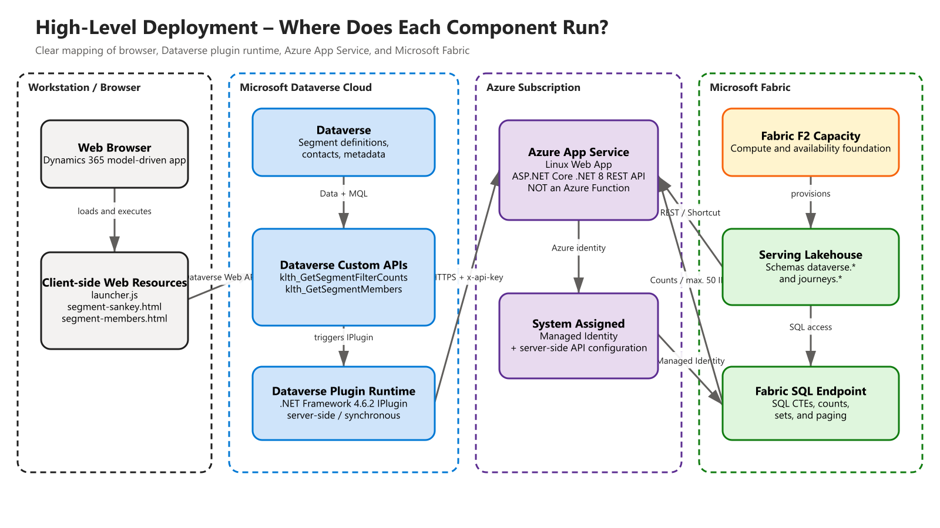
Figure 2: Physical runtime mapping of the components
Component | Technology | Runtime / Infrastructure | Key Clarification
Sankey and members dialog | HTML, CSS, JavaScript | Browser; files stored as Dataverse web resources | Client-side UI, no dedicated web server
Count and members plugin | C# IPlugin, .NET Framework 4.6.2 | Server-side Dataverse plugin runtime | No browser code and no Azure Function
Segment engine API | ASP.NET Core, .NET 8 | Azure App Service Linux Web App | Regular REST web API, explicitly not a Function App
Set computation | Fabric SQL | Fabric SQL Endpoint on F2 Capacity | Database-native CTE and set operations
Serving data | Delta/OneLake shortcuts | Fabric Serving Lakehouse | dataverse.* and journeys.*

2.4 Request Flow: Custom API, Plugin, Azure, and Fabric
In this solution, the Dataverse Custom API is the registered interface through which the web resource specifically triggers the associated plugin. The actual business and integration logic resides in the C# plugin. This plugin reads Dataverse data and then calls the REST API on the Azure Web App.
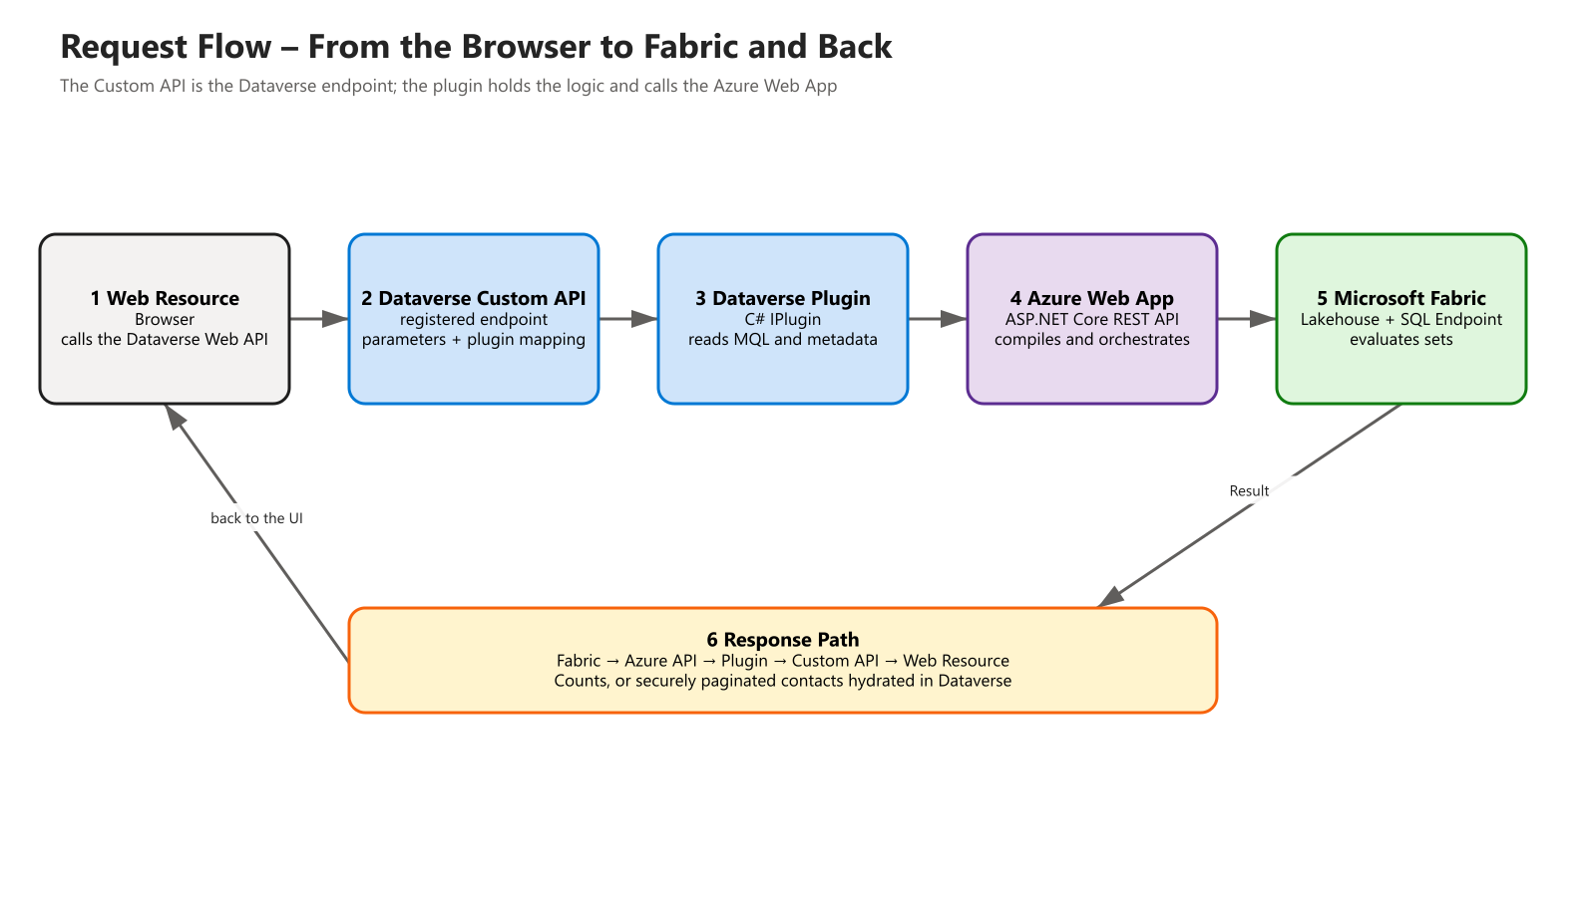
Figure 3: Outbound and return path of a segment request
- The JavaScript web resource calls the Dataverse Custom API via the authenticated Dataverse Web API.
- Dataverse validates the registered endpoint and its input/output parameters.
- The Custom API triggers the associated C# IPlugin type in the Dataverse plugin runtime.
- The plugin reads draft MQL, metadata, segment references, and server-side environment variables.
- The plugin calls the ASP.NET Core API on Azure App Service over HTTPS with a server-side x-api-key.
- The Azure API authenticates to Microsoft Fabric via managed identity and performs shortcut or SQL operations.
- Fabric returns counts or at most 50 profile IDs to the Azure API.
- The plugin hydrates member IDs as the currently signed-in Dataverse user and returns the response through the Custom API and web resource.

3. Logical Architecture
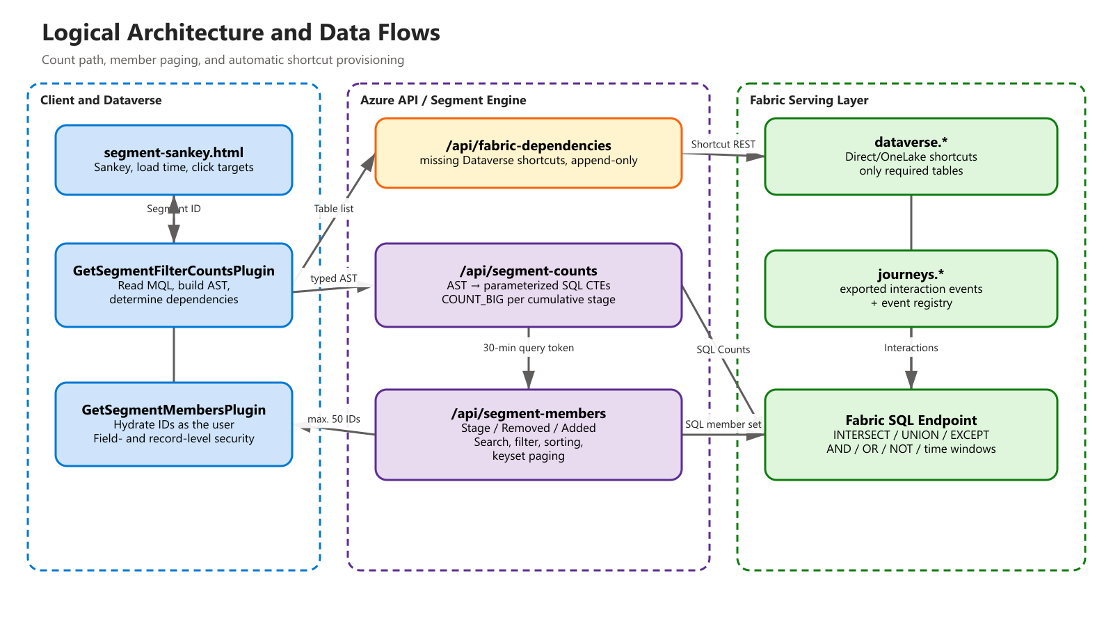
Figure 4: Count path, member paging, and shortcut provisioning

3.1 Client Components
Component | Task
cis_SegmentSankeyLauncher.js | Opens and navigates the side pane; synchronizes the active segment definition
segment-sankey.html | Visualizes counts, retention, inflows/outflows, and end-to-end load time
segment-members.html | Dialog for search, filter, sorting, paging, and record navigation

3.2 Dataverse Components
Component | Task
klth_GetSegmentFilterCounts | Global Custom API for the full draft evaluation
GetSegmentFilterCountsPlugin | Read and validate MQL, build dependencies and AST
klth_GetSegmentMembers | Global Custom API for a single members page
GetSegmentMembersPlugin | Hydrate Fabric IDs from Dataverse as the calling user
Environment Variables | Server-side API base URL and API key

3.3 Azure API Components
Endpoint | Responsibility
/api/health | Liveness of the ASP.NET Core application
/api/fabric-dependencies | Check required Dataverse shortcuts and add them append-only
/api/segment-counts | Compile the typed AST into SQL CTEs and execute stage counts
/api/segment-members | Execute the Stage/Removed/Added set with search, filter, sorting, and paging

3.4 Fabric Components
Component | Task
Serving Lakehouse | Shared, SQL-queryable serving layer
Schema dataverse.* | Direct/OneLake shortcuts to required Dataverse mirror tables
Schema journeys.* | Customer Insights Journeys events
SQL Endpoint | Execution of parameterized CTEs and set operations
Bootstrap Notebook | Daily synchronization of new event and Dataverse shortcuts
Registries | journeys._event_registry and dataverse._shortcut_registry

4. Data Architecture

4.1 Data Sources
The solution unifies two functional data sources in a Serving Lakehouse. Dataverse provides profiles, relationships, and consent tables. Customer Insights – Journeys exports interaction events into Delta structures, which become visible as tables in the journeys schema.
Source | Serving Schema | Content | Refresh
Dataverse Link to Fabric / Mirror | dataverse.* | Contact, relationships, consent, and other required tables | Direct/OneLake shortcuts; on-demand
Customer Insights Journeys Export | journeys.* | Email, link, event, and other interactions | Export + daily bootstrap notebook

4.2 Automatic Dependency Resolution
Before each evaluation, the MQL dependency resolver analyzes profile filters, RELATE relationships, consent, interactions, nested segments, and static segment references. The resulting table list is passed to /api/fabric-dependencies.
- Missing Dataverse shortcuts are created serially and append-only.
- Existing shortcuts are never deleted or replaced by a full reconfiguration.
- A limit of 20 tables applies per call.
- Table and column names are validated via INFORMATION_SCHEMA.

4.3 SQL Compilation
The SQL compiler generates named CTEs for base profile, filter groups, relationships, interactions, and set operations. Identifiers are quoted from the validated catalog; all business values are parameterized.
- Supported logic: AND, OR, NOT, comparison operators, IN, CONTAINS, and Count().
- Time windows: UTCMINUTES, UTCHOURS, UTCDAYS, UTCWEEKS, UTCMONTHS, and UTCYEARS.
- Text semantics: CONTAINS is case-insensitive but accent-sensitive.
- Counts use COUNT_BIG(*); no download of full profile sets.

4.4 Stage Semantics
Mode | Set Meaning
stage | Cumulative members of the selected stage
removed | Previous stage EXCEPT selected stage
added | Selected stage EXCEPT previous stage
result | Final cumulative stage set

5. Count Evaluation Flow
- The side pane calls klth_GetSegmentFilterCounts with the segment definition ID.
- The plugin reads the current draft MQL and resolves referenced segments and relationship metadata.
- The dependency resolver determines required Dataverse tables and Journeys events.
- The Azure API provisions missing Dataverse shortcuts in the Serving Lakehouse.
- The plugin passes the validated typed AST to /api/segment-counts.
- The catalog service resolves allowed tables and columns via INFORMATION_SCHEMA.
- The compiler generates parameterized SQL CTEs for all cumulative stages.
- Fabric executes the query and returns only COUNT_BIG per stage.
- The API also issues an encrypted query token valid for 30 minutes.
- The plugin returns ordered stages, the evaluation token, and a timestamp to the pane.
- The pane draws Sankey flows and calculates losses, additions, and retention.

5.1 Example of a Verified Result
Stage | Semantics | Count
0 | Active contacts | 640
1 | Has email address | 625
2 | Profile intersection | 407
3 | Behavioral intersection | 2
4 | Union with static segment | 75

6. Members View Flow
- The count result is available in the pane with an evaluation token and explicit stage order.
- The browser stores the dialog context under a random key in window.top; the token never appears in the URL.
- The dialog calls klth_GetSegmentMembers with stage, mode, search, filter, sorting, and an optional continuation token.
- The plugin translates evaluationToken into queryToken and calls /api/segment-members server-side.
- Fabric verifies the token and context binding, computes the requested set, and reads TOP(pageSize + 1).
- Fabric returns at most 50 profile IDs plus a new continuation token.
- The Dataverse plugin reads the contacts using CreateOrganizationService(context.UserId).
- Inaccessible records and secured fields are removed by Dataverse.
- The browser receives only the visible fields and can open the contact record.

6.1 Paging Approach
- Maximum of 50 IDs or visible contacts per page.
- Keyset paging instead of OFFSET for stable runtime with large data volumes.
- Sort key: null rank, sort value, and profile ID.
- The continuation token binds the query hash, stage, mode, filter, sorting, and last key.

6.2 Supported Fields
Field | Search | Filter | Sort | Display
fullname | Yes | Yes | Yes | Yes
firstname | Yes | Yes | Yes | Yes
lastname | Yes | Yes | Yes | Yes
emailaddress1 | Yes | Yes | Yes | Yes
telephone1 | Yes | Yes | Yes | Yes
address1_city | Yes | Yes | Yes | Yes
companyname | No | No | No | Yes; after Dataverse hydration

7. Security Architecture
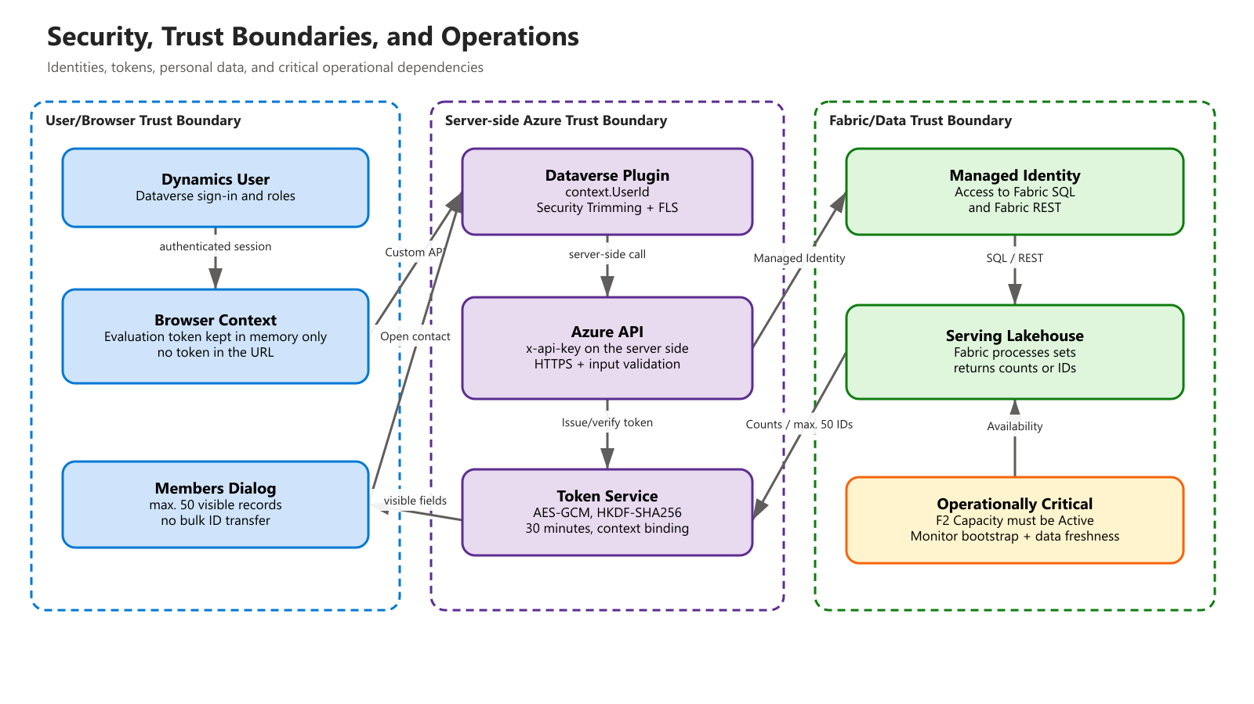
Figure 5: Trust boundaries, identities, tokens, and operational dependencies

7.1 Identities and Authentication
Connection | Authentication
Browser → Dataverse | Current Dynamics 365 user session
Dataverse Plugin → Azure API | Server-side x-api-key from environment variable
Azure API → Fabric SQL / REST | System Assigned Managed Identity
Plugin → Dataverse contacts | context.UserId of the calling user

7.2 Data Protection and Permissions
- The count path never transmits contact IDs or personal fields.
- The Fabric members response contains only profile IDs.
- Name, email, phone, city, and company are added only in Dataverse.
- Dataverse record-level security and field-level security remain active.
- The browser receives at most 50 visible records per page.
- The API key is never exposed to JavaScript or in URLs.

7.3 Token Security
Property | Implementation
Encryption | AES-GCM with a random 12-byte nonce
Key derivation | HKDF-SHA256 from the server-side API key
Key separation | Separate derived keys for query and continuation tokens
Validity | 30 minutes
Tamper protection | Authenticated encryption and canonical Base64URL verification
Context binding | Query hash, stage, mode, search/filter, sorting, and last key

7.4 Security Risks and Mitigations
Risk | Mitigation
SQL injection | Catalog allow-listing, identifier quoting, and parameterized values
Token tampering | AES-GCM, context binding, expiry, and canonical encoding
Data exfiltration | Counts-only on the main path; max. 50 IDs; Dataverse hydration
Permission bypass | Query as context.UserId; no server-side full-access hydration
Secret leakage | API key only in Dataverse environment variable and app configuration

8. Physical Deployment

8.1 Dataverse
Property | Value
Organization | orga7223214.crm4.dynamics.com
Organization ID | 8b3bfb3a-7c11-f111-afc0-000d3ab2a775
Plugin Assembly | CustomerInsightsSegmentSankey, Version 0.0.15.0
Plugin Assembly ID | 458b9dc7-1d9a-f111-b8dc-7ced8d762587
Custom APIs | klth_GetSegmentFilterCounts; klth_GetSegmentMembers
Publisher Prefix | klth

8.2 Azure
Property | Value
Resource Group | D365DemoTSCE21021953CXCS
Web App | klth-segment-sankey-8b3bfb3a
Runtime | .NET 8 on Linux
Identity | System Assigned Managed Identity
Current Plan | F1 Free, 1 worker
Always On | Currently disabled; not available on F1
TLS | TLS 1.2 minimum
API Base | https://klth-segment-sankey-8b3bfb3a.azurewebsites.net/api/
Operational recommendation: For production-like operation, use at least B1 and enable Always On. The currently observed as-built state is F1 with Always On disabled, which deviates from the recommended configuration.

8.3 Microsoft Fabric
Property | Value
Workspace ID | 904ef357-46bc-48b6-ac20-4d26032b0e32
Serving Lakehouse ID | 7b68f4e1-2300-4cf9-bf15-2d886efa95e4
SQL Endpoint ID | 7b996864-cda7-4817-a75f-dd80d52d5777
Capacity | d365demotsce21021953cxcs, F2, West Europe
Capacity ID | c42ec01a-0d0d-48d4-961c-c93dfbe3312e
Current Status | Active as of August 20, 2026

9. Operations and Monitoring

9.1 Availability Dependencies
Dependency | Impact on Failure | Check
Azure Web App | No count or member queries | /api/health
Fabric Capacity | Lakehouse, shortcuts, and SQL unreachable | Capacity state must be Active
Fabric SQL Endpoint | No segment evaluation | Test query / count endpoint
Dataverse Custom APIs | Pane cannot call the backend | Web API smoke test
Bootstrap Notebook | New events/tables missing | Notebook run + registries
Journeys Export | Behavioral data stale | Data freshness of the journeys tables

9.2 Typical Incident: Capacity Inactive
On August 20, 2026, the message "The existing Fabric shortcuts could not be read" occurred. The Fabric REST API returned EntityNotFound with the detail that capacity c42ec01a-0d0d-48d4-961c-c93dfbe3312e was unavailable. The capacity state was Inactive. After resuming the F2 capacity, the dependency check, SQL evaluation, and browser preview worked again.
- Check the capacity state in Fabric or via the Fabric REST API.
- If Inactive: resume the existing Azure Fabric Capacity.
- Test /api/fabric-dependencies with contact.
- Test klth_GetSegmentFilterCounts with a known segment.
- Refresh the pane and verify counts and load time.

9.3 Logging and Error Principles
- Plugin tracing logs endpoint calls and business errors.
- The Azure API returns machine-readable error codes, user-facing text, and technical details.
- Unsupported fields/events are reported explicitly.
- No silent fallback to sample values in Dataverse.
- A transient SQL timeout -2 is retried once during the initial catalog build.

9.4 Performance
Measurement Point | Observed Range
Web App warm | 0.15–0.49 s
Dependency check | 0.72–1.94 s
First Fabric SQL call | approx. 5.55 s
Warm Fabric SQL calls | 0.31–0.41 s
Full Sankey evaluation | 3.74–7.15 s; depends on Fabric warm state
The largest remaining latency comes from Fabric SQL cold starts and metadata/catalog work. A larger App Service plan with Always On only prevents Web App cold starts; Fabric Capacity has a separate availability and warm-start characteristic.

10. Scaling and Limits

10.1 Scaling Characteristics
- Counts transmit only aggregated values, independent of profile count.
- Set operations run close to the database in Fabric instead of in the Dataverse plugin.
- Keyset paging avoids OFFSET costs on deep pages.
- Catalog and connection pooling reduce warm follow-up costs.
- Automatic shortcuts avoid manual table maintenance per segment.

10.2 Known Limits
Limit | Assessment / Mitigation
Very large static segments | IDs are currently passed as a JSON parameter; use a persisted Fabric membership table in the future
Data freshness | Depends on Journeys export, Dataverse mirror, and bootstrap
Capacity paused/inactive | Entire Fabric evaluation unavailable; monitoring required
Company sorting | Not supported, since companyname only comes from Dataverse after Fabric paging
App Service F1 | No Always On; switch to B1 or higher for production operation
Editor-internal preview endpoint | Deliberately not used, since it is unsupported and unsuitable for partial filters

10.3 Target State for High Load
- Size Fabric Capacity according to data volume and concurrency.
- Keep the catalog and SQL connections warm; Azure App Service at least B1.
- Materialize static memberships above a defined size in a Fabric table.
- Monitor capacity status, SQL latency, bootstrap success, and data freshness.
- Perform load tests with realistic segments, interactions, and concurrent dialogs.

11. Quality Assurance and Verified State
Check | Result
Fabric unit tests | 53/53 passed
Plugin build | Release build succeeded, 0 warnings and 0 errors
Strong name | Token 7723c9b9c78b183b, consistent with the registered assembly
Live counts | 640 → 625 → 407 → 2 → 75
Members page | 50 records, continuation token, and page 2 without overlap
Search/filter | Live, expected single match in each case
Sorting | Verified live via email
Dialogs | Stage, Removed, Added, and Result opened live
Contact navigation | entityName contact, specific ID, openInNewWindow true
Capacity recovery | Correct counts and browser display again after resume

11.1 Acceptance Criteria
- All stages are ordered and match the full cumulative segment logic.
- Added/removed sets correspond to the directed EXCEPT operations.
- The browser shows no PII from Fabric and no tokens in URLs.
- Dataverse permissions determine the actually visible member rows.
- Error states show an understandable message instead of an apparent zero value.

12. Deployment and Change Process

12.1 Azure API
- Build the FabricApi sources and run the 53 tests.
- Publish the API and check /api/health.
- Run direct tests for /api/fabric-dependencies, /api/segment-counts, and /api/segment-members.
- Verify managed identity permissions and Fabric Capacity.

12.2 Dataverse Plugin and Custom APIs
- Increment the assembly version and build with the existing strong-name key.
- Update the assembly content; the fully qualified name must remain unchanged.
- Register new plugin types and Custom API parameters.
- Publish customizations.
- Test the count and members Custom APIs via the Dataverse Web API.

12.3 Web Resources
- Update segment-sankey.html, segment-members.html, and the launcher.
- Publish web resources and reload the Dynamics page to switch the cache version.
- Test the command, pane, all click targets, filters, paging, and contact navigation.

12.4 Rollback
- Re-upload the previous plugin assembly with the identical strong name.
- Restore and publish the previous web resource contents.
- Roll the Azure API back to the previous deployment.
- Do not delete existing Fabric shortcuts; provisioning is deliberately append-only.

13. API Contracts

13.1 Dataverse Count API
POST /api/data/v9.2/klth_GetSegmentFilterCounts
{ "klth_segmentid": "<Guid>" }

Response property: klth_resultjson (String)
Content: generatedAt, stages[{order,label,detail,count}], evaluationToken

13.2 Dataverse Members API
POST /api/data/v9.2/klth_GetSegmentMembers
{ "klth_requestjson": "{...}" }

Request: evaluationToken, stageOrder, viewMode, search, filter,
sortField, sortDirection, pageSize, continuationToken
Response: rows[], nextToken, hasMore, generatedAt

13.3 Azure API Protection
- All business endpoints expect x-api-key.
- The API base must be an absolute HTTPS URL.
- Payloads are validated for size, tables, fields, operators, and stage context.
- Managed identity authenticates the API to Fabric.

14. Source Code and Artifact Overview
Path | Purpose
CustomApi/GetSegmentFilterCountsPlugin.cs | Dataverse entry point for count evaluation
CustomApi/GetSegmentMembersPlugin.cs | Dataverse security boundary for the members view
CustomApi/FabricSegmentCountClient.cs | AST construction and Fabric count call
CustomApi/FabricDependencyProvisioningClient.cs | Automatic table provisioning
FabricApi/SegmentCountSqlCompiler.cs.txt | CTE and set compiler
FabricApi/FabricSegmentCountService.cs.txt | Count orchestration
FabricApi/FabricSegmentMemberService.cs.txt | Member paging
FabricApi/QueryTokenService.cs.txt | Encrypted query/continuation tokens
webresources/segment-sankey.html | Sankey side pane
webresources/segment-members.html | Members dialog
Fabric/bootstrap-events.py | Serving Lakehouse bootstrap
FabricApi.Tests/ | Compiler, token, and serialization tests

14.1 Included Diagram Sources
- documentation/diagrams/01-system-context.excalidraw
- documentation/diagrams/02-logical-architecture.excalidraw
- documentation/diagrams/03-security-operations.excalidraw
- documentation/diagrams/04-high-level-deployment.excalidraw
- documentation/diagrams/05-request-flow.excalidraw
The Excalidraw files are the editable sources. PNG and SVG versions are stored alongside them and can be used for presentations, wikis, and technical reviews.

15. Glossary
Term | Definition
AST | Abstract syntax tree of the validated segment logic
CTE | Common Table Expression; a named SQL subexpression
Draft MQL | Not-yet-published segment definition from the Journeys editor
FLS | Field-Level Security in Dataverse
Keyset Paging | Continuation via last sort value and primary key instead of OFFSET
Managed Identity | Identity managed by Azure with no secret in source code
OneLake Shortcut | Virtual reference to data without a physical copy
Serving Lakehouse | Shared, SQL-queryable layer for profiles and Journeys events
Stage | Cumulative result set after a segment filter or set operation

16. Open Operational Recommendations
- Scale the App Service back up to at least B1 and enable Always On.
- Set up an alert for a Fabric Capacity state other than Active.
- Monitor bootstrap failures and data freshness of the journeys/dataverse registries.
- Map very large static segments to a persisted Fabric membership table.
- Adopt technical runbooks for capacity resume, API rollback, and shortcut errors into operations.
- Update the document whenever APIs, security boundaries, Fabric schemas, or deployment IDs change.

