
MINISTRY OF EDUCATION AND RESEARCH
OF THE REPUBLIC OF MOLDOVA
Technical University of Moldova
Faculty of Computers, Informatics and Microelectronics
Department of Software Engineering and Automation
Sergiu Gherasim, FAF-242
Report
Laboratory Work No. 5
Operating Systems
Topic: The File System with Your Own Hands
Inodes, Links, Permissions and Disks on Linux
Checked by:
Patricia Reiţman, university assistant
Chişinău – 2026

Introduction
The purpose of this laboratory work is to check, on a real Linux system, every idea from the file system lecture: the directory tree and the file types, inodes standing behind the names, hard and symbolic links, permission bits, and finally the disks and pseudo file systems underneath. No programming is required; the work consists of commands, careful observation of their output, and short explanations.
All experiments were done on Debian 13 (running in a virtual machine on my laptop), as the normal user sergiu and not as root, because root ignores most permission checks and the experiments in Part 3 would give misleading results.
image 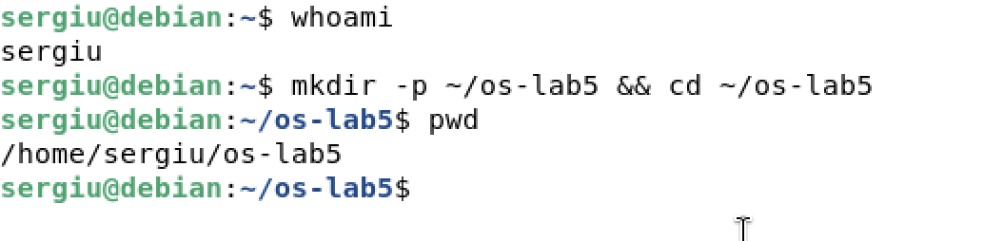
The working directory and the user

1 Short Theory

1.1 Files, Names and Inodes
In a Unix file system the name of a file and the file itself are two different objects. The file is described by an inode: a fixed-size record that stores the type, the owner, the permission bits, the size, the timestamps, the number of names (links) and the addresses of the data blocks. The inode does not store the name. Names live in directories, and a directory is just a table of pairs (name, inode number). Opening a path therefore means walking the tree from /, looking every component up in the table of its parent directory.

1.2 Hard and Symbolic Links
A hard link is a second entry in some directory that points to the same inode number. All hard links are equal; there is no “original”. The inode keeps a link counter and the kernel frees the inode and its blocks only when this counter reaches zero and no process keeps the file open. A symbolic link is a separate small file of type l whose content is a path. The kernel follows that path when the link is opened, so a symbolic link can point to another file system, to a directory, or to nothing at all (a dangling link).

1.3 Permissions
Every inode has an owner, a group and nine permission bits: read, write and execute for the owner (u), the group (g) and the others (o). The bits are often written in octal, one digit per class ($r=4$, $w=2$, $x=1$). On a directory, r allows listing the names, w allows creating and deleting entries, and x allows passing through the directory to reach the inodes behind the names. Three extra bits exist: setuid (s, the program runs with the identity of the file owner), setgid and the sticky bit (t, on a shared directory only the owner of a file may delete it). New files get the permissions requested by the program, minus the bits set in the process umask.

1.4 Disks and Pseudo File Systems
A disk is a block device that is split into partitions; a file system is created inside a partition and mounted onto a directory of the single tree. Not every mounted file system lives on a disk: /proc and /sys are generated by the kernel on the fly and expose processes, memory and hardware as ordinary-looking text files.

2 The Tree and the File Types
image 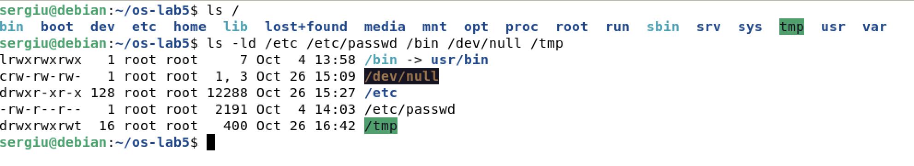
The root directory and the types of some important paths
image 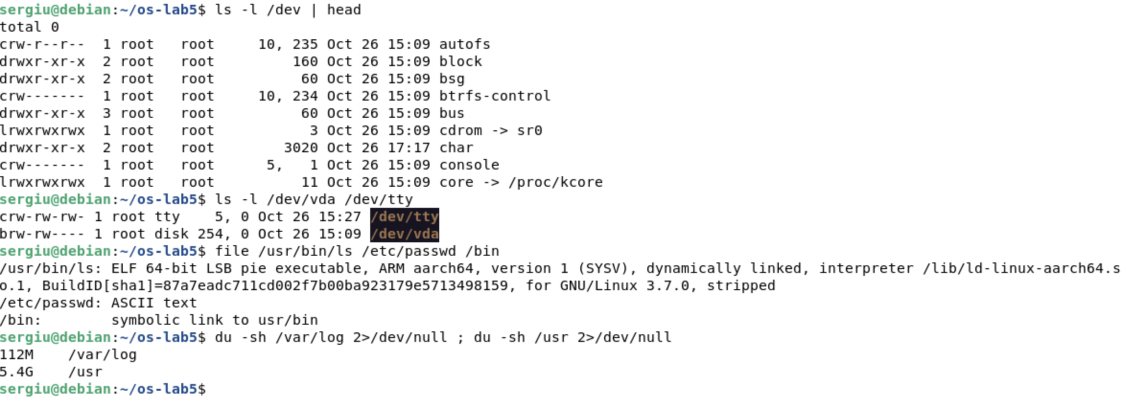
/dev, the file command and the disk usage

Observations
1. For each path in the second line, write its type from the first letter of ls -l.
File types read from the first column of ls -ld
Path | Letter | Type
/etc | d | directory
/etc/passwd | - | regular file
/bin | l | symbolic link
/dev/null | c | character device
/tmp | d | directory (with the sticky bit t)
2. What is /bin on your system: a directory or a link, and to where?
On Debian 13 /bin is not a directory but a symbolic link to usr/bin (a relative target, so it resolves to /usr/bin). This is the “merged /usr” layout: all programs live in /usr/bin and the old path is kept only for compatibility. The file command confirms it: /bin: symbolic link to usr/bin.
3. Find one character device and one block device in /dev.
Character device: /dev/null (or /dev/tty, /dev/console), marked with c; it is accessed byte by byte and has no fixed size. Block device: /dev/vda, the virtual disk, marked with b; it is accessed in blocks and can be partitioned and mounted. Instead of a size, ls shows the major, minor numbers, e.g. 1, 3 for /dev/null and 254, 0 for /dev/vda; the major number selects the driver in the kernel.
4. Which is bigger on your laptop, /var/log or /usr, and by roughly how much?
/usr is much bigger: about 5.4 GB against 112 MB for /var/log, i.e. roughly 49 times bigger. /usr holds all installed programs and libraries, while /var/log only holds text logs that are rotated and compressed regularly.

3 Inodes and Links

3.1 An Inode, and a Name that Is Not Part of It
image 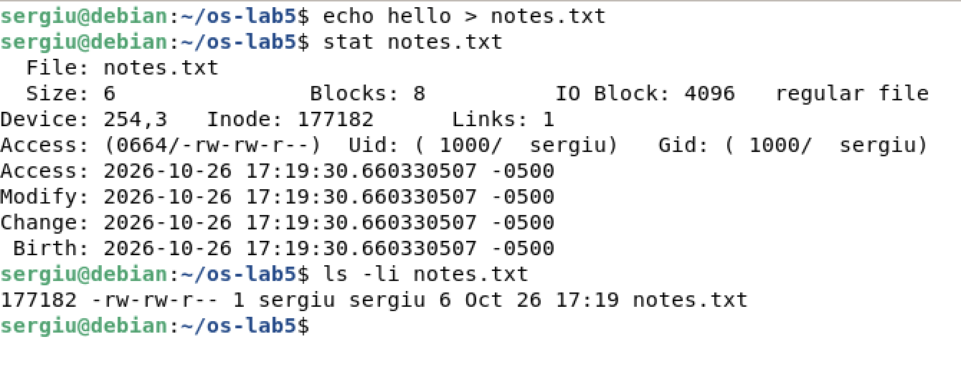
Creating a file and looking at its inode

3.2 Hard Link, then Remove the “Original”
image 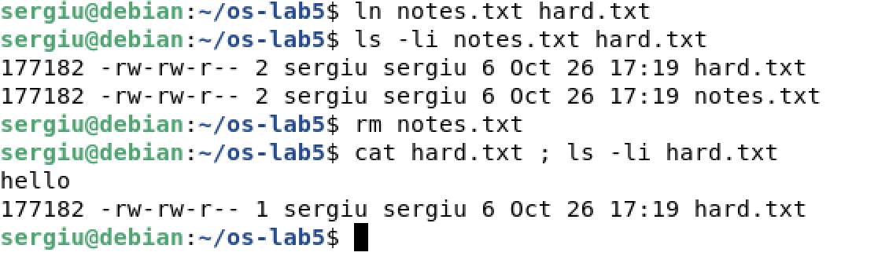
Two names for one inode

3.3 Symbolic Link, then Remove Its Target
image 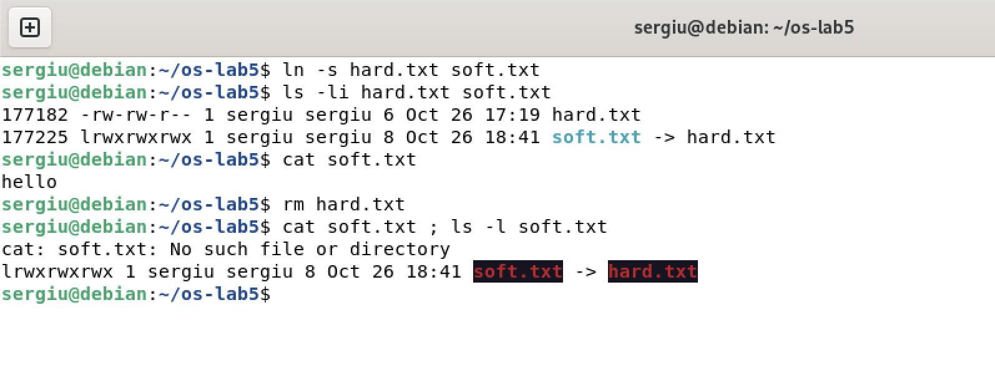
A symbolic link becomes dangling

3.4 Directories Have Links Too
Before running the commands I predicted 2 links for a new directory (its name in the parent and its own .) and 4 after creating two subdirectories (each new .. points back). The output confirmed the prediction:
image 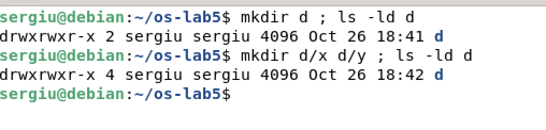
Link count of a directory

3.5 Size Is Not Space
image 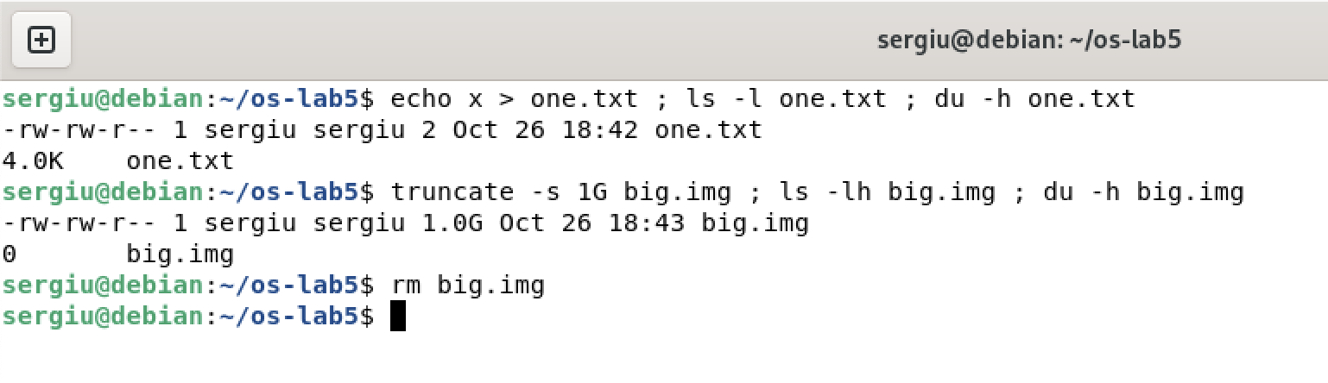
Apparent size versus allocated space

Observations
1. Which number in stat is the inode, and which tells how many names the file has?
The inode number is the field Inode: in the stat output (Figure 4); ls -li prints the same number in its first column. The number of names is Links: 1, which ls -l shows in the second column.
2. After rm notes.txt, why could you still read hard.txt? What does rm really remove?
notes.txt and hard.txt were two directory entries pointing to the same inode (Figure 5), so the link count was 2. rm calls unlink(): it removes only the name from the directory and decrements the link count. The count dropped to 1, so the inode and its data blocks stayed untouched and were still reachable through hard.txt. The data is freed only when the link count becomes 0 and no process has the file open.
3. Why did cat soft.txt fail at the end, although soft.txt still exists? How big is soft.txt and why exactly that size?
soft.txt has its own inode and only stores the path hard.txt. When cat opens it, the kernel follows that path, but after rm hard.txt no such name exists, so open fails with ENOENT – the link is dangling. Its size is 8 bytes, exactly the number of characters in the target string hard.txt (no terminating zero is stored).
4. A new directory has 2 links, and 4 after you create two subdirectories. Explain where each link comes from.
- link 1: the entry d in the parent directory ~/os-lab5;
- link 2: the entry . inside d, which points to d itself;
- links 3 and 4: the entries .. inside d/x and d/y, which point back to d.
In general a directory has $2+(\text{number of subdirectories})$ links.
5. Why does a 2-byte file use 4.0K, and a 1 GB file use 0?
ls -l shows the size stored in the inode, while du shows the space actually allocated. The file system allocates whole blocks; on ext4 a block is 4096 bytes, so even the 2-byte file x\n occupies one full 4 KiB block. truncate -s 1G only sets the size field and writes no data, so no block is allocated: the file is sparse, and reading it returns zeros generated by the kernel. Size and space are two different things.

4 Permissions

4.1 Files
image 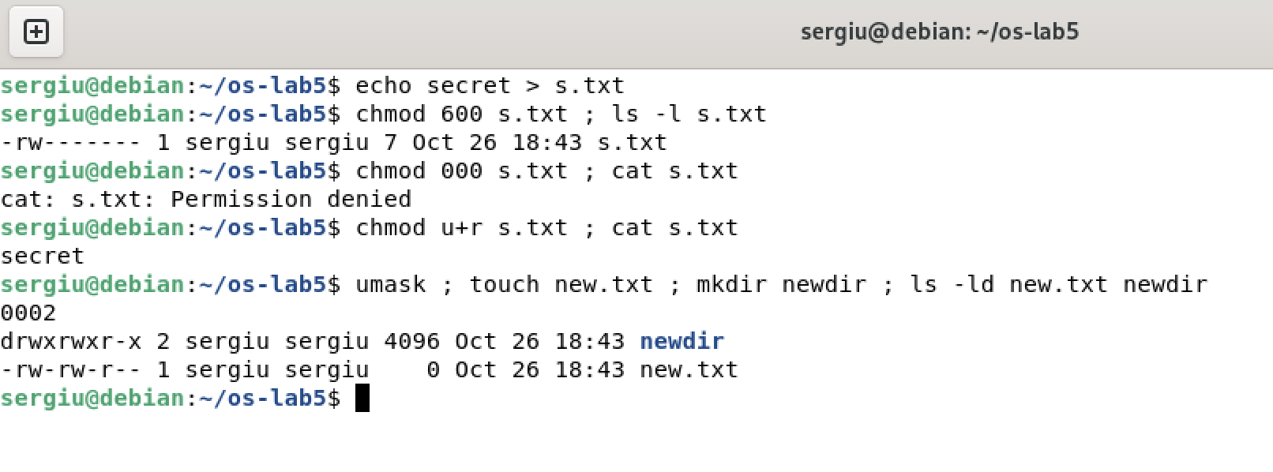
Permission bits on a regular file and the umask

4.2 Directories
Prediction: with only r I expected to see the names but not to be able to open the file; with only x the opposite. The results:
image 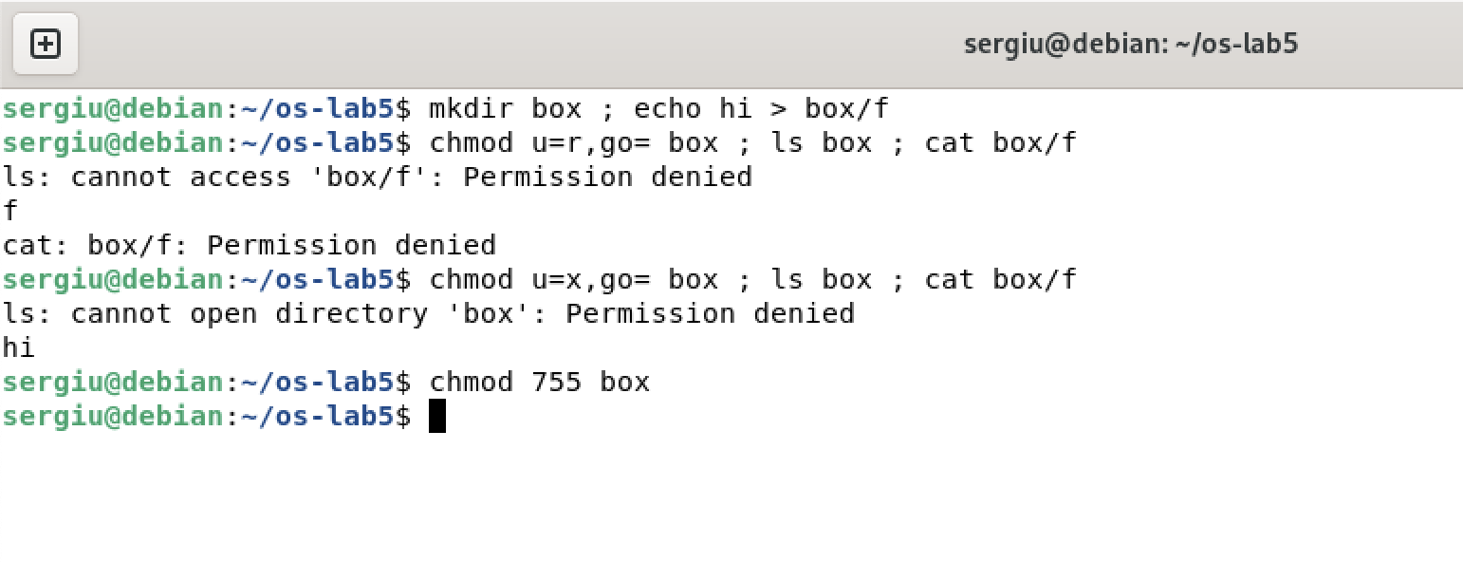
The box experiment

4.3 Special Bits and Other People’s Files
image 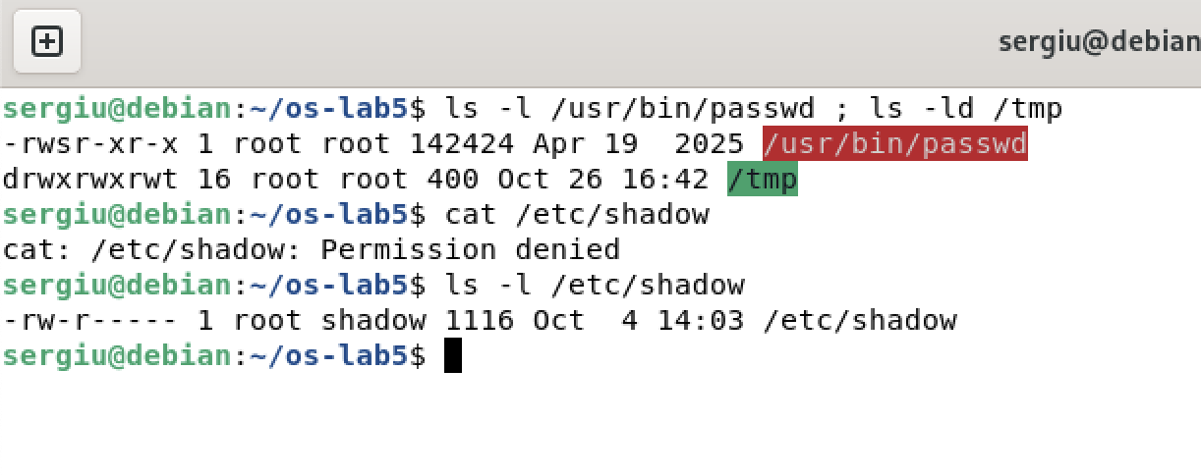
setuid, the sticky bit and a protected file

Observations
1. Write 600, 644, 755 and 700 as rwx strings, and give one real use for each.
Common permission modes
Octal | String | Typical use
600 | rw------- | private files: ~/.ssh/id_ed25519, a password file
644 | rw-r--r-- | ordinary documents and configs readable by all: /etc/passwd, report.md
755 | rwxr-xr-x | programs and public directories: /usr/bin/ls, /usr
700 | rwx------ | private directories or scripts: ~/.ssh, a personal script
2. With chmod 000 you own the file but cannot read it. Why does ownership not help?
The kernel checks the permission bits of the class the process belongs to, and only that class. Because my UID equals the owner of the file, the owner bits are used, and they are ---; the group and other bits are not consulted at all. Ownership does not give access by itself, it gives the right to change the permissions: that is why chmod u+r worked without sudo and then cat succeeded. Only root bypasses these checks.
3. What is your umask, and how does it explain the permissions of new.txt and newdir?
The umask is 0002, so the w bit for others is removed from every new object. touch asks for 666 (files are not created executable), $666\&¬002=664$, which gives rw-rw-r--. mkdir asks for 777, $777\&¬002=775$, which gives rwxrwxr-x. Debian uses 002 because every user has a private group of their own.
4. Explain the box experiment: what does r allow on a directory, and what does x allow?
A directory is a table of names and inode numbers. r allows reading that table: with u=r, ls could print the name f, but it could not stat it (hence the error for box/f), and cat box/f failed because it is not allowed to go through the directory to the inode. x allows searching/traversing: with u=x, ls box failed because the list of names cannot be read, but cat box/f worked because I already knew the name and the kernel was allowed to look it up and reach its inode.
5. What do the s in /usr/bin/passwd and the t in /tmp mean, and why does passwd need the s?
The s in the owner execute position is the setuid bit: the program runs with the effective UID of the file owner (root), no matter who starts it. passwd needs it because it must write the new password hash into /etc/shadow, which is rw-r----- for root:shadow – as shown above, a normal user cannot even read it. The program itself makes sure that a user can only change their own password. The t in the others execute position of /tmp is the sticky bit: everyone may create files in /tmp (rwxrwxrwx), but only the owner of a file (or of the directory, or root) may delete or rename it, so users cannot remove each other’s temporary files.

5 Disks and the Kernel as Files
image 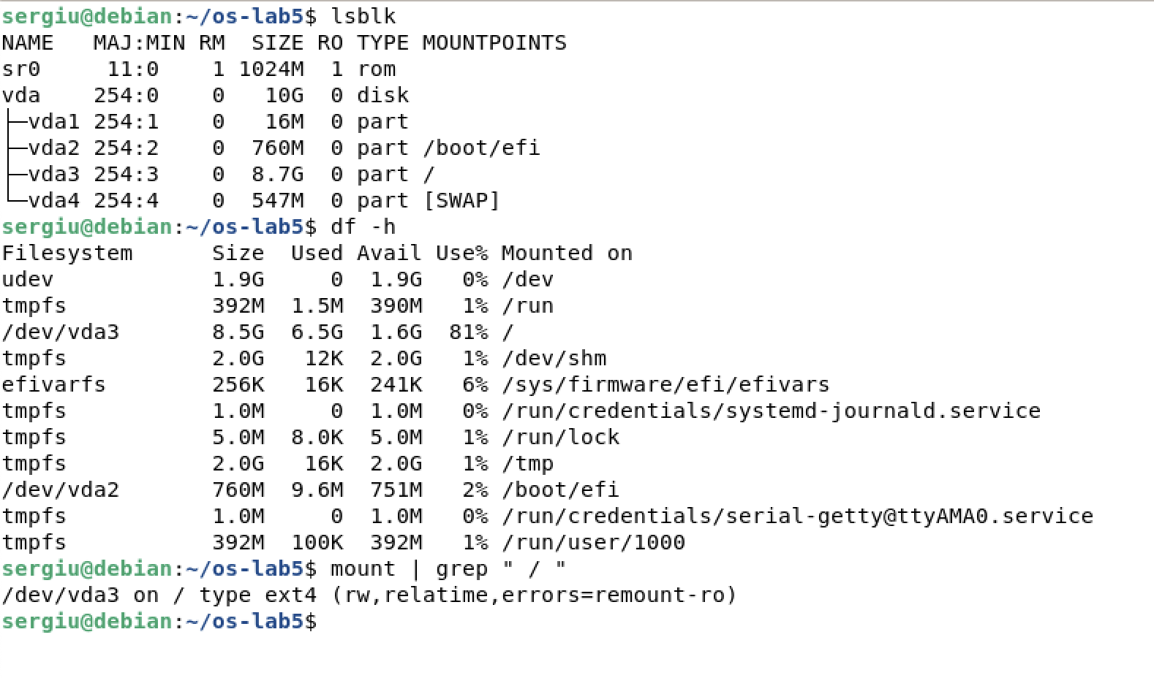
Block devices and mounted file systems
lsblk lists the block devices with their partitions and mount points, df -h shows the same file systems with their sizes and free space, and mount prints where each one is attached to the tree. Some of these file systems (tmpfs) live in RAM, not on a disk.
image 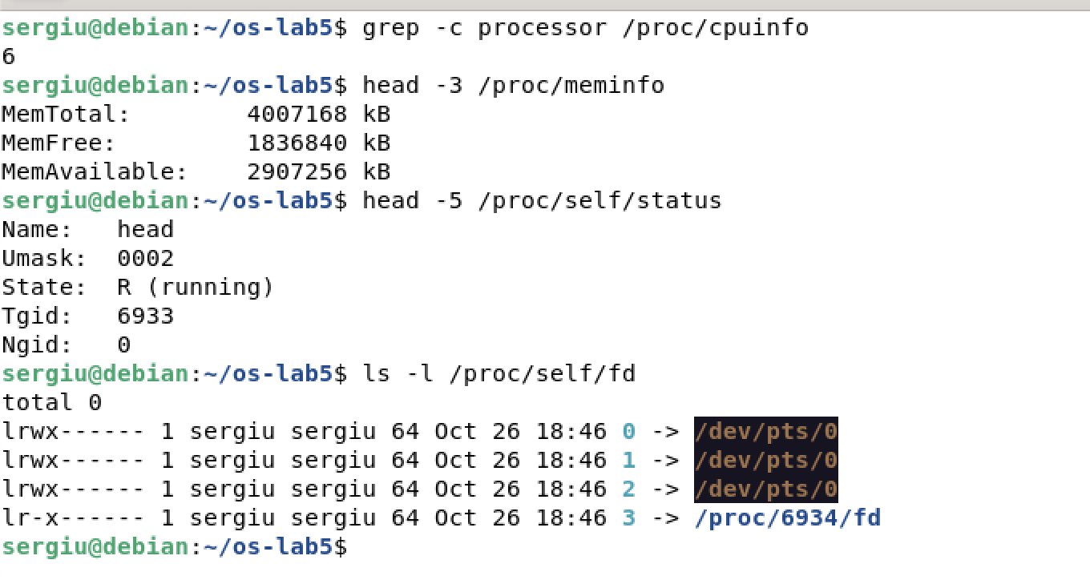
Processes, memory and file descriptors in /proc
/proc is not stored anywhere: the kernel builds these files when they are read. cpuinfo describes the processors, meminfo the memory, and /proc/self is a magic link to the process that is reading it at that moment.

Observations
1. Draw your disk: disk name, partitions, which one is mounted at / and with what file system type.
Layout of the disk, drawn from lsblk, df and mount
Partition | Size | File system | Mounted on
vda1 | 16 MB | — (no mount point) | not mounted
vda2 | 760 MB | vfat (EFI system) | /boot/efi
vda3 | 8.7 GB | ext4 | / (rw,relatime)
vda4 | 547 MB | swap | [SWAP]
The single disk is vda (major 254). The root file system / is the partition vda3, formatted as ext4; vda2 is the EFI partition on /boot/efi and vda4 is swap. sr0 is the (empty) virtual CD drive.
2. How full is your root file system?
/dev/vda3 has 8.5 GB, of which 6.5 GB are used and 1.6 GB are free: it is 81 % full. (Used + available is a bit less than the size, because ext4 reserves 5 % of the blocks for root.)
3. How many CPU cores and how much RAM does your laptop have, according to /proc?
/proc/cpuinfo lists 6 processors, so the system sees 6 cores. MemTotal is 4 007 168 kB, i.e. about 3.8 GiB (4 GB assigned to the machine, minus the memory the kernel reserves for itself).
4. /proc/self/status showed the name of a program. Which one, and why that one?
It showed Name: head. /proc/self is a magic link that always points to the directory of the process that is reading it. The file was opened by head, not by the shell, so self meant the head process. For the same reason ls -l /proc/self/fd showed the descriptors of ls itself, including the descriptor of the directory it was listing.

6 Stretch Tasks

6.1 (a) Magic Numbers
image 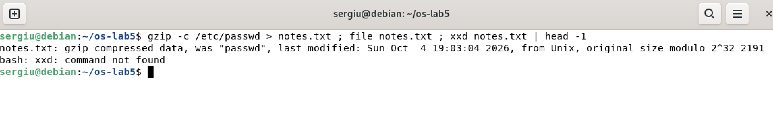
The type is in the content, not in the name
Although the file is called notes.txt, file recognises gzip data. It does not look at the extension: it compares the first bytes with a database of signatures (the hex dump in Figure 14 shows them). The first two bytes 1f 8b are the gzip magic number; 08 is the compression method (deflate) and the next 08 is the flag “original file name present”, which is why the name passwd is visible right after the header.

6.2 (c) Deleting a File That Is Still Open
image 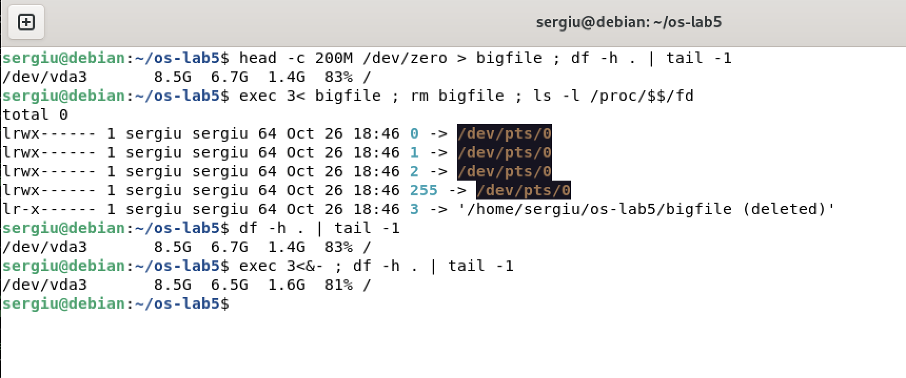
A deleted but still open file keeps its space
After rm the name is gone and the link count of the inode is 0, but the shell still holds descriptor 3 on it, so the link in /proc shows the old path with the suffix (deleted). The 200 MB are still counted as used. The space is really freed only when the last descriptor is closed with exec 3<&-: this is exactly the rule “link count = 0 and no open references”.

Conclusions
In this laboratory work I examined the Linux file system using only standard commands. I saw that the first letter of ls -l identifies the file type and that even /bin is, on a modern Debian, just a symbolic link. The experiments with links made the separation between names and inodes very concrete: rm only removes a directory entry, a hard link keeps the data alive, a symbolic link is a tiny file that contains a path and breaks when that path disappears, and directories collect one link from every subdirectory’s ... I also saw that the size of a file and the space it occupies are different things, thanks to block allocation and sparse files.
The permission experiments showed that the kernel applies exactly one class of bits, that ownership only grants the right to change permissions, that r and x mean “list” and “traverse” on a directory, and how the umask shapes every new file. The setuid bit of passwd and the sticky bit of /tmp explained how ordinary users can safely perform privileged or shared operations. Finally, lsblk, df and /proc showed how disks, partitions and even the kernel’s own state are presented as parts of the same single tree. These observations prepare the ground for Laboratory Work No. 6, where the same ideas are studied inside the source code of the xv6 file system.

