
MINISTRY OF EDUCATION AND RESEARCH
OF THE REPUBLIC OF MOLDOVA
Technical University of Moldova
Faculty of Computers, Informatics and Microelectronics
Department of Software Engineering and Automation
Sergiu Gherasim, FAF-242
Report
Laboratory Work No. 2
Operating Systems
Topic: Meet the OS You Will Build
Building, Using and Extending xv6 on RISC-V
Checked by:
Patricia Reiţman, university assistant
Chişinău – 2026

Introduction
In Laboratory Work No. 1 the operating system was met from the outside: a finished Linux system was observed through the terminal, and the programs could only be seen as black boxes that ask the kernel for help. In this laboratory work the view is reversed. The system itself is built from source, so both sides of every request become readable: the user program that asks and the kernel code that answers.
The system is xv6 for RISC-V, a modern re-implementation of Unix Version 6 written in about 9 000 lines of C. It is a complete, bootable Unix, but small enough to read the whole kernel. It is compiled with a RISC-V cross-compiler and started under QEMU, an emulator that pretends to be a RISC-V computer. The work has four steps: clone and build xv6, use it as a tiny Unix, read the source of a user program and of the system calls behind it, and finally add a new program, sleep, to the system and to its build.
I worked on the Linux virtual machine of the course, which already contains the toolchain. The submitted files are user/sleep.c and the modified Makefile; the answers to the two Observe boxes are in notes.md.
image 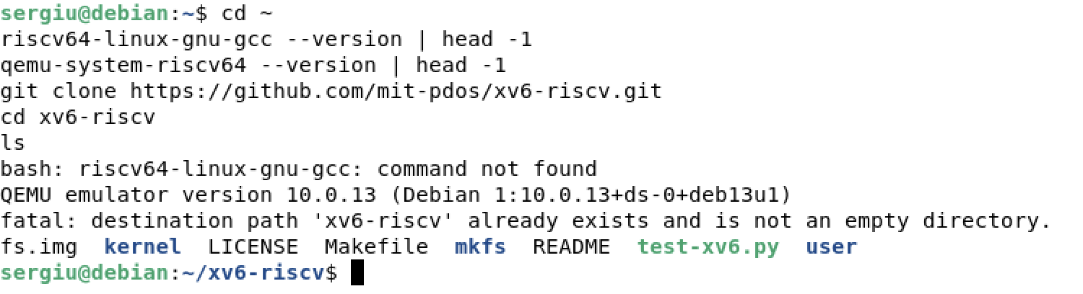
The RISC-V toolchain, QEMU and the cloned xv6 tree
The cross-compiler is a normal GCC, but it produces code for another processor: riscv64-linux-gnu-gcc runs on the Linux VM and writes RISC-V binaries, so the kernel can be built without a RISC-V computer. qemu-system-riscv64 is the emulator that will execute them. After git clone the tree contains the kernel in kernel/, the programs in user/, the Makefile that builds both, and the README.

1 Building and Booting xv6

1.1 The Build
make qemu does two things. First it builds kernel/kernel, the operating system itself, and every program listed in the UPROGS variable of the Makefile. Then a tool called mkfs packs those programs, together with README and the device files, into fs.img, a small disk image that xv6 will find as a file system. Finally make starts QEMU with the kernel, the disk image and no graphics window, so the machine appears as text in the terminal of the VM.
image 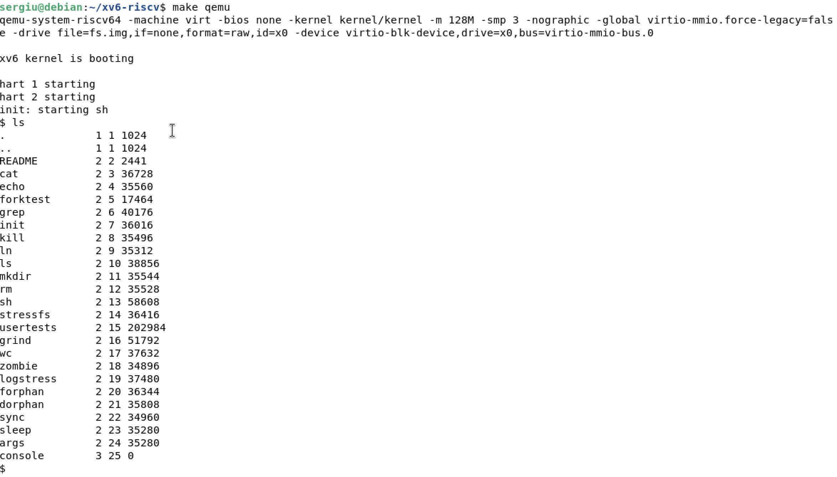
make qemu: end of the build, the xv6 boot banner and ls
The last lines of the build are the linking of the kernel. Then the emulated machine starts: xv6 prints xv6 kernel is booting, starts the first process, init, which prints init: starting sh and gives the shell. The prompt is $, and the ls that follows runs inside xv6, not on Linux: it lists the files of the xv6 disk image, which are the programs mkfs packed there.
To leave QEMU the sequence is Ctrl-A and then X. This is handled by QEMU itself, not by xv6; the small shell of xv6 has no exit command.

2 Using xv6 as a Unix
The programs of xv6 are the ancestors of the Linux commands used in Laboratory Work No. 1, with the same names and the same habits: they read from standard input, write to standard output and can be chained with a pipe.
image 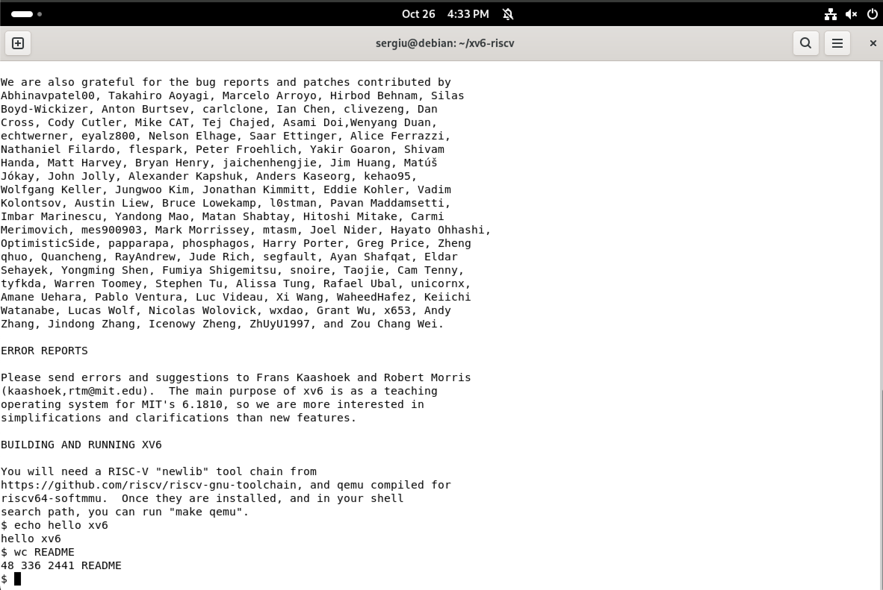
cat README, echo hello xv6 and wc README inside xv6
cat README prints the text of the file to the terminal: cat opens the file, copies it in blocks into a buffer and writes each block out. echo hello xv6 prints its arguments; the same text sent through a pipe, echo hello xv6 | wc, would instead be counted. wc README prints three numbers, the lines, the words and the bytes of the file, followed by its name.

2.1 Pipes
image 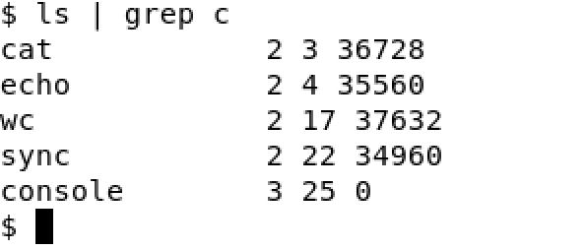
A pipe inside xv6: ls | grep c
A shell builds a pipe with the pipe system call, which returns two file descriptors: one writes, the other reads. Then it starts both programs with fork, and each child replaces itself with exec: the left program writes into the pipe, the right one reads from it. Here ls lists the programs of xv6 and grep c keeps only the names that contain the letter c. Neither program knows about the other; the kernel moves the bytes between them.
Some programs that xv6 ships with, all of them under user/.
Program | What it does
ls | lists the entries of a directory
cat | copies files to standard output
echo | prints its arguments
wc | counts lines, words and bytes
grep | prints the lines that match a pattern
usertests | runs the kernel test suite (optional)
1. List three programs xv6 ships with.
cat, echo and wc. The full list is the UPROGS variable of the Makefile, and the source of each one is a single small file in user/.
2. You just used a pipe (|) inside xv6. Which two OS features must exist for a pipe to work?
Processes and inter-process communication. A pipe only makes sense between two processes running at the same time, so the kernel must be able to create (fork), run and schedule them. And because the two processes have separate address spaces, they cannot share a buffer directly: the kernel must own a communication channel between them and copy the bytes through it.
3. In one sentence: how does the xv6 shell compare to the Linux shell from Lab 1?
It is much smaller: the same basic commands and pipes work, but there are far fewer of them (for example clear does not exist), there is no command history or completion, and it is noticeably slower, because every program is started with a fresh fork and exec on an emulated processor.

3 Reading the Source
The tree is split into two folders, and this split is the shape of every operating system. kernel/ is the system itself: it runs in supervisor mode, keeps the page table, schedules the processes, stores the files and handles the system calls. user/ holds ordinary programs that run on top of it. A program in user/ cannot touch the disk or the devices; it can only ask the kernel with a system call.

3.1 A User Program
image 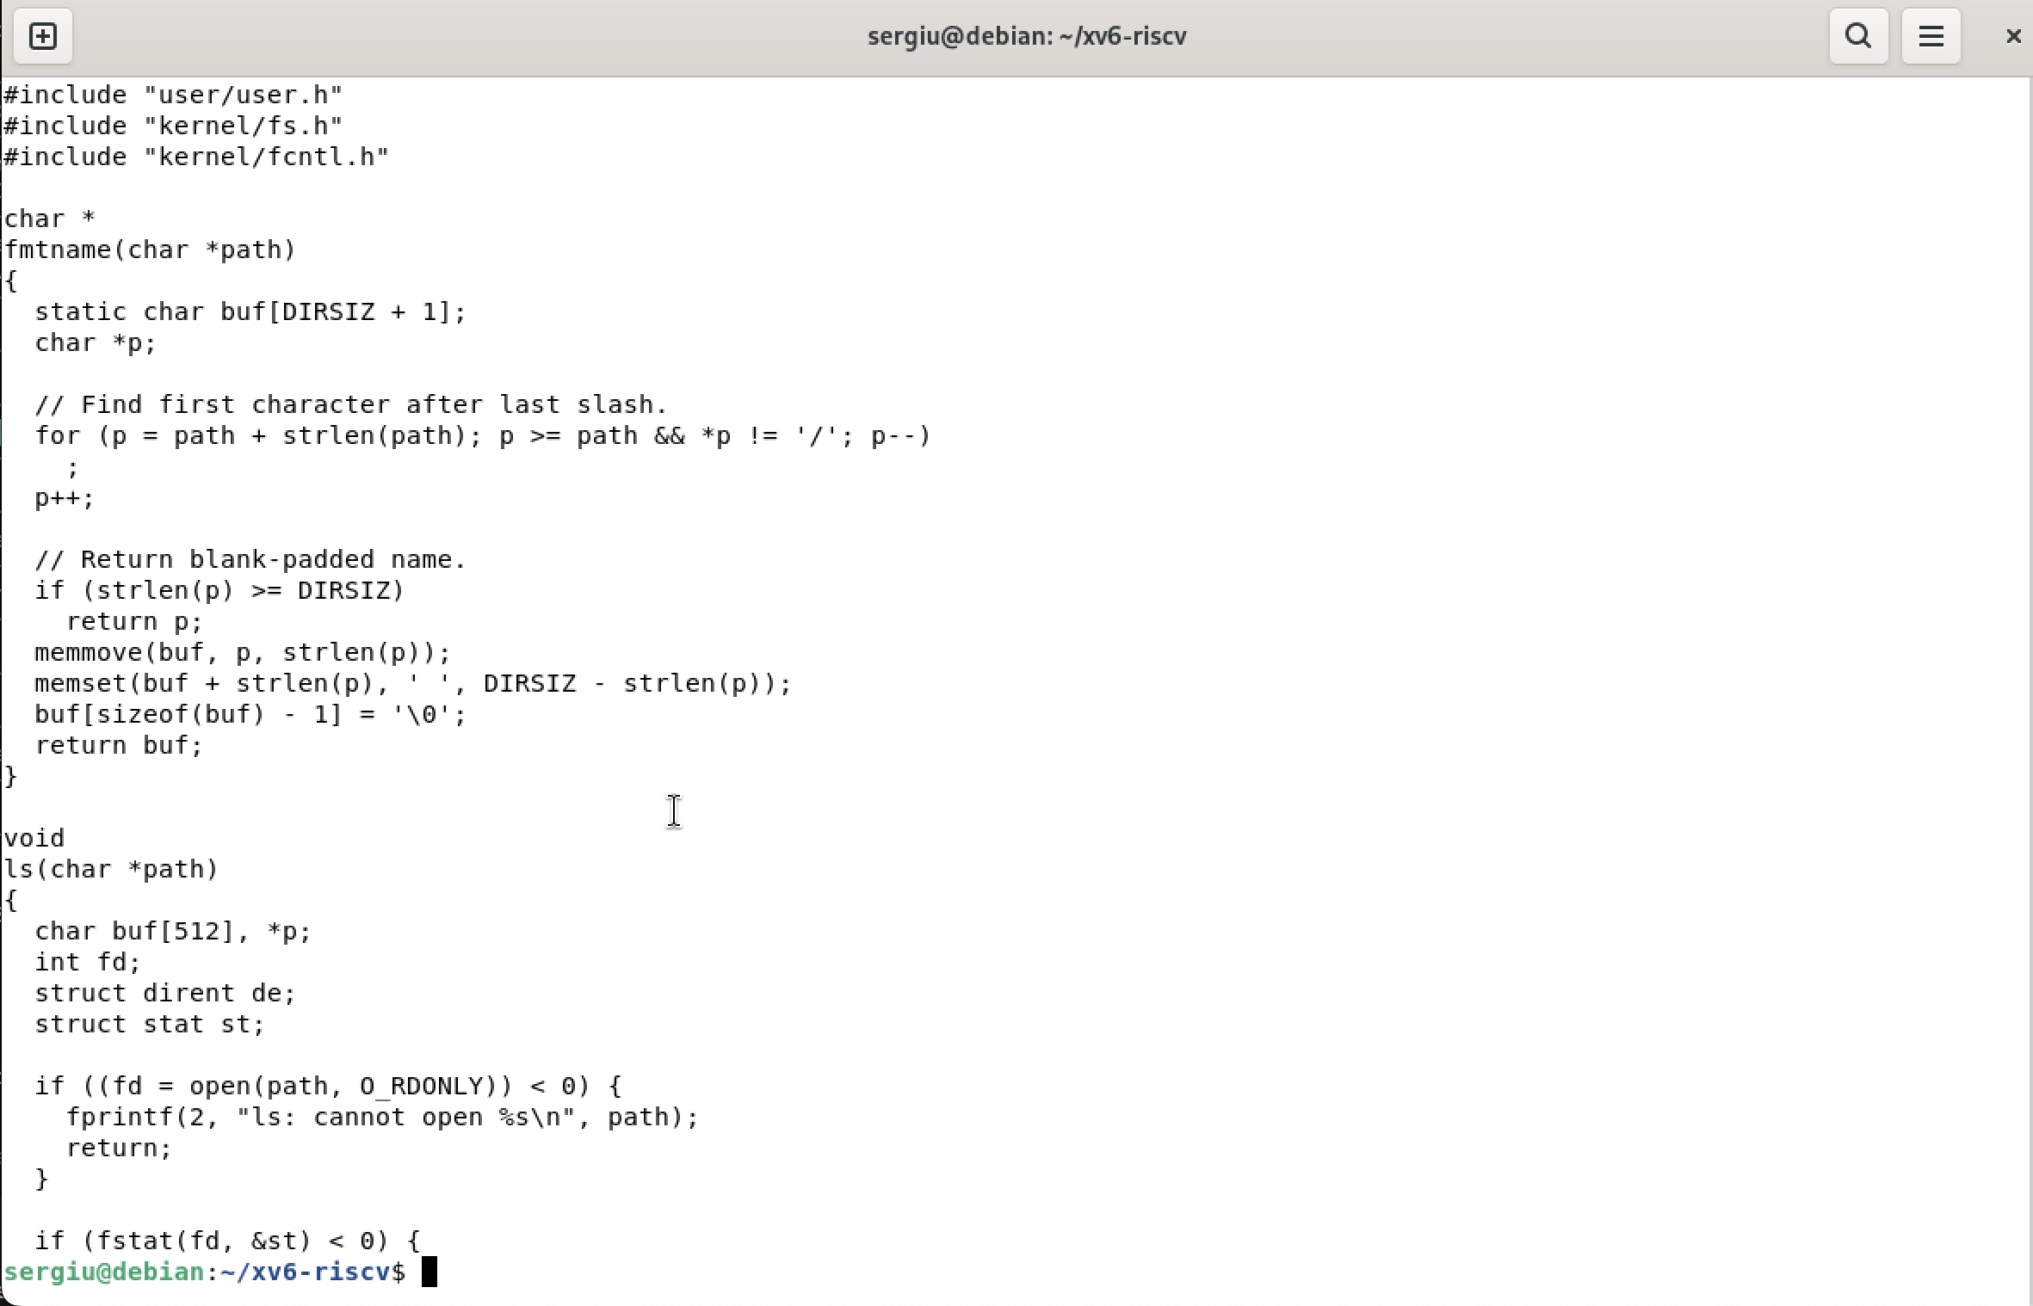
The first lines of user/ls.c
user/ls.c is a complete ls in about a hundred lines. The shape is the usual C program: main reads the arguments and calls ls for each path. ls then opens the path, reads the directory entries block by block and prints a name for every entry; for each one it calls stat to know the type and the size. The functions fmtname and ls are local, but open, read, close and fstat are not: they are declared in user/user.h and implemented in the kernel.
image 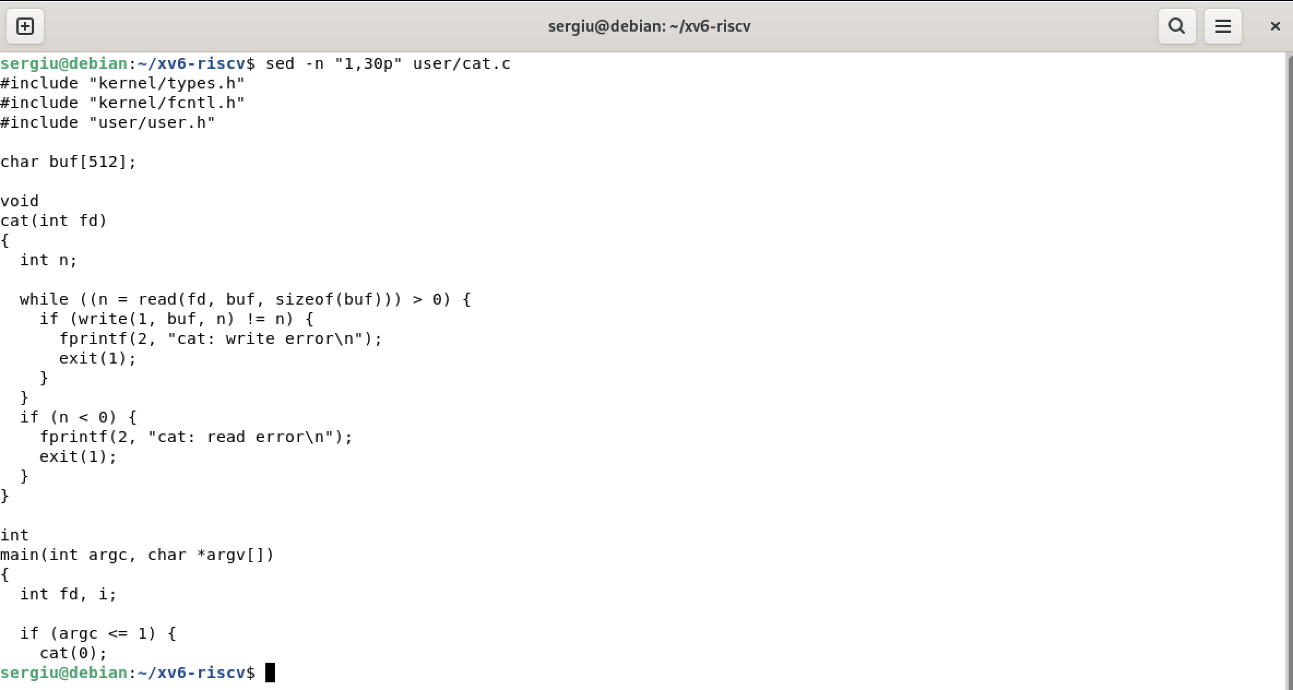
The first lines of user/cat.c
user/cat.c is even smaller. Its main calls cat for every file name, and cat does one thing in a loop: read a block into a buffer, write that buffer to descriptor 1, repeat until read returns 0. If a file cannot be opened, it prints an error on descriptor 2 and exits with status 1.

3.2 The System Call Interface
image 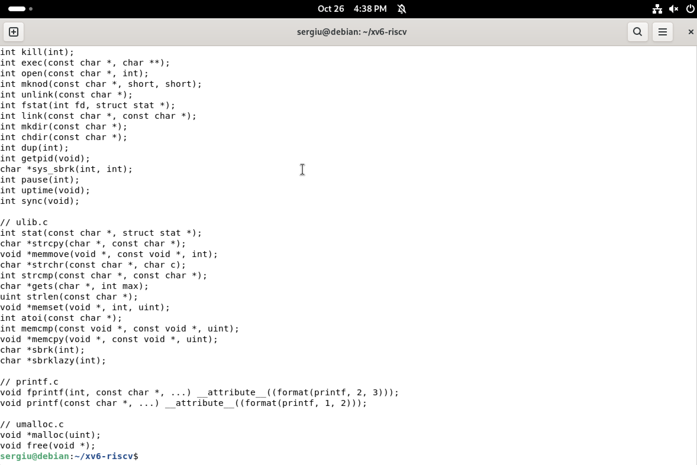
user/user.h, the list of system calls available to a program
user/user.h is the contract between the two folders. It declares a few library helpers (printf, atoi, malloc) and, below them, every system call a user program may make. These functions have no body in user/: their implementation is a few instructions of assembly (in user/usys.S) that put the call number in a register and execute the ecall instruction. That single instruction switches the processor into supervisor mode and jumps into the kernel, which does the real work and returns.
image 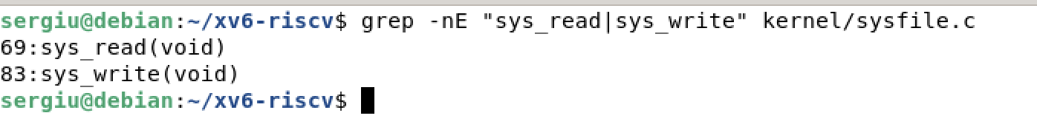
Locating sys_read and sys_write in the kernel
On the other side of ecall sits kernel/syscall.c, which reads the call number and dispatches to the right function through the table syscalls. The file system calls themselves are in kernel/sysfile.c: sys_read first fetches the arguments from the user process with argfd and argaddr, then calls fileread on the open file, which finally asks the inode to read the blocks.
1. Which system calls does user/cat.c use, and what does each one ask the kernel to do?
It uses open, read, write, close and exit.
The system calls of cat. Each one is a request that only the kernel may perform.
Call | Request to the kernel
open | find the named file, check the permissions and return a file descriptor
read | copy the next bytes of an open file into a buffer of the process
write | copy bytes from a buffer to an open file (here descriptor 1, the terminal)
close | release a file descriptor so the number may be used again
exit | terminate the process and give its status to the parent
2. In which kernel file, and on which line, is sys_read implemented?
In kernel/sysfile.c. The grep -n output shows sys_read at line 69, and the next function, sys_write, at line 83. The numbers are the ones of the current xv6-riscv master; they move when the file changes, which is why one searches for the name instead of remembering the line.
3. In one sentence: what is the difference between the code in kernel/ and the code in user/?
kernel/ is the operating system itself, which runs privileged, owns the hardware and cannot be removed without the machine stopping, while user/ holds the ordinary programs that run unprivileged on top of it and may be replaced or deleted freely.

4 Adding a User Program

4.1 Using the Sleep System Call
The kernel already implements the call that pauses a process: it takes a number of clock ticks, marks the calling process as sleeping and calls the scheduler, which runs something else until the timer wakes the process up. In the current xv6-riscv this system call is named pause; it was called sleep until August 2025, when it was renamed to avoid confusion with the program of the same name (older copies of the tree, such as the one used by the task sheet, still show sleep). What is missing is a program that uses it. The task asks for a program that takes exactly one argument and, if the argument is missing, prints a usage message instead of crashing.
#include "kernel/types.h"
#include "user/user.h"
int
main(int argc, char *argv[])
{
if(argc != 2){
fprintf(2, "usage: sleep <ticks>\n");
exit(1);
}
pause(atoi(argv[1])); // the sleep system call of current xv6
exit(0);
}
argc counts the words of the command line including the program name, so a correct call has argc == 2. argv[1] is the text typed after the name, and atoi turns it into a number, because the system call needs an integer. fprintf(2, ...) writes the usage message on descriptor 2, standard error, and exit(1) reports failure to the shell. A successful run ends with exit(0).
image 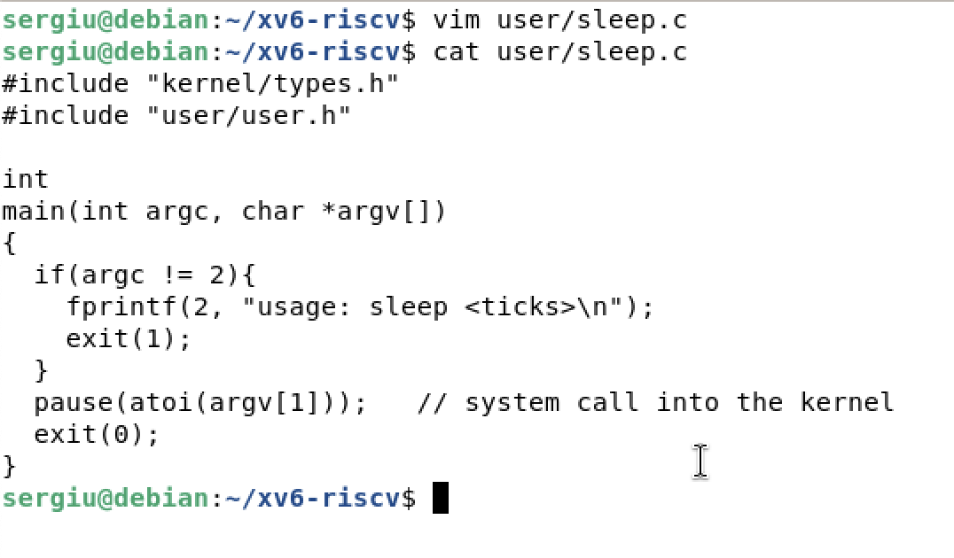
The new file user/sleep.c

4.2 Teaching the Build About It
A file in user/ is not compiled by itself. The Makefile holds the list UPROGS of the programs that go into fs.img, and only those are built. Each line is the name of the object with an underscore in front, followed by a backslash, and the indentation is a tab: the list is one long command continued from line to line, so a space instead of a tab breaks it.
image 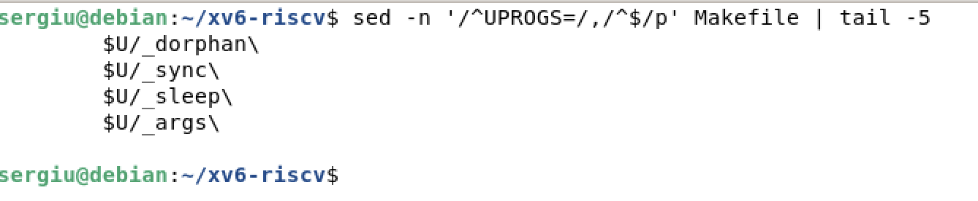
UPROGS in the Makefile with the new _sleep entry
UPROGS=\
$U/_cat\
$U/_echo\
...
$U/_wc\
$U/_zombie\
$U/_sleep\

4.3 Testing Inside xv6
image 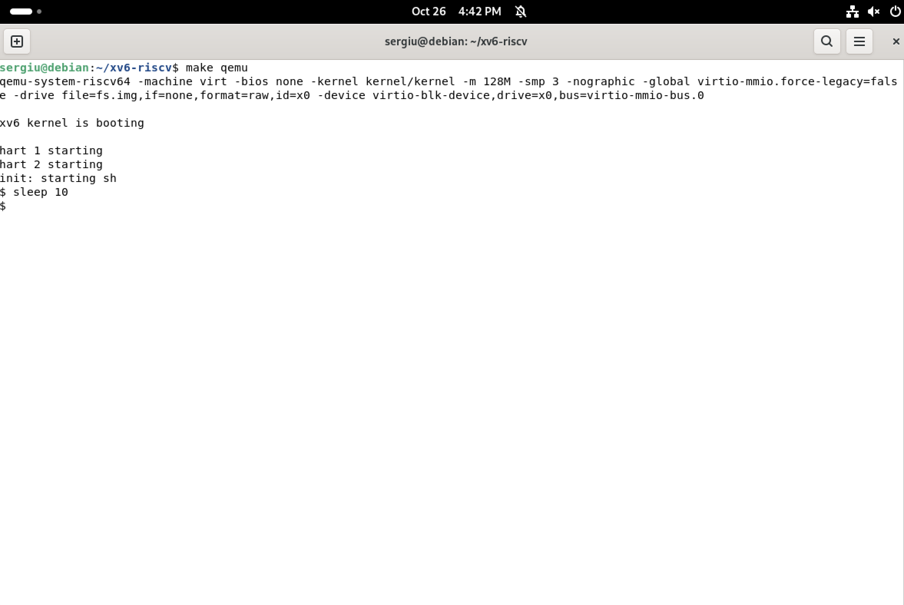
Rebuilding, then sleep 10 inside xv6
After make qemu the new program is part of the disk image, so it appears in ls like the others. sleep 10 returns to the prompt after ten clock ticks without printing anything: the process really did stop, and the shell was not running meanwhile, which shows that the scheduler had other work to do or the processor was idle. This is the first program of the course that calls into a kernel compiled on the same machine.
image 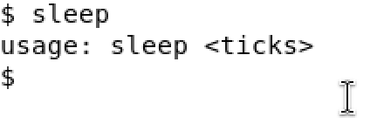
Calling sleep without an argument prints the usage message
With no argument, argc is 1 and the program takes the error branch: it prints usage: sleep <ticks> and exits with status 1. The shell simply shows the next prompt, since xv6 does not report exit statuses by default.

Conclusions
In this laboratory work I built an operating system from source and ran it on emulated hardware. Comparing it with Laboratory Work No. 1 makes the position of the kernel clear: on Linux I could only see programs from the outside, with ps and /proc, while in xv6 I could read both sides of the same request. The user program in user/ calls read or sleep, the assembly stub executes ecall, the kernel looks the call up in its table and runs sys_read or sys_pause; nothing in user/ can touch a disk or a device by itself.
The pipe experiment showed the two features that make this cooperation useful: processes, created and scheduled by the kernel, and inter-process communication, a channel owned by the kernel because the processes cannot share memory directly. Writing sleep closed the circle: a new file in user/, one tab-indented line in UPROGS, and the program becomes part of the system that is built and booted. The kernel and the programs are the same kind of C code, separated only by privilege and by the system call interface.

