
MINISTRY OF EDUCATION AND RESEARCH
OF THE REPUBLIC OF MOLDOVA
Technical University of Moldova
Faculty of Computers, Informatics and Microelectronics
Department of Software Engineering and Automation
Sergiu Gherasim, FAF-242
Report
Laboratory Work No. 1
Operating Systems
Topic: The OS as a Resource Manager
First Contact with the Operating System
Checked by:
Patricia Reiţman, university assistant
Chişinău – 2026

Introduction
In the lecture the operating system was presented as the manager that stands between programs and the hardware. The purpose of this laboratory work is to watch that manager at work from the terminal of a Linux virtual machine, through its four core jobs: managing files, processes, memory and devices. For each of them I ran the commands from the task, looked at the output and wrote down what it shows.
I used a Debian 13 virtual machine with 6 CPU cores and 4 GB of RAM, running in UTM on my laptop. First I created a working folder and asked the OS who I am, which kernel manages the machine and how long it has been running.
image 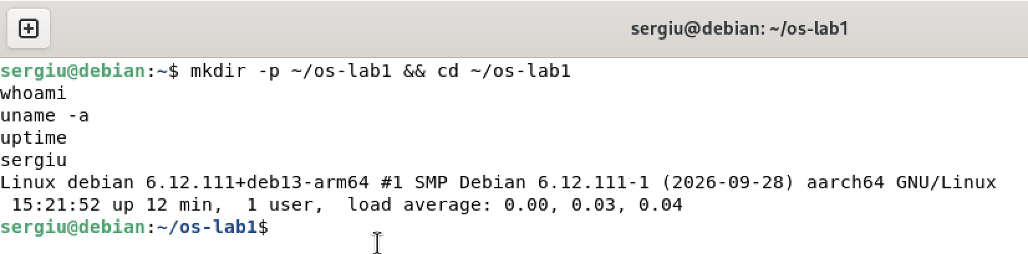
Working folder, whoami, uname -a and uptime
whoami prints my user name, sergiu. uname -a shows that the machine is managed by the Linux kernel 6.12 (6.12.111+deb13-arm64), built for the aarch64 architecture (64-bit ARM). uptime shows that the system had been running for 12 minutes with 1 user logged in, and load averages of almost 0 for the last 1, 5 and 15 minutes: the VM was idle.

1 Files and Directories

1.1 Navigating and Inspecting
image 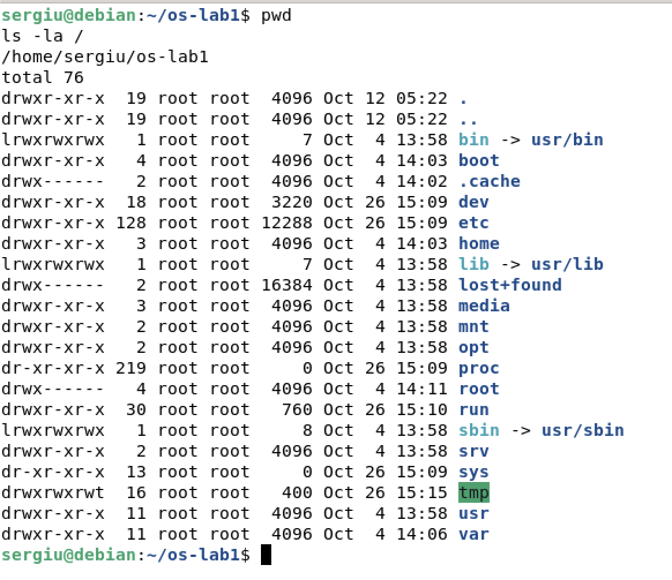
pwd and ls -la /
pwd prints the directory I am in. ls -la / lists the root of the whole tree. Every line starts with the type and permissions, followed by the number of links, the owner, the group, the size, the modification date and the name. Everything under / belongs to root. /proc and /sys have the size 0, because they are not on the disk but generated by the kernel, and /tmp has the permissions drwxrwxrwt, so everybody may create files there. On Debian, /bin, /lib and /sbin are symbolic links (type l) into /usr.
image 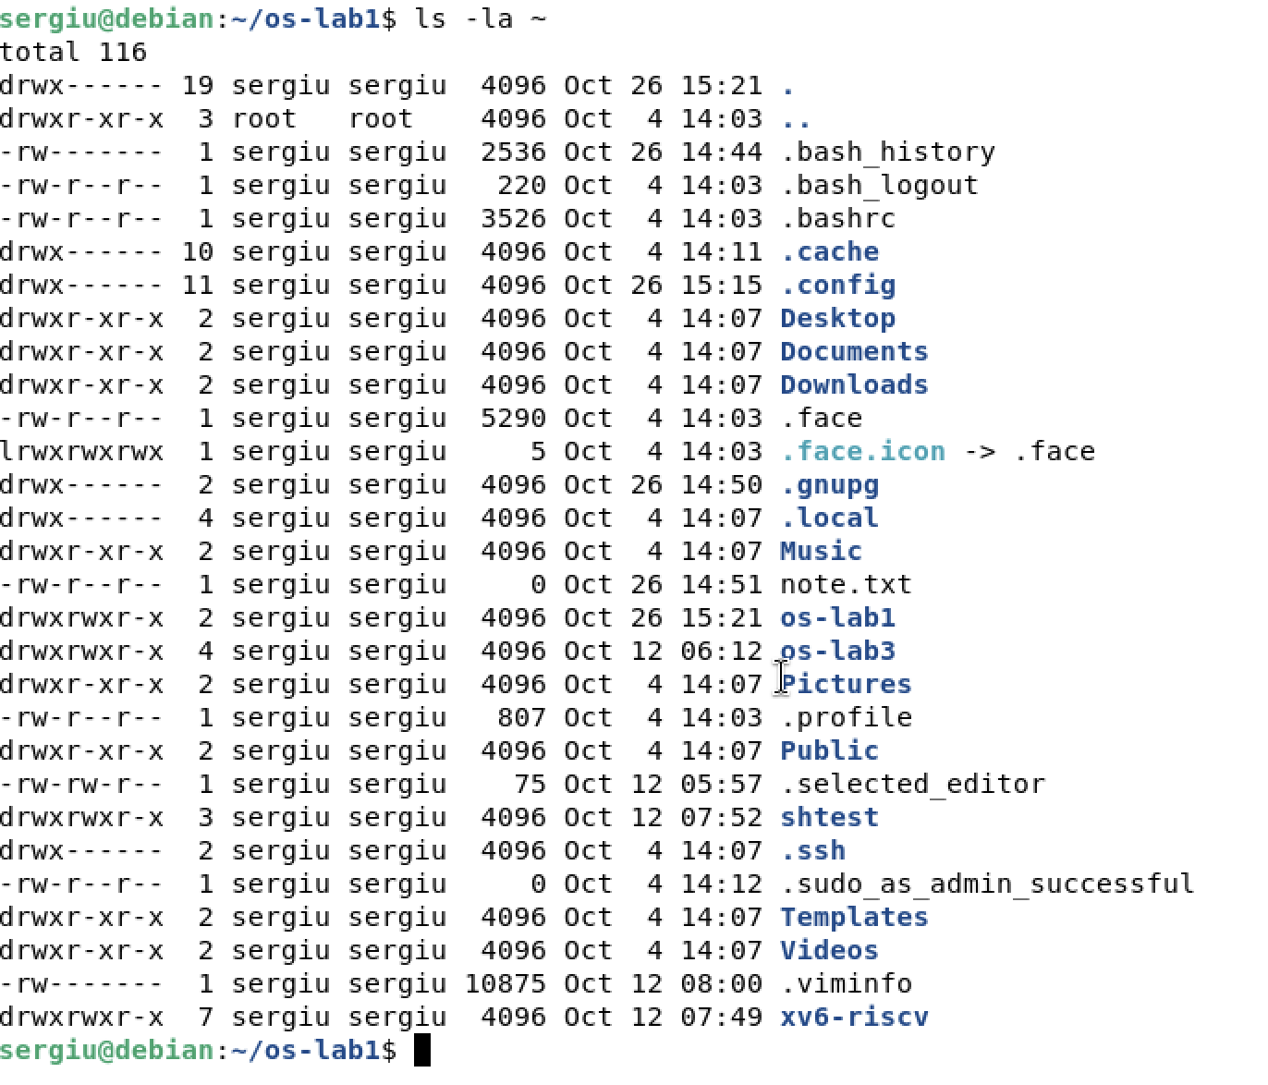
ls -la ~
The home directory belongs to me and is closed to other users (drwx------). Besides my os-lab1 folder it contains the usual folders of a desktop user (Desktop, Documents, Downloads) and hidden configuration files whose names start with a dot, such as .bashrc and .profile.
image 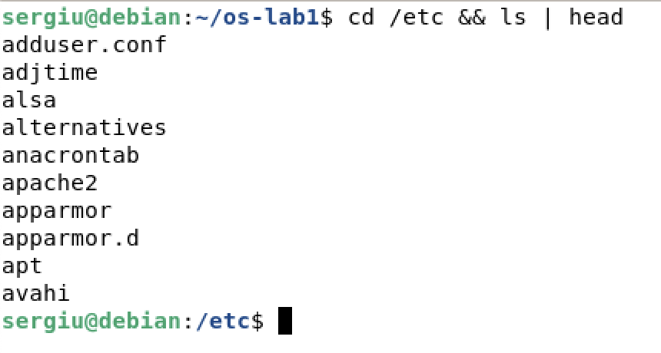
cd /etc and ls | head
/etc holds the configuration of the whole system: users, groups, network settings and the configuration of installed services.

1.2 Creating, Copying, Renaming and Removing
image 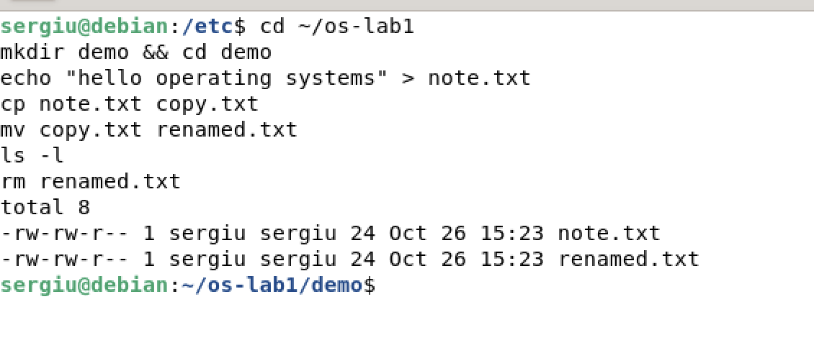
mkdir, echo, cp, mv, ls -l and rm in the demo folder
mkdir demo && cd demo creates a directory and enters it. echo "hello operating systems" > note.txt creates a file and writes the text into it through output redirection. cp makes a second, independent copy of the file, and mv renames the copy. There is no separate rename command: inside the same file system mv does not copy any data, it only changes the name stored in the directory. ls -l shows both files with the same size of 24 bytes (23 characters and a newline), and rm removes the renamed one without printing anything.

1.3 Ownership and Permissions
image 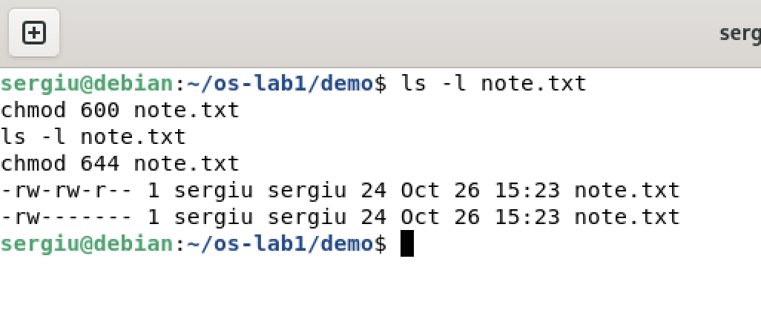
ls -l, chmod 600 and chmod 644 on note.txt
The new file was created as -rw-rw-r--: my umask is 0002, so the group also gets write access. Each digit of chmod is a sum of $r=4$, $w=2$ and $x=1$, for the owner, the group and others in this order. chmod 600 leaves read and write only to the owner, and chmod 644 sets -rw-r--r--: read and write for the owner, read only for the group and others.
1. Who owns the files you just created, and which group?
The owner is my user sergiu and the group is sergiu. On Debian every user gets a private group with the same name.
2. What do the ten characters at the start of ls -l mean for note.txt after chmod 600?
After chmod 600 they are -rw-------. The first character - means a regular file (a directory would have d). The next three, rw-, mean that the owner can read and write but not execute. The group (---) and all other users (---) have no rights at all.
3. Name two directories directly under / and what they hold.
/etc holds the system-wide configuration files. /home holds the home directories of the users, with their personal files.

2 Processes

2.1 Listing Processes
image 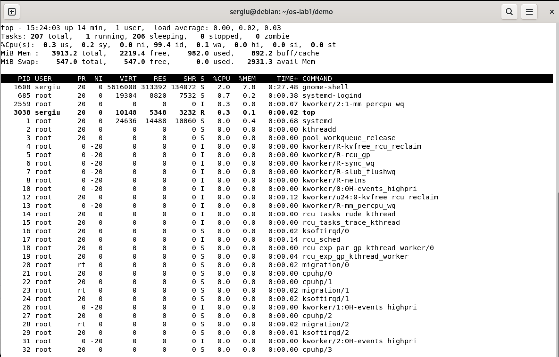
ps aux | head and ps aux | wc -l
ps aux lists every process with its owner, PID, CPU and memory usage, state, start time and command. The first line is PID 1. Most of the other processes at the top are kernel threads, whose names are shown in square brackets. wc -l counts 210 lines, one of which is the header.
image 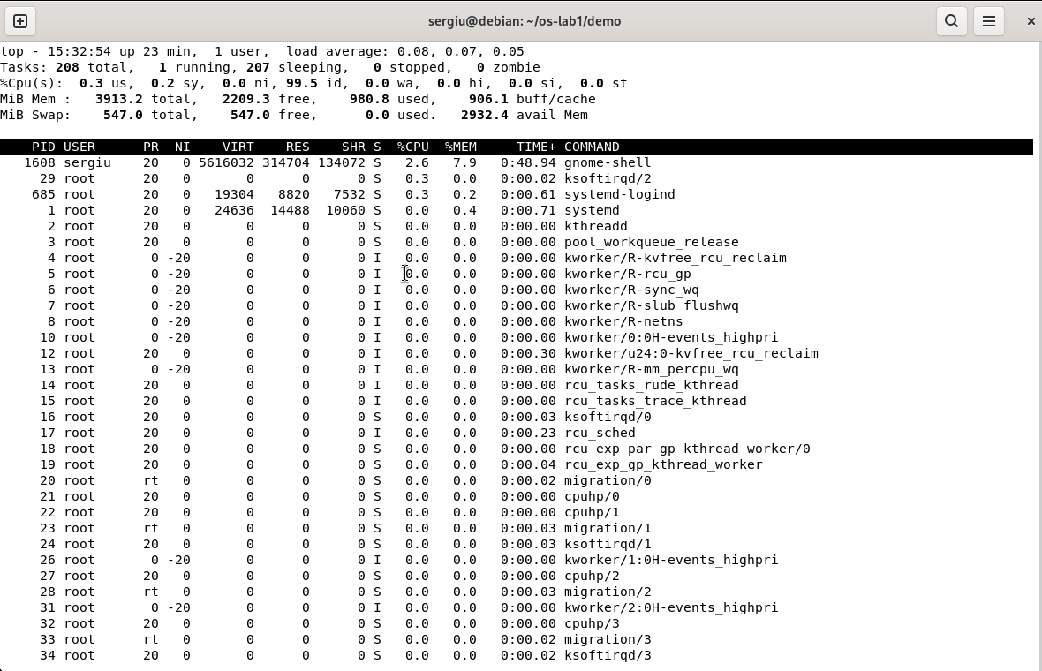
top
top shows the same list live, sorted by CPU usage and refreshed every few seconds. Its header summarises the uptime, the load, the number of tasks in each state, the CPU usage and the memory and swap totals. On the idle VM there were 208 tasks, of which only 1 was running (top itself) and 207 were sleeping, and the CPU was 99.5 % idle. The busiest process was gnome-shell, the desktop, with 2.6 % CPU. Most of the other lines are kernel threads (kworker, ksoftirqd, migration) with no memory of their own; state I means an idle kernel thread.

2.2 A Background Process
image 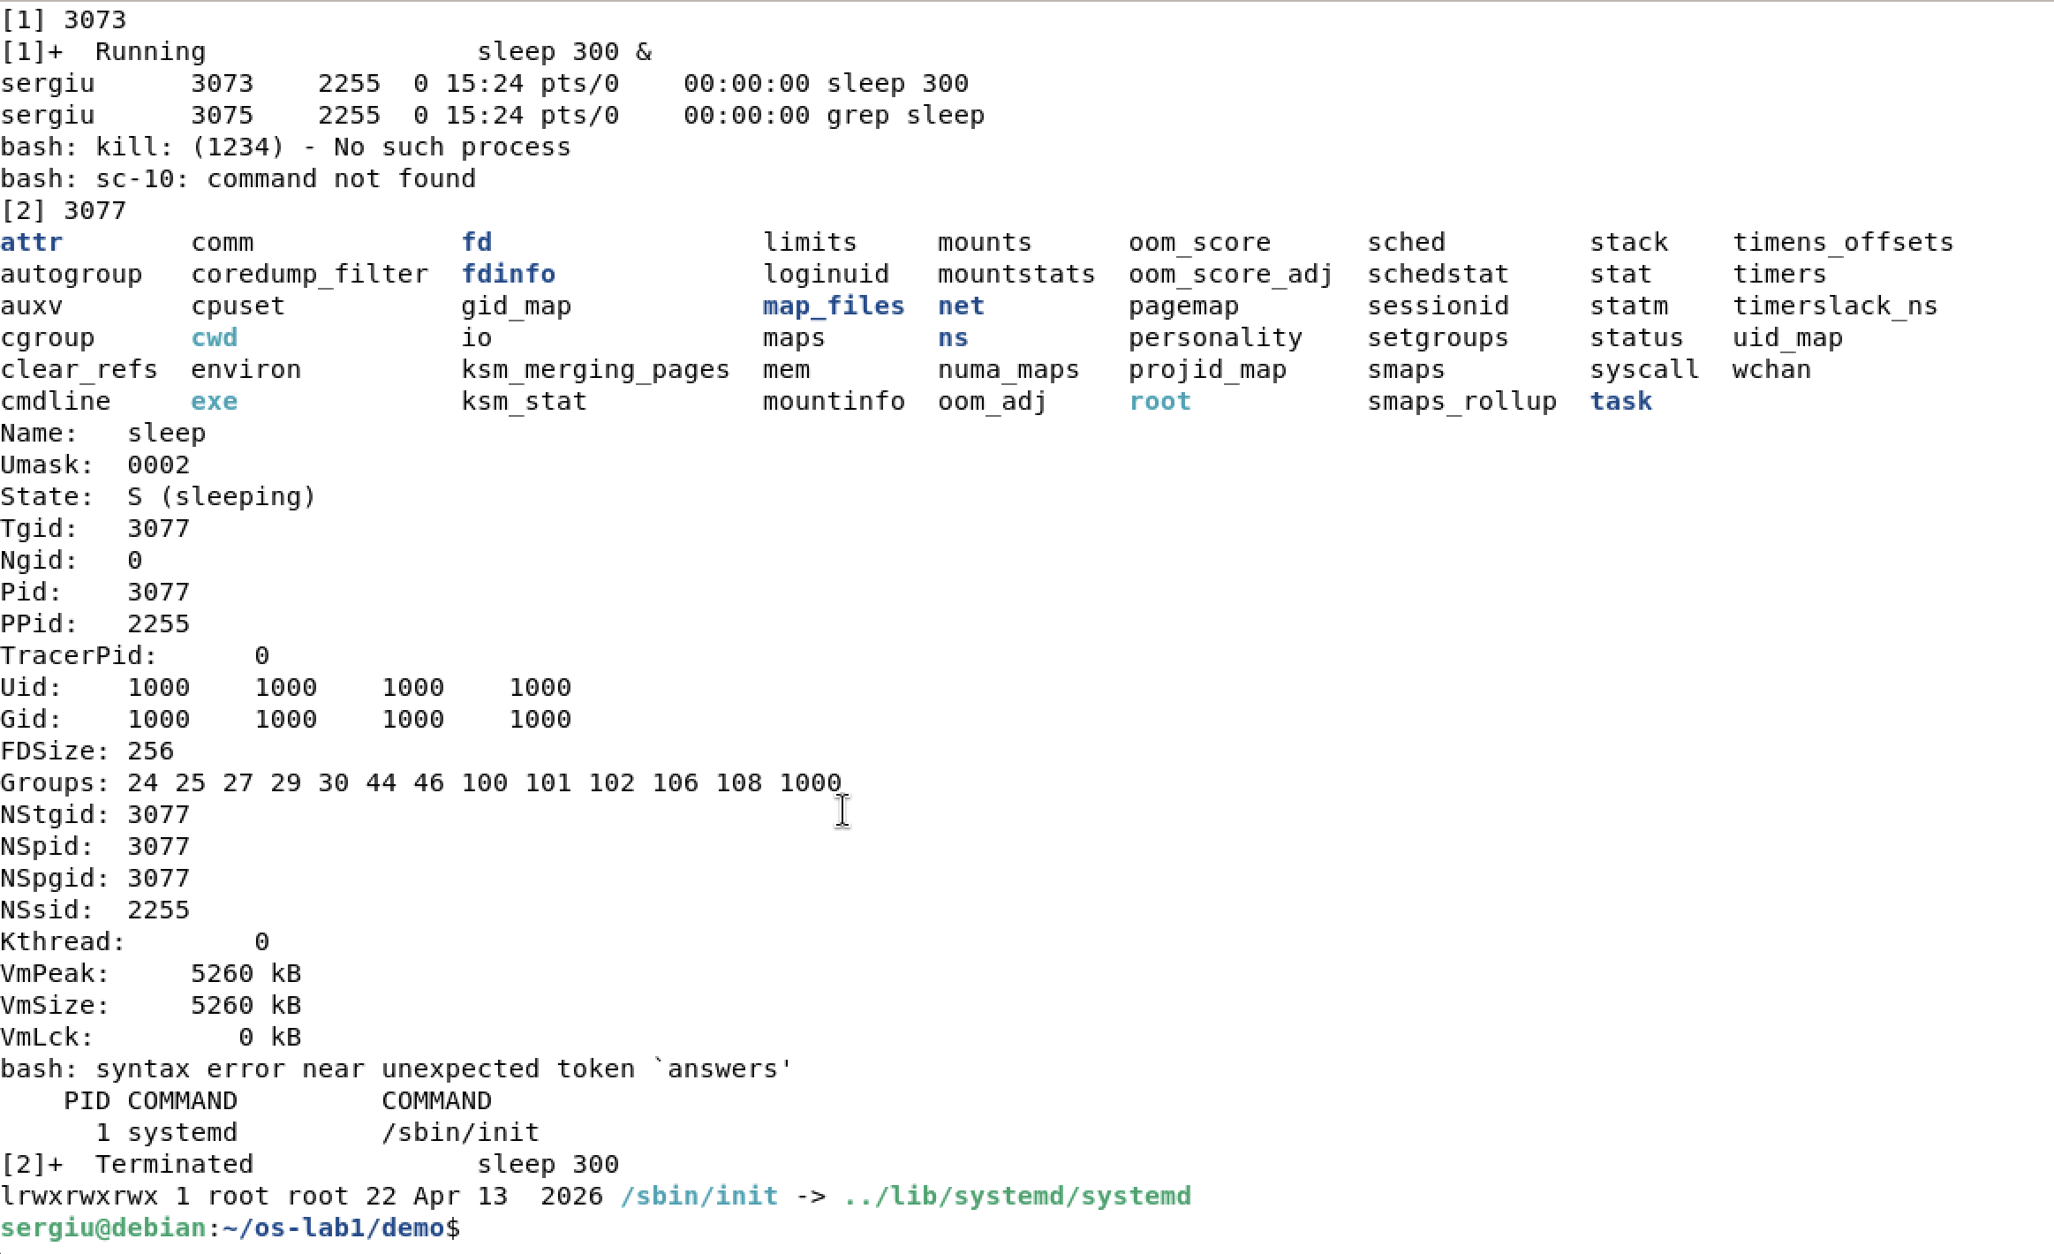
sleep 300 &, jobs, ps -ef | grep sleep and kill
sleep 300 & starts sleep in the background; the shell prints the job number [1] and the PID 3073. jobs shows the job as running. ps -ef | grep sleep finds it among all processes; its parent PID is the PID of my shell. The second line is the grep command itself. kill sends the signal SIGTERM, and the shell reports the job as terminated.

2.3 The /proc Pseudo-Filesystem
image 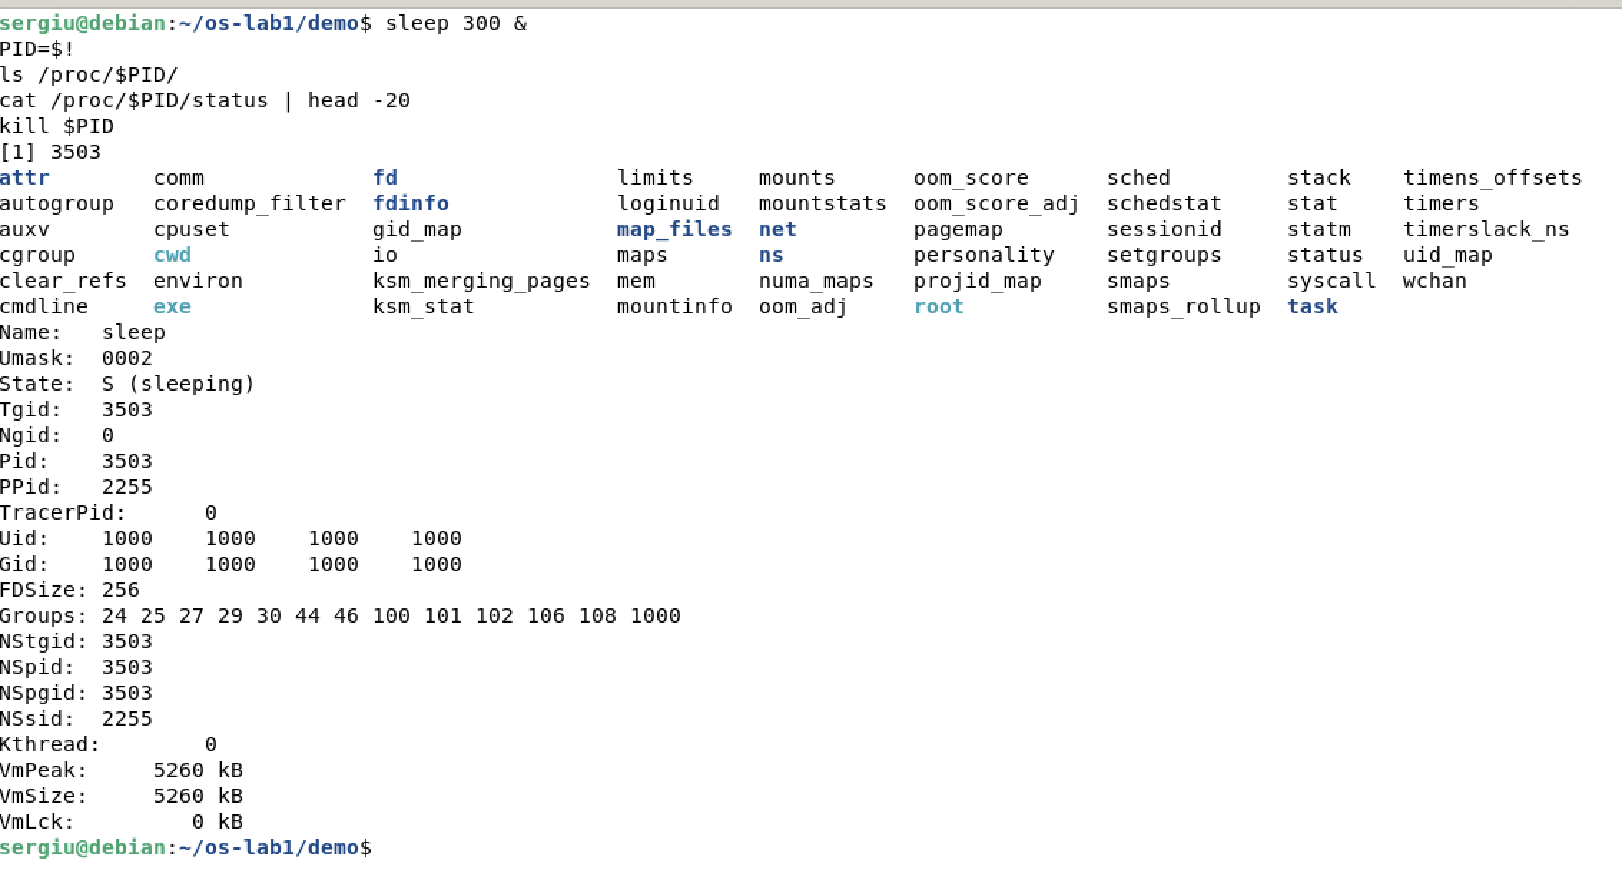
ls /proc/$PID/ and cat /proc/$PID/status | head -20
$! is the PID of the last background process, so PID=$! saves it in a variable. /proc/$PID is not stored on any disk: the kernel generates these files when they are read. They describe the process: cmdline holds its command line, fd its open files, maps its memory areas, and status a readable summary. In status I can see the name sleep, the state, the PID 3503 and the parent PID 2255 (my bash), my user and group ID 1000, and the virtual memory size of 5260 kB.
image 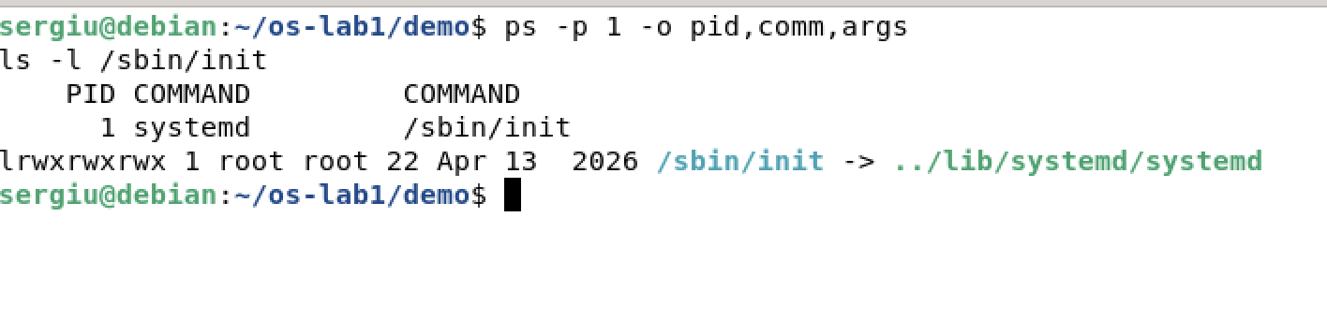
Process number 1
1. What is the PID of process number 1, and what is it?
PID 1 is systemd. It was started as /sbin/init, which is a symbolic link to /lib/systemd/systemd. It is the first user process, started by the kernel at the end of boot. It starts all the other services, and it becomes the new parent of every process whose parent dies. If it stops, the kernel panics.
2. Roughly how many processes were running on your idle VM?
About 208, according to top. htop splits them into 109 user processes and 101 kernel threads, so about half are not programs at all but parts of the kernel.
3. What does the “State:” line of /proc/<pid>/status say for your sleeping process?
It says S (sleeping): the process waits for its timer to expire and does not use the CPU until the kernel wakes it up.

3 Memory
image 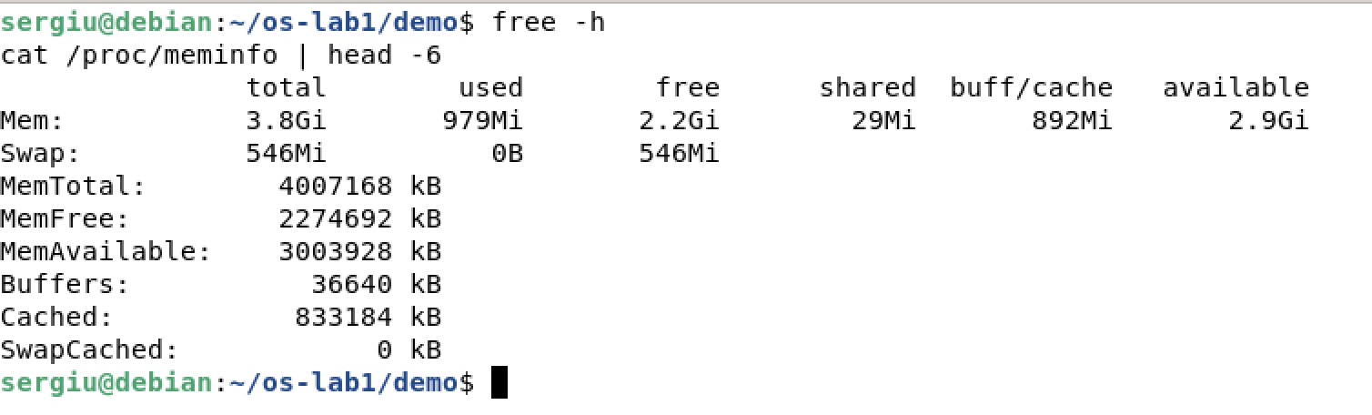
free -h and cat /proc/meminfo | head -6
image 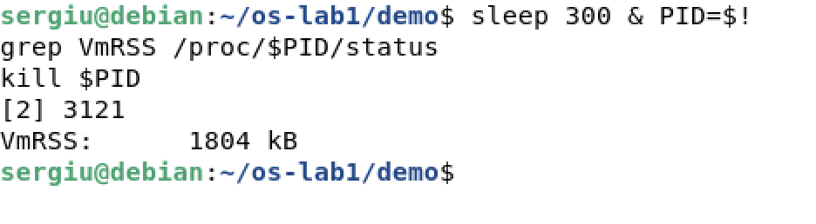
VmRSS of a sleep process
1. How much total RAM does the VM have, and how much is free?
The VM has 3.8 GiB of RAM (MemTotal is 4 007 168 kB). free -h shows 979 MiB used, 2.2 GiB free and 2.9 GiB available. The available column is more useful than free, because it also counts the file cache that the kernel can release when a program needs memory. free reads the same numbers that /proc/meminfo shows (MemTotal, MemFree, MemAvailable).
2. What is swap, and how much is configured?
Swap is space on the disk where the kernel moves memory pages that are not used often when RAM runs out. This keeps programs running at the cost of speed, because a disk is much slower than RAM. This VM has 546 MiB of swap configured, on its own disk partition vda4 (see Figure 14), and none of it is used, because more than half of the RAM is still free.
3. How much resident memory (VmRSS) does a bare sleep process use, and does that surprise you?
VmRSS is 1804 kB, about 1.8 MiB. At first this surprised me, because sleep does nothing. But even the smallest program has its code, a stack and the shared C library mapped into memory. Most of these pages are shared with other processes, so the real cost of one more sleep is much smaller.

4 Devices and Storage
image 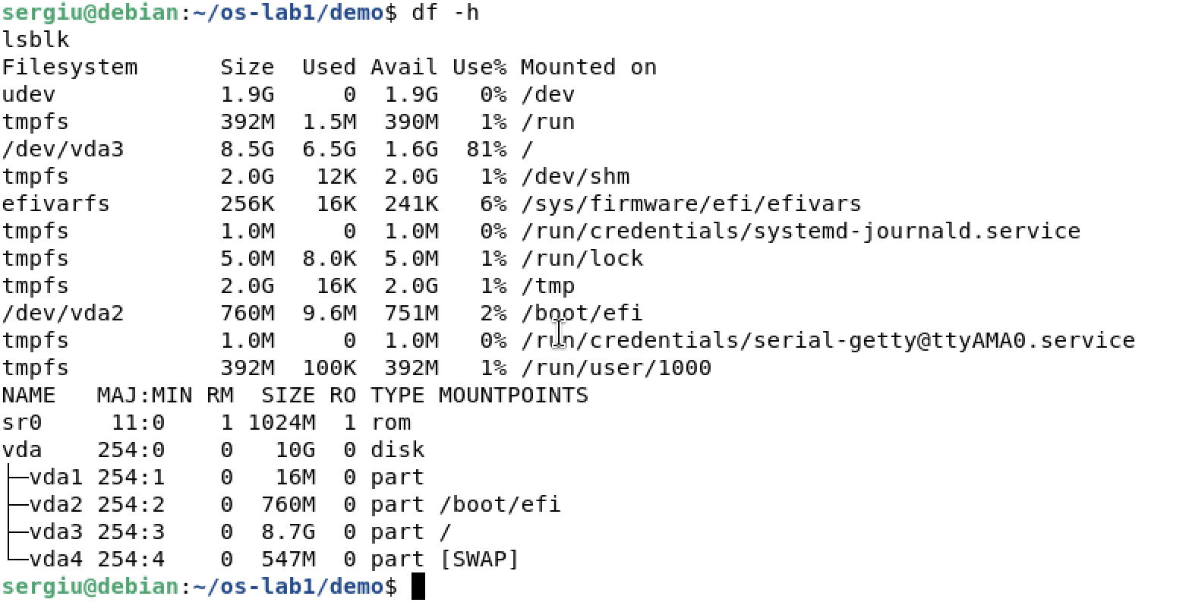
df -h and lsblk
df -h lists the mounted file systems with their size and free space. Some of them, such as tmpfs and udev, are not on a disk at all but in memory. lsblk shows the block devices themselves: the 10 GB virtual disk vda with four partitions (vda2 for /boot/efi, vda3 for /, vda4 for swap) and the virtual CD drive sr0. The root file system is 8.5 GB and already 81 % full.
image 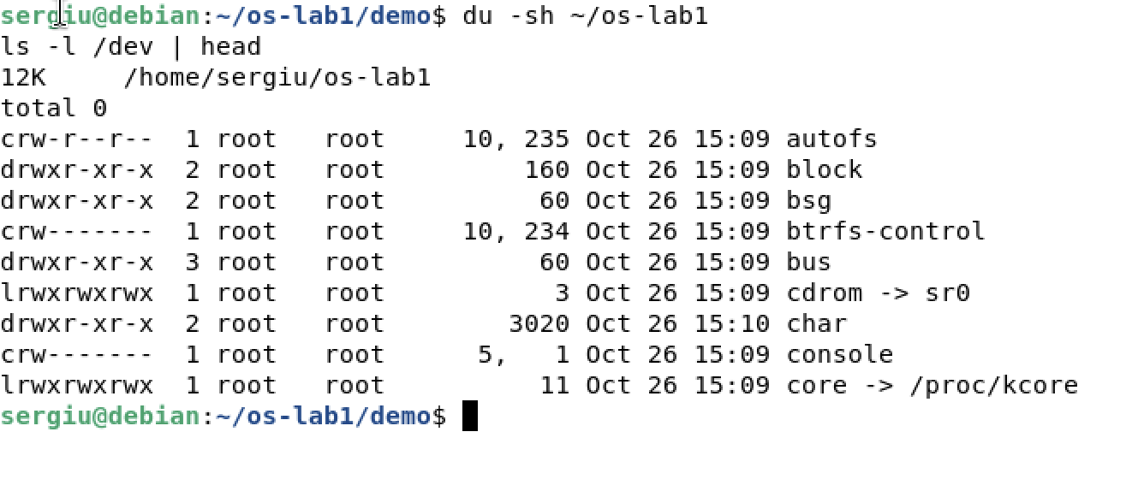
du -sh ~/os-lab1 and ls -l /dev | head
du -sh shows that my work folder occupies only 12 KB: three 4 KB blocks, for os-lab1, demo and note.txt. In ls -l /dev the first letter is c for character devices, which transfer a stream of bytes (terminals, null), or b for block devices, which are read in blocks (disks). Instead of a size, a device file shows two numbers (for example 5, 1 for console), the major and the minor number, which tell the kernel which driver and which device the file stands for.
image 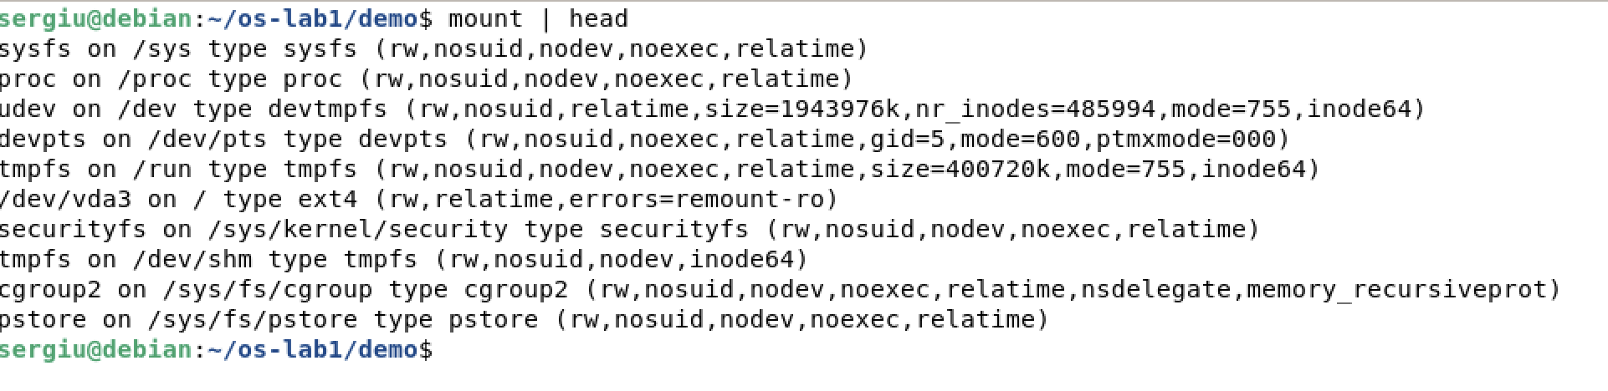
mount | head
mount shows that besides the disk, the kernel mounts virtual file systems such as sysfs on /sys, proc on /proc and devtmpfs on /dev.
1. Which device is your root filesystem “/” mounted on?
/ is mounted on /dev/vda3, the third partition of the virtual disk of the VM, formatted as ext4.
2. Give one entry from /dev and say what real thing it stands for.
/dev/vda is the whole virtual hard disk of the machine. Reading it gives the raw bytes of the disk, below any file system. Another example is /dev/null, which stands for no device at all: it discards everything written to it.
3. What does “everything is a file” mean, based on what you saw?
Disks, terminals, processes and kernel information all appear as names in the same file tree (/dev, /proc) and are used with the same operations as regular files: open, read, write and close.

5 Finished Early
image 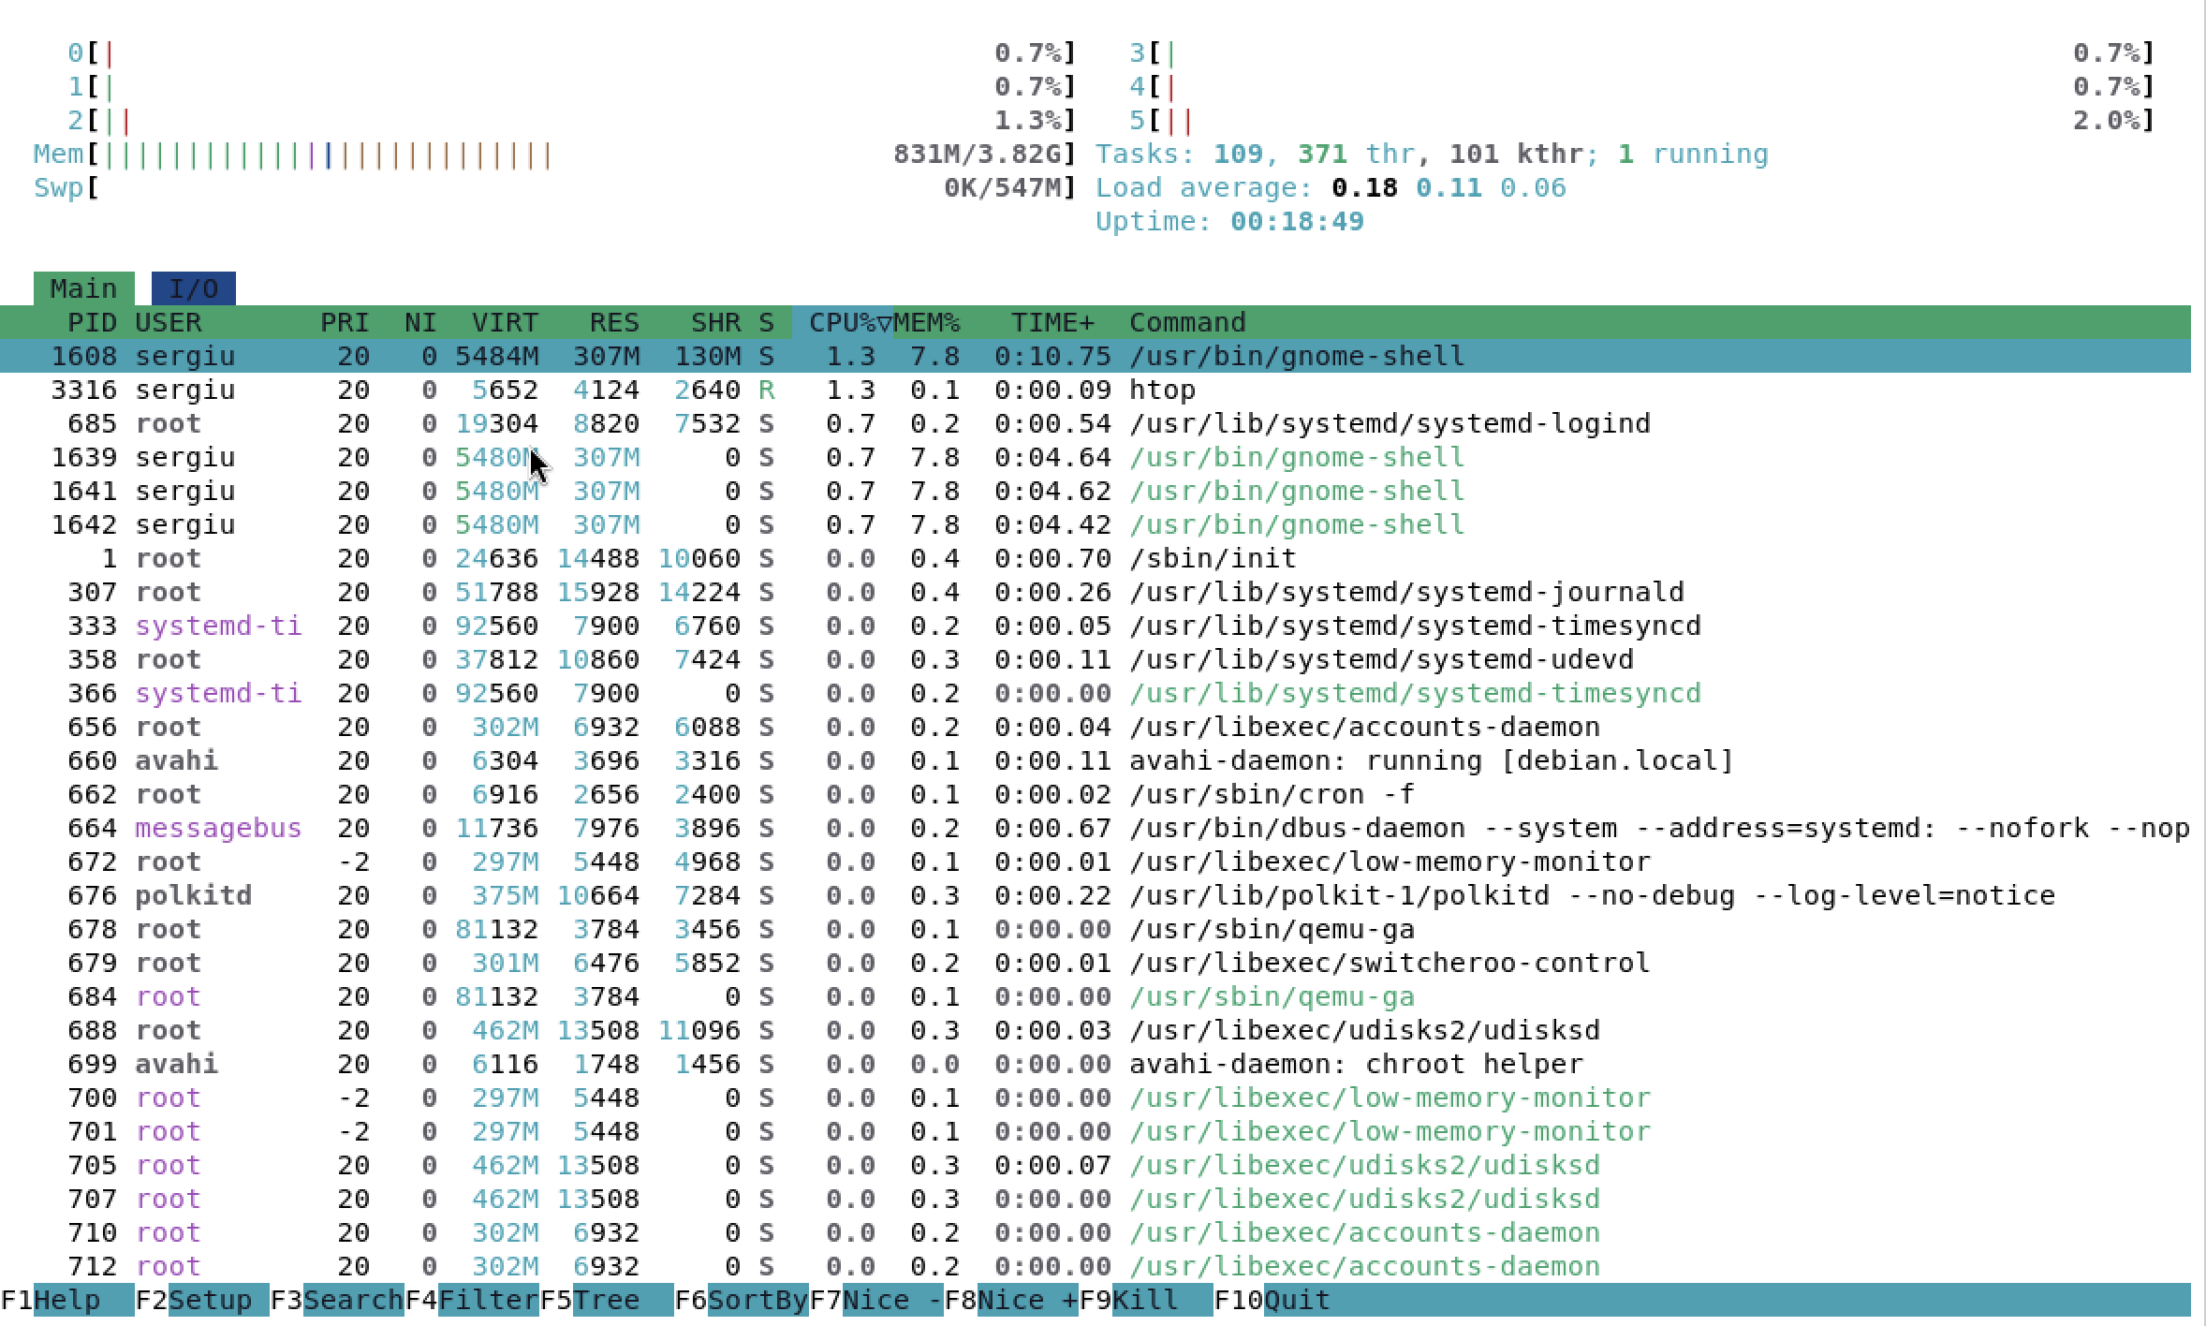
htop
htop shows the same information as top, but with a bar for every CPU core (6 here) and for memory and swap, and it separates the 109 user processes from the 101 kernel threads. It can also scroll, sort, show processes as a tree and kill them with the keyboard.
image 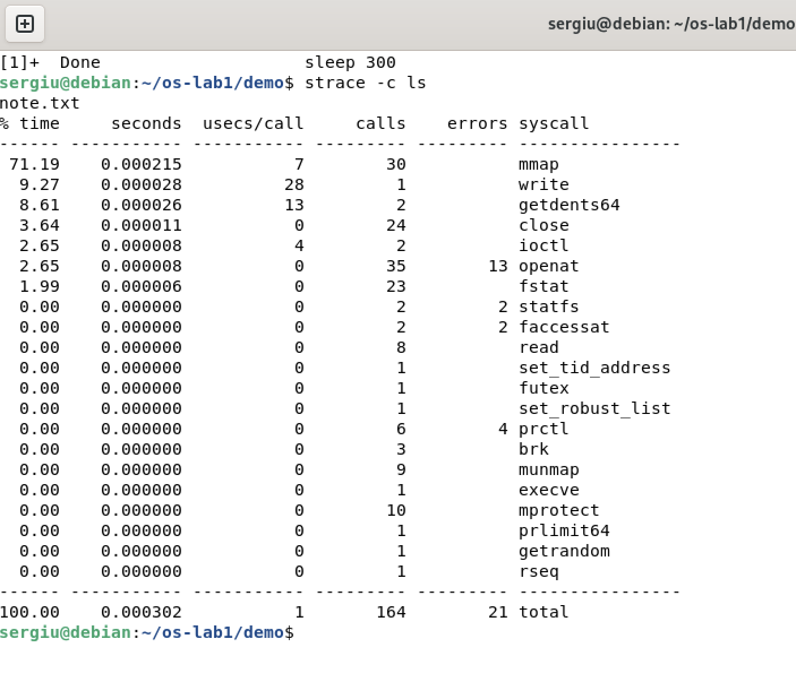
strace -c ls
strace -c runs ls and counts every system call it makes. Listing a directory with a single file needed 164 calls of 21 different kinds, and 21 of them failed. Most of them only prepare the program: execve loads it, then 35 openat, 30 mmap and 24 close calls look for and load the shared libraries and locale files (the 13 failed openat calls are files that were looked for but do not exist). The real work is only 3 calls: 2 getdents64 read the directory entries and 1 write prints note.txt. Every one of these calls is a request to the OS, because a program cannot touch the disk or the terminal by itself.

Conclusions
The operating system manages four resources: files, processes, memory and devices. I saw files with ls -l, which shows the owner and permissions the OS keeps for every name in the tree, and processes with ps aux, which lists every program the OS has created and is scheduling. I saw memory with free -h, which shows how the OS shares the physical RAM and swap, and devices with lsblk, which shows the disks the OS hides behind file-like names in /dev.

