
MINISTRY OF EDUCATION AND RESEARCH
OF THE REPUBLIC OF MOLDOVA
Technical University of Moldova
Faculty of Computers, Informatics and Microelectronics
Department of Software Engineering and Automation
Sergiu Gherasim, FAF-242
Report
Laboratory Work No. 6
Operating Systems
Topic: Inside the xv6 File System
mystat, the Limits of fs.h and a Recursive find
Checked by:
Patricia Reiţman, university assistant
Chişinău – 2026

Introduction
The purpose of this laboratory work is to look at the same file system ideas as in Laboratory Work No. 5 – inodes, directories as tables of names, hard links, a journal – but this time inside xv6, where the whole file system is a few hundred readable lines of C. The work has four steps: reading what the xv6 ls shows, writing a mystat program that prints the fields of struct stat, measuring the limits written in kernel/fs.h, and writing find, a program that walks the directory tree recursively (the find exercise of the MIT 6.1810 util lab).
I used the same xv6-riscv tree as in the previous labs. Every new program is a file user/NAME.c plus a line $U/_NAME\ in the UPROGS list of the Makefile. The submitted files are mystat.c, find.c and the Makefile.

1 Short Theory

1.1 The Layout of the xv6 Disk
The xv6 disk image fs.img is an array of blocks of BSIZE = 1024 bytes. The first blocks are metadata: block 0 is the boot block (unused), block 1 is the superblock that describes the layout, then come the blocks of the log (the journal that makes multi-block updates crash-safe), the blocks with the on-disk inodes, and the free-block bitmap. All the remaining blocks hold file data. The tool mkfs builds this image at compile time and prints the layout.

1.2 Inodes and Directories
An on-disk inode (struct dinode) stores the type of the file, the device numbers, the link count, the size and the addresses of the data blocks: NDIRECT = 12 direct block numbers and one indirect block, which itself contains block numbers. A directory is a file of type T_DIR whose content is an array of struct dirent: a 2-byte inode number and a name of at most DIRSIZ = 14 characters. An entry with inode number 0 is a free slot. Exactly as on Linux, the name lives only in the directory and the inode does not know its own name.

1.3 The stat System Call
stat(path, &st) (and fstat(fd, &st)) copies the metadata of an inode into a struct stat defined in kernel/stat.h: dev, ino, type, nlink and size. Programs like ls and find use it to learn whether a name is a file, a directory or a device.

2 Read What xv6 Shows You
After make clean ; make qemu I listed the root directory and created an empty directory (Figure 1):
image 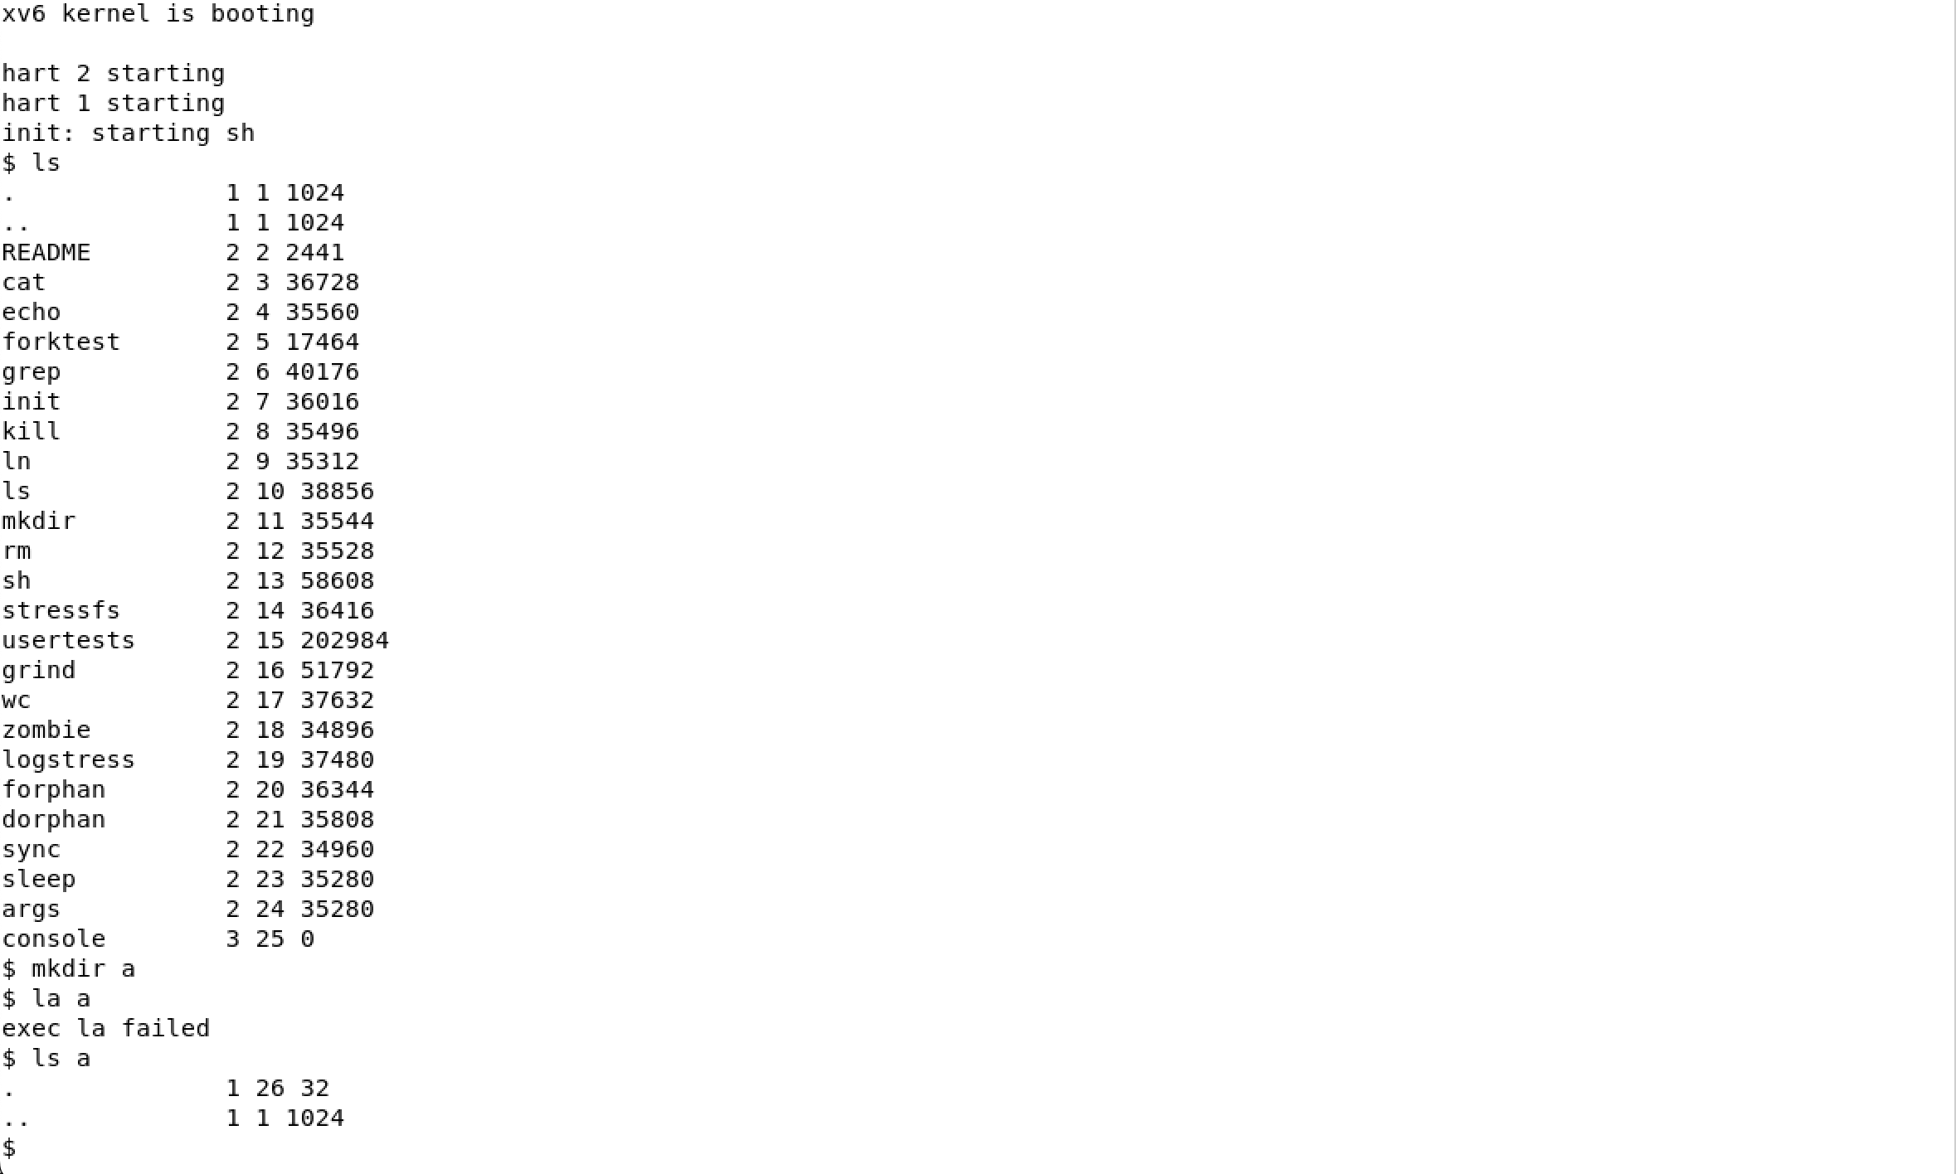
The root directory of xv6 and a new, empty directory
Every line is: name, type, inode number, size in bytes. To decode the type I opened kernel/stat.h:
#define T_DIR 1 // Directory
#define T_FILE 2 // File
#define T_DEVICE 3 // Device
struct stat {
int dev; // File system's disk device
uint ino; // Inode number
short type; // Type of file
short nlink; // Number of links to file
uint64 size; // Size of file in bytes
};

Observations
1. What do types 1, 2 and 3 mean (kernel/stat.h)?
Type 1 is T_DIR, a directory; type 2 is T_FILE, a regular file (README and all the programs); type 3 is T_DEVICE, a device file – here only console, whose size is 0 because its data comes from the console driver and not from disk blocks.
2. Which inode number does the root directory have, and why are . and .. the same there?
The root directory has inode number 1 (ROOTINO in kernel/fs.h; inode 0 is never used, because 0 marks a free directory entry). Both . and .. show inode 1: . always points to the directory itself, and the root has no parent, so mkfs makes its .. point back to itself as well. That is why cd .. in / stays in /.
3. An empty directory a has size 32. A directory entry has a fixed size. How big is one entry, and which two entries does a contain?
One struct dirent is 16 bytes: a ushort inum (2 bytes) and char name[DIRSIZ] (14 bytes). An “empty” directory still contains two entries, $2×16=32$ bytes: . pointing to itself (the inode printed on the . line of ls a in Figure 1) and .. pointing to its parent, the root (inode 1).

3 Write mystat

3.1 Implementation
The skeleton had two TODOs: translate the numeric type into a word, and call stat() for every argument, printing an error on descriptor 2 if it fails and continuing with the next argument.
#include "kernel/types.h"
#include "kernel/stat.h"
#include "user/user.h"
char *
typename(int t)
{
switch(t){
case T_DIR:
return "directory";
case T_FILE:
return "file";
case T_DEVICE:
return "device";
}
return "?";
}
int
main(int argc, char *argv[])
{
struct stat st;
if(argc < 2){
fprintf(2, "usage: mystat <path>...\n");
exit(1);
}
for(int i = 1; i < argc; i++){
if(stat(argv[i], &st) < 0){
fprintf(2, "mystat: cannot stat %s\n", argv[i]);
continue;
}
printf("%s: %s, inode %d, links %d, size %d bytes\n",
argv[i], typename(st.type), st.ino, st.nlink, (int)st.size);
}
exit(0);
}
The program was added to UPROGS:
image 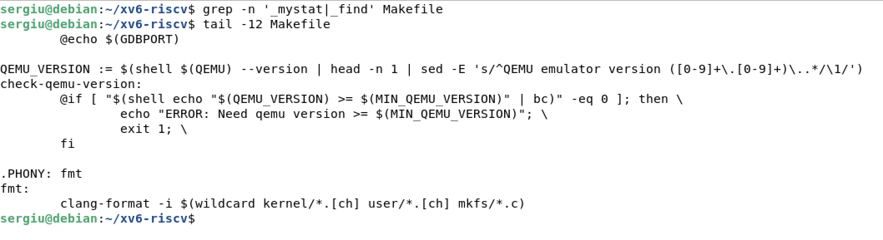
The new lines at the end of UPROGS

3.2 Watching Hard Links at Work
image 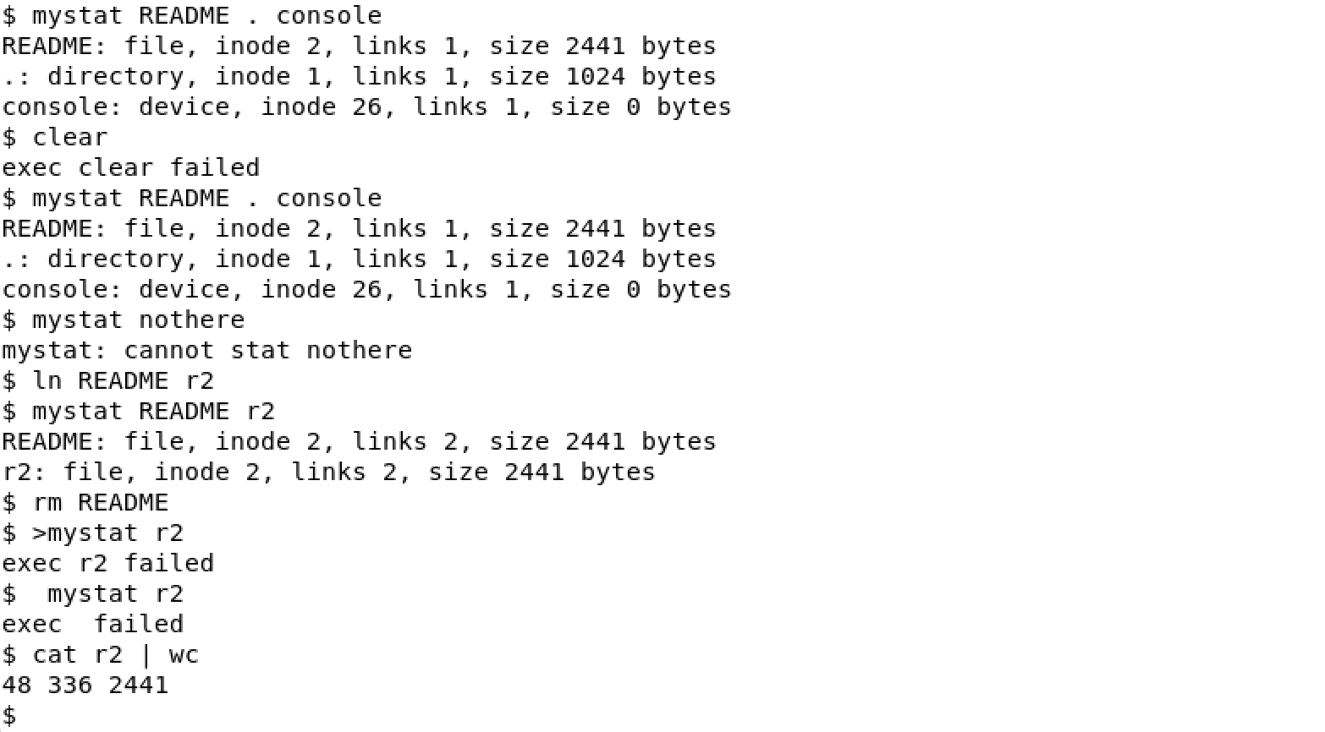
mystat before and after ln and rm
(The root directory reports links 1: mkfs gives the root inode one link, and in this freshly rebuilt image no subdirectory points back to it yet. After a mkdir a the count becomes 2, because create() in kernel/sysfile.c does dp->nlink++ for every new subdirectory, to account for its .. entry.)

Observations
1. Paste the outputs after ln and after rm. What changed and what did not?
After ln README r2 both names report the same inode 2, and the link count went from 1 to 2. After rm README the name README disappeared and r2 reports the same inode with links 1. What did not change: the inode number, the type and the size (2441 bytes) – and the content, as cat r2 | wc shows the full README. ln and rm only add and remove directory entries and adjust nlink; the inode and its data blocks were never touched.
2. Find the line in kernel/sysfile.c (sys_unlink) that decrements the link count. When are the data blocks freed?
memset(&de, 0, sizeof(de));
if (writei(dp, 0, (uint64)&de, off, sizeof(de)) != sizeof(de))
panic("unlink: writei");
if (ip->type == T_DIR) {
dp->nlink--;
iupdate(dp);
}
iunlockput(dp);
ip->nlink--;
iupdate(ip);
iunlockput(ip);
The decrement is ip->nlink--; (line 244 in my tree). Before it, the directory entry is overwritten with zeros, which turns it into a free slot (inum == 0). sys_unlink does not free any block. That happens in iput() in kernel/fs.c, called through iunlockput(ip): when the last in-memory reference is dropped (ip->ref == 1) and the link count is 0, iput calls itrunc(ip), which frees all direct and indirect data blocks, and then marks the inode free. So the blocks are freed only when no name and no open file refers to the inode any more – the same rule as on Linux.
3. xv6 has no symbolic links and no permissions. Look at struct dinode in kernel/fs.h: which fields does an xv6 inode have?
struct dinode {
short type; // File type
short major; // Major device number (T_DEVICE only)
short minor; // Minor device number (T_DEVICE only)
short nlink; // Number of links to inode in file system
uint size; // Size of file (bytes)
uint addrs[NDIRECT + 1]; // Data block addresses
};
An xv6 inode has only six fields: type, major and minor (for devices), nlink, size and addrs[13] (12 direct block numbers plus one indirect block). Compared with ext4 it has no owner (UID/GID), no permission bits, no timestamps and no symlink type. Its size is $4×2+4+13×4=64$ bytes, so 16 inodes fit in one 1024-byte block.

4 Measure the Limits
kernel/fs.h holds the constants that describe the geometry of the file system, and the mkfs tool prints the layout it writes into fs.img at build time (Figure 4):
image 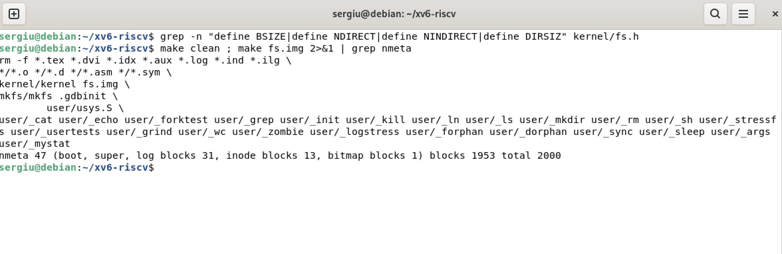
The constants in kernel/fs.h and the layout printed by mkfs
The same constants limit the names: DIRSIZ is 14, so a longer name is silently cut when the directory entry is written (Figure 5).
image 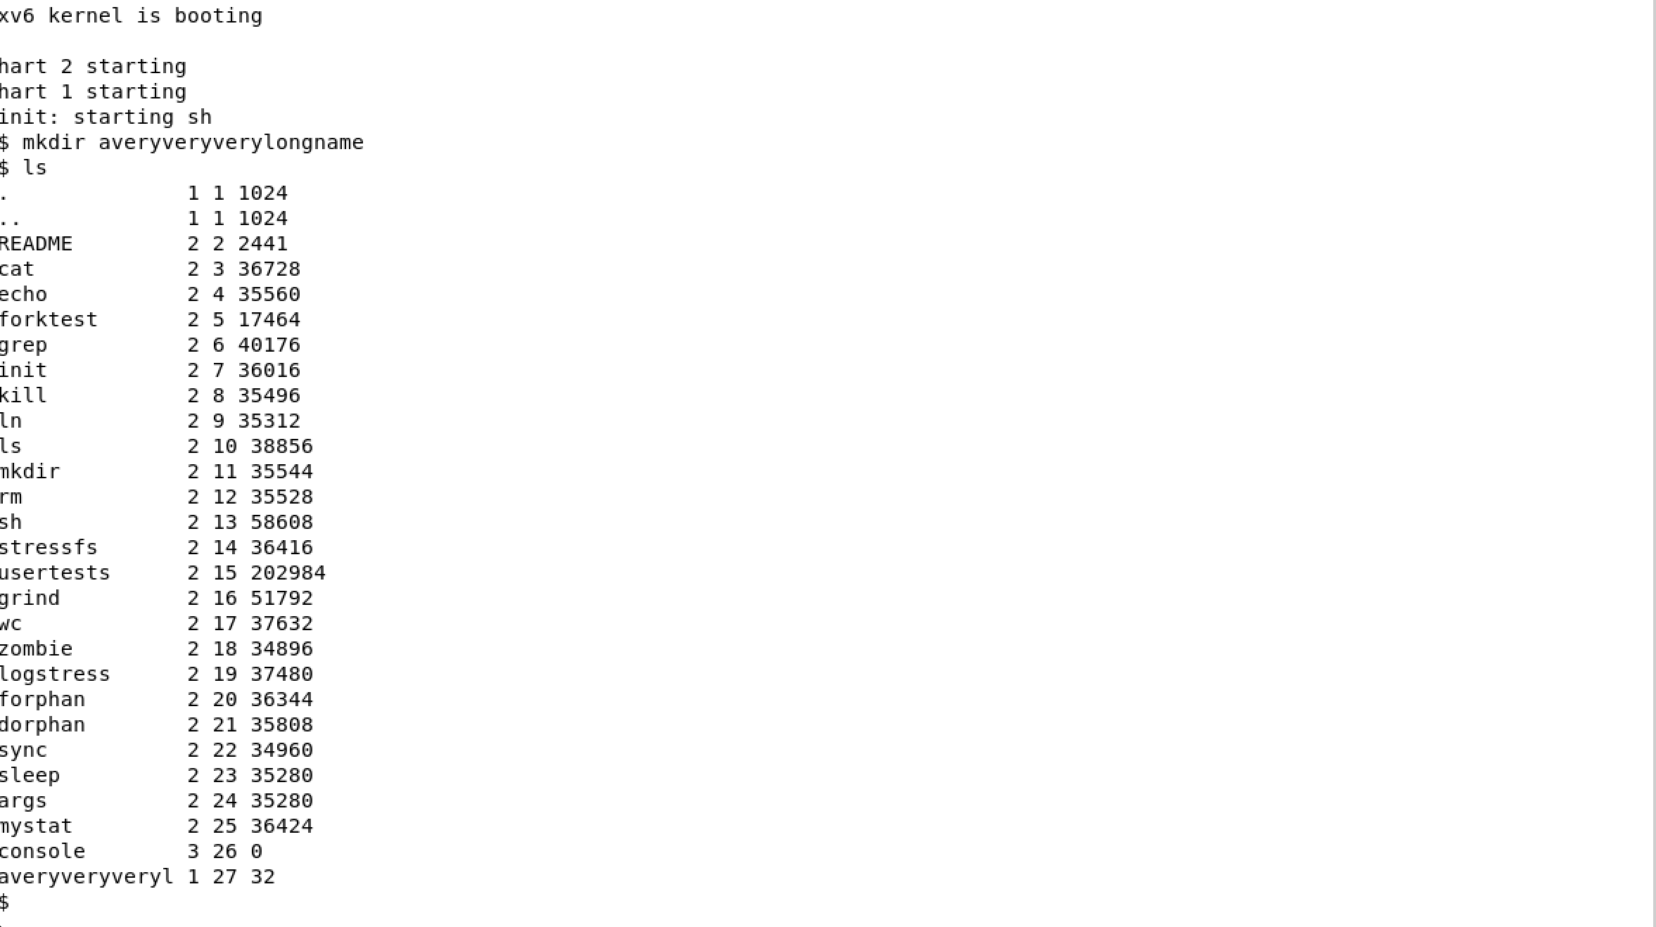
A file name longer than DIRSIZ

Observations
1. What does ls show for averyveryverylongname, and which constant explains it?
ls shows averyveryveryl: the name was cut to its first 14 characters. The constant is DIRSIZ = 14: a struct dirent has room for exactly 14 bytes of name. skipelem() and dirlink() in kernel/fs.c silently copy only DIRSIZ bytes, and when the name is exactly 14 characters long there is no terminating zero in the entry – this is why ls copies the name into a buffer and adds p[DIRSIZ] = 0 itself.
2. Compute the largest file xv6 can hold.
$$\begin{aligned}\text{NINDIRECT}&=\frac{\text{BSIZE}}{\text{sizeof(uint)}}=\frac{1024}{4}=256\text{ block numbers}, \\ \text{MAXFILE}&=\text{NDIRECT}+\text{NINDIRECT}=12+256=268\text{ blocks}, \\ \text{max size}&=268×1024=274 432\text{ bytes}=268\text{ KiB}.\end{aligned}$$
A file of more than 268 KiB cannot be written in xv6; writei() refuses to go past MAXFILE * BSIZE.
3. From the nmeta line: how many blocks does the whole disk have, and how many are for the log, the inodes, and the data?
Layout of fs.img (blocks of 1024 bytes)
Region | Blocks | Where it comes from
boot + superblock | 2 | blocks 0 and 1
log | 31 | 1 header + LOGBLOCKS $=3×$ MAXOPBLOCKS $=30$
inodes | 13 | NINODES/IPB $+1=200/16+1$
bitmap | 1 | 2000 bits fit in one block of 8192 bits
metadata (nmeta) | 47 | $2+31+13+1$
data | 1953 | $2000−47$
total | 2000 | FSSIZE in kernel/param.h
The whole disk has 2000 blocks (about 2 MB): 31 for the log, 13 for the inodes, 1 for the bitmap and 1953 for data – exactly what the nmeta line in Figure 4 reports.

5 Write find

5.1 Implementation
I started from user/ls.c, which already shows how to open a directory, read struct dirent entries one by one, build the full path in a buffer and call stat on it. The changes are:
- entries with inum == 0 (free slots) are skipped;
- . and .. are never followed, otherwise the recursion would never end;
- the last component is compared with the wanted name using strcmp, and the full path is printed on a match;
- if the entry is a directory, find calls itself on the new path;
- every opened directory is closed before returning, because a process may have only 16 open files (NOFILE) and a deep recursion would otherwise run out of descriptors;
- the optional third argument -n (the stretch task) also prints the inode number of each match.
#include "kernel/types.h"
#include "kernel/stat.h"
#include "user/user.h"
#include "kernel/fs.h"
#include "kernel/fcntl.h"
// find <dir> <name> [-n]
// prints every path under <dir> whose last component is <name>;
// with -n it also prints the inode number of each match.
int show_inode = 0;
// return a pointer to the last component of path
char *
lastname(char *path)
{
char *p;
for(p = path + strlen(path); p >= path && *p != '/'; p--)
;
return p + 1;
}
void
find(char *path, char *name)
{
char buf[512], *p;
int fd;
struct dirent de;
struct stat st;
if((fd = open(path, O_RDONLY)) < 0){
fprintf(2, "find: cannot open %s\n", path);
return;
}
if(fstat(fd, &st) < 0){
fprintf(2, "find: cannot stat %s\n", path);
close(fd);
return;
}
if(st.type != T_DIR){
// find was started on a file: only compare its own name
if(strcmp(lastname(path), name) == 0){
if(show_inode)
printf("%s %d\n", path, st.ino);
else
printf("%s\n", path);
}
close(fd);
return;
}
if(strlen(path) + 1 + DIRSIZ + 1 > sizeof buf){
fprintf(2, "find: path too long\n");
close(fd);
return;
}
strcpy(buf, path);
p = buf + strlen(buf);
*p++ = '/';
while(read(fd, &de, sizeof(de)) == sizeof(de)){
if(de.inum == 0) // free directory slot
continue;
memmove(p, de.name, DIRSIZ);
p[DIRSIZ] = 0;
if(strcmp(p, ".") == 0 || strcmp(p, "..") == 0)
continue; // never walk back up the tree
if(stat(buf, &st) < 0){
fprintf(2, "find: cannot stat %s\n", buf);
continue;
}
if(strcmp(p, name) == 0){
if(show_inode)
printf("%s %d\n", buf, st.ino);
else
printf("%s\n", buf);
}
if(st.type == T_DIR)
find(buf, name); // recurse into subdirectories
}
close(fd); // only 16 open files per process
}
int
main(int argc, char *argv[])
{
if(argc < 3 || argc > 4 || (argc == 4 && strcmp(argv[3], "-n") != 0)){
fprintf(2, "usage: find <dir> <name> [-n]\n");
exit(1);
}
if(argc == 4)
show_inode = 1;
find(argv[1], argv[2]);
exit(0);
}

5.2 Testing on a Fresh Disk
image 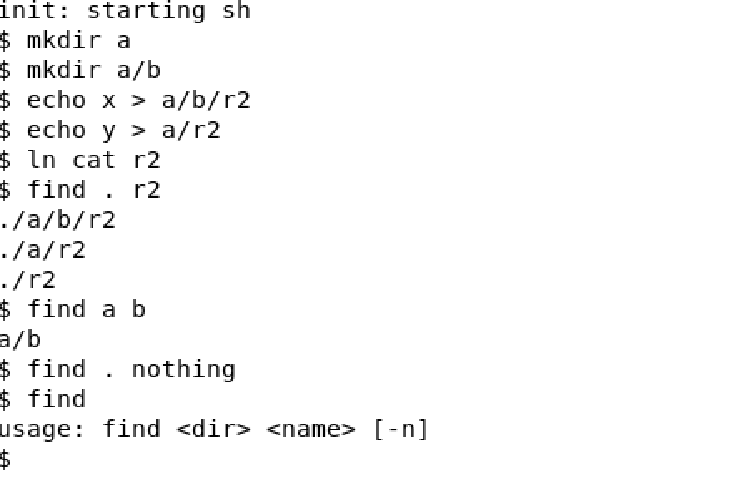
find on a fresh disk
The output (Figure 6) contains exactly the three expected paths. The order follows the order of the entries in each directory: a was created before r2 in the root, so the subtree of a is printed first.

6 Stretch Task: find with Inode Numbers
image 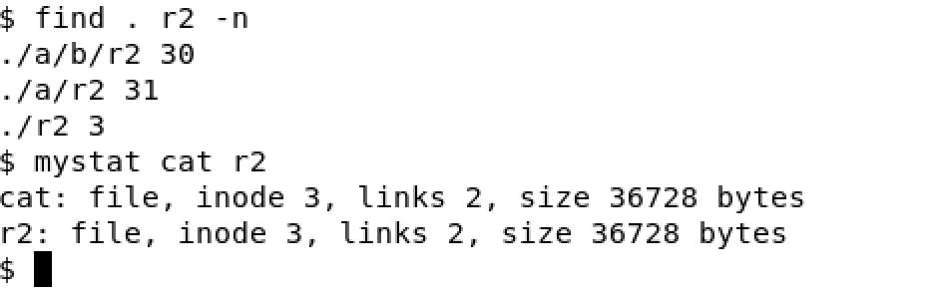
find . r2 -n and the inodes of the two names of cat
Only ./r2 is the same file as cat: find . r2 -n prints inode 3 for it, and mystat shows that this inode has 2 links. ./a/r2 (inode 31) and ./a/b/r2 (inode 30) are new, independent files created by echo, which received fresh inodes (Figure 7). Running ./r2 would in fact start the cat program.

Conclusions
In this laboratory work I explored the xv6 file system from the user side and from the source code. Decoding the output of ls showed that an xv6 directory is literally an array of 16-byte entries, that the root has inode 1 and is its own parent, and that even an empty directory holds . and ... Writing mystat made the content of struct stat visible and allowed me to watch hard links: ln and rm only change directory entries and nlink, while the inode and its data stay the same. Reading sys_unlink and iput confirmed the rule I had already observed on Linux in Laboratory Work No. 5: blocks are freed only when the link count is zero and nobody uses the inode any more.
Measuring the limits from kernel/fs.h showed how small xv6 deliberately is: names of at most 14 characters, files of at most 268 KiB, and a 2000-block disk of which 47 blocks are metadata, including a 31-block log. Finally, by turning ls into a recursive find I practised walking the directory tree, skipping free slots and ./.., and closing every descriptor to stay within the per-process limit. The stretch task with inode numbers showed once more that a name is only a pointer to an inode: ./r2 and cat are two names of the same file.

