
MINISTRY OF EDUCATION AND RESEARCH
OF THE REPUBLIC OF MOLDOVA
Technical University of Moldova
Faculty of Computers, Informatics and Microelectronics
Department of Software Engineering and Automation
Sergiu Gherasim, FAF-242
Report
Laboratory Work No. 4
Operating Systems
Topic: The xv6 Shell from the Outside
bash versus sh, argv, and the Shell Source
Checked by:
Patricia Reiţman, university assistant
Chişinău – 2026

Introduction
The whole user interface of xv6 is a single program, user/sh.c, about 500 lines long. It reads a line, splits it into a command and its arguments, and then either runs the program or does the small amount of work that a program cannot do for itself. In this laboratory work that shell is used side by side with bash: the same commands are typed in both, and the differences show what a shell must do and what bash adds on top of it.
The work has four parts. First the sleep program from Laboratory Work No. 2 is fixed for the current xv6, where the system call was renamed from sleep to pause. Then ten commands are run in bash and in the xv6 shell, and the results are collected in a table. Third, a tiny program, args, is written twice, once for xv6 and once for Linux, to see exactly which arguments each shell hands to a program and therefore who expands * and who removes quotes. Finally, four grep commands are run over user/sh.c to read how the shell is built from the inside.
I used the Linux virtual machine of the course with the same xv6-riscv tree as in the previous labs. The submitted files are user/sleep.c, user/args.c, args_linux.c and the Makefile.

1 Fixing sleep for the current xv6
In August 2025 the xv6 authors renamed the sleep system call to pause, so a sleep program written for an older tree no longer compiles. The first step is to ask the tree which name it uses:
$ grep -n "pause\|sleep" user/user.h
int pause(int);
image image
The grep result in user/user.h
My tree declares pause, so the call inside the program has to change. The program itself is still called sleep, because that is the name the course gives to it and the name that must appear in UPROGS.
image 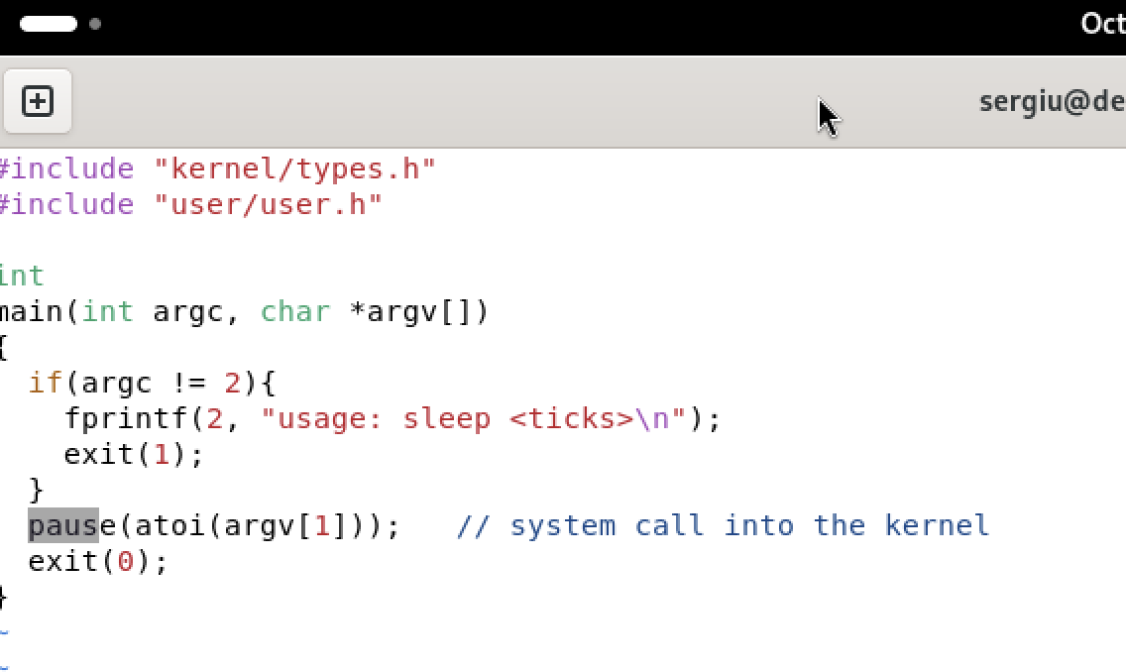
The updated user/sleep.c
#include "kernel/types.h"
#include "user/user.h"
int
main(int argc, char *argv[])
{
if(argc != 2){
fprintf(2, "usage: sleep <ticks>\n");
exit(1);
}
pause(atoi(argv[1])); // was sleep() before August 2025
exit(0);
}
Only one line changes: the comment marks the call that used to be sleep(). The rest of the program works as before, since the two names describe the same system call with the same argument, a number of clock ticks.
image 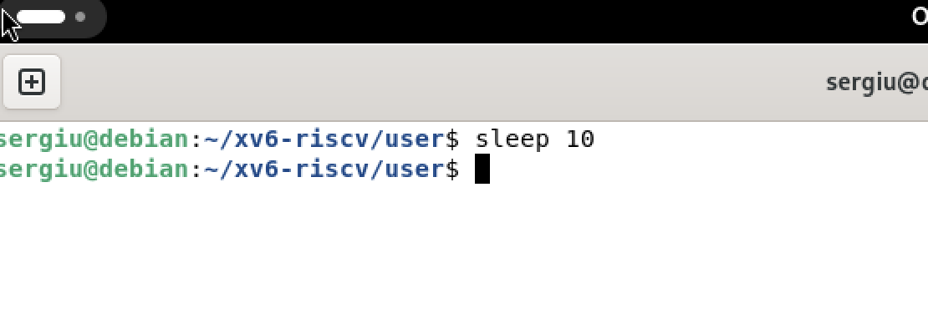
Running the program with an argument
After make qemu the program is rebuilt into fs.img and starts from the xv6 prompt. With one argument it waits for that many ticks and returns to the prompt without printing anything. Without an argument argc is 1, so the program prints usage: sleep <ticks> and exits with status 1 instead of reading a missing argument.

2 bash versus the xv6 shell
Every command was run twice: once in bash on Linux, inside an empty folder that contains a file named README, and once at the xv6 prompt.
image 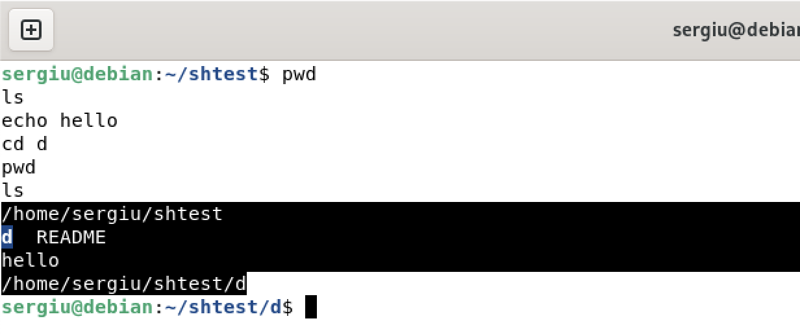
Basic commands and cd in bash
image 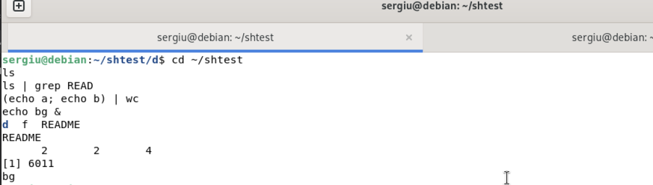
Redirection, pipe, grouping and background in bash
In bash pwd prints the current directory, ls lists it and echo prints its arguments. A pipe connects the standard output of one program to the standard input of the next, so ls | grep READ keeps only the line with README, and (echo a; echo b) | wc counts the output of a group of commands. A trailing & puts the command in the background and bash prints a job number.
image 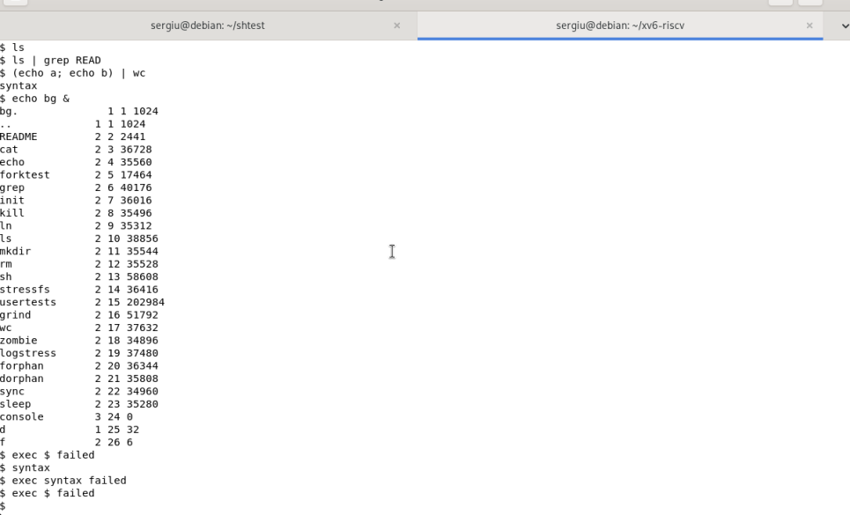
The same commands in xv6
image 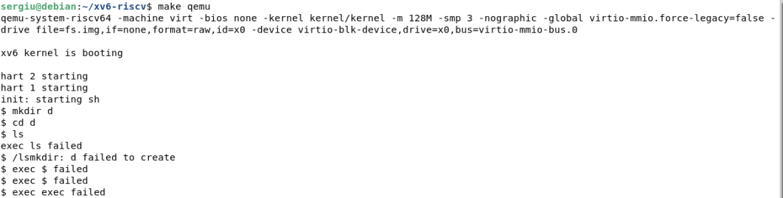
ls failing after cd d, and the working alternative /ls
The xv6 shell runs the same programs, but it does much less around them. Its ls prints the name, the type, the inode number and the size of every entry, so ls | grep READ shows more than bash. There is no globbing, no variable expansion and no quote removal, and the shell cannot read a command that continues on a second line.
The same commands in both shells.
Command | Tests | bash | xv6
echo hello > f ; cat < f | redirection | works | works
ls | grep READ | pipe | prints README | works, but prints name, type, inode and size
(echo a; echo b) | wc | grouping, list | 2 2 4 | syntax: no multi-line commands
echo one ; echo two | sequence | one, then two | one, then two
echo bg & | background | [1] 6011 and bg | bg
ls * | globbing | f README | ls: cannot open *
echo $HOME | variables | /home/sergiu | $HOME
echo "a b" | quotes | a b | "a b"
mkdir d ; cd d ; ls .. | PATH | d f README | exec mkdir failed, exec cd failed
arrow up, Tab, Ctrl+R | history, completion | work | do not work
1. List the features both shells have, and the ones only bash has.
Both shells execute programs, connect them with pipes (|), redirect input and output (<, >), run a command in the background (&), group commands with parentheses, run commands in sequence with ;, and change directory with cd.
Only bash has command history, tab completion, environment variables and $ expansion, a PATH to look programs up, job control (jobs, fg, bg), command substitution, and a scripting language with variables and loops.
2. In xv6, ls stops working after cd d. Why? Find a way to run ls from inside d anyway.
Because xv6 has no PATH variable. When a name contains no slash, exec looks for the file in the current directory only. After cd d the current directory is the empty d, so there is no file called ls to run. Giving the absolute path /ls works, because a name that starts with a slash is resolved from the root of the file system, where the programs of fs.img actually live.
3. Which missing feature would you miss most in daily work, and which would be easiest to add?
Command history and tab completion, because they are used in every single command. History would also be the easiest to add: the shell already reads its input with getcmd, so it could keep the lines it has read in a buffer and let the arrow keys walk through them.

3 Who expands *? A program that prints its argv
The same program is written twice. For xv6 it uses the two xv6 headers and exit, and it is added to UPROGS like sleep. For Linux only stdio.h is needed and main returns 0.
#include "kernel/types.h"
#include "user/user.h"
int main(int argc, char *argv[]) {
printf("argc = %d\n", argc);
for (int i = 0; i < argc; i++)
printf("argv[%d] = [%s]\n", i, argv[i]);
exit(0);
}
#include <stdio.h>
int main(int argc, char *argv[]) {
printf("argc = %d\n", argc);
for (int i = 0; i < argc; i++)
printf("argv[%d] = [%s]\n", i, argv[i]);
return 0;
}
image 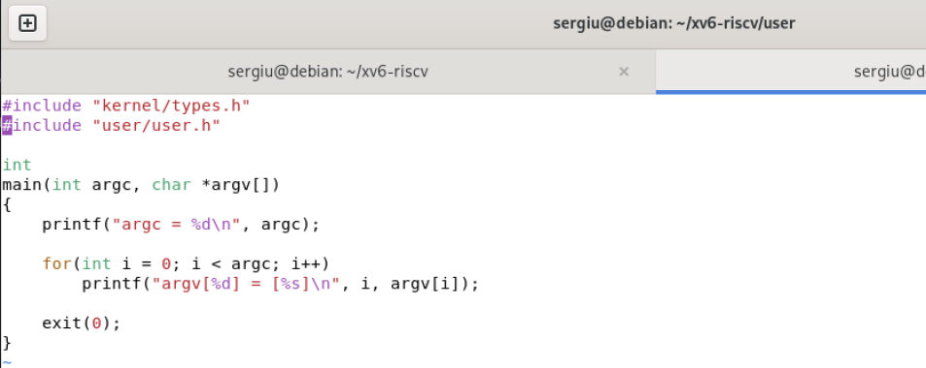
args.c and the UPROGS line
The Linux version is compiled with gcc -o args args_linux.c and started as ./args, because the current directory is not in PATH by default. The xv6 version is started as args, because in xv6 every program lives in the directory the shell is in.
image 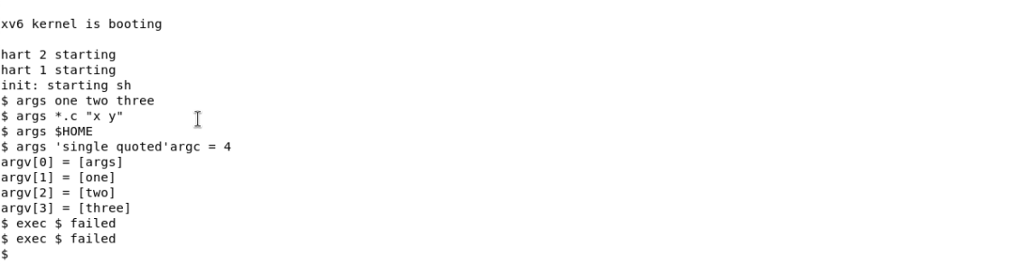
The args output in xv6
image 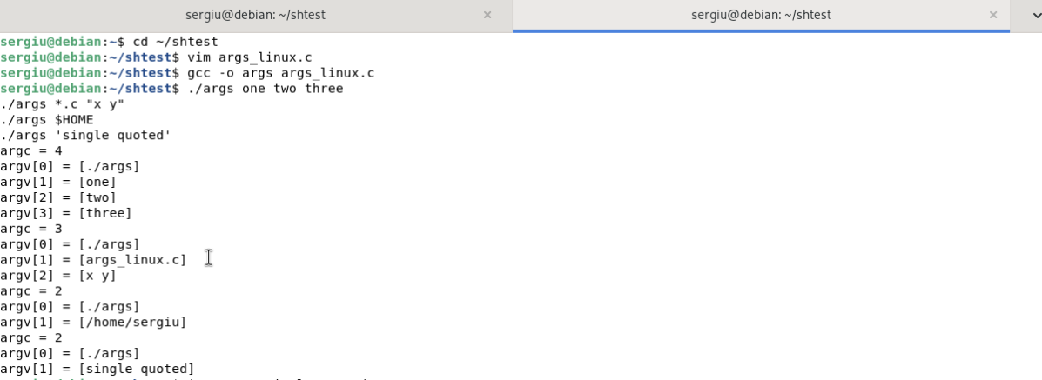
The args_linux output in bash
1. Paste both outputs for args *.c "x y". How many arguments did each program receive?
In bash the program receives 3 arguments:
argc = 3
argv[0] = [./args]
argv[1] = [args_linux.c]
argv[2] = [x y]
In xv6 it receives 4:
argc = 4
argv[0] = [args]
argv[1] = [*.c]
argv[2] = ["x]
argv[3] = [y"]
The difference is one argument: bash replaced the pattern with a file name and joined "x y" into a single word, while xv6 kept both the star and the quotes as ordinary characters.
2. So who turns *.c into file names and removes the quotes: the program, the kernel, or the shell?
The shell. The program only receives the list of words that is already prepared, and the kernel only copies that list into the new process when exec is called. Since the same args program prints a file name under bash and a literal star under xv6, the change must have happened before the program started: it is part of what the shell does when it parses the line.
3. What happened to the extra spaces in one two three?
They disappear before the program runs. The shell treats every run of unquoted spaces as a single separator, so args one two three arrives as argv[1] = [one], argv[2] = [two], argv[3] = [three], and the program cannot tell how many spaces were typed. Both shells behave the same way here.

4 Reading the shell
The shell is one while loop in main: read a line with getcmd, parse it into a tree of commands, run the tree, repeat. Four grep commands show the parts of that loop.
image 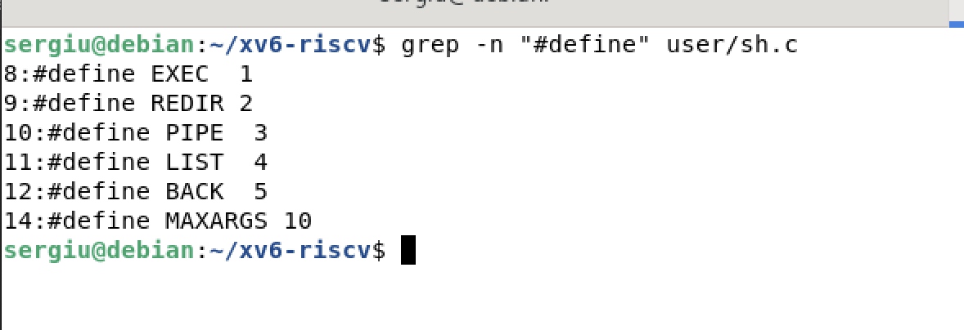
The kinds of command defined in user/sh.c
user/sh.c has about 500 lines. The five kinds of command are numbered constants, and each kind is represented by a struct that points to its parts: an execcmd holds the argument vector, a redircmd holds the file to open, and the pipe, list and background commands hold pointers to the commands they connect.
image 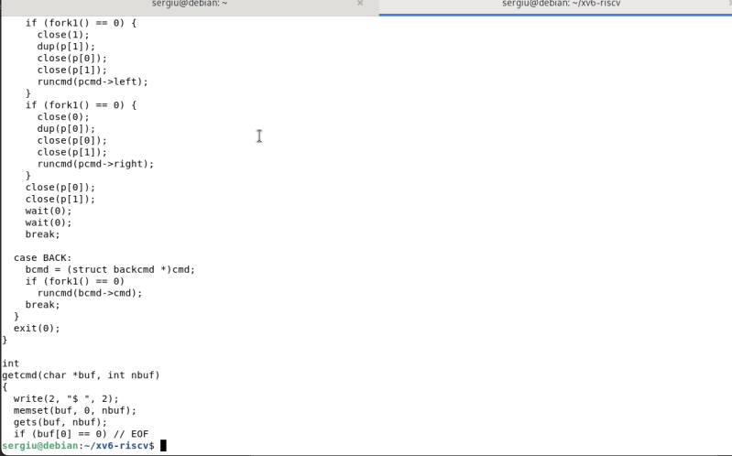
Where each kind of command is run
runcmd is a switch over the kind of command. EXEC calls exec; REDIR opens the file, replaces the right descriptor with dup and runs the inner command; PIPE creates a pipe, forks twice and gives each child one end; LIST runs the left command, waits, then the right one; BACK runs the left command in a child without waiting.
image 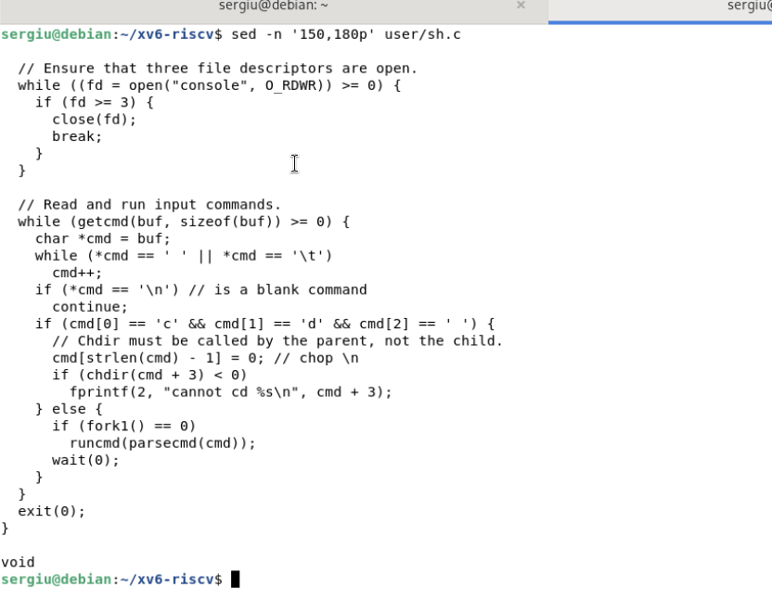
The code that handles cd
1. Name the five kinds of command the xv6 shell knows and the character that produces each.
EXEC (a plain command), REDIR (<, > or >>), PIPE (|), LIST (;) and BACK (&). They are defined as the numbers 1 to 5 at the top of user/sh.c, together with MAXARGS = 10, the largest number of arguments a command may have.
2. Where is cd handled, and why is it not run as a separate program?
It is handled in the main loop of user/sh.c, before the line is parsed: if the line starts with cd followed by a space, the shell cuts the newline, calls chdir(cmd+3) itself and continues. A separate program could not do it, because every program runs as a child process with its own copy of the working directory. The child would change its own directory and then exit, and the shell would still be where it was. For the change to be visible, it must happen in the shell process itself.
3. Search sh.c for any code that handles * or $. What does that explain about Part 2?
There is none. The parser only knows spaces, the redirection characters, |, ;, & and parentheses. A star and a dollar sign are copied into the argument vector like any other character, which is why ls * asks for a file literally named * and echo $HOME prints $HOME: no part of xv6 expands them.

Conclusions
This laboratory work looked at the same shell from three sides: its behaviour, its contract with programs, and its source. Running identical commands showed that xv6 and bash share the core of the Unix interface – programs, pipes, redirection, sequences, groups and background jobs – while bash adds everything that makes a shell comfortable in daily use: history, completion, variables, PATH lookup and a scripting language.
The args experiment separated the responsibilities cleanly. Wildcards and quotes never reach the program: the shell expands them while it parses the line, and the kernel only copies the finished argument list into the new process. The same program prints *.c in xv6 and a file name in bash, which proves that the difference is in the shell and nowhere else.
Reading user/sh.c explained the last mystery of the table: the file contains no code for * or $, so xv6 cannot expand them, and it handles cd inside its own main loop because a child process could not change the working directory of its parent. The shell is small enough to read completely, and after this work its behaviour stops being magic: every line of the 500-line file maps to one thing the shell does with a command line.

