CSE 473 – Introduction to Computer Networks

Lab 2 Report

Bingkun Guo 10/1/2013

Part A (20 points). Place a copy of your source code for TcpMapServer here.
paste your code here
/**
* Name: Bingkun Guo
* Date: 30/Sep/2013
* Explanation and Protocol Document: This class represents a
* Tcp MapServer, it holds a HashMap which stores (key, value) pairs.
* When the server the server is running, it will be listening on a specific
* port number, waiting for the client's connection. Once connected, a socket
* will be created to communicate with the client. The server will respond the
* messages sent by the server based on the protocol.
*
* Usage: java TcpMapServer [IP address] [Port Number]
* The server should take two optional command line arguments. The first is the
* IP address to which the server’s socket is to be bound. If this is omitted,
* the server should use the wildcard address. The second argument is a port number.
* If no port number is specified, the server should use port 30123.
* If the port number is specified, the IP address must also be specified.
*
* Here are the types of operation:
* get(k): returns the value part of the pair whose key is k
* put(k,v): adds the pair (k,v) to the set, possibly replacing some other pair (k,x).
* put(k): delete the key-value pair where key is k
* get all: The get all command requests all the key-value pairs stored in the map.
* All pairs are returned on a single line, with each key-value pair separated by
* a pair of colons.
*
* * Example of messages sent from the client:
* (1) get:this is the key string
* After receiving this message, the server should return the value whose
* key is "this is the key string".
*
* (2) put:another key string:and the corresponding value
* After receiving this message, the server should add key value pair
* ("another key string", "and the corresponding value")
*
* (3) put:another key
* After receiving this message, the server should remove the key value pair
* with key equal to "another key"
*
* (4) get all
* After receiving this message, the server will return all the key value pairs
* on a single line, with each key-value pair separated by a pair of colons.
*
* Example of messages sent from the server:
* (1) ok:this is the value string
* If the key-value pair exists, return the value for that key,
* in this case, the value is "this is the value string"
*
* (2) no match
* If the key-value pair doesn't exist, return "no match"
*
* (3) error: unrecognizable input: put a copy of the input packet’s payload here
* If the request has a wrong format which the server doesn't recognize, then
* send a error message.
*
* (4) ok
* If the put command has been successfully executed, the server will respond ok
*
* (5) key:lock::major key:bee flat::public key:flabber jabber heehaw
* After receiving command "get all". The server respond all the key value
* pairs on a single line, with each key-value pair separated by a pair of colons.
*
*/

import java.io.*;
import java.net.*;
import java.util.*;

public class TcpMapServer {

public static void main(String args[]) throws Exception {
// create a empty key-value pairs hash map
HashMap<String,String> pairs = new HashMap<String,String>();
// set default port number to 30123
int port = 30123;
InetAddress servAddr = null;
// if provided more than 2 command line arguments
// must specify the IP address and port number
if (args.length == 2) {
servAddr = InetAddress.getByName(args[0]);
port = Integer.parseInt(args[1]);
} else if (args.length == 1) {
// set the IP address to the given one
servAddr = InetAddress.getByName(args[0]);
}

// create a listening socket on the "port" and "servAddr"
ServerSocket listenSocket = new ServerSocket(port, 0, servAddr);

while (true) {
// keep listening until a client establishes a TCP connection
// the connSock will be used to communicate with the client
Socket connSock = listenSocket.accept();
BufferedReader in = new BufferedReader(new InputStreamReader(
connSock.getInputStream(), "US-ASCII"));
BufferedWriter out = new BufferedWriter(new OutputStreamWriter(
connSock.getOutputStream(), "US-ASCII"));

while (true) {
String line = in.readLine();
// When the message is empty or a blank line,
// close the connection
if (line == null || line.length() == 0) break;
// split the message by setting ":" delimiter
String splitedMsg[] = line.split(":");
// get the operation command
String operation = splitedMsg[0];
String key;
String value;
String reply = "";

if (operation.equals("get") && splitedMsg.length == 2) {
// if the operation is get(),
// return the value of that key
key = splitedMsg[1];
if (pairs.get(key) != null) {
reply = "ok:" + pairs.get(key);
} else {
reply = "no match";
}
} else if (operation.equals("put")) {
// if the operation is put(),
// add a key pair or delete a key pair
if (splitedMsg.length == 2) {
key = splitedMsg[1];
if (pairs.keySet().contains(key)) {
pairs.remove(key);
}
reply = "ok";
} else if (splitedMsg.length == 3) {
key = splitedMsg[1];
value = splitedMsg[2];
pairs.put(key, value);
reply = "ok";
} else {
reply = "error:unrecognizable input:" + line;
}
} else if (operation.equals("get all")) {
// if the operation is "get all"
// send back all the key-value pairs
String keyArr[] = pairs.keySet().toArray(new String[0]);
for (int i = 0; i < keyArr.length; i++) {
if (i != keyArr.length - 1) {
reply += keyArr[i] + ":" + pairs.get(keyArr[i]) + "::";
} else {
reply += keyArr[i] + ":" + pairs.get(keyArr[i]);
}
}
} else {
reply = "error:unrecognizable input:" + line;
}
// send back the reply to the client
out.write(reply);
// send newline indication
out.newLine();
// flush the buffer
out.flush();
}
// close the connection
connSock.close();
}
}
}
Part B (10 points). Place a copy of your source code for TcpMapClient here.
paste your code here
/**
* Name: Bingkun Guo
* Date: 30/Sep/2013
* Explanation: This class represents a Tcp MapClient.
* After this client is running, a socket will be created to
* establish a TCP connection with the server. Then it will take the
* inputs from the user by System.in, and then send the user's command to
* the server, and then receive and output the server's response.
*
* Usage: java TcpMapClient [IP address] [Port Number]
* The client program should take from 1-2 arguments. The first argument
* is the name or IP address of the host that the server is running
* on and the second (if present) is the port number on which it’s listening.
* The second argument defaults to 30123.
*
* Here are the types of operation users should enter:
* get(k): returns the value part of the pair whose key is k
* put(k,v): adds the pair (k,v) to the set, possibly replacing some other pair (k,x).
* put(k): delete the key-value pair where key is k
* get all: get all the key-value pairs
*
* Example of messages sent from the client:
* (1) get:this is the key string
* After receiving this message, the server should return the value whose
* key is "this is the key string".
*
* (2) put:another key string:and the corresponding value
* After receiving this message, the server should add key value pair
* ("another key string", "and the corresponding value")
*
* (3) put:another key
* After receiving this message, the server should remove the key value pair
* with key equal to "another key"
*
* (4) get all
* After receiving this message, the server will return all the key value pairs
* on a single line, with each key-value pair separated by a pair of colons.
*
* Example of messages sent from the server:
* (1) ok:this is the value string
* If the key-value pair exists, return the value for that key,
* in this case, the value is "this is the value string"
*
* (2) no match
* If the key-value pair doesn't exist, return "no match"
*
* (3) error: unrecognizable input: put a copy of the input packet’s payload here
* If the request has a wrong format which the server doesn't recognize, then
* send a erro message.
*
* (4) ok
* If the put command has been successfully executed, the server will respond ok
*
* (5) key:lock::major key:bee flat::public key:flabber jabber heehaw
* After receiving command "get all". The server respond all the key value
* pairs on a single line, with each key-value pair separated by a pair of colons.
*
*/

import java.io.*;
import java.net.*;

public class TcpMapClient {

public static void main(String args[]) throws Exception {
// default port number is 30123
int port = 30123;
// get server address using first command-line argument
InetAddress addr = InetAddress.getByName(args[0]);
// if provided, update the new port number
if (args.length > 1) port = Integer.parseInt(args[1]);
// bind the new socket to the server
Socket sock = new Socket(addr, port);

BufferedReader in = new BufferedReader(new InputStreamReader(
sock.getInputStream(), "US-ASCII"));
BufferedWriter out = new BufferedWriter(new OutputStreamWriter(
sock.getOutputStream(), "US-ASCII"));

// use sysin to read inputs from the user
BufferedReader sysin = new BufferedReader(new InputStreamReader(
System.in));

String line;
// while the users doesn't enter a blank line, the client is active
// to collect inputs from the user
while (true) {
line = sysin.readLine();
// if the user enters a blank line, close the connection
if (line == null || line.length() == 0) break;
// send the inputs from the user
out.write(line);
// send a newline indication
out.newLine();
// flush the buffer
out.flush();
// read the reply from the server and then output it
String reply = in.readLine();
System.out.println(reply);
}
// close the connection
sock.close();
}
}

Part C (10 points). Use the provided localScript to test your client and server. You may do this testing on any Unix (including MacOS) or Linux computer (shell.cec.wustl.edu or onl.wustl.edu). Paste a copy of the output below.
paste your output here

ok
ok
ok
ok:slim jim
ok:ho ho
ok:world
goodbye:world::hah:ho ho::foo bar:slim jim
error:unrecognizable input:get
error:unrecognizable input:foo:who
no match
ok
ok:toast is tasty
goodbye:world::foo:toast is tasty::hah:ho ho::foo bar:slim jim
goodbye:world::foo:toast is tasty::hah:ho ho::foo bar:slim jim
ok
goodbye:world::foo:toast is tasty::hah:ho ho::foo bar:slim jim

Part D (15 points). In the remaining parts of the lab, you will be testing your application in ONL. Use the RLI to reserve an experimental network using the provided configuration file, cse473-lab2.onl (remember to first open an ssh connection to ONL with the tunnel required by the RLI), and commit your network. Open two separate ssh windows, one connecting to the host h4x2 and the other to the host h7x1 (remember to load the topology file first). First, start the server using the window for host h7x1. When starting the server, you should specify the host name (h7x1) or IP address (192.168.7.1) for the host in the experimental network. Use the default port number. Run the command in the “background” by putting an ampersand (&) at the end of the line. This will allow you to use the window for command input, even while the server is running (read the job control section of the bash manual to learn more about running jobs in the foreground and background). Note that once you start the server, it will “run forever” until you stop it. One simple way to do this is to type kill %1. Note that if you have multiple jobs running in the background, you will need to substitute the appropriate job number for %1. See the bash manual for details.
Now that your server is running in the background, type the following command in the window for h7x1.
netstat -an | grep 30123
and paste a copy of the output below.
and here
Output: tcp6 0 0 192.168.7.1:30123 :::* LISTEN

Now, start the client on h4x2 (supplying the appropriate arguments) and then re-run netstat on h7x1 and paste the output below.
and here
tcp6 0 0 192.168.7.1:30123 :::* LISTEN
tcp6 0 0 192.168.7.1:30123 192.168.4.2:59969 ESTABLISHED
Explain the netstat output in the two cases. You should read the man page on netstat before answering this part (type “man netstat” to get the man page).
netstat displays the current active connections on the port 30123.
In the first case, there is only the server socket listening on port 30123,
In the second case, we can see the client has established a TCP connection with the server, there is a connected socket using remote port number 59969.
Now, run the provided remoteScript on h4x2. Paste the output from your run below.
paste your output here

ok
ok
ok
ok:slim jim
ok:ho ho
ok:world
goodbye:world::hah:ho ho::foo bar:slim jim
error:unrecognizable input:get
error:unrecognizable input:foo:who
no match
ok
ok:toast is tasty
goodbye:world::foo:toast is tasty::hah:ho ho::foo bar:slim jim
goodbye:world::foo:toast is tasty::hah:ho ho::foo bar:slim jim
ok
rab:oof::goodbye:world::foo:toast is tasty::hah:ho ho::foo bar:slim jim
Part E (10 points). In this part, you are to re-run the remoteScript and take a screen capture of the two monitoring windows showing the traffic that results from running the remoteScript (ignore the queue length window). You can pause a monitoring window by selecting Stop from its Options menu. This makes it easier to do the screen capture. Restart the paused window by select Stop a second time.
paste your screenshot here
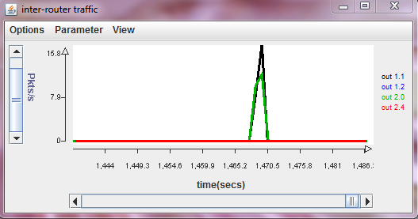
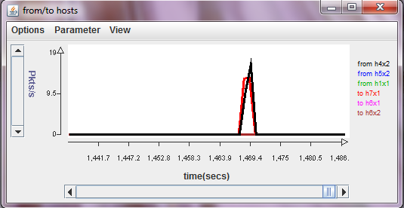
The charts should show a burst of traffic for some of the curves and no traffic for others. Which curves show a burst of traffic? Is this consistent with what you expect? Note that there are two possible routes between the two end hosts. Which of the two routes are used in this case?
In the top chart, the black curves show that traffic is leaving output 1 of router 1, the green curves show that traffic is leaving output 0 of router 2.
In the bottom chart, the red curves show that packets are leaving h4x2 for h7x1, the black curves show that packets are arriving at h7x1 from h4x2.
None of the other curves show any traffic, this is consistent with what I expect.

Part F (10 points). In this next part, you are to run remoteScript once again, but this time, you will be using Wireshark to capture packets as seen at both hosts. Using Wireshark in onl requires a little extra effort, since Wireshark itself must run on the target computer within onl, while the graphical interface needs to appear on your local computer. You will need X-windows support on your local computer to make this work. The PCs in the Urbauer labs are configured to support X, so we’ll start with the procedure used there. Start by opening a new command window on your local computer and type
startxwin
This will open a new window. In this new window, type
ssh –X myLogin@onl.wustl.edu
This creates an ssh connection that forwards “X-windows” commands from onlusr back to your local computer. X-windows is a generic windowing system developed at MIT in the 1980s. It is still used for a number of unix/linux applications, including Wireshark. Now, type
source /users/onl/.topology
ssh –X $h4x2
This will log you into host h4x2 and forward X-windows commands from h4x2 back through onlusr to your local computer. Next, type
sudo wireshark
After you enter your onl password, Wireshark will start running on h4x2, and the Wireshark window will open on your local computer. If you want to do this part of the lab using your own computer, you may have to do some initial configuration. If you have a Mac or a Linux computer, with Wireshark installed, you’re probably good to go. Just open a terminal window and type
ssh –X myLogin@onl.wustl.edu
and proceed as described above (note, you don’t need the startxwin step). If you are using a Windows computer, there are several options for installing X, but the most straightforward is probably to install cygwin, and configure it to enable X (this is the approach used in the Urbauer lab computers). Cygwin is a Unix emulation environment that runs on Windows. Use your favorite search engine to find the cygwin site, read the instructions and then download/install. Once you have things setup, just follow the procedure given above for the Urbauer computers.
Now, configure Wireshark to capture packets on the data0 interface and then re-run remoteScript in the original terminal window connected to h4x2. Find the packet going from h4x2 to h7x1 that includes the “get:goodbye” command. Highlight that packet in the upper sub-window and make sure that the packet contents are visible in the lower sub-window.

Paste a copy of the Wireshark window here.
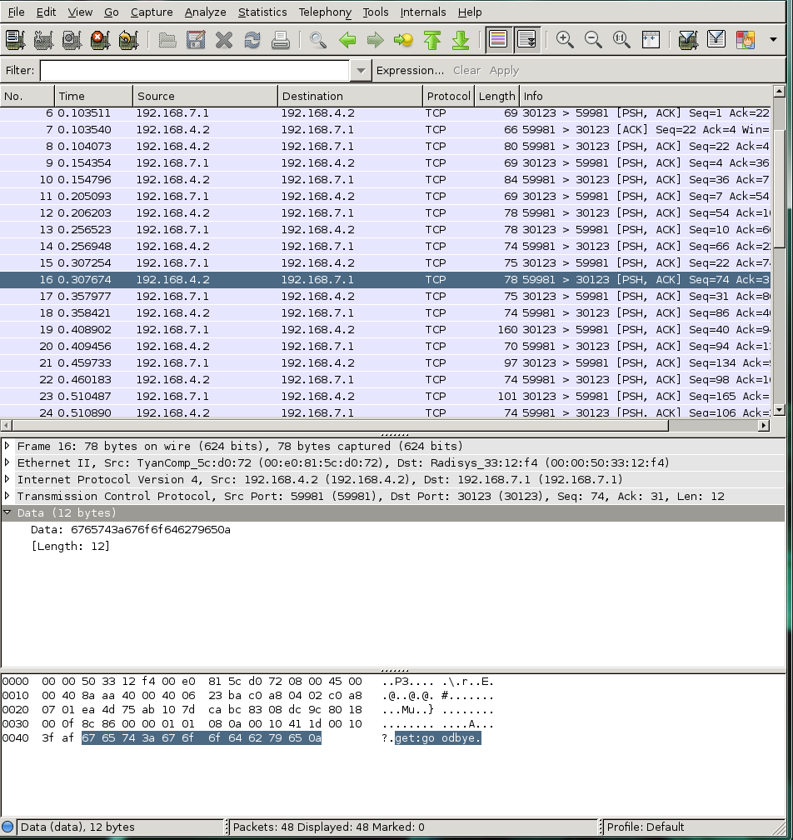

How much time passes between the time this packet is sent and the time the reply arrives? (Note, the reply appears on the next line and the second column of the displays shows the times relative to the start of the capture.)
Time difference = 0.357977 – 0.307674 = 0.050303 seconds = 50303 microseconds

The observed time is caused primarily by an artificial delay that has been configured in one of the routers, using a special delay plugin. Which router contains the delay plugin?
Router 1 contains a delay plugin
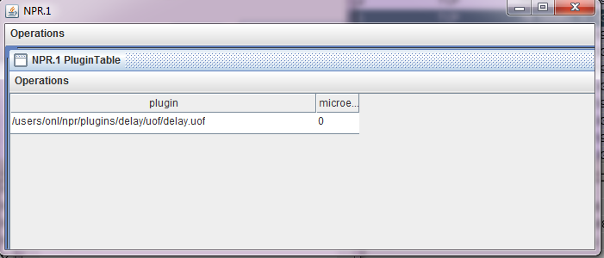
Find the filter that causes packets to pass through the plugin and turn it off, using the RLI. Don’t forget to commit after disabling the filter. Now, start a new Wireshark capture and re-run remoteScript.
Paste a copy of the new Wireshark window here.
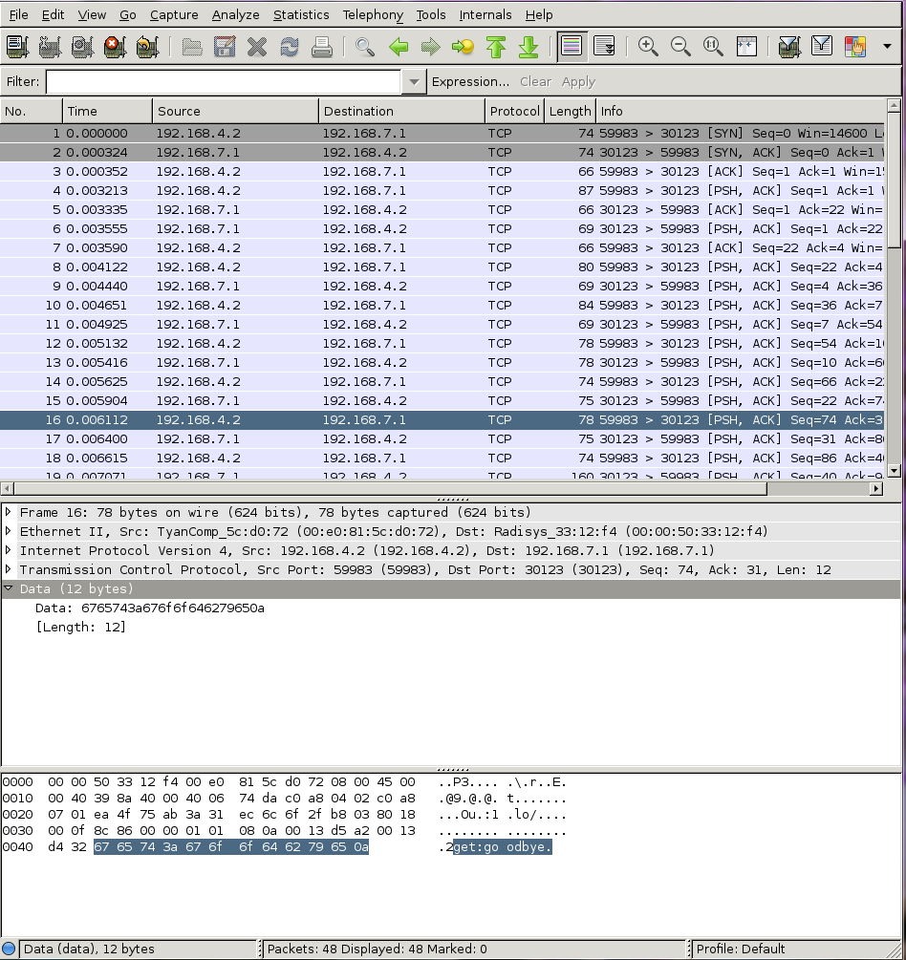

Now, how much time passes between the sending of the packet and the response?
Time difference = 0.006400 – 0.006112 =0.000288 seconds = 288 microseconds

Part G (10 points). In this part, you will measure the performance of your application in another way. Run the provided longScript on the client. This performs a large number of puts and gets. Make a screen capture of the two monitoring windows showing the packet traffic in the network.
Paste the screenshot here
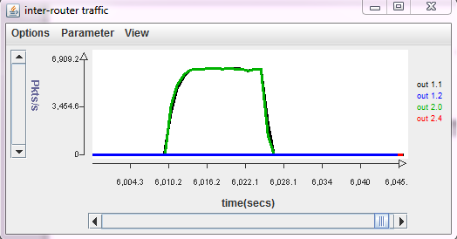
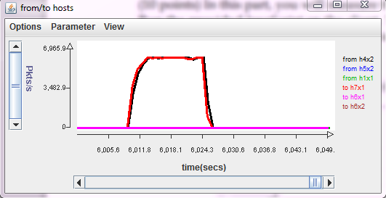

What does the traffic data tell you about the performance of the application?
The charts show a traffic rate of nearly 7000 packets per second in each direction.
We can also know it takes 1/7000 seconds, approximately 143 microseconds between each pair of commands.

Repeat the above experiment while running Wireshark on h7x1. Select a packet going from h4x2 to h7x1 from somewhere near the middle of the capture.
Paste a copy of your Wireshark window here.
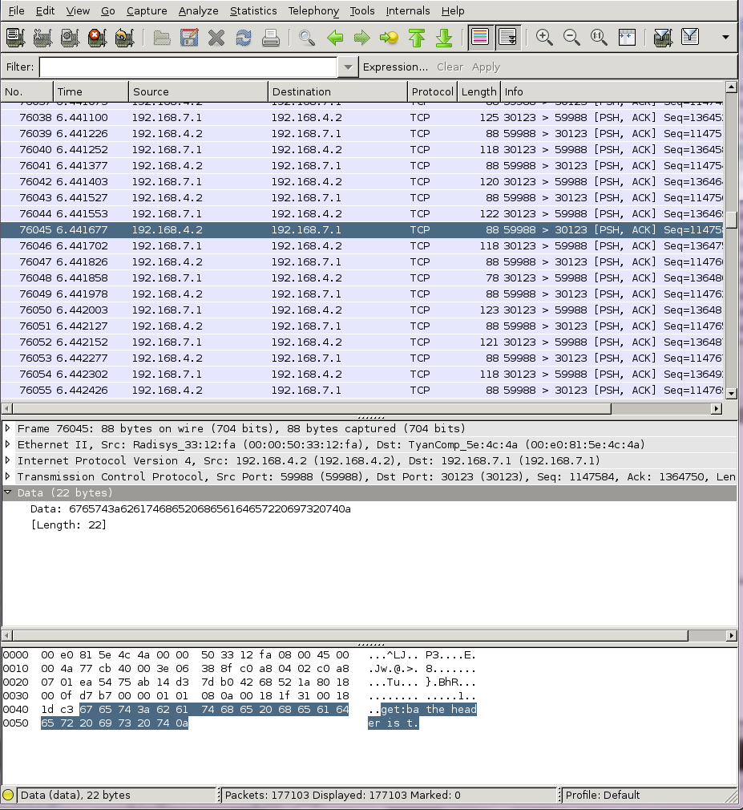

How much time passes between when h7x1 receives the packet and the time it sends its reply?
Time difference = 6.441702 – 6.441677 = 0.000025 = 25 microseconds

How much time from when h7x1 receives this packet and the time it receives the next one.
The time when h7x1 receives this packet: 6.441677
The time when h7x1 receives the next one: 6.441826
Time difference = 6.441826 – 6.441677 = 0.000149 = 149 microseconds

Is this consistent with what you observed based on the packet rate chart?
Since one packet is sent and received in 149 microseconds, we can calculate the number of packets sent in 1 second by doing the calculation of 1 second / 149microseconds = 6711 packets/second, which is consistent with the rate in the chart.

