case frac bar: end
case frac skw: 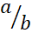 end
case frac lin: 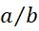 end
case frac noBar: end
case sqrt: end
case root: 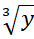 end
case sup: end
case sub: end
case subsup: end
case pre: end
case integral: 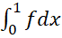 end
case sum: 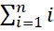 end
case product: 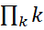 end
case delim: 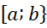 end
case paren: 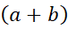 end
case func: 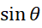 end
case limlow: 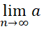 end
case limupp: end
case acc: end
case acc hat: end
case bar top: end
case bar bot: end
case box: end
case borderbox: 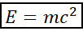 end
case eqarr: 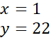 end
case matrix: 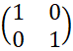 end
case groupchr: 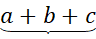 end
case groupchr top: end
case phant: 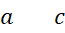 end
case styles: 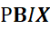 end
case scripts: 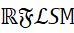 end
case normal text: 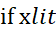 end
case colour: 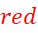 end
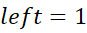
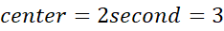
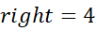
last paragraph
table cell | 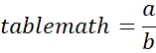
note anchor


