**Personal Portfolio Template**

(Group 94)

HUGH MCINTYRE N9169814

(Github)

**Artefact 1** – (Name of Artefact)

Med UI Design, High UI Design

(Screen capture of where it’s used)

(Brief description of how it was used/contribution to the project)

(Github path for backup and verification purposes only)

(Relevant story from sprint - X)

These UI designs were used to get an idea of how the clients wanted the web application to look like. The first UI design was created in the first interaction with the customer to get an understanding of how the client imagined the web application to be. The UI designs provide a base for the website so it is relevant to multiple stories.

The Homepage/Welcome page drawing at the top shows two different layout methods to display information such as: “Top 10”, “Activities” etc. One method on the left uses blocks to display the information and the drawing on the right displays the information using banners. The drawing at the bottom shows a rough example of the layout once the user is logged in. In blocks it will display information relevant to the logged in user account, e.g. Student user will display universities.

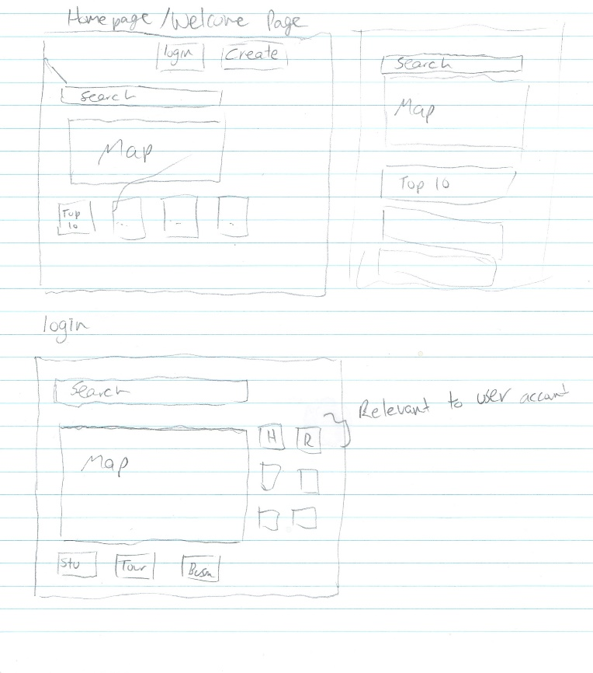

A more detailed drawing of the homepage was then created. The client decided to use a navigation bar to display Home, About, Contact Details, Register and Login. This will allow the user to easily select the page they are looking for. The user can then select the City they are in so that they are able to search locations within the city.

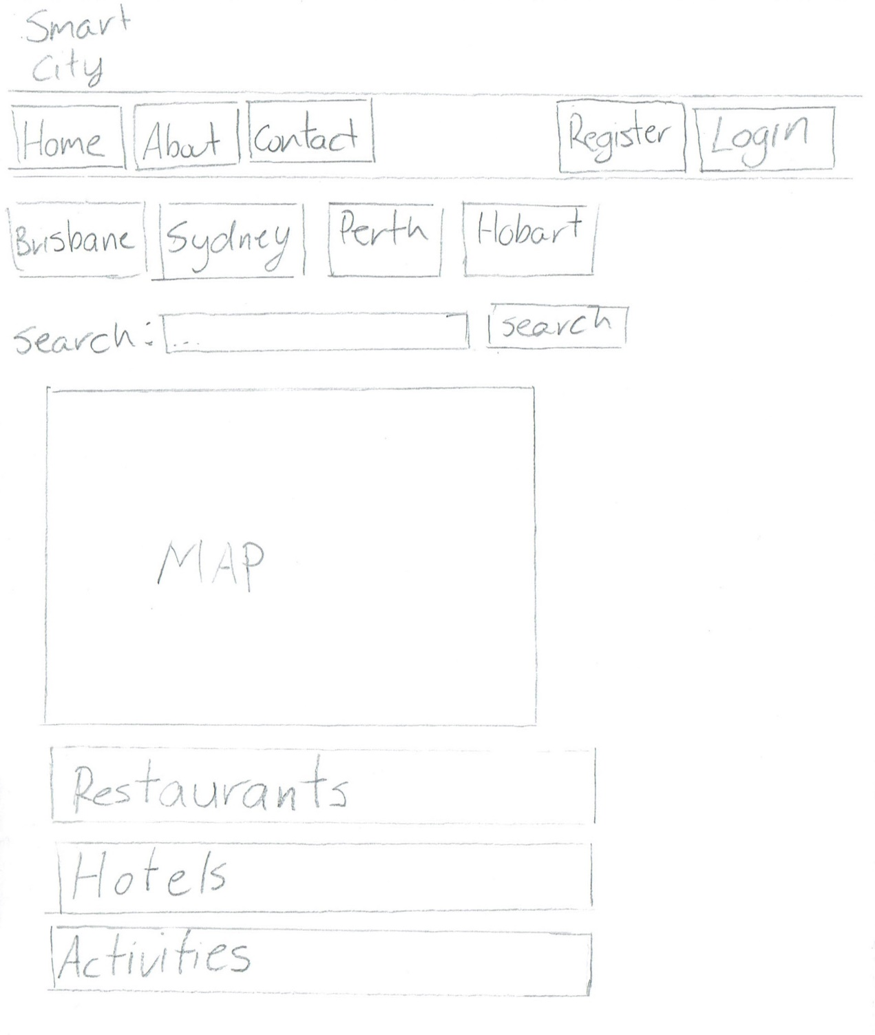

Login page drawing

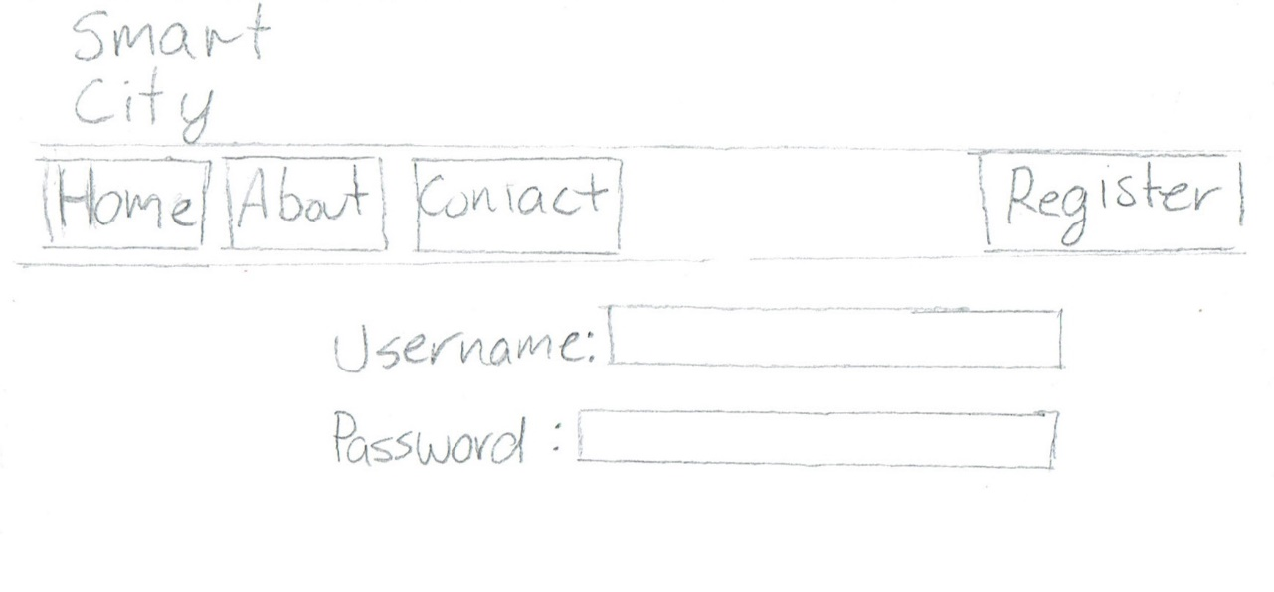

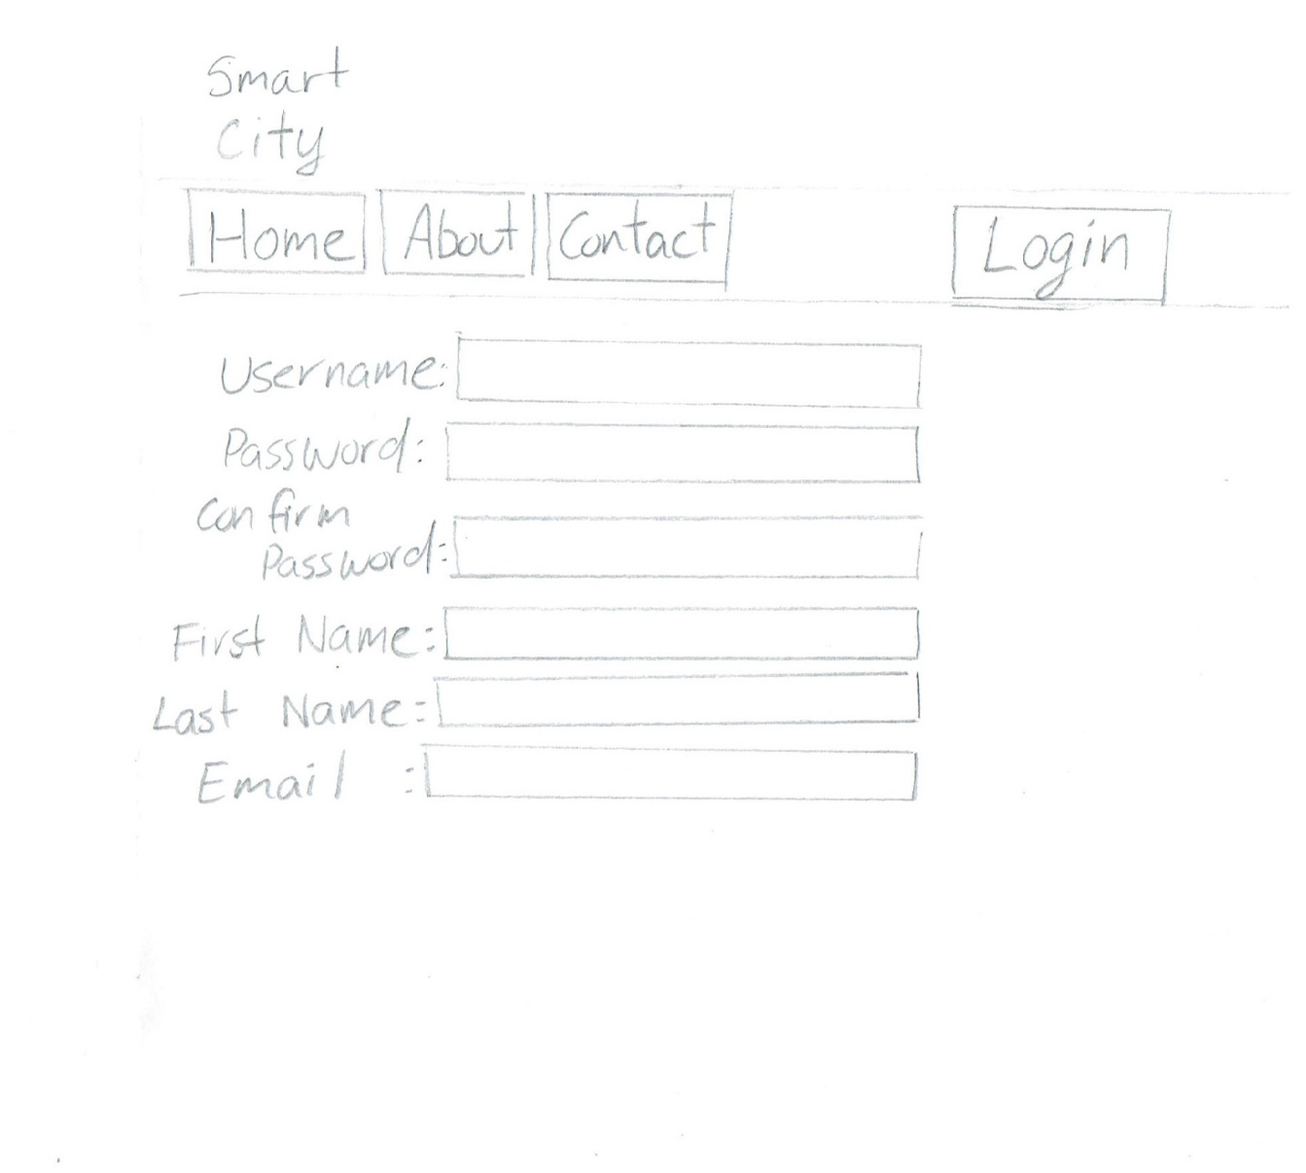Register Page drawing

**Artefact 2** – (Name of Artefact)

Web Prototyping tool to create examples of the user interface.

(Screen capture of where it’s used)

(Brief description of how it was used/contribution to the project)

(Github path for backup and verification purposes only)

(Relevant story from sprint - X)

The client was very pleased with the Low-Med level UI designs, a mockup website that was created using Balsamiq. This gave the client an example of what the layout and feel of the website would be. It also gave the fellow developers an image to base the web application on .

Below is a UI design of the Home/Welcome page.

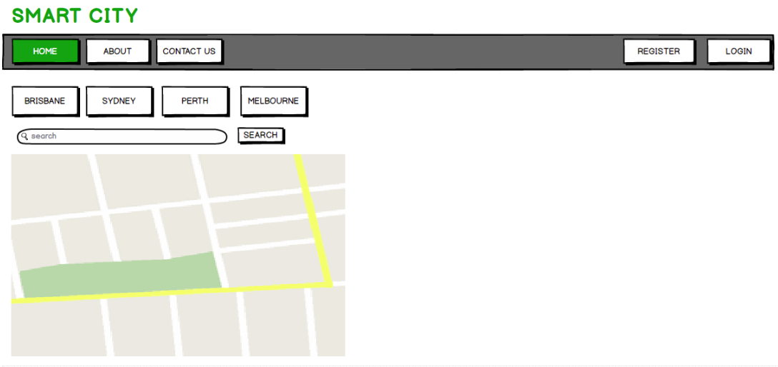

After further discussions with the client, it was decided to display the results in blocks to the left of the map, so that the user can easily click on them to find information.  
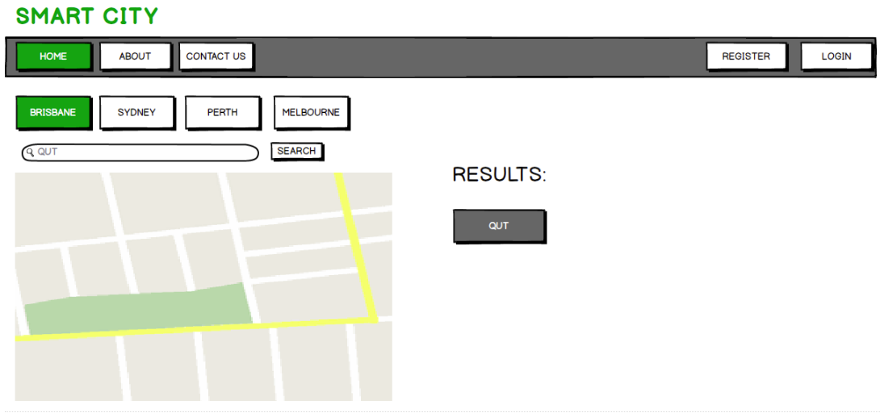

About page

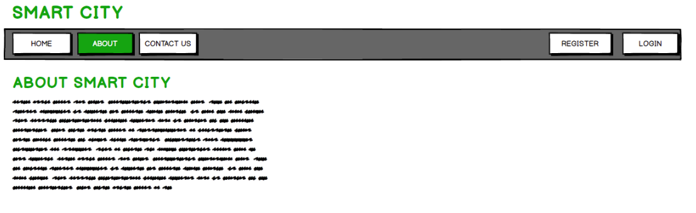

Contact Page

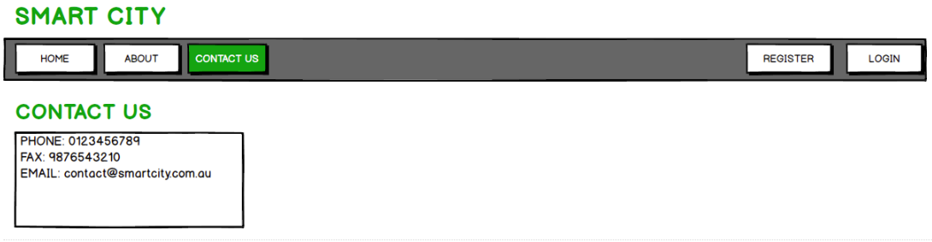

Register

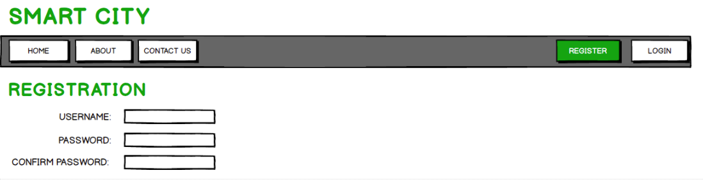

Login

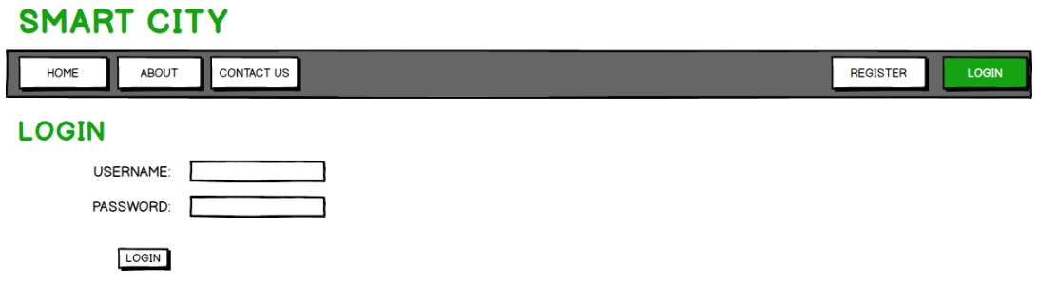

The two images below display two different error messages for when the user enters the wrong username or password. The first is a popup message, the second being a simple error text which is only display if the user tries to login with an unknown account. Both methods were shown to the client and the second simple text option was chosen for the web application.

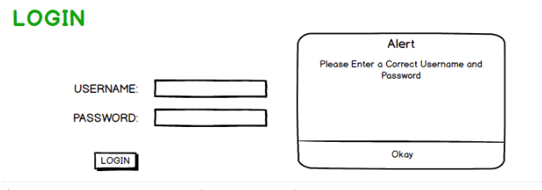

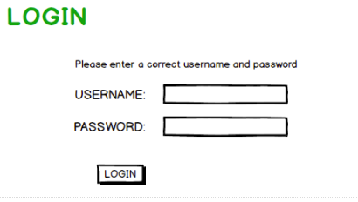

**Artefact 3** – (Name of Artefact)

LOGO

(Screen capture of where it’s used)

(Brief description of how it was used/contribution to the project)

(Github path for backup and verification purposes only)

(Relevant story from sprint - X)

Several different logo designs were drawn up so that the client can have a selection of which logo they desired. The logo will be used on the top of every page on the web application, that is why it is important to have an appealing logo.

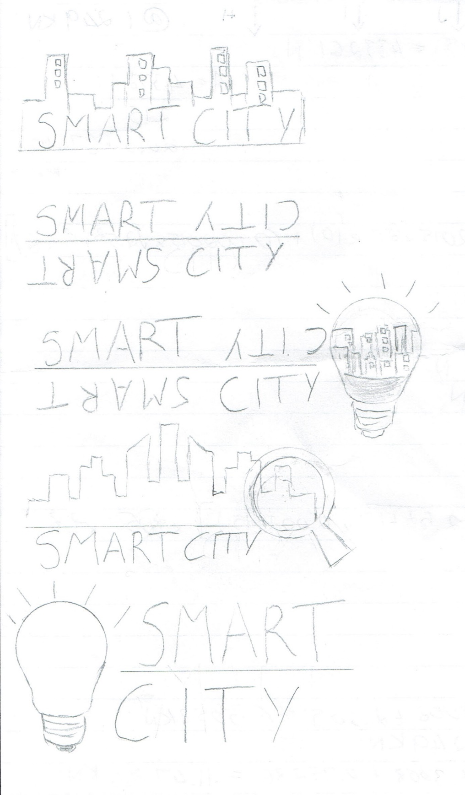

The forth logo was chosen due to its relevance to the function of the web application. Shown below if the completed logo.



**Artefact 4** – (Name of Artefact)

Implementing Map

(Screen capture of where it’s used)

(Brief description of how it was used/contribution to the project)

(Github path for backup and verification purposes only)

(Relevant story from sprint - X)

The map is used to find the location of what the user is looking for in a specific city. The user will select the city that they are in, then use the search to find the location/information they are after. This related back to our second story ID: “A map displaying relevant locations”

The image below displays the city “Brisbane” selected by the user (highlighted in green). The map then displays the city selected.

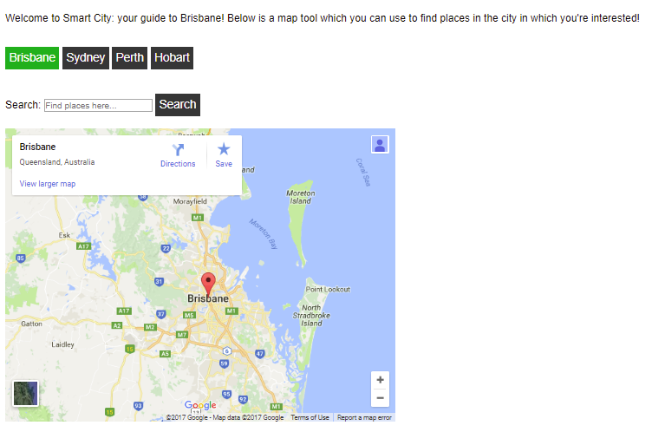

The user is then able to search locations/information using the search bar. The image below shows the results from searching “QUT”. The results are then displayed below the map.

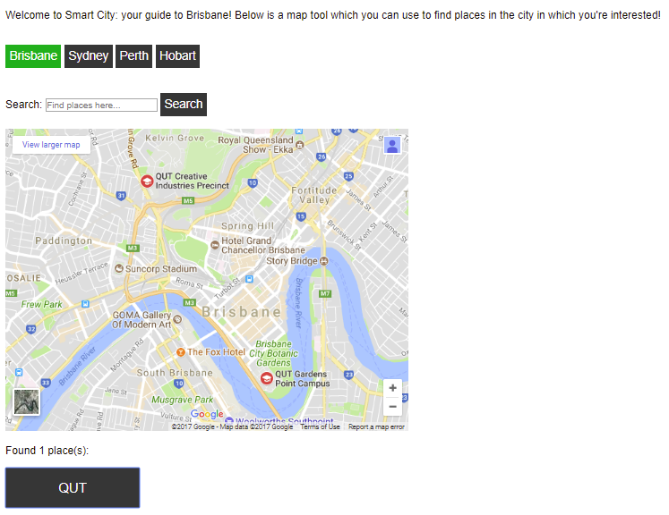

The code below shows how the map was implemented. The code takes the query that is searched and saves it as a variable. It then uses the Google maps API to search the query at the city location (e.g. Brisbane). If nothing is entered in the search bar, the map displays the city that is selected.

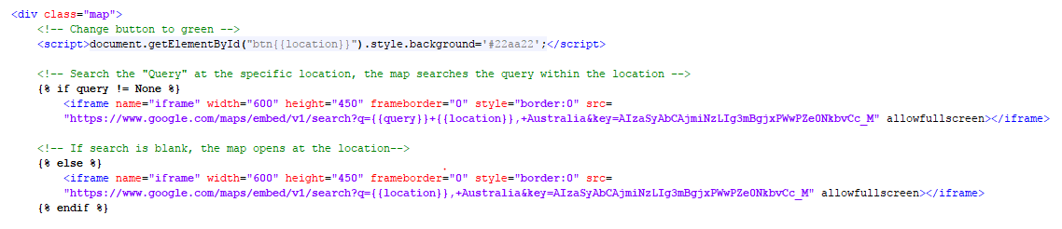

**Artefact 5** – (Name of Artefact)

Ensuring SCRUM adoption by each team member

The burndown chart was used to display the progress of sprint 1. I was in charge of updating the burndown chart whenever a task was completed and also ensuring each member was following the SCRUM adoption. There were high amounts of communication with the team to ensure that the tasks were being completed a head of schedule. As shown on the chart below we were ahead of schedule for majority of sprint 1. However, the was not enough time to finish the remaining 7 tasks. These will have to be pushed to the next sprint. The burndown chart gives the team a realistic view of our progress. This is a very useful tool as it shows whether we were behind or in front of schedule. I will use this chart to keep everyone updated on our progress throughout the project.