|  |  |  |
| --- | --- | --- |
| *Hugh McIntyre* | *N9169814* | Developer |
| *Klein Geard* | *N9937706* | Developer |
| *Daniel Field* | *N9932496* | Developer |
| *Brandon Coyte* | *N9750436* | Client, Scrum master |

Prepared for:

*Benjamin Saljooghi*

*6/10/2017*

Effective communication with the team

During our first sprint, we made full use of online tools available to us such as:

*Facebook groups*

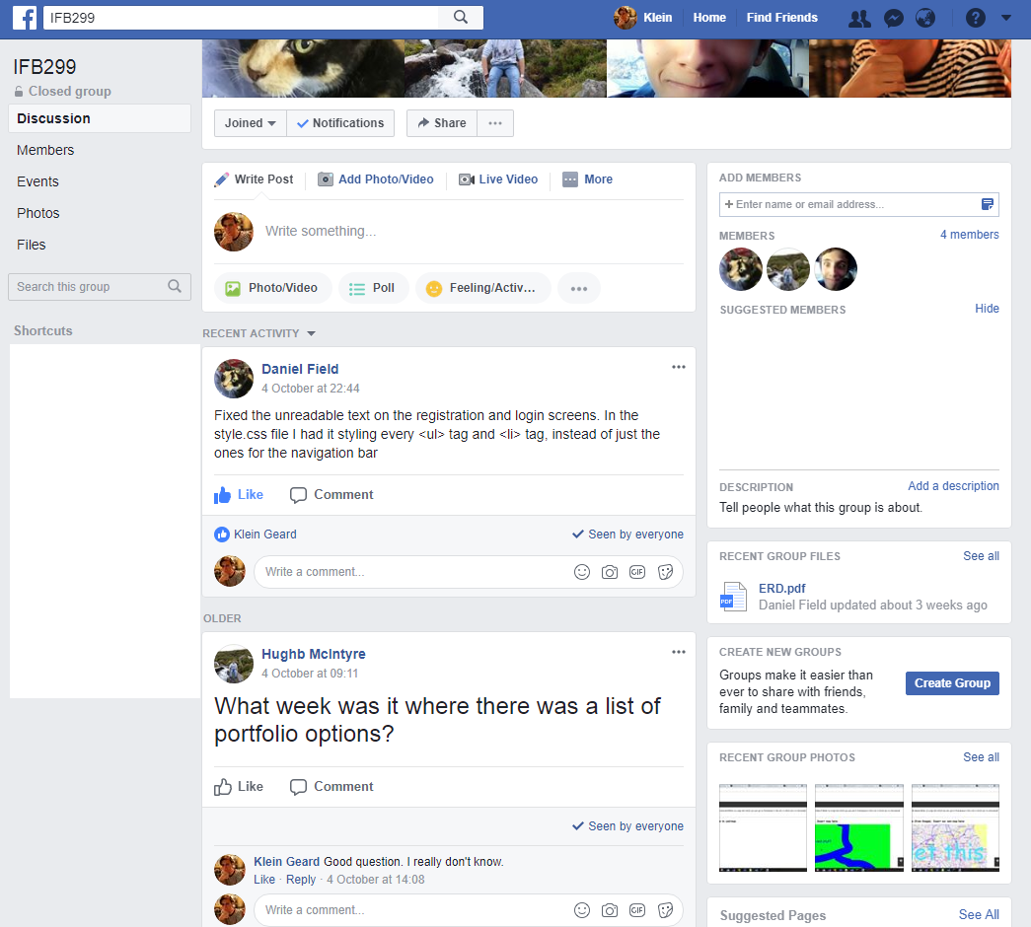

*Github issues*

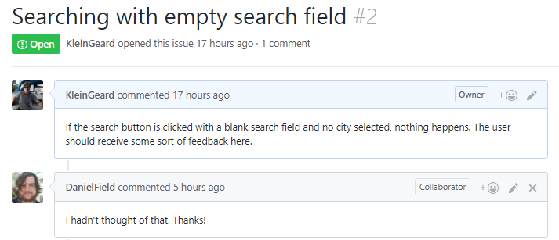

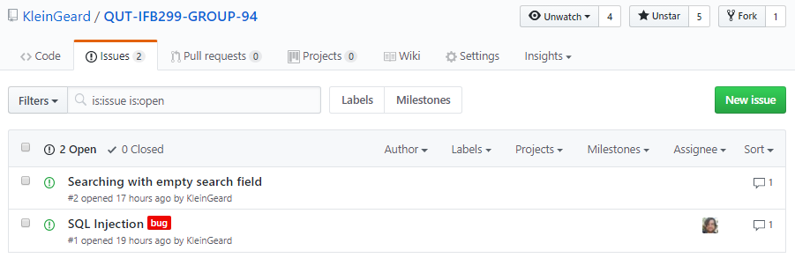

*Google Drive*

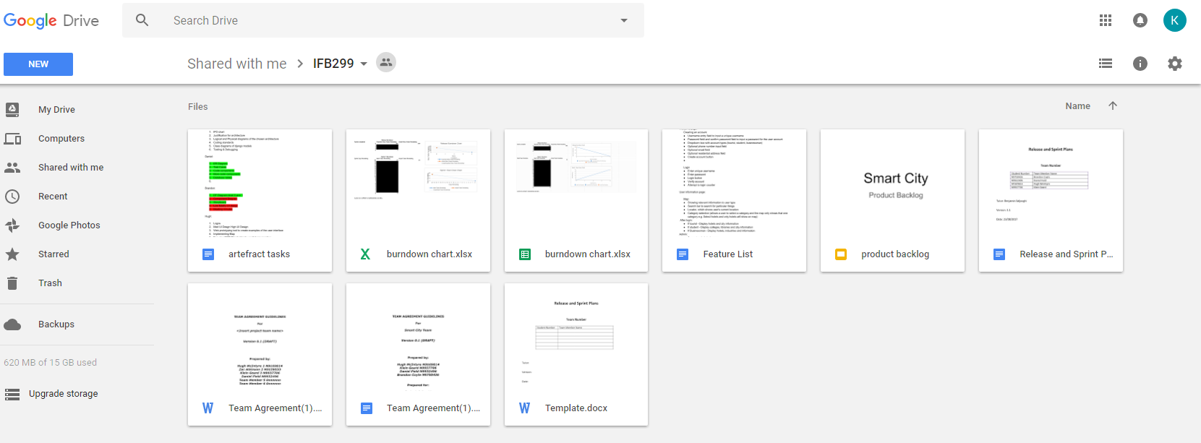

Overall, I can confidently say that communication within our group ran quite smoothly and I can’t say there is much we will do differently during our next sprint iteration.

Effective team participation (e.g., talking with tutor or client)

Throughout the course of our first sprint iteration, we have asked our tutor for feedback and clarity regarding the requirement area. We have recorded the feedback we have received.

Klein:

* I asked my tutor for advice and feedback regarding the descriptions stating how artefacts are relevant to our sprint. In response, I was told that I was doing well.
* I expressed my concern with the subjectivity of marking criteria and in response I was told it’s just how it is.
* For my coding standards artefact, I was told that simply setting the coding standards is not enough and that I would have to provide evidence of its enforcement to demonstrate software engineering skills.
* For my justification for architecture and my diagrams, I was given a nod of approval and a “yeah”.

Daniel:

* I asked the tutor what a view is in Django. He responded by asking if I knew about model-view controller (MVC). This sparked my brain into remembering what I had learned about MVC previously.
* Can we use Google Maps to embed a map of the city within our project? The tutor said yes, and that helped save a LOT of time.

Hugh:

* I asked the tutor about the best methods for implementing the map. The tutor told me the best way would be to use a Google maps API, as they are very simple to integrate. This helped me greatly because the Google API method was a lot easier than trying to create our own map.

Effective efforts to control the quality of the project

Klein:

I have put in quite a lot of effort into ensuring the quality of the work of my team members. To assist my team members, I have done things such as teach modelling software to my team members, improve code quality, and provide my own feedback and suggestions to group members. My own team members have also done the same for me by reading through my artefacts and telling me whether or not it made sense to them and what potential improvements I could make.

Effective keeping the client or tutor informed

Throughout the course of the sprint, our client has been able to keep track of our project by viewing our burndown charts:

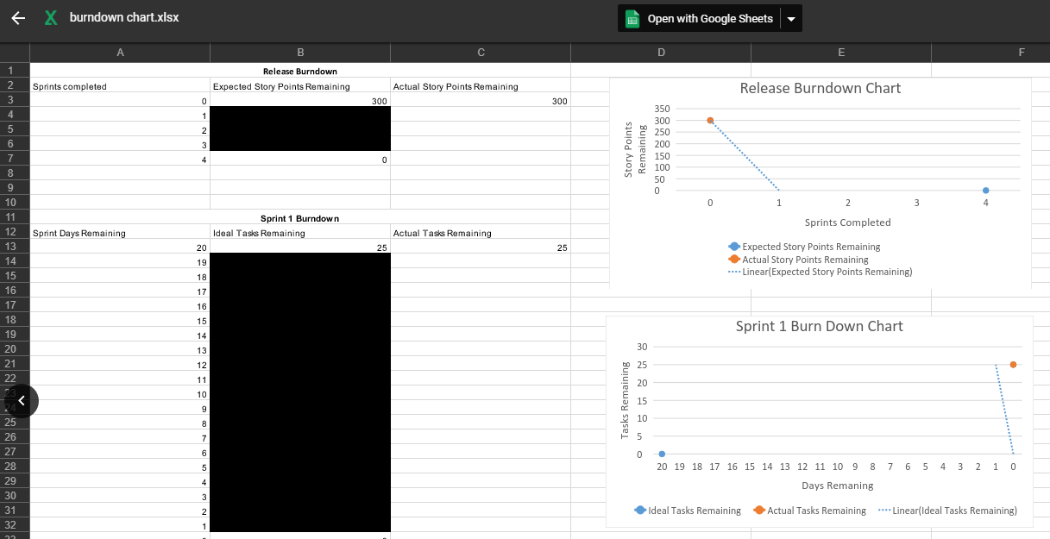

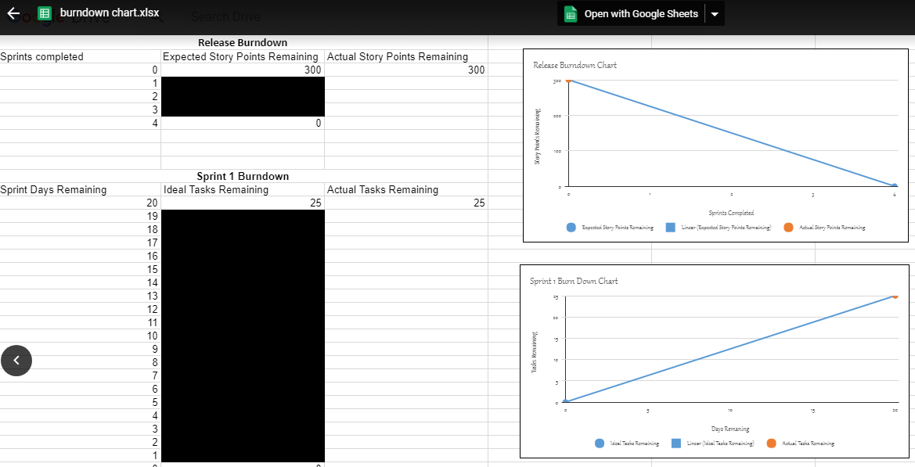

Our client and tutor have also been active in our discussions and provided regular input during the course of our sprint.

Issues raised

Daniel:

*“One of the problems with our web application is that the cities are hardcoded into the system and administrators are unable to add additional cities without manually editing the database and the code - This is a big issue if the business decides to expand. Currently it supports Brisbane, Sydney, Hobart, and Perth.”*

Hugh:

*“My understanding of Django limited me as I could not effectively complete as many tasks as I would have liked. We failed to complete all the tasks in the sprint, this could come down to not knowing whether we were in front or behind schedule.”*

Klein:

*“For me, dealing with merge conflicts was the most difficult part about this project as Daniel and I were often working on the code repository and making commits at the same time. One issue we had while dealing with merge conflicts was where we accidentally discarded a large part of our code which caused our application to break.”*