SYSTEM NAVIGATION SCENARIOS

PENRO Report Submission Tracker & Indicator System

SCENARIO 1: WORKER - ON-TIME DIGITAL SUBMISSION
User: Juan Dela Cruz (ICT Department)
Date: May 3, 2025 | Deadline: May 5, 2025

Navigation Steps:
- Login → System shows: "Welcome, Juan Dela Cruz - ICT Department"
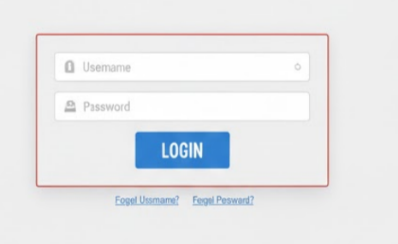
- Dashboard View:
  - Status: "Not Submitted" (Red)
  - Banner: "Report Due: May 5, 2025 (2 days remaining)"
  - 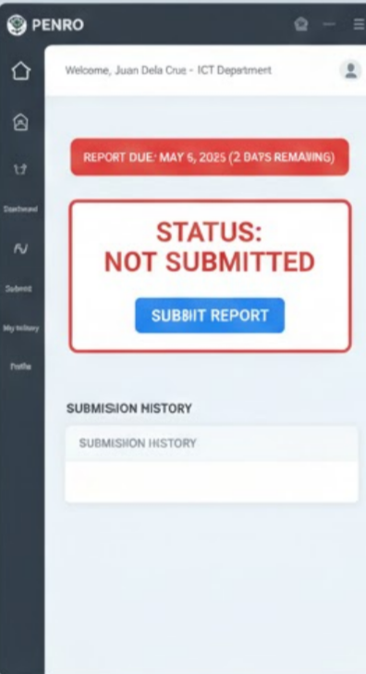
- Click "Submit Report"
  - Check submission method:
    - ☑ Upload file
    - ☐ Deliver documents to admin personally
  - Choose file: ICT_Report_May2025.pdf
  - Add notes (optional): "All systems operational"
  - Click "Submit Report"
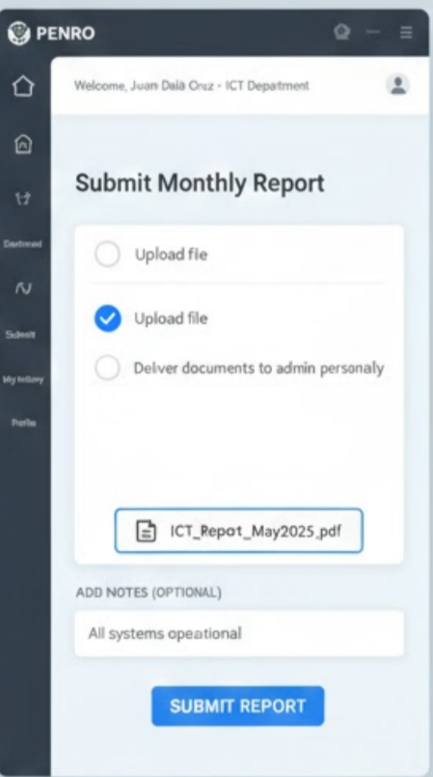
- Result:
  - System automatically determines: "Submitted (On Time)" (Green/Yellow)
  - Timestamp: May 3, 2025 - 2:45 PM (Before deadline)
  - Status: "Pending Review"
  - Email confirmation sent
  - 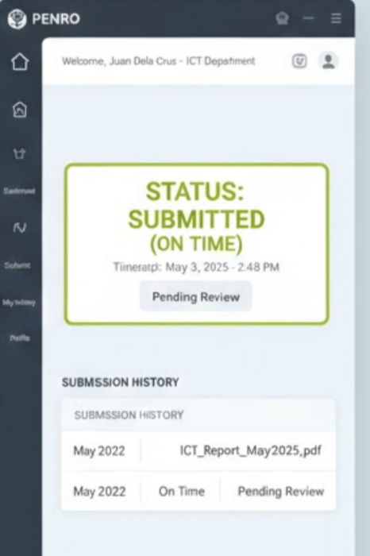

SCENARIO 2: WORKER - LATE PHYSICAL SUBMISSION
User: Ana Reyes (Planning Department)
Date: May 6, 2025 | Deadline: May 5, 2025 (passed)

Navigation Steps:
- Login → System shows alert: "⚠️ DEADLINE PASSED - Report was due May 5, 2025"
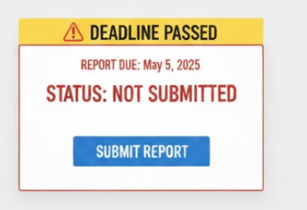
- Dashboard View:
  - Status: "Not Submitted" (Red)
  - Deadline shown in red
- Click "Submit Report"
  - Check submission method:
    - ☐ Upload file
    - ☑ Deliver documents to admin personally
  - Add notes: "Report submitted physically to Admin Maria"
  - Upload proof (optional): received_stamp.jpg
  - Click "Submit"
- Result:
  - System automatically determines: "Submitted (Late)" (Orange)
  - Timestamp: May 6, 2025 - 9:15 AM (After deadline: May 5, 2025)
  - Status: "Pending Review"
  - Email confirmation sent
  - 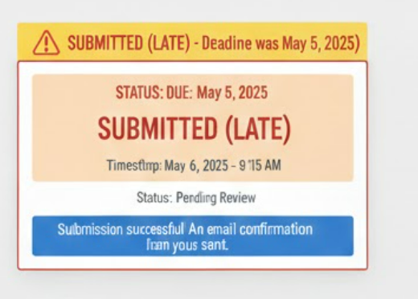

SCENARIO 3: ADMIN - REVIEWING AND APPROVING SUBMISSION
User: Maria Santos (Administrator)
Date: May 6, 2025

Navigation Steps:
- Login → Admin Dashboard shows:
  - Overview: "5 Pending Review | 12 Submitted | 3 Not Submitted"
  - List of pending reviews
  - 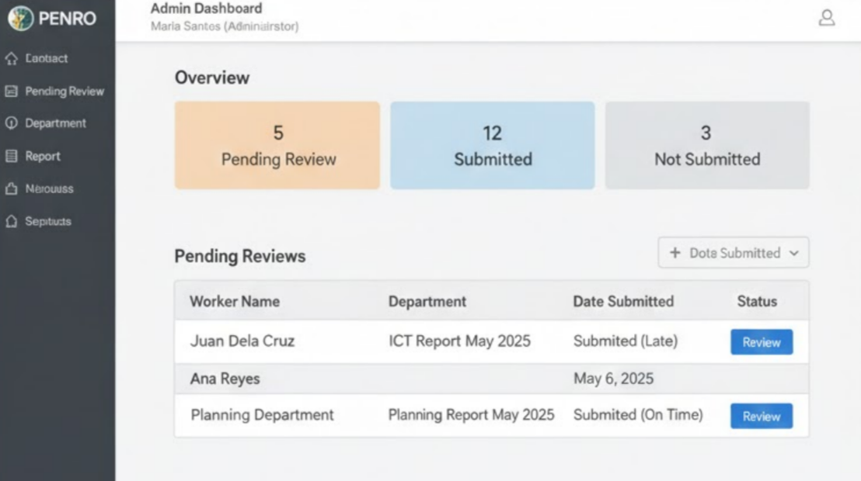
  - 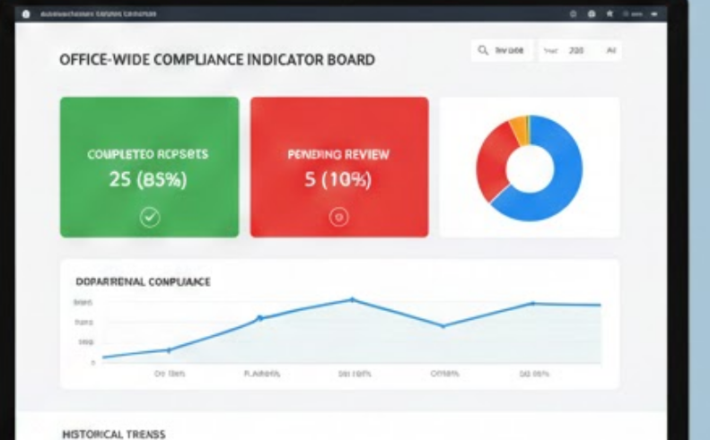
- Click "Review" on Juan's submission
  - View details: Worker name, department, file, timestamp
  - Download and review: ICT_Report_May2025.pdf
  - Document is complete and accurate
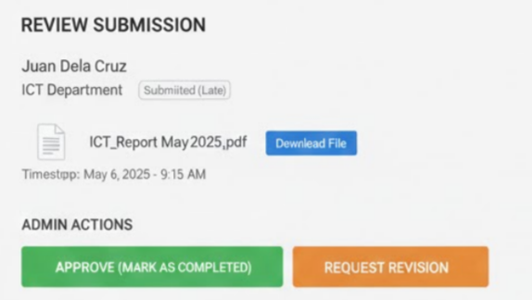
- Approve the submission:
  - Click "Approve (Mark as Completed)"
  - Add remarks: "Report approved. All sections complete."
  - Click "Submit Approval"
- Result:
  - Juan's status changes to: "Completed" (Green)
  - System sends notification to Juan (in-app + email)
  - Timestamp logged: Reviewed by Maria Santos, May 6, 2025 - 2:30 PM
  - 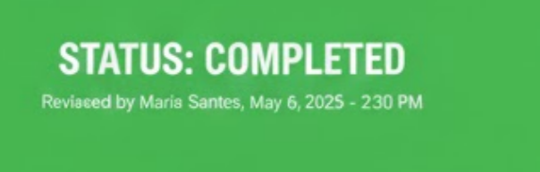

SCENARIO 4: ADMIN - REQUESTING REVISION
User: Maria Santos (Administrator)
Date: May 6, 2025

Navigation Steps:
- Click "Review" on Ana's submission
  - View details: Worker name, department, proof image
  - Review physical report
  - Found issues: Missing data in Section 3, incomplete table
- Request revision:
  - Click "Request Revision"
  - Type issues to address:
    - "Section 3: Add Q2 projections data"
    - "Budget table on page 4: Complete missing figures"
  - Upload annotated file (optional): Ana_Report_Annotated.pdf
  - Click "Submit Review"
- Result:
  - Ana's status changes to: "For Revision" (Orange)
  - System sends notification to Ana (in-app + email) with feedback
  - Timestamp logged: Reviewed by Maria Santos, May 6, 2025 - 2:45 PM
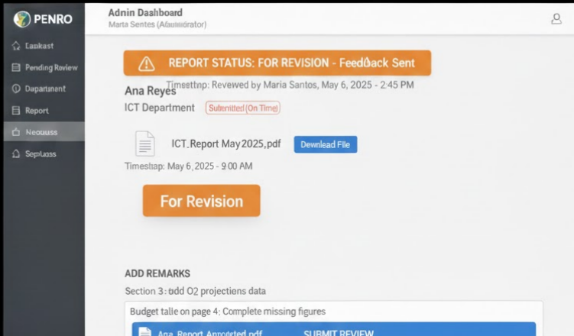

SCENARIO 5: WORKER - RESUBMITTING AFTER REVISION
User: Ana Reyes (Planning Department)
Date: May 7, 2025

Navigation Steps:
- Login → Dashboard shows:
  - Status: "For Revision" (Orange)
  - Red badge: "Action Required: Resubmit Report"
  - Admin feedback visible
- Click "Resubmit Report"
  - System shows previous feedback
  - Check submission method:
    - ☐ Upload file
    - ☑ Deliver documents to admin personally
  - Add notes: "All corrections completed as requested"
  - Upload proof: received_stamp_resubmission.jpg
  - Click "Resubmit"
- Result:
  - System uses current timestamp: May 7, 2025 - 9:00 AM
  - Status: "Resubmitted - Pending Review (Version 2)" (Yellow)
  - Version history shows: v1, v2 (current)
  - Admin Maria receives notification
  - Email confirmation sent to Ana

SCENARIO 6: ADMIN - APPROVING RESUBMISSION
User: Maria Santos (Administrator)
Date: May 7, 2025

Navigation Steps:
- View notification: "Ana Reyes resubmitted May 2025 report (Version 2)"
- Click "Review"
  - System shows version history: v1 (required revision), v2 (current)
  - View Ana's notes about corrections made
  - Review physical report
  - All corrections verified
- Approve resubmission:
  - Click "Approve (Mark as Completed)"
  - Add remarks: "Resubmission approved. All corrections addressed."
  - Click "Submit Approval"
- Result:
  - Ana's status changes to: "Completed" (Green)
  - Final version: v2
  - System sends notification to Ana (in-app + email)
  - Full history logged: Submitted (Late) → Required Revision → Resubmitted → Approved

SCENARIO 7: ADMIN - GENERATING MONTHLY REPORT
User: Maria Santos (Administrator)
Date: May 10, 2025

Navigation Steps:
- Navigate to: "Reports & Analytics"
  - Quick stats visible:
    - "Completed: 25 (83%) | Not Submitted: 3 (10%)"
    - "On Time: 20 (80%) | Late: 5 (20%)"
- Generate report:
  - Select Report Type: "Monthly Summary"
  - Select Period: May 2025
  - Select Department: "All"
  - Select Format: "Both (Excel and PDF)"
  - Click "Generate Report"
  - 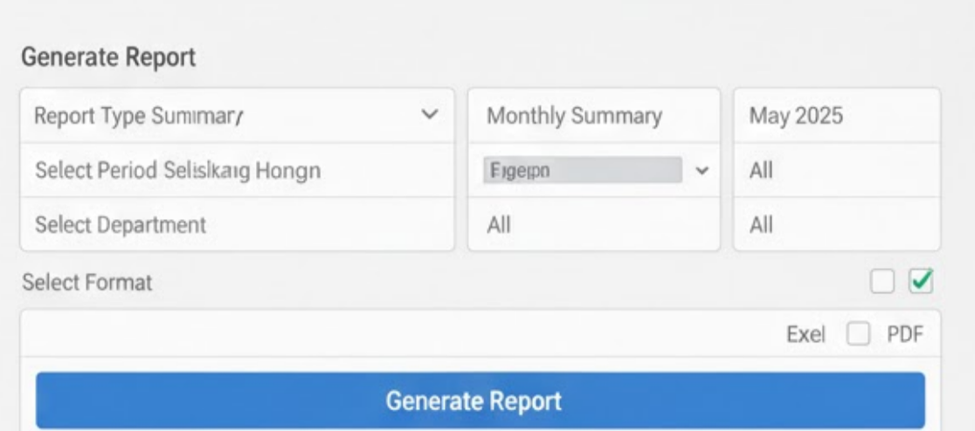
- System processing:
  - Loading: "Generating report..."
  - Success: "Report Generated Successfully!"
  - 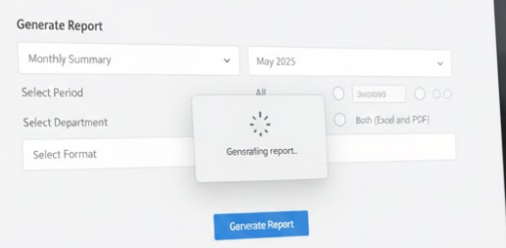
- Download options:
  - Click "Download Excel" → File: PENRO_Report_May2025_Summary.xlsx
  - Click "Download

SCENARIO 9: MANAGEMENT - VIEWING DASHBOARD
User: Director Rodriguez (Management - Read Only)
Date: May 11, 2025

Navigation Steps:
- Login → System shows: "Welcome, Director Rodriguez - Management View"
- Management Dashboard displays:
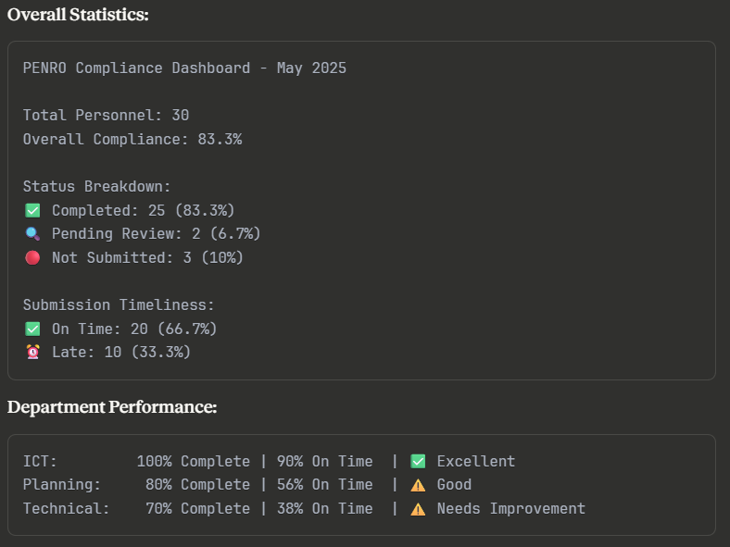
• Click on "Technical Department"
- Drills down to worker list (read-only)
- Can see individual statuses
- Cannot edit or change anything
• Actions available:
- View detailed reports
- Export data
- Compare previous months
- View trends/graphs

SUMMARY OF KEY NAVIGATION FLOWS

Worker Actions:
- Login → View dashboard → Submit report (checkbox: upload/physical) → See status (auto-determined on-time/late)
- If "For Revision" → Resubmit → Wait for approval

Admin Actions:
- Login → View statistics (all departments with percentages)
- Click department → See worker list with statuses
- Review submissions → Approve / Request Revision
- Generate reports → Download or email

