
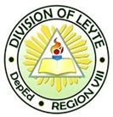
Republic of the Philippines
Department of Education
Region VIII( Eastern Visayas)
Division of Leyte
Tag-os Elementary School
Tag-os, Matalom, Leyte

7.4.2 Develop a personal professional improvement plan based on reflection of one’s practice and ongoing professional learning
NCOI

