**МИНОБРНАУКИ РОССИИ**

**Санкт-Петербургский государственный**

**электротехнический университет**

**«ЛЭТИ» им. В.И. Ульянова (Ленина)**

**Кафедра Вычислительной техники**

отчет

**по лабораторной работе №2**

**по дисциплине «Алгоритмы и структуры данных»**

Тема: Алгоритмы кодирования

**Вариант 2**

|  |  |  |
| --- | --- | --- |
| Студентка гр. 9302 |  | Кнауб К.В. |
| Преподаватель |  | Тутуева А.В. |

Санкт-Петербург

2021

# Постановка задачи

Реализовать кодирование и декодирование по алгоритму Шеннона-Фано входной стоки, вводимой через консоль. Посчитать объем памяти, который занимает исходная и закодированная строки. Вывести на экран таблицу частот и кодов, результат кодирования и декодирования, коэффициент сжатия.

# Описание реализуемого алгоритма и структур данных

В данной лабораторной работе был использован созданный раннее ассоциативный массив на основе красно-черного дерева.

|  |  |
| --- | --- |
| **Название** | **Описание** |
| void push_back() | добавление в конец списка |
| void push_front() | добавление в начало списка |
| void pop_back() | удаление последнего элемента |
| void pop_front() | удаление первого элемента |
| void insert() | добавление элемента по индексу |
| data_T at() | получение элемента по индексу |
| void remove() | удаление элемента по индексу |
| size_t GetSize() | получение размера списка |
| void print_to_console() | вывод элементов в консоль через разделитель |
| bool isEmpty() | проверка на пустоту списка |
| void clear() | удаление всех элементов списка |
| void reverse | изменение порядка элементов на обратный |
| void set(size_t, data_T) | замена элемента по индексу |
| data_T top() | получение первого элемента в списке |

|  |  |
| --- | --- |
| **Название** | **Назначение** |
| void insert | добавление элемента с ключом и значением |
| void remove | удаление элемента дерева по ключу |
| Tree_Node* find | поиск элемента по ключу |
| void clear | очищение ассоциативного массива |
| void get_keys | возвращает список ключей |
| void get_values | возвращает список значений |
| void print | вывод в консоль |
| void Insert_fixup | восстанавливает свойства дерева после вставки нового узла в дерево |
| void Transplant | перемещает поддеревья в дереве |
| void Remove_fixup | восстанавливает свойства дерева после удаления узла из дерева |
| void NIL_Root | создает новый объект NIL |
| void Left_turn | метод левого поворота |
| void Right_turn | метод правого поворота |
| Tree_Node* get_Root | передаёт методам необходимых указателей |
| Tree_Node* get_Parent | передает методам необходимых указателей |
| Tree_Node* Tree_min | возвращает указатель на минимальный элемент |

|  |  |
| --- | --- |
| **Название** | **Описание** |
| void Bubble_Sort() | сортировка массивов |
| void Search_Border() | поиск середины массива |
| void Shannon_Fano() | алгоритм шеннона-фано |
| Void Fill_Array() | работа с массивом |
| void Decoding() | кодирование и декодирование |

# Оценка временной сложности каждого алгоритма

|  |  |
| --- | --- |
| void Bubble_Sort() | $$O(N^{2})$$ |
| void Search_Border() | $$O(N)$$ |
| void Algorithm_Fano() | $$O(N^{2})$$ |
| void Fill_Array() | $$O(N)$$ |
| void Decoding() | $$O(N^{2})$$ |

# Описание реализованных unit-тестов

|  |
| --- |
| **Название теста** |
| Bubble_Sorting_1 |
| Bubble_Sorting_2 |
| Border_Search_1 |
| Border_Search_2 |
| Algorithm _Fano |

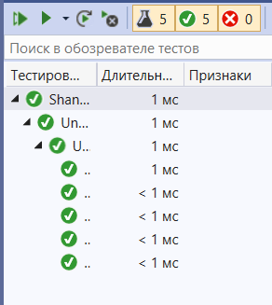

# Пример работы

The first half of life consists of the capacity to enjoy without the chance, the last half consists of the chance without the capacity.

Mark Twain

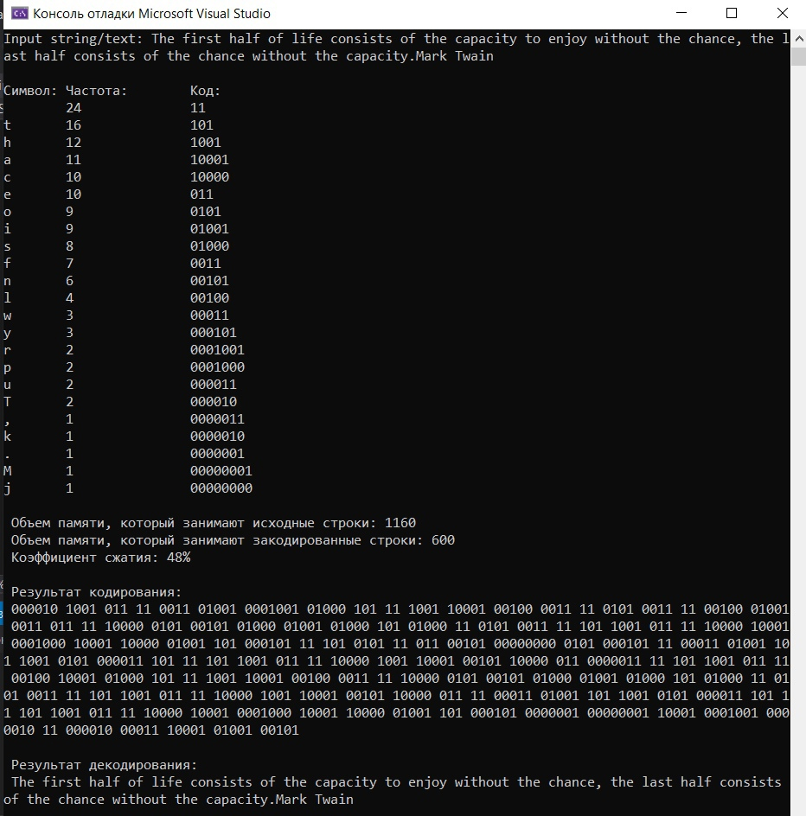

The roots of education are bitter, but the fruit is sweet.

Aristotle

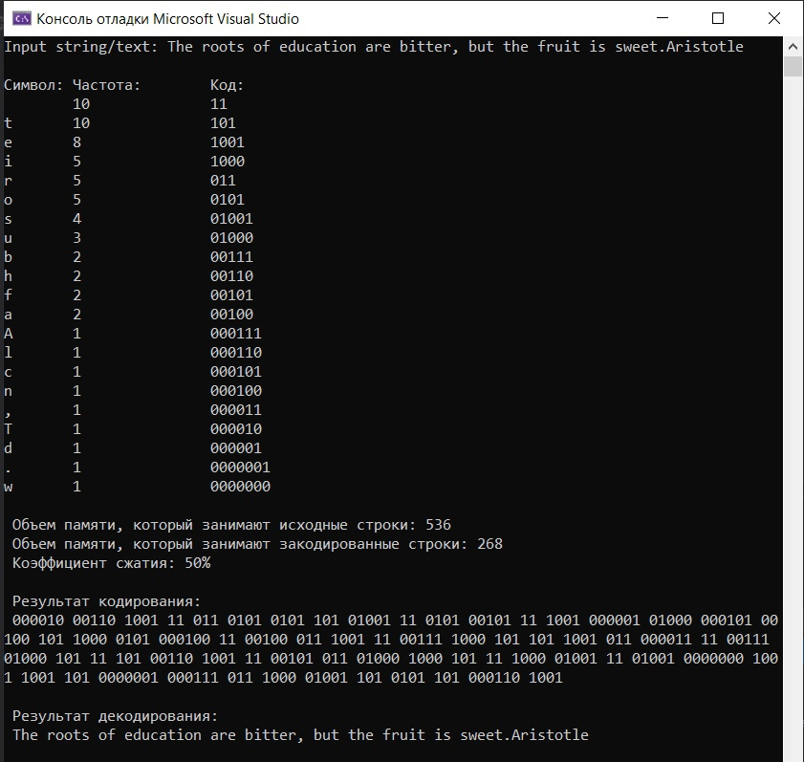

It is with our passions, as it is with fire and water, they are good servants but bad masters.

Aesop

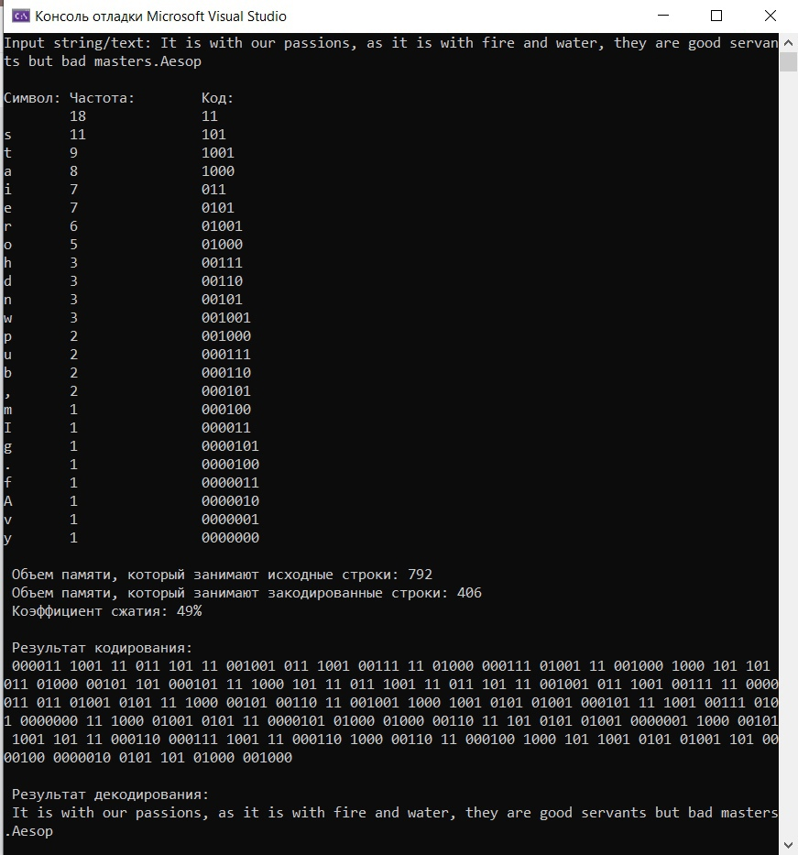

# Листинг

|  |
| --- |
| **LinkedList.h** |
| #pragma once  template<class NODE_TYPE>  class LinkedList  {  public:    LinkedList();  ~LinkedList();  void push_back(NODE_TYPE newEl);  void push_front(NODE_TYPE newEl);  void pop_back();  void pop_front();  void insert(NODE_TYPE newEl, size_t index);  int at(size_t index) const;  void remove(size_t index);  size_t get_size();  void print_to_console();  void clear();  void set(size_t index, NODE_TYPE newData);  bool isEmpty();  void sort();  size_t find_first(LinkedList *list);  bool isPrinted();  private:  class Node  {  public:  Node(NODE_TYPE data, Node* next = nullptr, Node* prev = nullptr)  {  this->data = data;  this->next = next;  this->prev = prev;  }  NODE_TYPE data;  Node* next;  Node* prev;  };    Node* head;  Node* tail;  size_t size;  };  #include "LinkedList.inl" |
| **LinkedList.inl** |
| #include "LinkedList.h"  #include <iostream>  #include <stdexcept>  #include <string>  #include <iomanip>  using namespace std;  template<class NODE_TYPE>  LinkedList<NODE_TYPE>::LinkedList()  {  head = nullptr;  tail = nullptr;  size = 0;  }  template<class NODE_TYPE>  LinkedList<NODE_TYPE>::~LinkedList()  {  clear();  }  template<class NODE_TYPE>  void LinkedList<NODE_TYPE>::push_back(NODE_TYPE newEl)  {  Node* temp;  if (size == 0)  {  head = new Node(newEl);  tail = head;  }  else  {  temp = tail;  tail->next = new Node(newEl);  tail = tail->next;  tail->prev = temp;  }  size++;  }  template<class NODE_TYPE>  void LinkedList<NODE_TYPE>::push_front(NODE_TYPE newEl)  {  Node* temp;  if (size == 0)  {  head = new Node(newEl);  tail = head;  }  else  {  temp = head;  head = new Node(newEl, head);  temp->prev = head;  }  size++;  }  template<class NODE_TYPE>  void LinkedList<NODE_TYPE>::pop_back()  {  if (size == 0)  return;  if (size == 1)  {  delete head;  head = nullptr;  tail = nullptr;  }  else  {  Node* cur = tail;  cur = cur->prev;  cur->next = nullptr;  delete tail;  tail = cur;  cur->prev = tail->prev;  }  size--;  }  template<class NODE_TYPE>  void LinkedList<NODE_TYPE>::pop_front()  {  if (size == 0)  return;  if (size == 1)  {  delete head;  head = nullptr;  tail = nullptr;  }  else  {  Node* cur = head;  cur = cur->next;  cur->prev = nullptr;  delete head;  head = cur;  }  size--;  }  template<class NODE_TYPE>  void LinkedList<NODE_TYPE>::insert(NODE_TYPE newEl, size_t index)  {  Node* temp_pointer = nullptr, * cur;  Node* temp = new Node(newEl);  cur = head;  int i = 0;  if (index >= size || index < 0)  throw out_of_range("Index is greater than list size");  while (cur != NULL && i<int(index))  {  cur = cur->next;  i++;  }  if (cur == NULL)  {  if (head == NULL)  {  cout << "List is empty\n";  return;  }  return;  }  if (cur != head)  {  temp_pointer = cur->prev;  cur->prev = temp;  temp->next = cur;  temp->prev = temp_pointer;  }  else  push_front(newEl);  if (temp_pointer != NULL)  temp_pointer->next = temp;  size++;  }  template<class NODE_TYPE>  int LinkedList<NODE_TYPE>::at(size_t index) const  {  if (size == 0)  cout << "List is empty\n";  if (index >= size || index < 0) {  throw out_of_range("Index is greater than list size");  }  if ((index < size) && (size != 0))  {  size_t counter = 0;  Node* cur = head;  while (counter != index)  {  cur = cur->next;  counter++;  }  return cur->data;  }  }  template<class NODE_TYPE>  void LinkedList<NODE_TYPE>::remove(size_t index)  {  size_t counter = 0;  Node* cur = head;  if (index >= size || index < 0)  throw out_of_range("Index is greater than list size");  while (counter != index)  {  cur = cur->next;  counter++;  }  if (cur == head)  {  pop_front();  return;  }  if (cur == tail)  {  pop_back();  return;  }  Node* prev, * next;  prev = cur->prev;  next = cur->next;  if (prev != NULL)  prev->next = cur->next;  if (next != NULL)  next->prev = cur->prev;  delete cur;  size--;  }  template<class NODE_TYPE>  size_t LinkedList<NODE_TYPE>::get_size()  {  return size;  }  template<class NODE_TYPE>  void LinkedList<NODE_TYPE>::print_to_console()  {  Node* cur = head;  cout << "List elements:\t";  while (cur != nullptr)  {  cout <<setw(3)<< cur->data <<' ';  cur = cur->next;  }  cout << '\n';  }  template<class NODE_TYPE>  void LinkedList<NODE_TYPE>::clear()  {  while (head)  {  tail = head->next;  delete head;  head = tail;  size--;  }  }  template<class NODE_TYPE>  void LinkedList<NODE_TYPE>::set(size_t index, NODE_TYPE newData)  {  Node* cur = head;  if (index >= size || index < 0)  throw out_of_range("Index is greater than list size");  size_t counter = 1;  while (counter <= index)  {  counter++;  cur = cur->next;  }  cout << "Element " << cur->data;  cur->data = newData;  cout << " replaced by " << cur->data << '\n';  }  template<class NODE_TYPE>  bool LinkedList<NODE_TYPE>::isEmpty()  {  if (head != NULL)  return true;  else  return false;  }  template<class NODE_TYPE>  inline void LinkedList<NODE_TYPE>::sort()  {  Node* cur = head;  while (cur->next)  {  if ((cur->data) < (cur->next->data))  {  NODE_TYPE temp = cur->next->data;  cur->next->data = cur->data;  cur->data = temp;  cur = cur->next;  sort();  }  else  {  cur = cur->next;  }  }  }  template<class NODE_TYPE>  bool LinkedList<NODE_TYPE>::isPrinted()  {  Node* cur = head;  while (cur != nullptr)  {  cout << cur->data << ' ';  cur = cur->next;  }  cout << '\n';  if (cur == nullptr)  return true;  else  return false;  }  template<class NODE_TYPE>  size_t LinkedList<NODE_TYPE>::find_first(LinkedList* list)  {  int counter = 0;  Node* curL1, * curL2;  curL1 = (*list).head;  curL2 = head;  if (curL1 == nullptr || curL2 == nullptr)  return 0;  if ((*list).get_size() > size)  {  while (curL2->data != curL1->data && curL1->next != NULL)  {  curL1 = curL1->next;  counter++;  }  while (curL2->data == curL1->data && curL2->next != NULL && curL1->next != NULL)  {  curL2 = curL2->next;  curL1 = curL1->next;  }  if (curL2->next == NULL)  {  return counter;  }  else  return 0;  }  else  {  if ((*list).get_size() == size)  if (curL1->data == curL2->data)  goto analysis;  else  return 0;  while (curL1->data != curL2->data && curL2->next != NULL)  {  curL2 = curL2->next;  counter++;  }  analysis:  while (curL1->data == curL2->data && curL1->next != NULL && curL2->next != NULL)  {  curL1 = curL1->next;  curL2 = curL2->next;  }  if (curL1->next == NULL)  {  return counter;  }  else  return 0;  }  } |
| **Tree.h** |
| #pragma once  #include "LinkedList.h"  #include <iostream>  enum NodeColor { BLACK, RED };  template<class NODE_TYPE_1, class NODE_TYPE_2>  class RB_TREE_Node  {  public:  ~RB_TREE_Node();  void NIL_N_Root();  void Left_Rotate(RB_TREE_Node* node_x);  void Right_Rotate(RB_TREE_Node* node_y);  void Insert(NODE_TYPE_1 key, NODE_TYPE_2 data);  void Insert_Fixup(RB_TREE_Node* node_z);  void Transplant(RB_TREE_Node* u, RB_TREE_Node* v);  void Remove(NODE_TYPE_1 key);  void Remove_Fixup(RB_TREE_Node* node_x);  RB_TREE_Node* Find(NODE_TYPE_1 key, RB_TREE_Node* node_x);  void Clear(RB_TREE_Node* tree);  void Get_Keys(RB_TREE_Node* node_x, LinkedList<NODE_TYPE_1>* List_of_Keys);  void Get_Values(RB_TREE_Node* node_x, LinkedList<NODE_TYPE_2>* List_of_Values);  void Print(RB_TREE_Node* node_x);  RB_TREE_Node* Get_Root() { return root; }  RB_TREE_Node* Get_Parent() { return parent; }  template<class ARRAY_TYPE>  void Fill_Array(RB_TREE_Node* node_x, ARRAY_TYPE* array, const char* key_or_data)  {  static int i = 0;  if (key_or_data == "data")  {  if (node_x->Get_Parent() == NULL)  throw "RB Tree is empty";  if (node_x == NIL)  return;  else  {  array[i++] = node_x->data;  if (node_x->left != NIL)  Fill_Array(node_x->left, array, key_or_data);  }  if (node_x->right != NIL)  Fill_Array(node_x->right, array, key_or_data);  }  else if (key_or_data == "key")  {  if (node_x->Get_Parent() == NULL)  throw "RB Tree is empty";  if (node_x == NIL)  return;  else  {  array[i++] = node_x->key;  if (node_x->left != NIL)  Fill_Array(node_x->left, array, key_or_data);  }  if (node_x->right != NIL)  Fill_Array(node_x->right, array, key_or_data);  }  }    NODE_TYPE_2& operator[] (const NODE_TYPE_1 key)  {  RB_TREE_Node* node = Find(key, root);  return node->data;  }  void operator = (NODE_TYPE_2 new_data)  {  data = new_data;  }  void operator ++ () { ++data; }  unsigned Get_Size() { return size; }  RB_TREE_Node* Tree_Minimum(RB_TREE_Node* node_x);  private:  RB_TREE_Node* left, * right, * parent;  RB_TREE_Node* root;  RB_TREE_Node* NIL;  NodeColor color;  NODE_TYPE_1 key;  NODE_TYPE_2 data;  unsigned size;  };  #include "Tree.inl" |
| **Tree.inl** |
| #include "LinkedList.h"  #include "Tree.h"  #include <iostream>  template<class NODE_TYPE_1, class NODE_TYPE_2>  RB_TREE_Node<NODE_TYPE_1, NODE_TYPE_2>::~RB_TREE_Node()  {  Clear(root);  }  template<class NODE_TYPE_1, class NODE_TYPE_2>  void RB_TREE_Node<NODE_TYPE_1, NODE_TYPE_2>::NIL_N_Root()  {  NIL = new RB_TREE_Node;  NIL->color = BLACK;  root = NIL;  }  template<class NODE_TYPE_1, class NODE_TYPE_2>  void RB_TREE_Node<NODE_TYPE_1, NODE_TYPE_2>::Left_Rotate(RB_TREE_Node* node_x)  {  RB_TREE_Node* node_y = node_x->right;  node_x->right = node_y->left;  if (node_y->left != NIL)  node_y->left->parent = node_x;  if (node_y != NIL)  node_y->parent = node_x->parent;  if (node_x->parent == NIL)  root = node_y;  else if (node_x == node_x->parent->left)  node_x->parent->left = node_y;  else  node_x->parent->right = node_y;  node_y->left = node_x;  if (node_x != NIL)  node_x->parent = node_y;  }  template<class NODE_TYPE_1, class NODE_TYPE_2>  void RB_TREE_Node<NODE_TYPE_1, NODE_TYPE_2>::Right_Rotate(RB_TREE_Node* node_x)  {  RB_TREE_Node* node_y = node_x->left;  node_x->left = node_y->right;  if (node_y->right != NIL)  node_y->right->parent = node_x;  if (node_y != NIL)  node_y->parent = node_x->parent;  if (node_x->parent == NIL)  root = node_y;  else if (node_x == node_x->parent->left)  node_x->parent->left = node_y;  else  node_x->parent->right = node_y;  node_y->right = node_x;  if (node_x != NIL)  node_x->parent = node_y;  }  template<class NODE_TYPE_1, class NODE_TYPE_2>  void RB_TREE_Node<NODE_TYPE_1, NODE_TYPE_2>::Insert(NODE_TYPE_1 key, NODE_TYPE_2 data)  {  RB_TREE_Node* node_z = new RB_TREE_Node;  node_z->key = key;  node_z->data = data;  RB_TREE_Node* node_x = root;  RB_TREE_Node* node_y = NIL;  while (node_x != NIL)  {  node_y = node_x;  if (node_z->key == node_x->key)  throw -1;  if (node_z->key < node_x->key)  node_x = node_x->left;  else  node_x = node_x->right;  }  node_z->parent = node_y;  if (node_y == NIL)  root = node_z;  else if (node_z->key < node_y->key)  node_y->left = node_z;  else  node_y->right = node_z;  node_z->left = NIL;  node_z->right = NIL;  node_z->color = RED;  Insert_Fixup(node_z);  size++;  }  template<class NODE_TYPE_1, class NODE_TYPE_2>  void RB_TREE_Node<NODE_TYPE_1, NODE_TYPE_2>::Insert_Fixup(RB_TREE_Node* node_z)  {  while (node_z->parent->color == RED && node_z != root)  {  if (node_z->parent == node_z->parent->parent->left)  {  RB_TREE_Node* node_y = node_z->parent->parent->right;  if (node_y->color == RED)  {  node_z->parent->color = BLACK;  node_y->color = BLACK;  node_z->parent->parent->color = RED;  node_z = node_z->parent->parent;  }  else  {  if (node_z == node_z->parent->right)  {  node_z = node_z->parent;  Left_Rotate(node_z);  }  node_z->parent->color = BLACK;  node_z->parent->parent->color = RED;  Right_Rotate(node_z->parent->parent);  }  }  else  {  RB_TREE_Node* node_y = node_z->parent->parent->left;  if (node_y->color == RED)  {  node_z->parent->color = BLACK;  node_y->color = BLACK;  node_z->parent->parent->color = RED;  node_z = node_z->parent->parent;  }  else  {  if (node_z == node_z->parent->left)  {  node_z = node_z->parent;  Right_Rotate(node_z);  }  node_z->parent->color = BLACK;  node_z->parent->parent->color = RED;  Left_Rotate(node_z->parent->parent);  }  }  }  root->color = BLACK;  }  template<class NODE_TYPE_1, class NODE_TYPE_2>  void RB_TREE_Node<NODE_TYPE_1, NODE_TYPE_2>::Transplant(RB_TREE_Node* node_u, RB_TREE_Node* node_v)  {  if (node_u->parent == NIL)  root = node_v;  else if (node_u == node_u->parent->left)  node_u->parent->left = node_v;  else  node_u->parent->right = node_v;  node_v->parent = node_u->parent;  }  template<class NODE_TYPE_1, class NODE_TYPE_2>  void RB_TREE_Node<NODE_TYPE_1, NODE_TYPE_2>::Remove(NODE_TYPE_1 key)  {  RB_TREE_Node* node_z = Find(key, root);  RB_TREE_Node* node_y = node_z, * node_x;  NodeColor node_y_original_color = node_y->color;  if (node_z->left == NIL)  {  node_x = node_z->right;  Transplant(node_z, node_z->right);  }  else if (node_z->right == NIL)  {  node_x = node_z->left;  Transplant(node_z, node_z->left);  }  else  {  node_y = Tree_Minimum(node_z->right);  node_y_original_color = node_y->color;  node_x = node_y->right;  if (node_y->parent == node_z)  node_x->parent = node_y;  else  {  Transplant(node_y, node_y->right);  node_y->right = node_z->right;  node_y->right->parent = node_y;  }  Transplant(node_z, node_y);  node_y->left = node_z->left;  node_y->left->parent = node_y;  node_y->color = node_z->color;  }  if (node_y_original_color == BLACK)  Remove_Fixup(node_x);  size--;  }  template <class NODE_TYPE_1, class NODE_TYPE_2>  void RB_TREE_Node<NODE_TYPE_1, NODE_TYPE_2>::Remove_Fixup(RB_TREE_Node* node_x)  {  while (node_x != root && node_x->color == BLACK)  {  if (node_x == node_x->parent->left)  {  RB_TREE_Node* node_w = node_x->parent->right;  if (node_w->color == RED)  {  node_w->color = BLACK;  node_x->parent->color = RED;  Left_Rotate(node_x->parent);  node_w = node_x->parent->right;  }  if (node_w->left->color == BLACK && node_w->right->color == BLACK)  {  node_w->color = RED;  node_x = node_x->parent;  }  else  {  if (node_w->right->color == BLACK)  {  node_w->left->color = BLACK;  node_w->color = RED;  Right_Rotate(node_w);  node_w = node_x->parent->right;  }  node_w->color = node_x->parent->color;  node_x->parent->color = BLACK;  node_w->right->color = BLACK;  Left_Rotate(node_x->parent);  node_x = root;  }  }  else  {  RB_TREE_Node* node_w = node_x->parent->left;  if (node_w->color == RED)  {  node_w->color = BLACK;  node_x->parent->color = RED;  Right_Rotate(node_x->parent);  node_w = node_x->parent->left;  }  if (node_w->right->color == BLACK && node_w->left->color == BLACK)  {  node_w->color = RED;  node_x = node_x->parent;  }  else  {  if (node_w->left->color == BLACK)  {  node_w->right->color = BLACK;  node_w->color = RED;  Left_Rotate(node_w);  node_w = node_x->parent->left;  }  node_w->color = node_x->parent->color;  node_x->parent->color = BLACK;  node_w->left->color = BLACK;  Right_Rotate(node_x->parent);  node_x = root;  }  }  }  node_x->color = BLACK;  }  template<class NODE_TYPE_1, class NODE_TYPE_2>  RB_TREE_Node<NODE_TYPE_1, NODE_TYPE_2>* RB_TREE_Node<NODE_TYPE_1, NODE_TYPE_2>::Find(NODE_TYPE_1 key, RB_TREE_Node* node_x)  {  if (node_x->Get_Parent() == NULL)  throw "Element not found";  if (node_x == NIL || node_x->key == key)  return node_x;  if (key < node_x->key)  return Find(key, node_x->left);  else  return Find(key, node_x->right);  }  template<class NODE_TYPE_1, class NODE_TYPE_2>  void RB_TREE_Node<NODE_TYPE_1, NODE_TYPE_2>::Clear(RB_TREE_Node* tree)  {  if (tree == NIL)  return;  else  {  if (tree->left)  Clear(tree->left);  if (tree->right)  Clear(tree->right);  }  delete tree;  }  template<class NODE_TYPE_1, class NODE_TYPE_2>  void RB_TREE_Node<NODE_TYPE_1, NODE_TYPE_2>::Get_Keys(RB_TREE_Node* node_x, LinkedList<NODE_TYPE_1>* List_of_Keys)  {  if (node_x->Get_Parent() == NULL)  throw "RB Tree is empty";  if (node_x == NIL)  return;  else  {  List_of_Keys->push_back(node_x->key);  if (node_x->left != NIL)  Get_Keys(node_x->left, List_of_Keys);  }  if (node_x->right != NIL)  Get_Keys(node_x->right, List_of_Keys);  }  template<class NODE_TYPE_1, class NODE_TYPE_2>  void RB_TREE_Node<NODE_TYPE_1, NODE_TYPE_2>::Get_Values(RB_TREE_Node* node_x, LinkedList<NODE_TYPE_2>* List_of_Values)  {  if (node_x->Get_Parent() == NULL)  throw "RB Tree is empty";  if (node_x == NIL)  return;  else  {  List_of_Values->push_back(node_x->data);  if (node_x->left != NIL)  Get_Values(node_x->left, List_of_Values);  }  if (node_x->right != NIL)  Get_Values(node_x->right, List_of_Values);  }  template<class NODE_TYPE_1, class NODE_TYPE_2>  void RB_TREE_Node<NODE_TYPE_1, NODE_TYPE_2>::Print(RB_TREE_Node* node_x)  {  if (node_x->Get_Parent() == NULL)  throw "RB Tree is empty";  if (node_x == NIL)  return;  else  {  std::cout << "Key = " << node_x->key << ", data = " << node_x->data << std::endl;  if (node_x->left != NIL)  Print(node_x->left);  }  if (node_x->right != NIL)  Print(node_x->right);  }  template<class NODE_TYPE_1, class NODE_TYPE_2>  RB_TREE_Node<NODE_TYPE_1, NODE_TYPE_2>* RB_TREE_Node<NODE_TYPE_1, NODE_TYPE_2>::Tree_Minimum(RB_TREE_Node* node_x)  {  if (node_x->Get_Parent() == NULL)  throw "RB Tree is empty";  while (node_x->left != NIL)  node_x = node_x->left;  return node_x;  } |
| **Decode.h** |
| #pragma once  #include <iostream>  #include "LinkedList.h"  #include "Tree.h"  #include <string>  #include <iomanip>  using namespace std;  template<class ARRAY_TYPE_1, class ARRAY_TYPE_2>  void Bubble_Sort(ARRAY_TYPE_1* array_1, ARRAY_TYPE_2* array_2, int Array_Size)  {  ARRAY_TYPE_1 temp_1;  ARRAY_TYPE_2 temp_2;  for (int i = 0; i < Array_Size; ++i)  {  for (int j = i + 1; j < Array_Size; ++j)  {  if (array_1[i] < array_1[j])  {  temp_1 = array_1[i];  array_1[i] = array_1[j];  array_1[j] = temp_1;  temp_2 = array_2[i];  array_2[i] = array_2[j];  array_2[j] = temp_2;  }  }  }  }  template<class ARRAY_TYPE>  unsigned Search_Border(ARRAY_TYPE* array, int start, int end)  {  unsigned from_begin = 0, from_end = 0;  int j = end - 1;  for (int i = start; ; i++)  {  if (i == j)  {  return i;  }  from_begin += array[i];  while (true)  {  if (from_end < from_begin)  from_end += array[j--];  else  break;  if (i == j)  {  return i;  }  }  if (i == j)  {  return i;  }  }  }  void Shannon_Fano(unsigned* freq, char* sym, string& Branch, string& Full_Branch, int start, int end, RB_TREE_Node<char, string>* Symbols_Code, unsigned& Memory_Size_After)  {  unsigned m;  string T_Branch = "";  T_Branch = Full_Branch + Branch;  if (start == end)  {  Memory_Size_After += T_Branch.length() * freq[start];  Symbols_Code->Insert(sym[start], T_Branch);  cout << sym[start] << "\t" << freq[start] << "\t\t" << T_Branch << endl;  return;  }  m = Search_Border(freq, start, end);  string zero = "0", one = "1";  Shannon_Fano(freq, sym, one, T_Branch, start, m, Symbols_Code, Memory_Size_After);  Shannon_Fano(freq, sym, zero, T_Branch, m + 1, end, Symbols_Code, Memory_Size_After);  }  void Decoding(string& str)  {    cout << "Input string/text: " << str << "\n\n";  unsigned Memory_Size_Before = str.length() * 8, Memory_Size_After = 0;  RB_TREE_Node<char, unsigned> Frequency;  Frequency.NIL_N_Root();  for (int i = 0; i < str.length(); ++i)  {  try  {  Frequency.Insert(str[i], 1);  }  catch (int ex)  {  if (ex == -1)  Frequency[str[i]]++;  }  }  unsigned Array_Size = Frequency.Get_Size();  unsigned* A = new unsigned[Array_Size];  char* B = new char[Array_Size];  Frequency.Fill_Array(Frequency.Get_Root(), A, "data");  Frequency.Fill_Array(Frequency.Get_Root(), B, "key");  Bubble_Sort(A, B, Array_Size);  string zero = "";  RB_TREE_Node<char, string> Symbols_Code;  Symbols_Code.NIL_N_Root();  setlocale(LC_ALL, "Russian");  cout << "Символ:\tЧастота:\tКод:\n";  Shannon_Fano(A, B, zero, zero, 0, Array_Size - 1, &Symbols_Code, Memory_Size_After);  cout << "\n Oбъем памяти, который занимают исходные строки: " << Memory_Size_Before << "\n Объем памяти, который занимают закодированные строки: " << Memory_Size_After << endl;  cout << " Коэффициент сжатия: " << round((1 - ((double)Memory_Size_After / (double)Memory_Size_Before)) * 100) << "%\n";  string Encoding_Result = "";  for (int i = 0; i < str.length(); i++)  {  Encoding_Result += Symbols_Code[str[i]] + " ";  }  cout << "\n Результат кодирования:\n " << Encoding_Result << endl;  RB_TREE_Node<string, char> Codes_Symbol;  Codes_Symbol.NIL_N_Root();  for (int i = 0; i < Array_Size; ++i)  {  Codes_Symbol.Insert(Symbols_Code[B[i]], B[i]);  }  string Decoding_Result = "", Code;  for (int i = 0; i < Encoding_Result.length(); i++)  {  Code = "";  while (true)  {  if (Encoding_Result[i] != ' ')  Code += Encoding_Result[i++];  else  break;  }  Decoding_Result += Codes_Symbol[Code];  }  cout << "\n Результат декодирования:\n " << Decoding_Result << endl;  delete[] A;  delete[] B;  } |
| **UnitTest_2.cpp** |
| #include "pch.h"  #include "CppUnitTest.h"  #include "..\Shannon-Fano\LinkedList.h"  #include "..\Shannon-Fano\Tree.h"  #include "..\Shannon-Fano\Decode.h"  using namespace Microsoft::VisualStudio::CppUnitTestFramework;  namespace UnitTest_2  {  TEST_CLASS(UnitTest_2)  {  public:  TEST_METHOD(Bubble_Sorting_1)  {  int* temp1 = new int[5];  double* temp2 = new double[5]{ 1.01,1.02,1.03,1.04,1.05 };  double* check = new double[5]{ 1.05,1.04,1.03,1.02,1.01 };  for (int i = 0; i < 5; i++)  temp1[i] = double(i);  Bubble_Sort(temp1, temp2, 5);  for (int i = 0; i < 5; ++i)  {  Assert::IsTrue(temp1[i] == double(4.0 - i));  Assert::IsTrue(temp2[i] == check[i]);  }  }  TEST_METHOD(Bubble_Sorting_2)  {  unsigned* temp1 = new unsigned[10]{ 1,2,3,4,5,6,7,8,9,10 };  char* temp2 = new char[10]{ 'a', 'b', 'c', 'd', 'e','f','g','h','i','j' };  unsigned* temp1_check = new unsigned[10]{ 10,9,8,7,6,5,4,3,2,1 };  char* temp2_check = new char[10]{ 'j','i','h','g','f','e', 'd', 'c', 'b', 'a' };  Bubble_Sort(temp1, temp2, 10);  for (int i = 0; i < 10; ++i)  {  Assert::AreEqual(temp1[i], temp1_check[i]);  Assert::AreEqual(temp2[i], temp2_check[i]);  }  }  TEST_METHOD(Border_Search_1)  {  int* temp = new int[5]{ 100,40,30,20,10 };  int border = Search_Border(temp, 0, 5);  Assert::AreEqual(border, 0);  }  TEST_METHOD(Border_Search_2)  {  int* temp = new int[7]{ 10,6,5,4,3,2,1 };  int border = Search_Border(temp, 0, 7);  Assert::AreEqual(border, 1);  }  TEST_METHOD(Algorithm_Fano)  {  string str = "Happy Holidays!";  unsigned Memory_Size_Before = str.length() * 8, Memory_Size_After = 0;  RB_TREE_Node<char, unsigned> Frequency;  Frequency.NIL_N_Root();  for (int i = 0; i < str.length(); ++i)  {  try  {  Frequency.Insert(str[i], 1);  }  catch (int ex)  {  if (ex == -1)  Frequency[str[i]]++;  }  }  unsigned Array_Size = Frequency.Get_Size();  unsigned* temp1 = new unsigned[Array_Size];  char* temp2 = new char[Array_Size];  Frequency.Fill_Array(Frequency.Get_Root(), temp1, "data");  Frequency.Fill_Array(Frequency.Get_Root(), temp2, "key");  Bubble_Sort(temp1, temp2, Array_Size);  string zero = "";  RB_TREE_Node<char, string> Symbols_Code;  Symbols_Code.NIL_N_Root();  Shannon_Fano(temp1, temp2, zero, zero, 0, Array_Size - 1, &Symbols_Code, Memory_Size_After);  RB_TREE_Node<char, string> Symbols_Code_Check;  Symbols_Code_Check.NIL_N_Root();  Symbols_Code_Check.Insert('a', "111");  Symbols_Code_Check.Insert('H', "110");  Symbols_Code_Check.Insert('p', "101");  Symbols_Code_Check.Insert('y', "100");  Symbols_Code_Check.Insert('l', "011");  Symbols_Code_Check.Insert('i', "0101");  Symbols_Code_Check.Insert('d', "0100");  Symbols_Code_Check.Insert('!', "0011");  Symbols_Code_Check.Insert('o', "0010");  Symbols_Code_Check.Insert(' ', "0001");  Symbols_Code_Check.Insert('s', "0000");  char keys[] = { 'a', 'H', 'p', 'y' , 'l', 'i', 'd', '!', 'o', ' ','s' };  Assert::AreEqual(Memory_Size_Before, (unsigned)120);  Assert::AreEqual(Memory_Size_After, (unsigned)51);  for (int i = 0; i < 10; ++i)  Assert::AreEqual(Symbols_Code[keys[i]], Symbols_Code_Check[keys[i]]);  delete[] temp1;  delete[] temp2;  }  };  } |