**Admin**:

1.Ne admin agency do ta ndryshohet profili sipas rolit qe ka agjenc-Admin:

*http://127.0.0.1:8000/admin/dashboard*

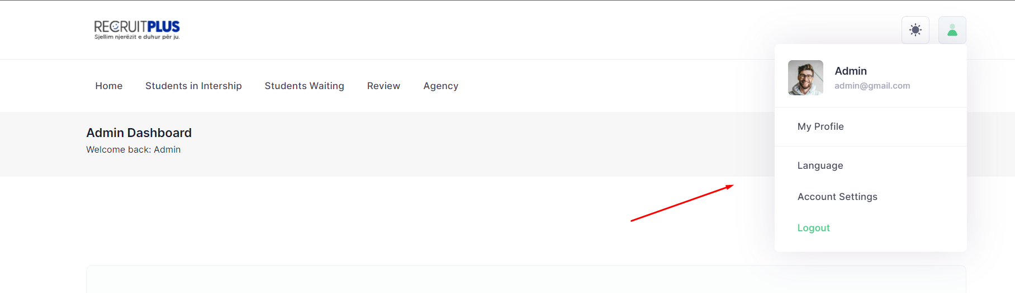

2. Na table thead do te heqim ikonen chek ne te dyja tabelat

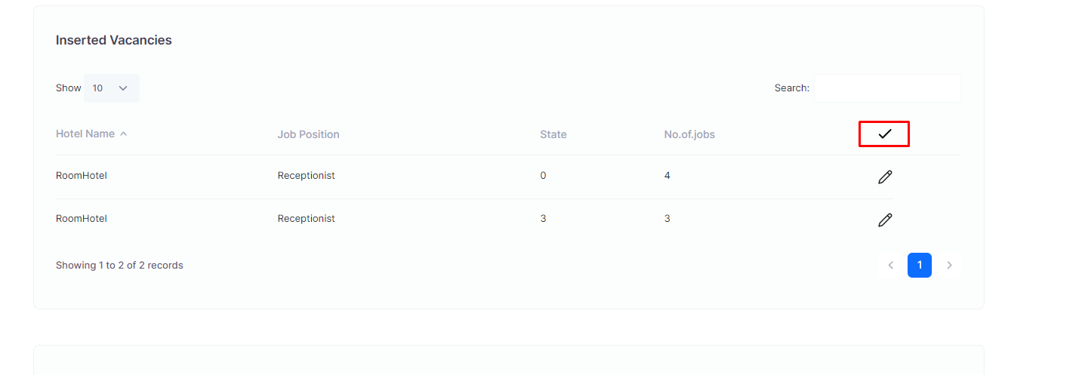

3. Ne tabelen Position in Process tek modal duhen shtuar icon user sipas figmes.

*http://127.0.0.1:8000/admin/dashboard*

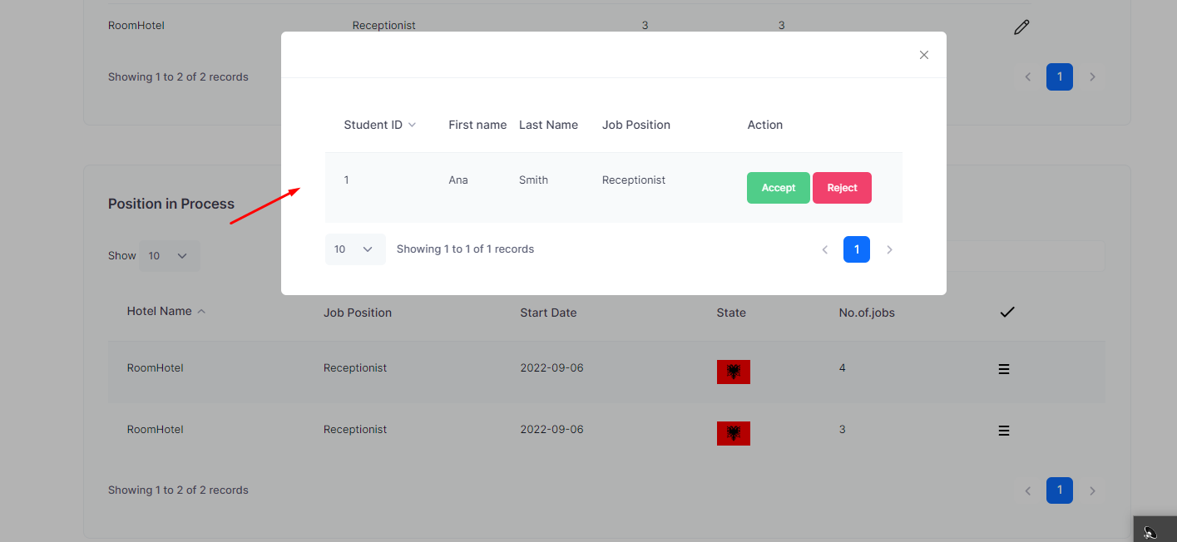

4. Linket pages: kliko ne students in Intership

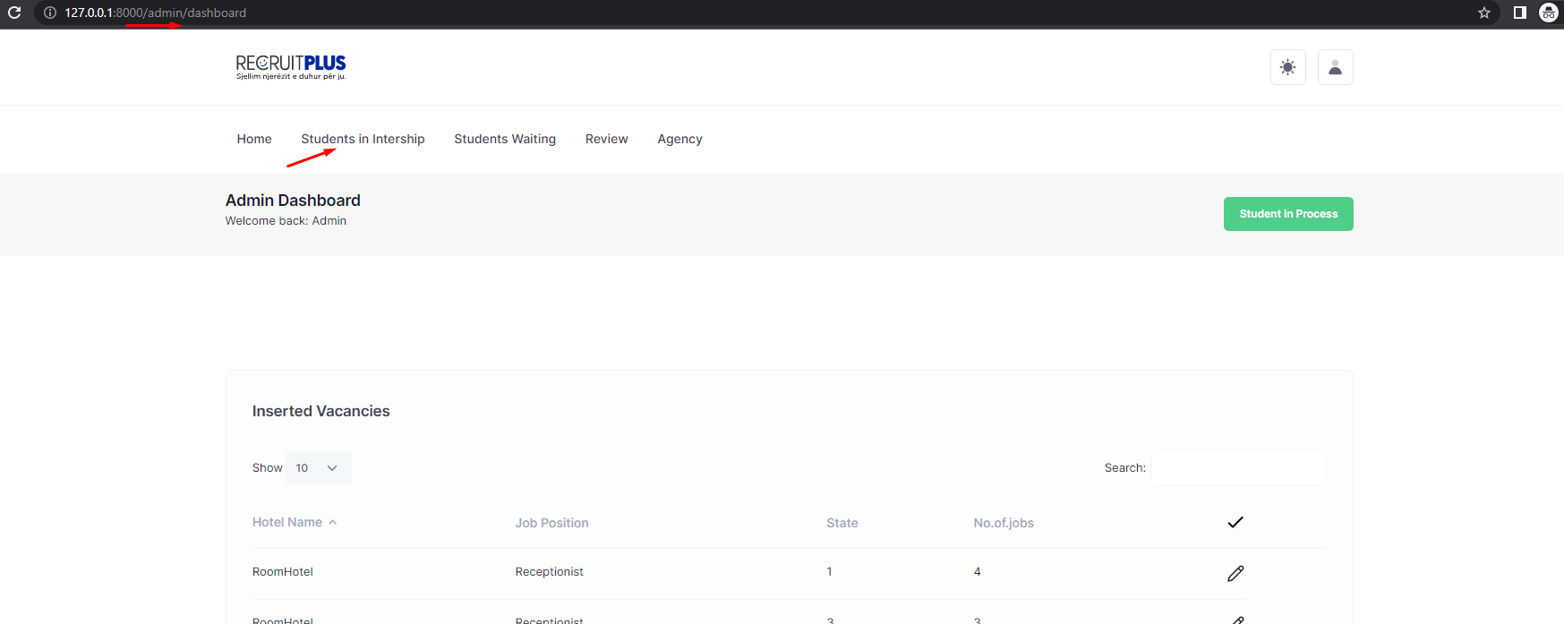

5. Ne tabelen Students in intership Process duhet bere lidhja e Profilit te studentit

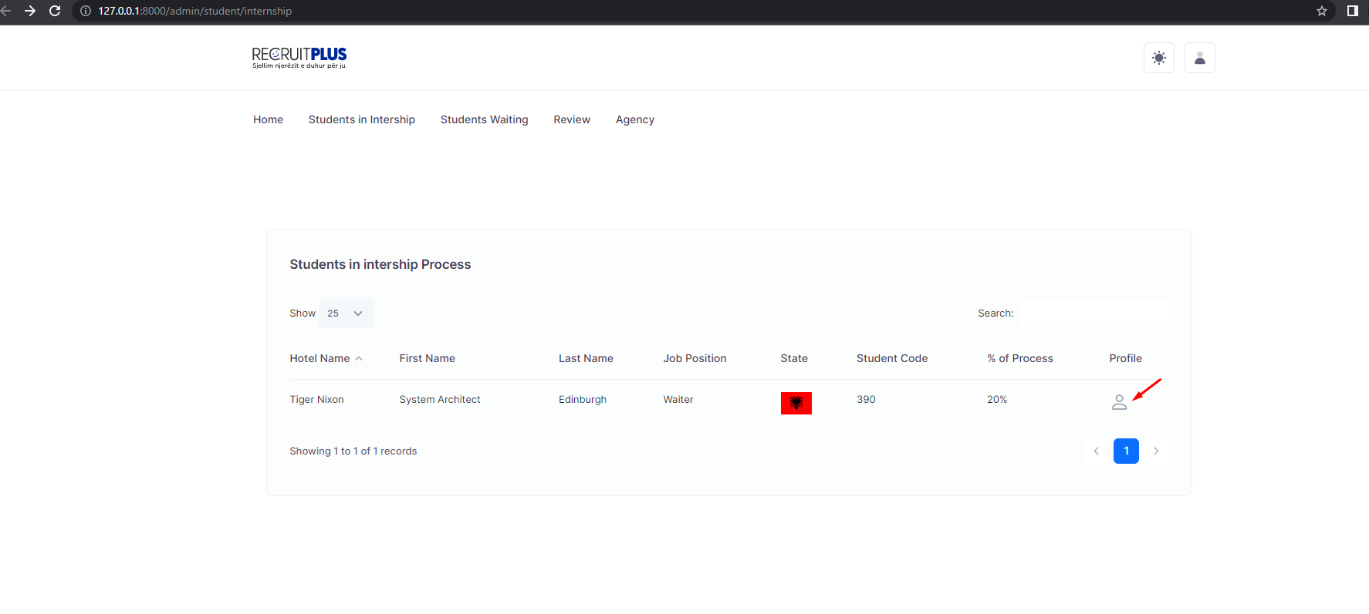

6. Menu Agency eshte bosh ne figma duhet ta dime ku te con agency ne student/intership:

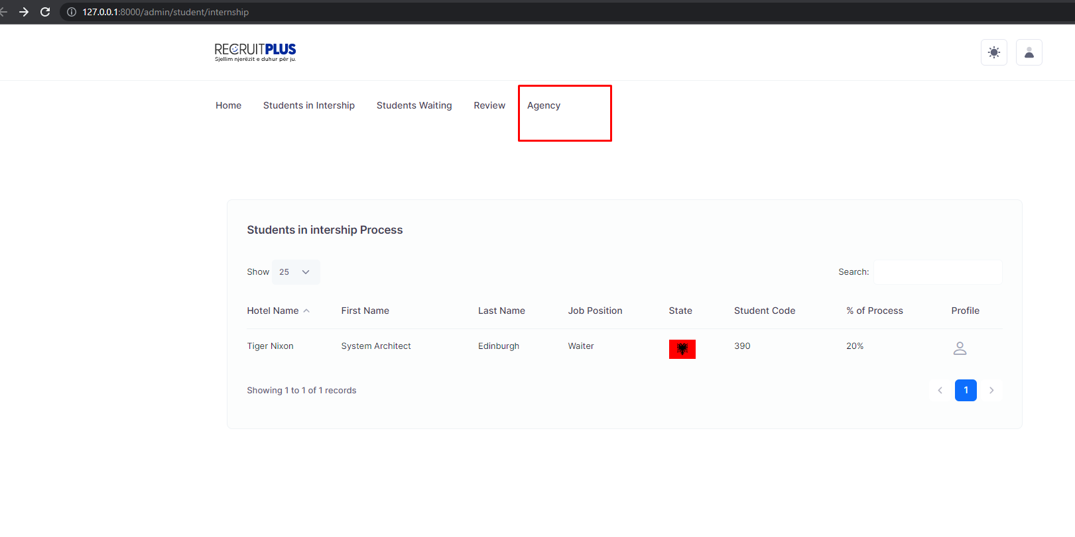

Dt: 08/09/22

1. Select Lunch Break by the conditions of the Hotel.

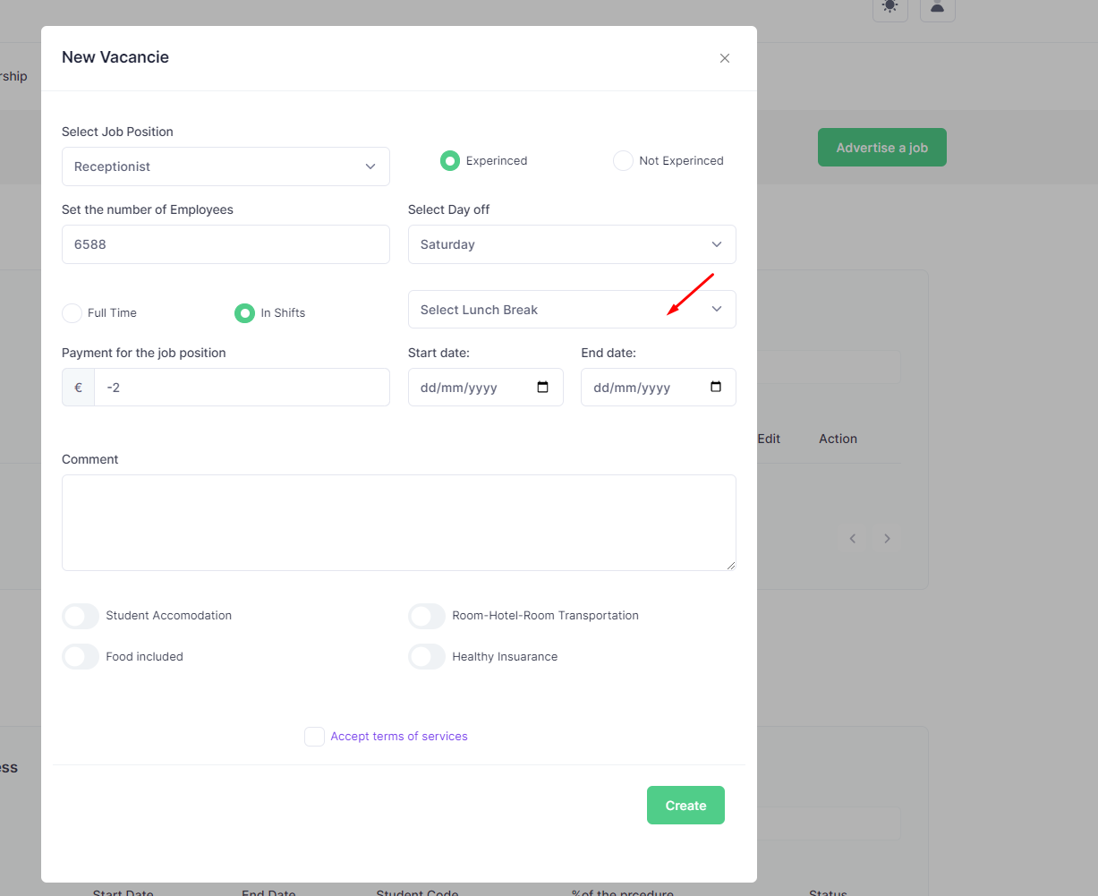

1. Start date duhet te jete 7 dite pune
2. Field set the number of Employees Hotel should to edit within 24 hours.

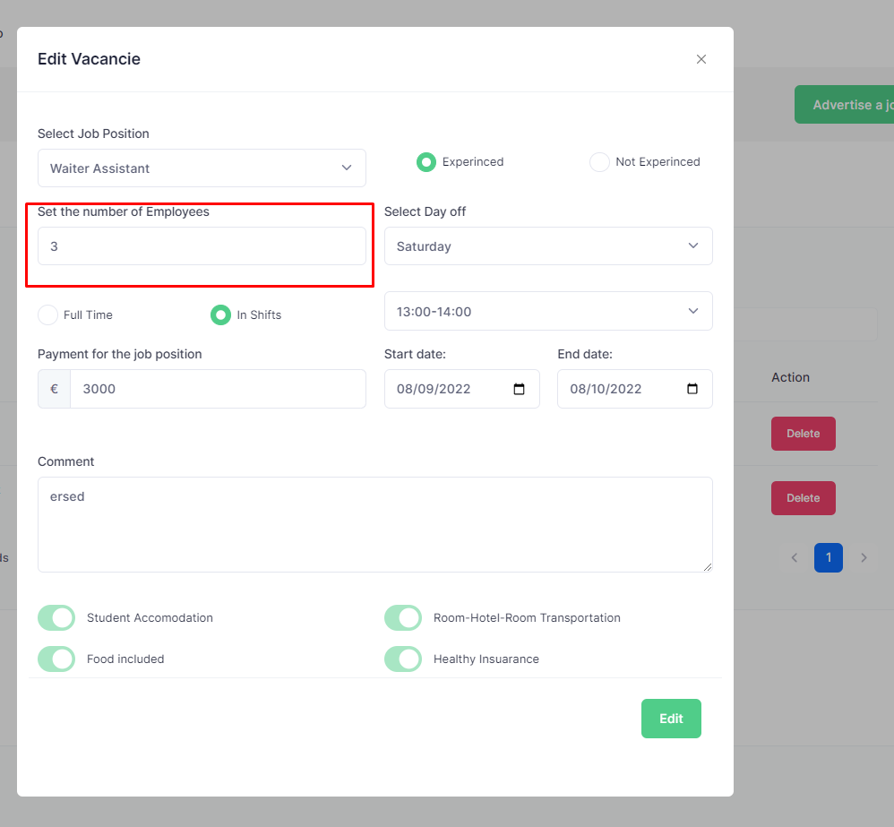

1. Delete only for 24 hours:

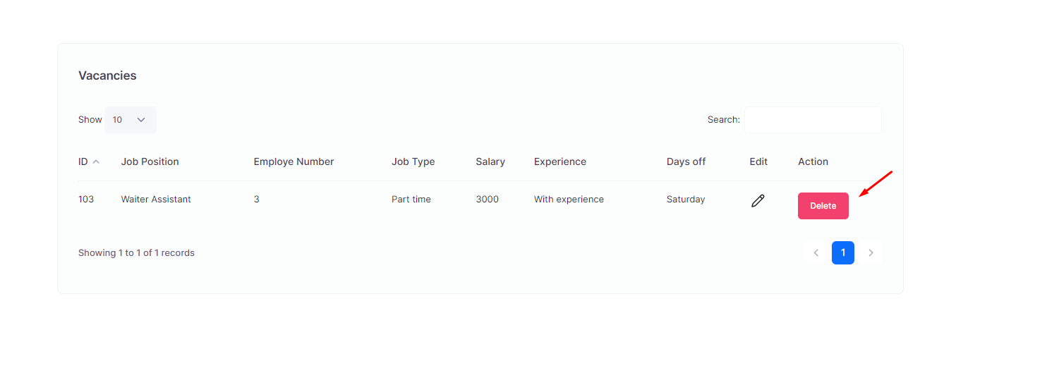

5. Select all days weekend:

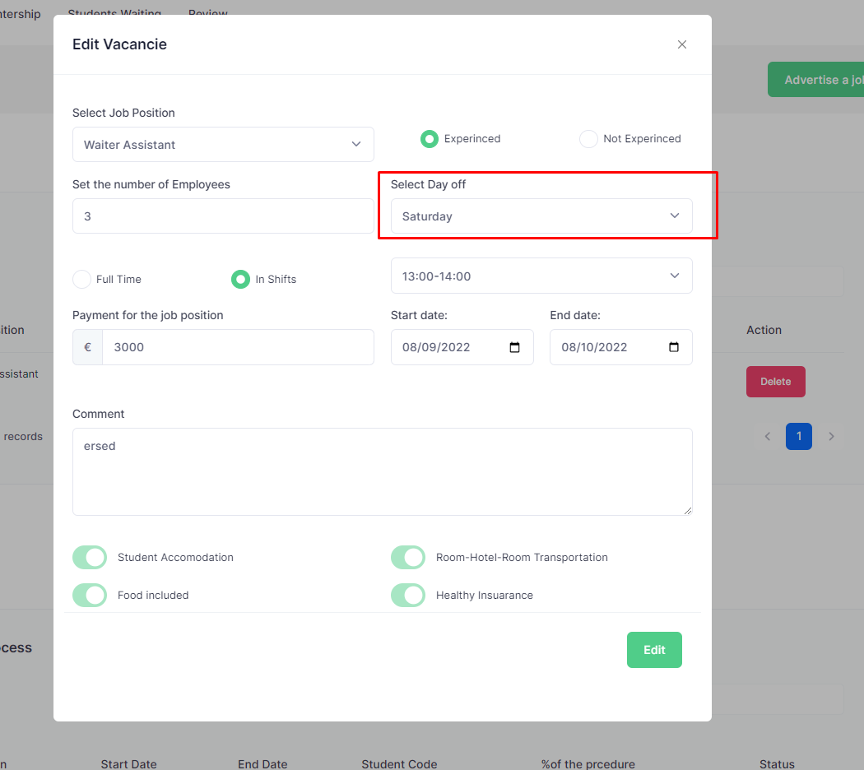

1. Stars doesn’t retrn back. Hoteli le revju per studentin

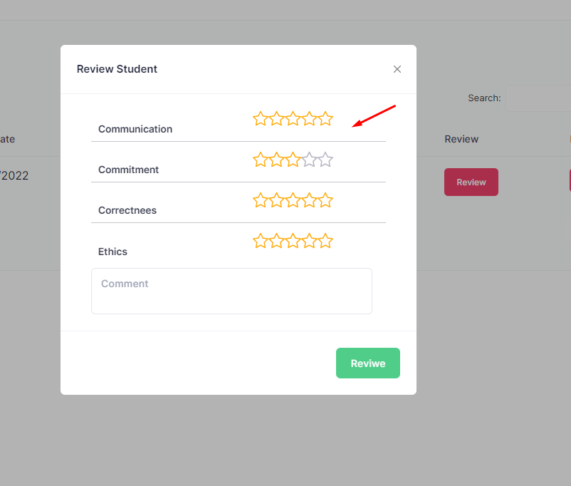

1. When click on the button of the user to open new page or modal.

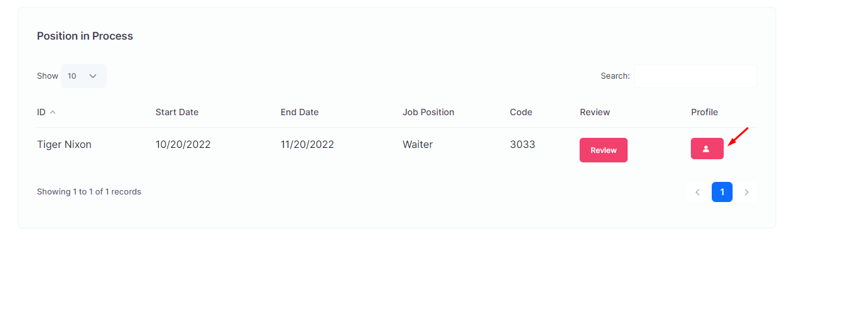

1. Change title from Position in Process to students in intership. Fixed also design fonts.

http://127.0.0.1:8000/hotel/student/internship

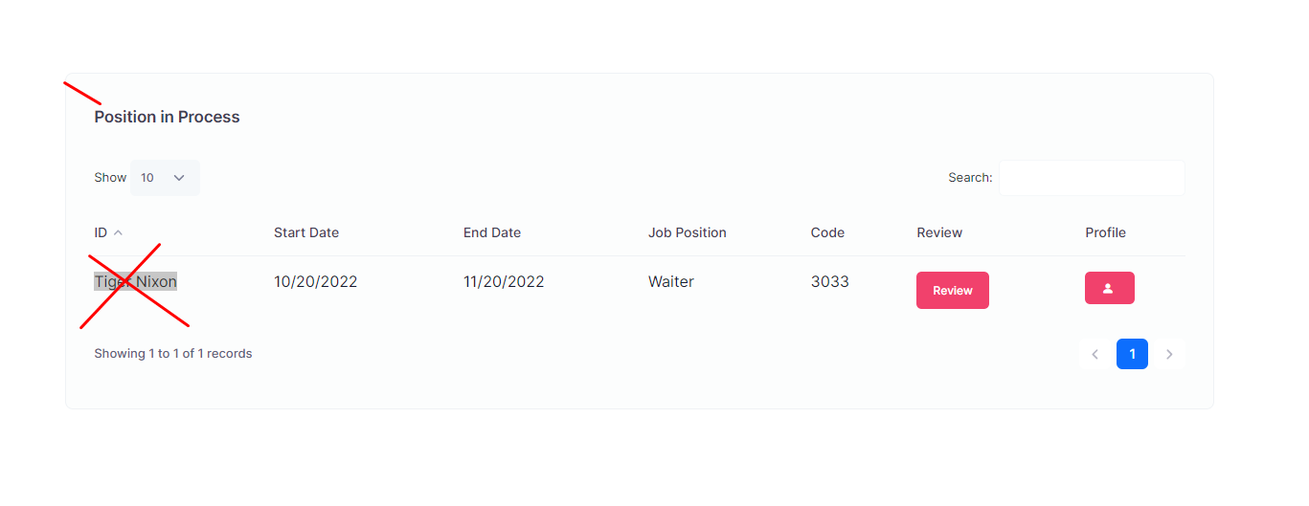

1. ID in table connect with table vacancies in hotel also table position in process / also add code student:

http://127.0.0.1:8000/hotel/student/internship

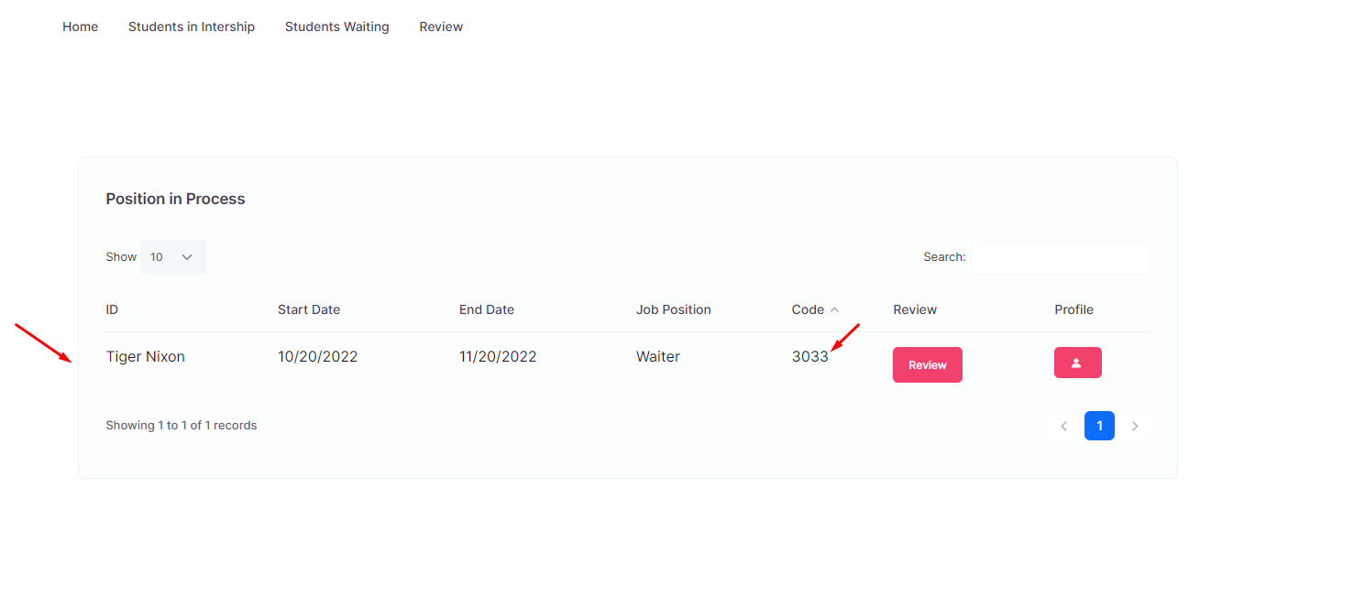

1. At hotel menu students waiting should link with another page students that are waiting for intership. http://127.0.0.1:8000/hotel/dashboard

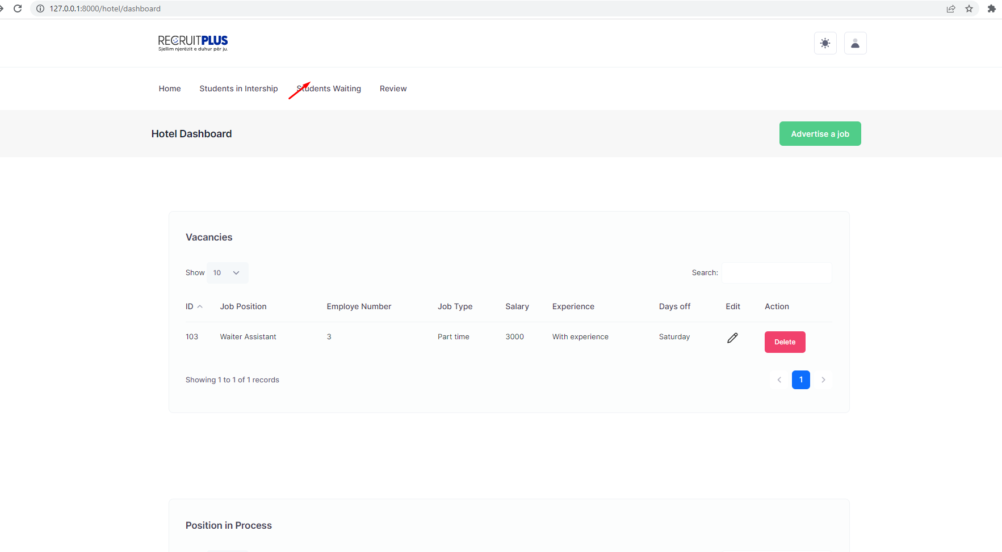

1. Ne hotel menu review duhet te coj ne nje faqe tjeter ku te kemi rivju nga hoteli dhe studenti.

Rivju per hotelin dhe rivju per studentin.

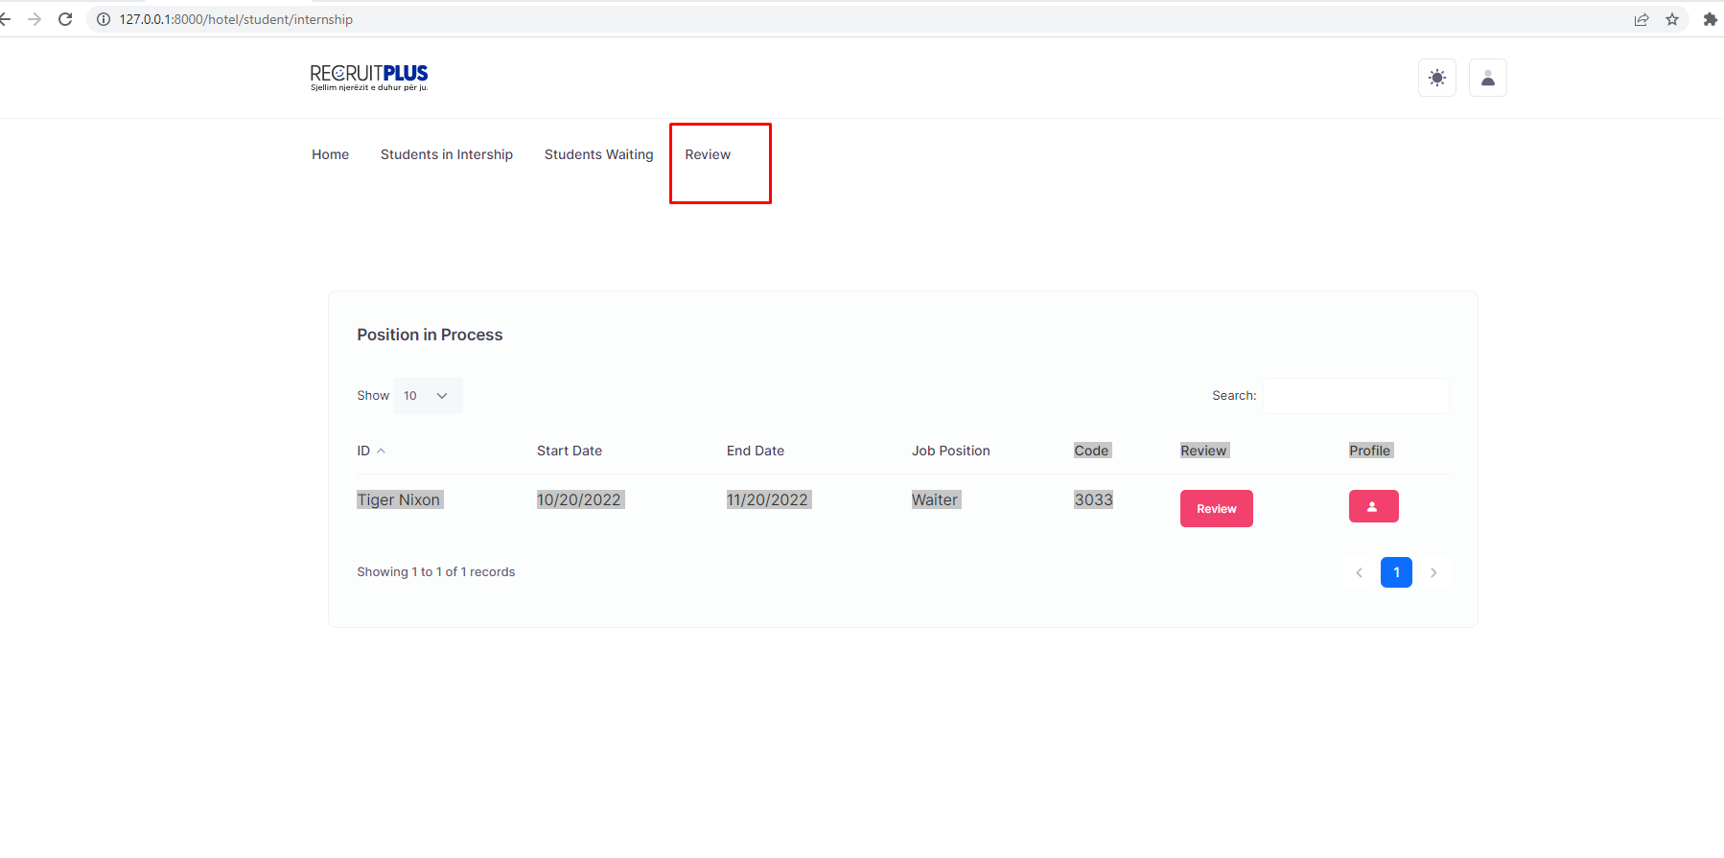

1. I choose shifts in the modal and in tabel me display part time.

Job type.

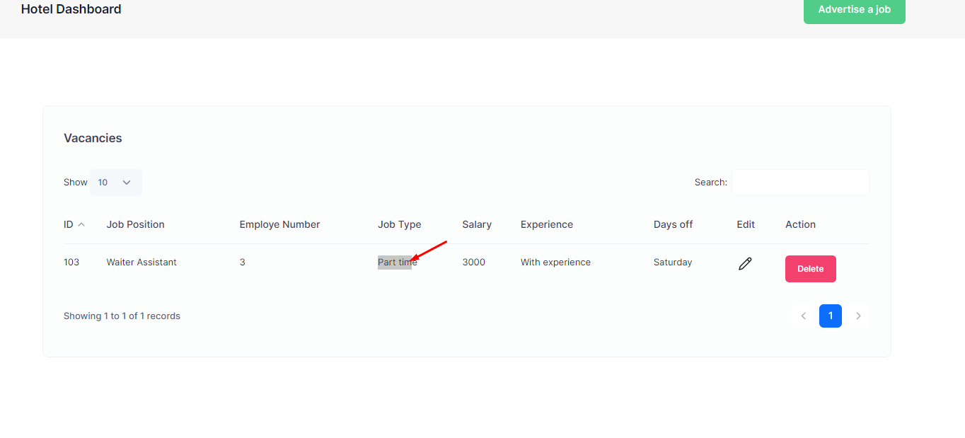

1. Textarea should display only agency admin and local agency:

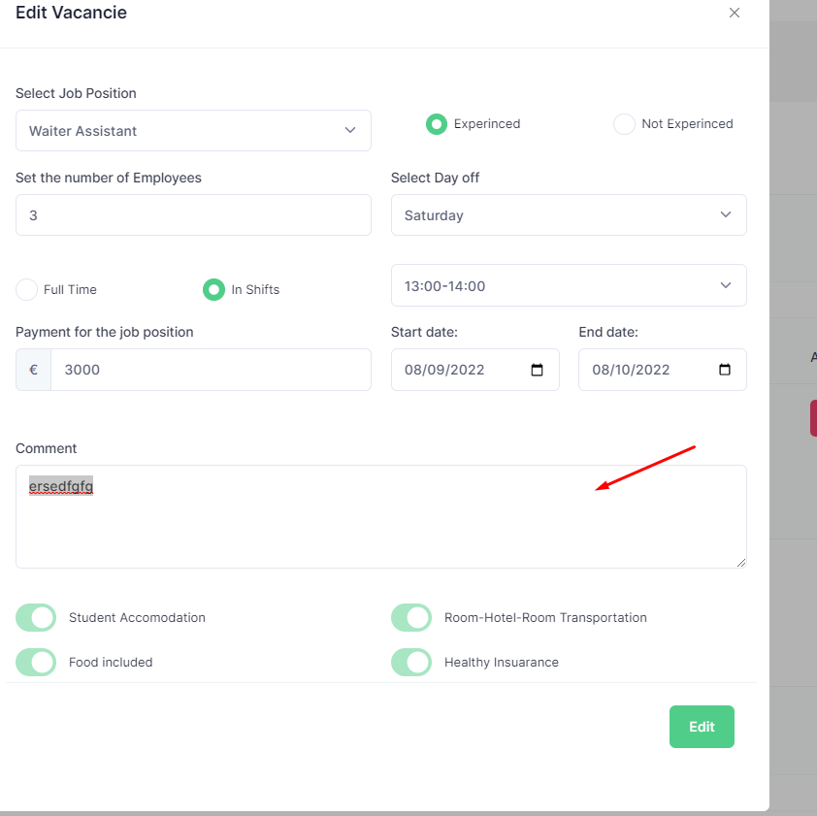

1. Duhet te shfaqet nr studentet qe jane insenjuar agjencia admin.

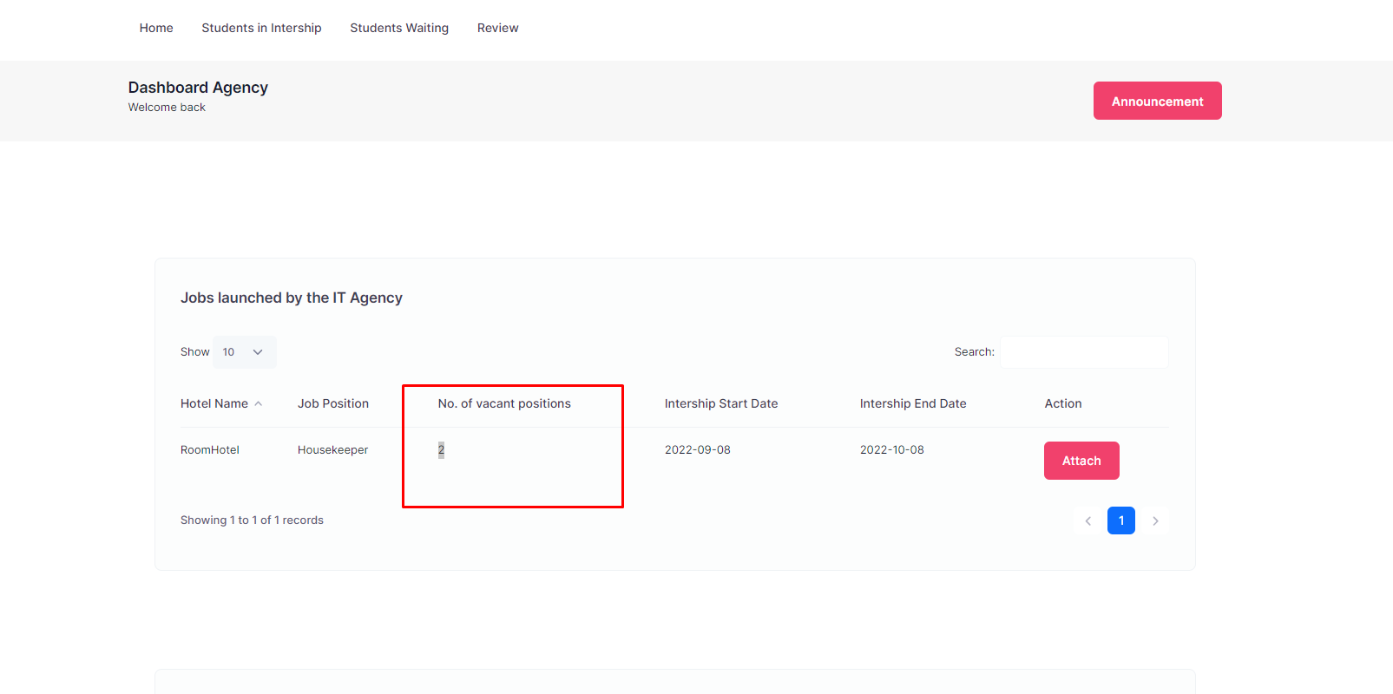

1. <http://127.0.0.1:8000/admin/dashboard> Vnedos vendet e punes Orderby ID

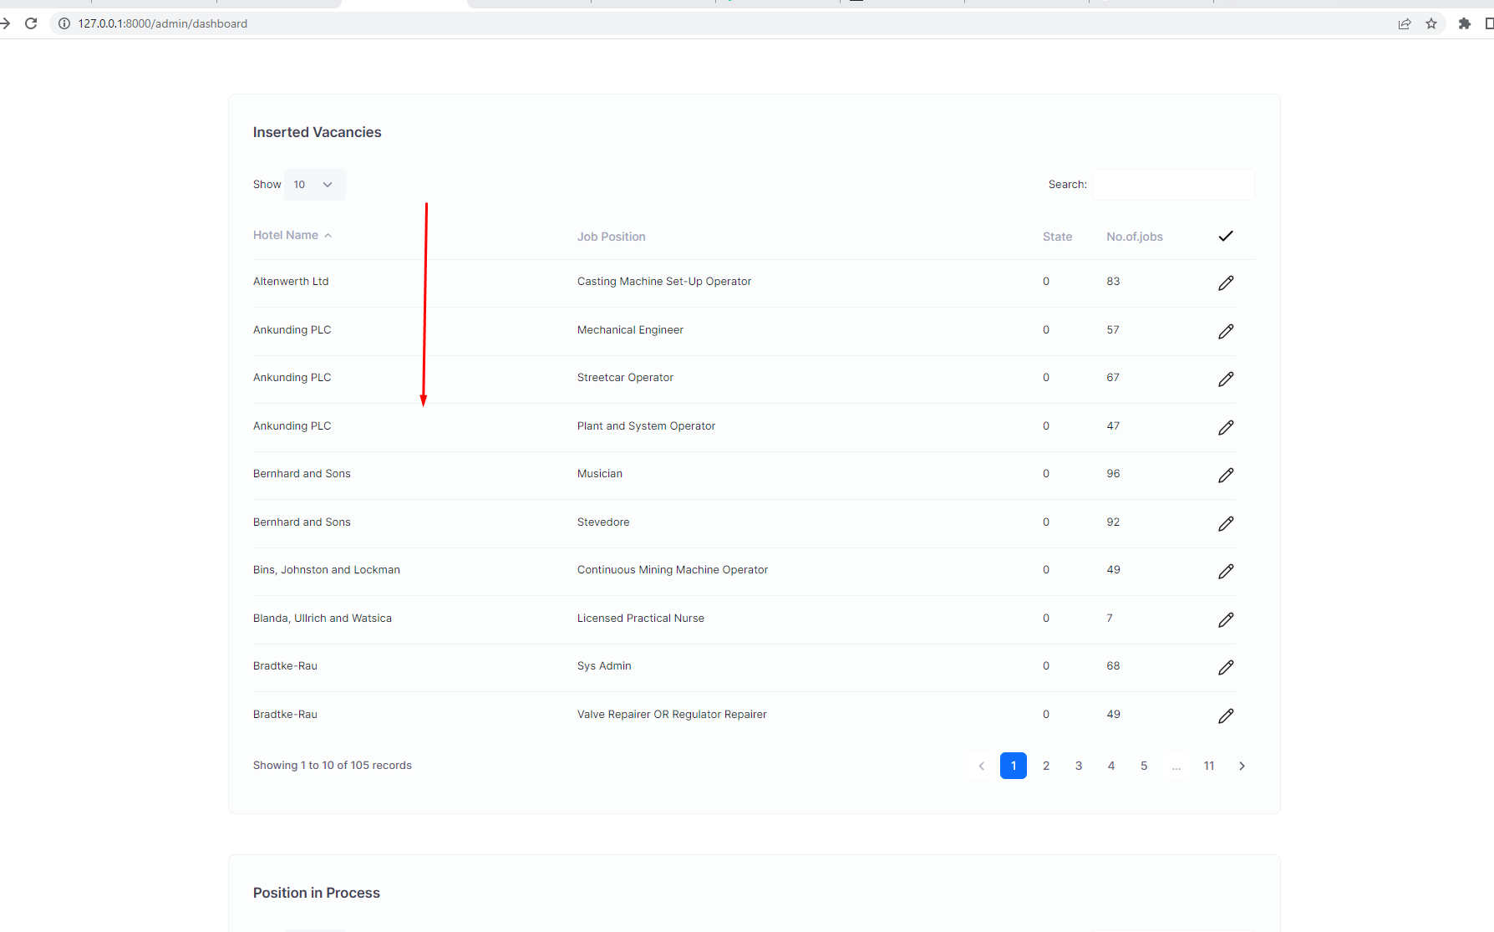

16. Vendos ikon te profilit te studentit add title per modal.

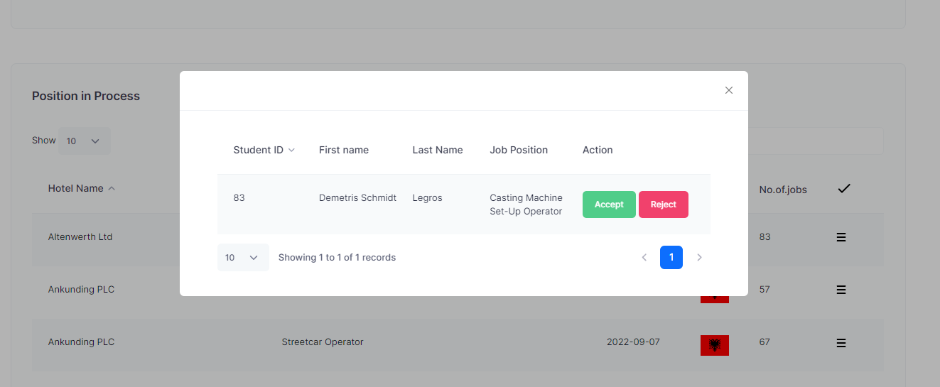

Mund te behet approvim pa pare profilin most e bej accept/delete.

1. In table Inserted Vacancies admin/dashboard. Duhet bere qe agjencia admin te kete te drejte qe agjencia admin tu japi vende pune te gjithe shteteve. 10/57. Te ndryshojme th state. Ta mari direkte ndryshim pa bere refresh.

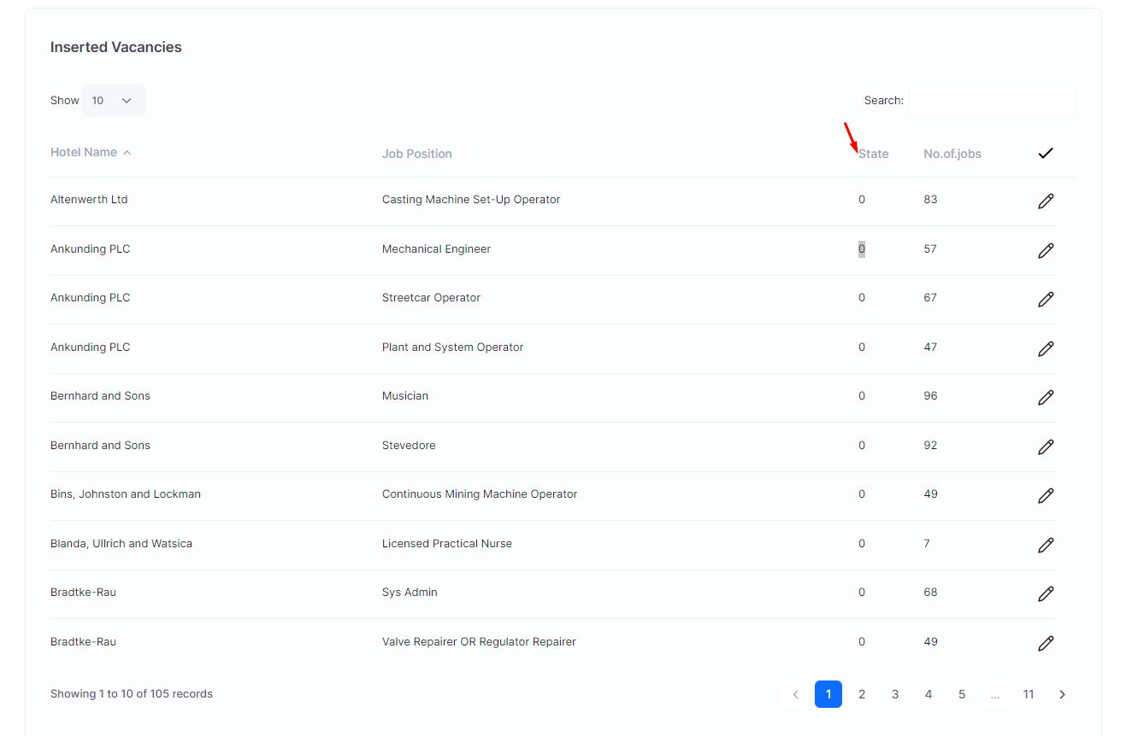

Student.

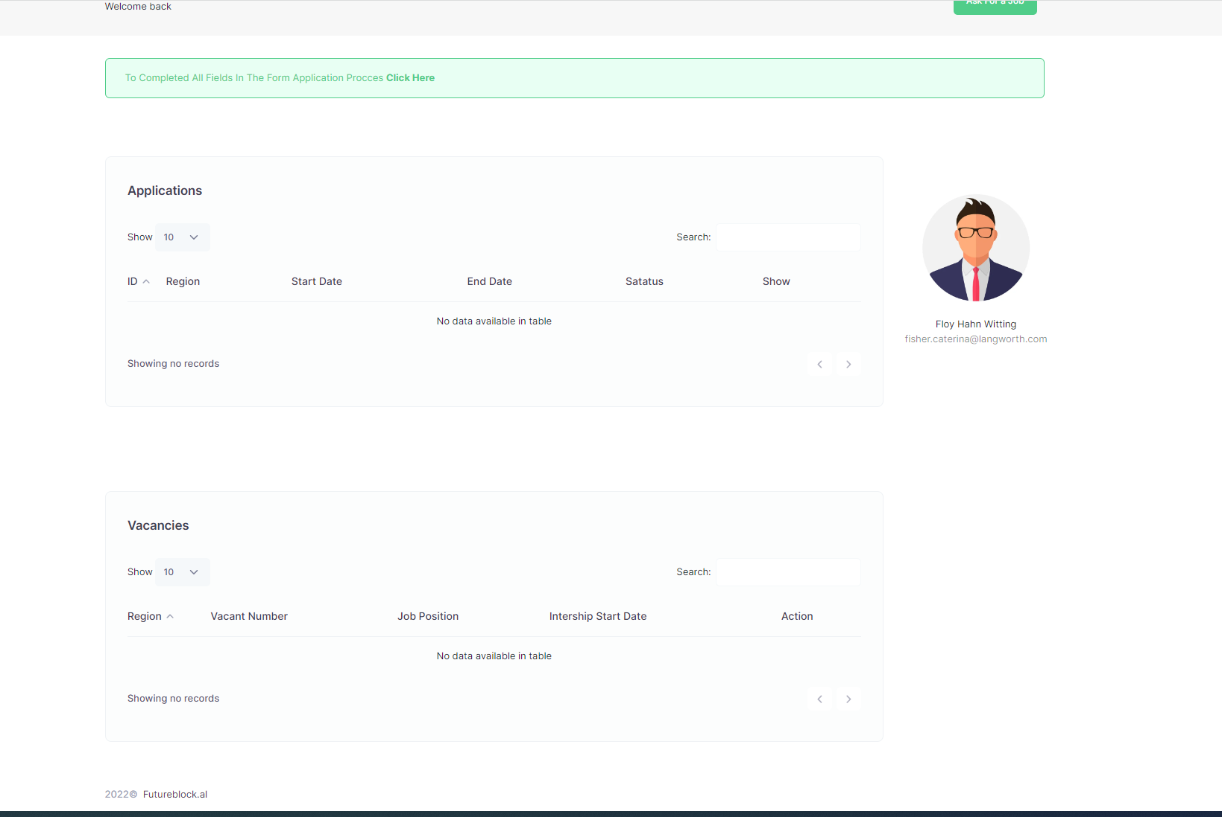

1. Display modal in the button View Progress

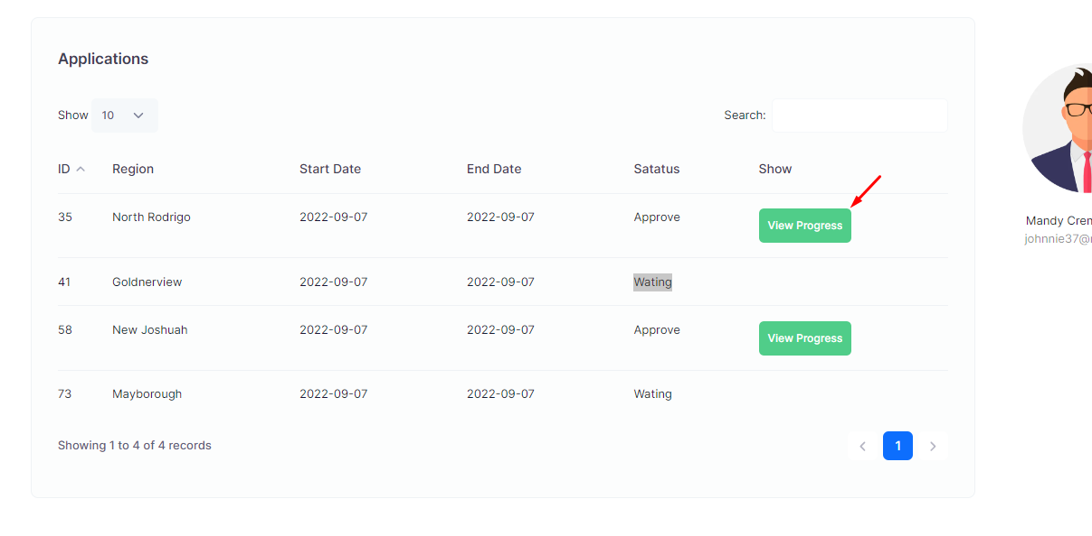

1. View Progress duhet te jete vetem 1 button.

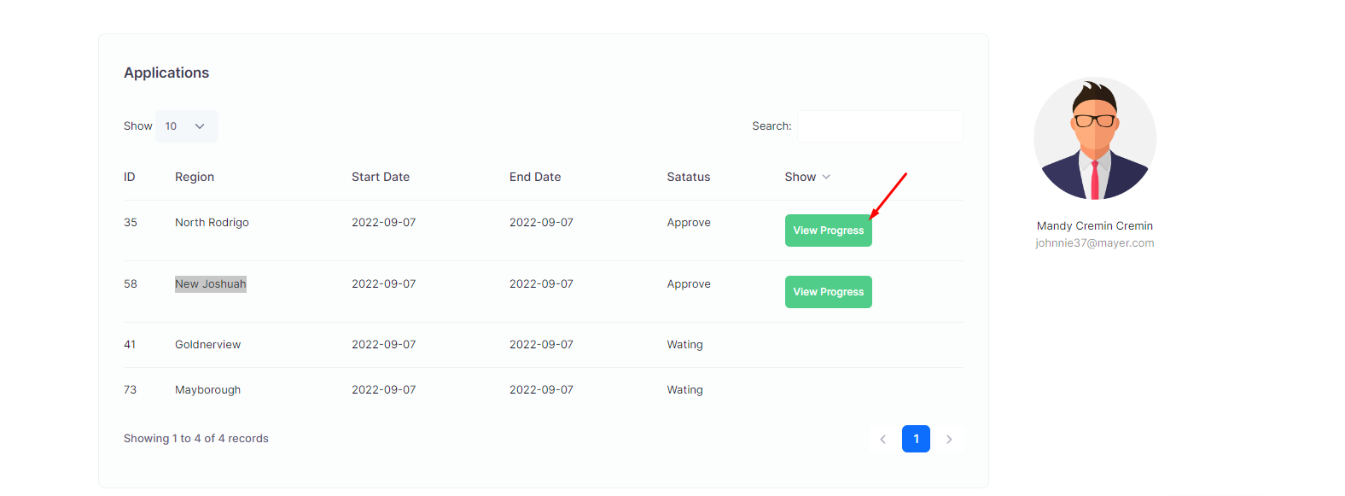

1. Ne tab Pos in Prcess shto Job ID:

http://127.0.0.1:8000/admin/dashboard

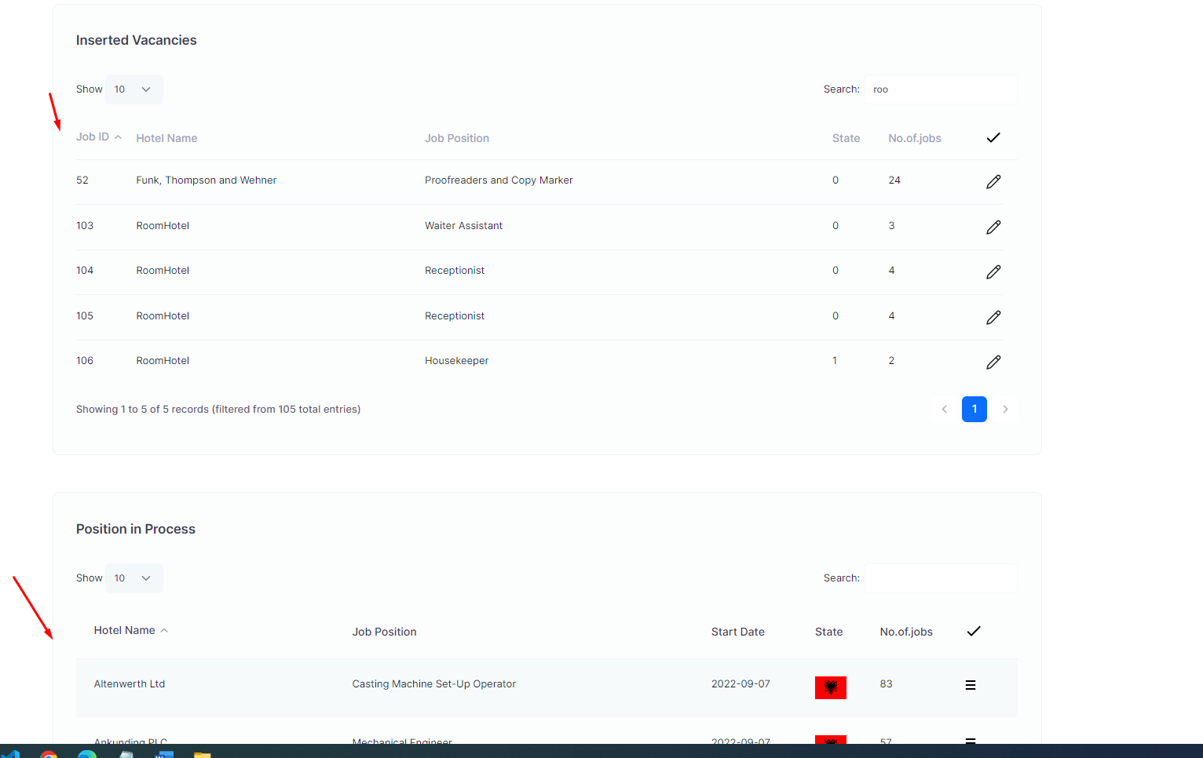

1. Change state:

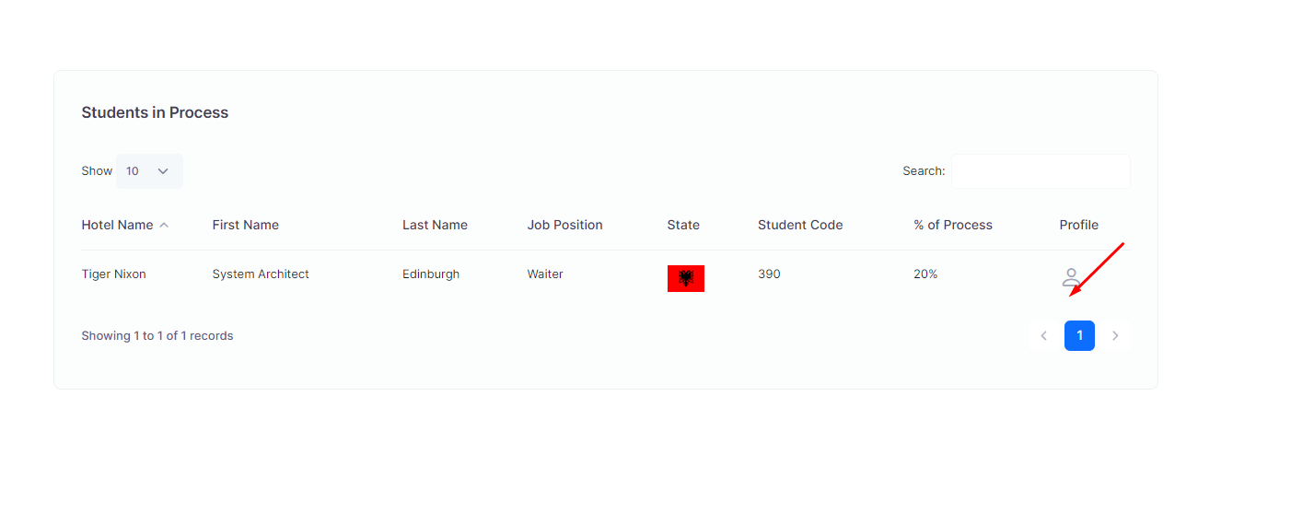

1. Link profile user.

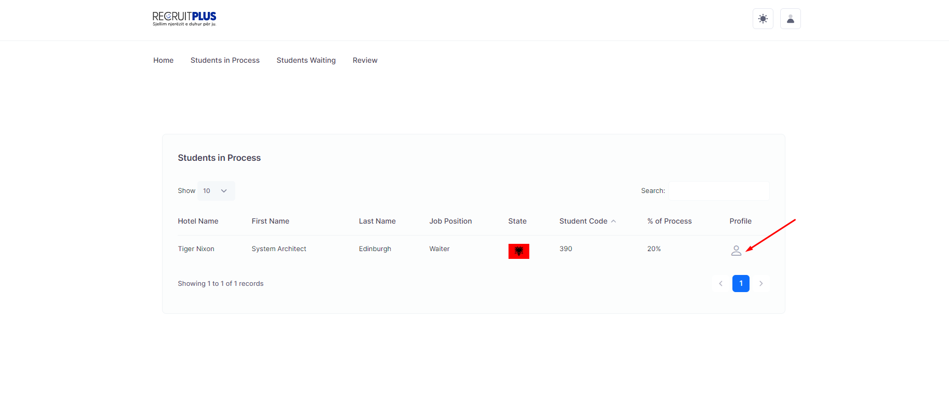

1. Agjenci Admin le rivju per agjencine locale:

http://127.0.0.1:8000/agency/student/internship

1. 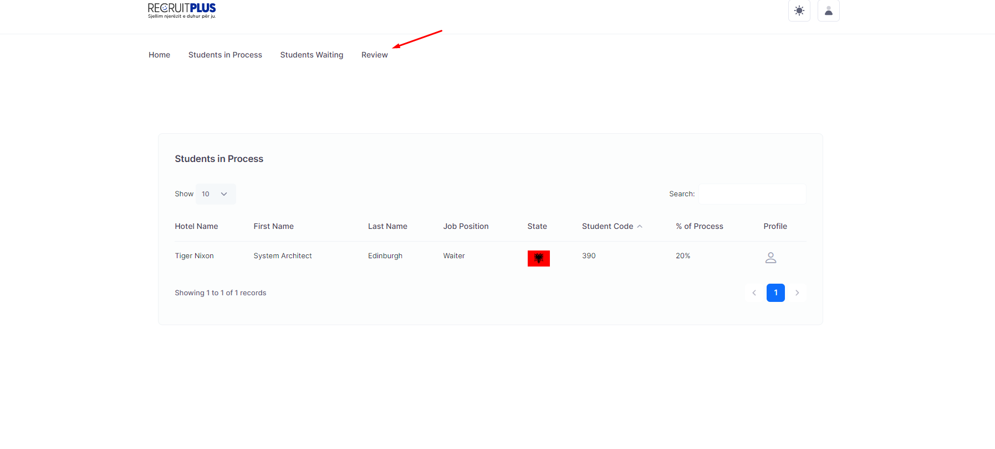
2. Fixed No.of vacantion position: http://127.0.0.1:8000/agency/dashboard#
3. 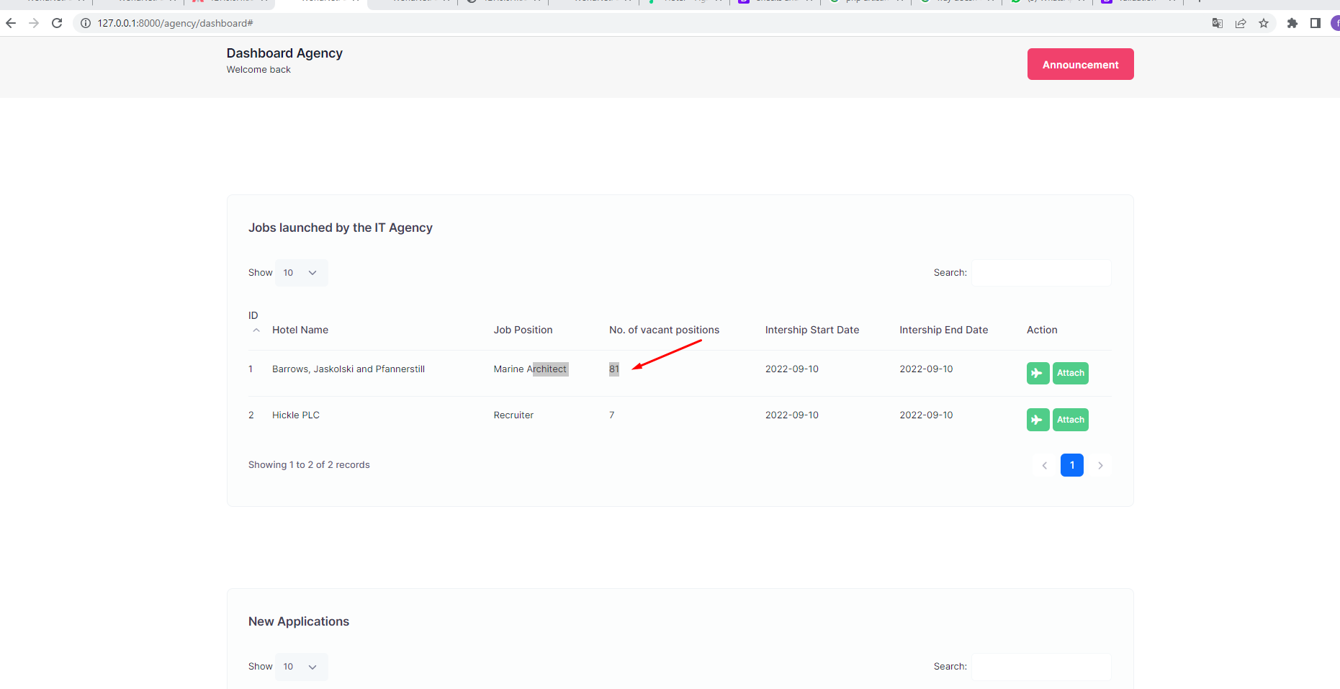

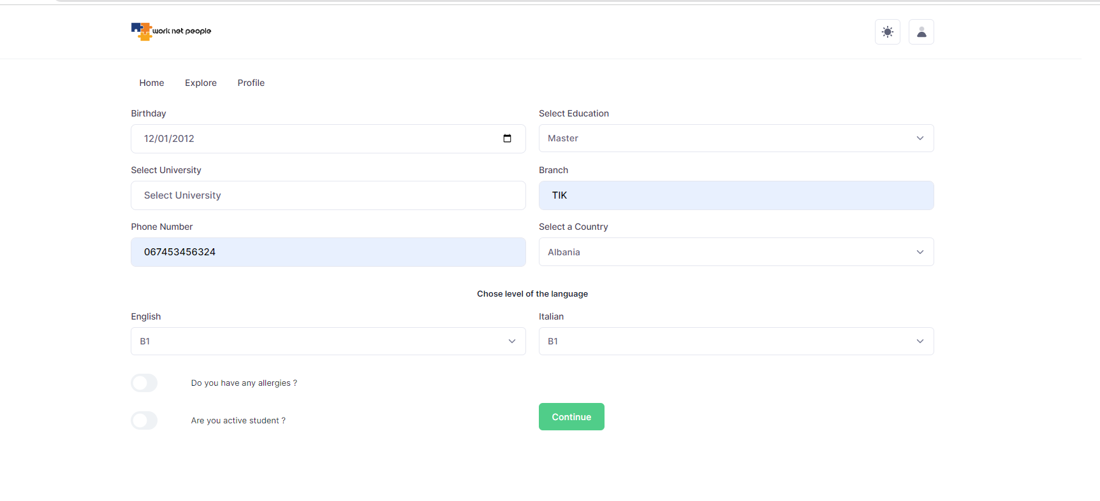

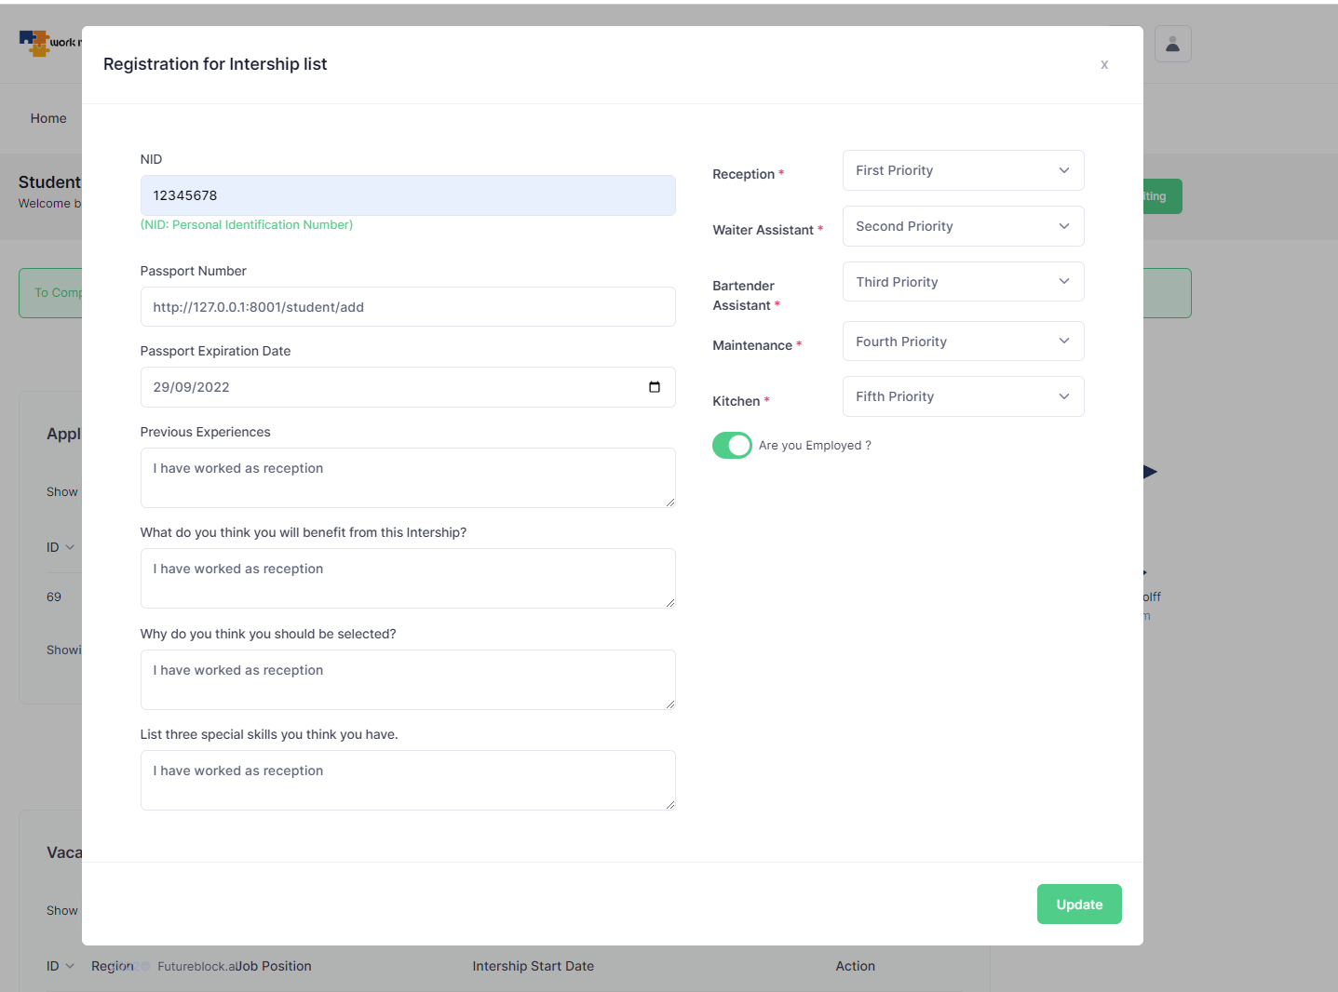

Tek agjencia eshte gabim nuk duhet te lejoj sistemi te mari te njejtin email:

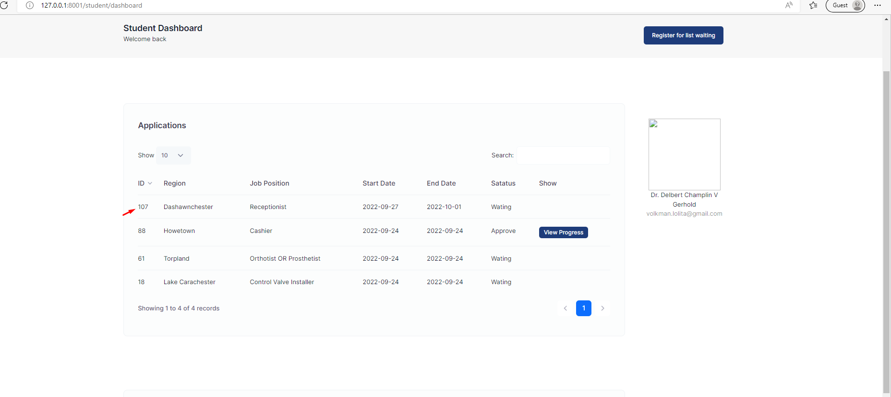

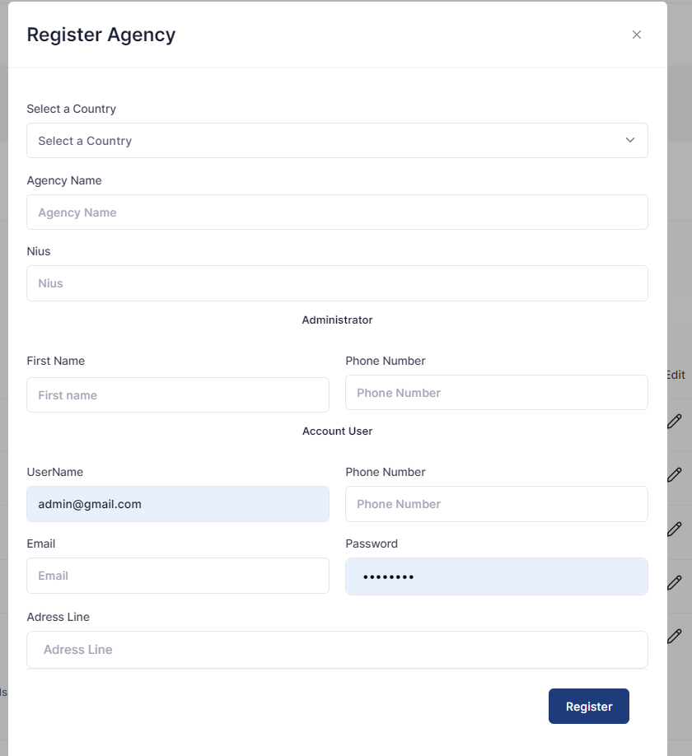

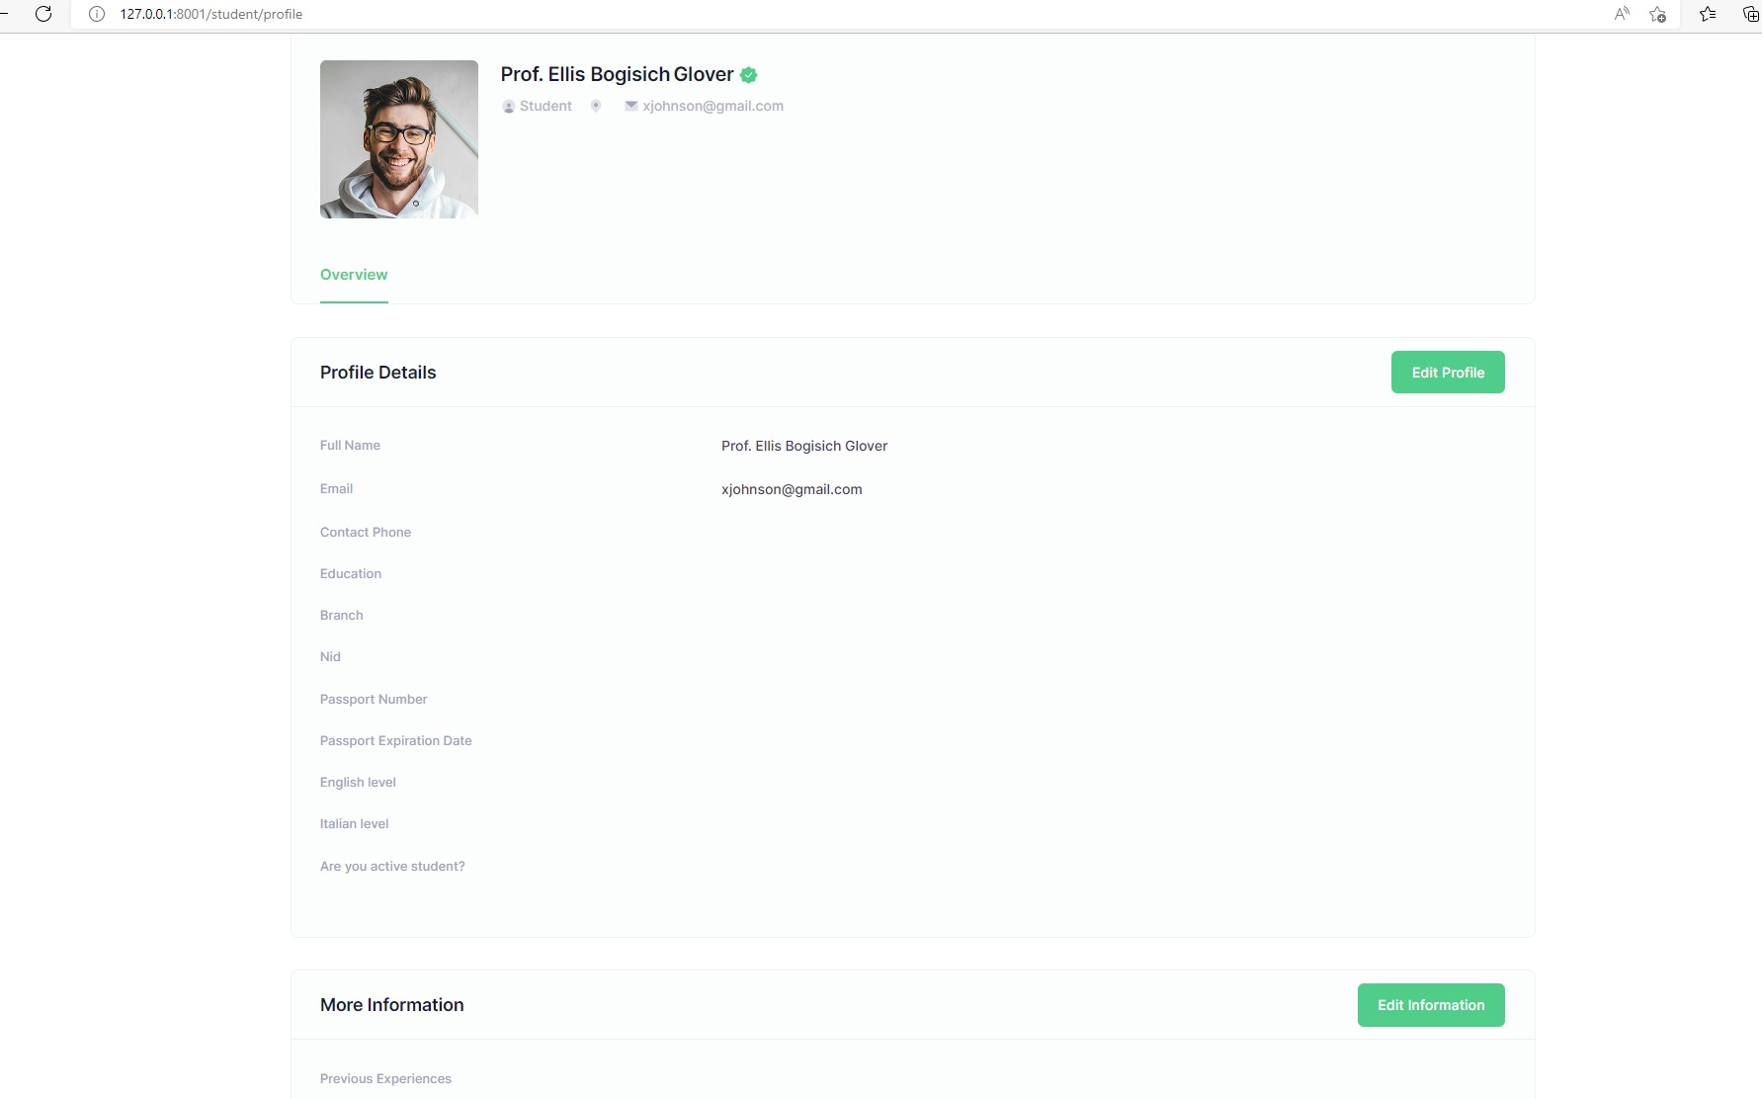

Testing profile of the Hotel:

1. Ne email duhet te vendosim code_zip

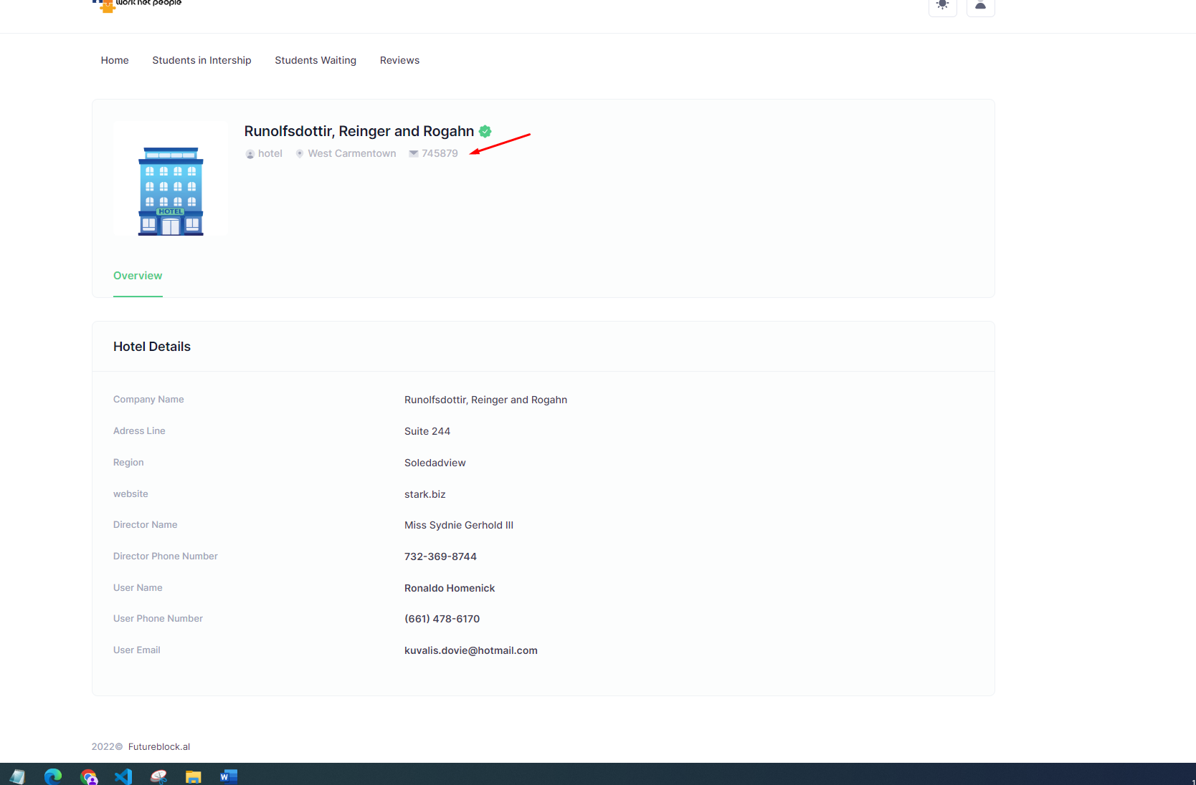

1. Admini vetem te ndryshoj passwordin.
2. Agjecni profile nes emund ete bejme ndarje per account si user dhe admin:

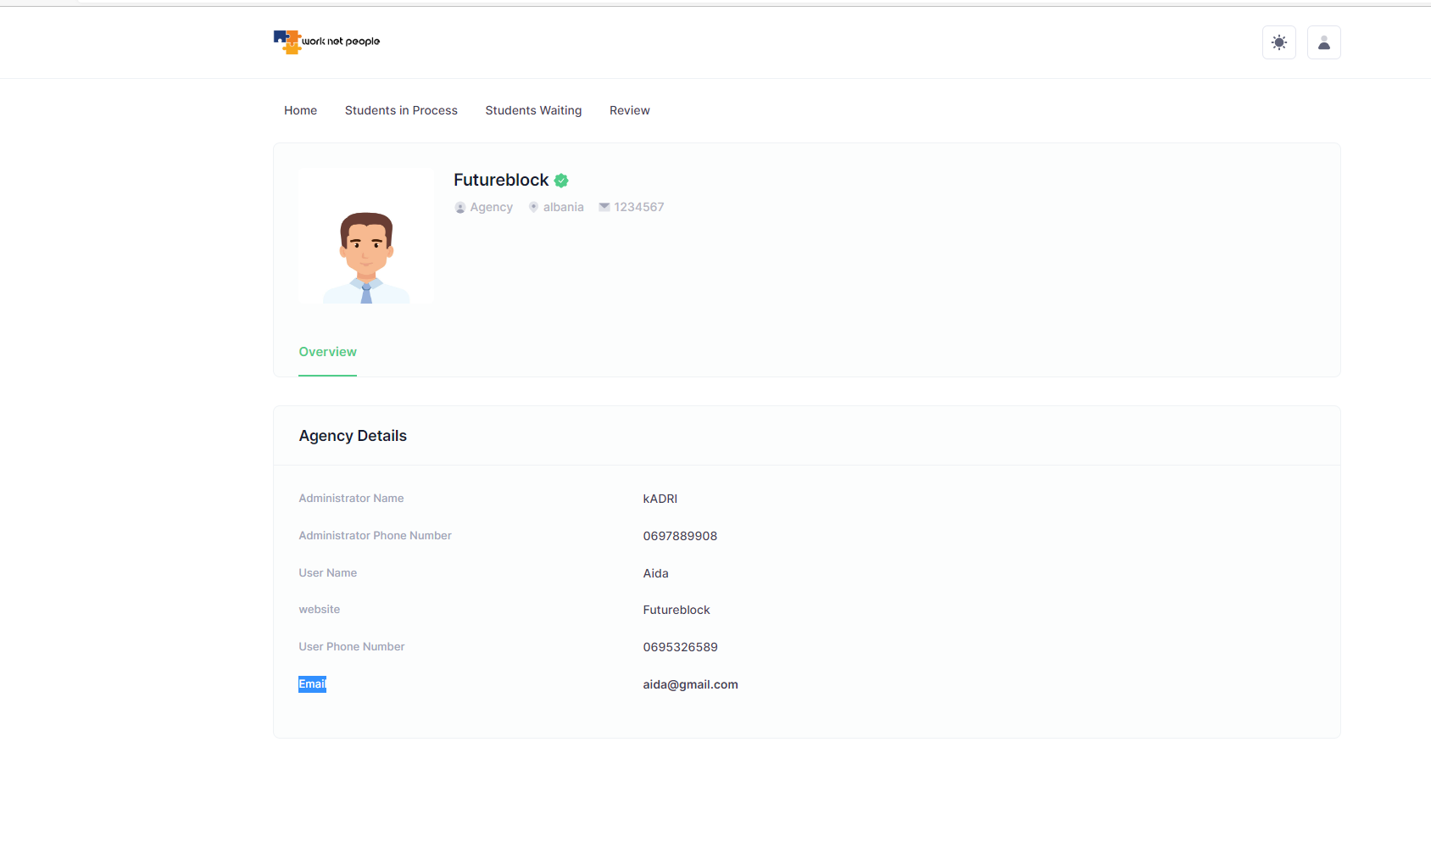

1. Studio Profil Studenti:

http://127.0.0.1:8001/hotel/dashboard

Tabela Position in process do ta vendosim ne menu students in process ose do ta leme ne tab e dyte

