**Contract Project Management System: A Comprehensive Contract and Financial Monitoring Solution for Seamless Profject Oversight and Financial Control**

**Project Proponent’s Name**

**Corcoro, Kyan C.**

**Gumapac, Klien John B.**

**Hernane, Teodolfo G.**

**Project Background**

Most of current construction industry management is mainly based on human rule management assisted by technology systems to implement automatic construction management (Chen, J., Su, M., Azzizi, V., et al, 2021). At present, rather difficult economic conditions for conducting commercial activities in the retail sector require all market participants to mobilize their external and internal reserves. In this situation, effective contract management becomes one of the key components of successful business of network trading companies. It should be noted that in the conditions of digitalization of the economy, special attention of company stakeholders is paid to process management, which can not be considered without regard to the contract strategy of the organization. This is due to the fact that the activities of network trading companies are implemented through the implementation of management, basic and supporting business processes. At the same time, during the implementation of a significant part of business processes, there is a consistent agreement, conclusion and execution of various agreements (contracts). Thus, the contract (agreement) is a documentary form that implements the goals of stakeholders, and the management of various groups of contracts is an integral part of the operating business model of network trading companies (Voronova, O., 2020). Both parties of the construction project shall cooperate in the principle of fairness and voluntariness and sign a written contract. The content of the project contract contains many information such as the cost of

construction, the quality of construction project, the time of construction project, etc. in the process of performing the contract, things that can't be estimated, such as "claim event", will directly or indirectly affect the contract itself, and even lead to the change of the contract. If the change is negative, it is likely to give rise to the construction The project itself brings immeasurable losses. In order to guarantee the interests of both parties, we should strengthen the level of project contract management and optimize the handling of "claim events" (Wang, T., 2020).

**Contract Management System**

**Objectives**

**Contract Management System**

* To develop a system that easily manages contract details, pricing, and other pertinent information.
* To provide a user-friendly interface for efficient contract creation, modification, and tracking.
* To develop a system capable of real-time contract status updates and notifications.
* To enable easy modification of contract terms, renewal, and client information updates.
* To integrate secure payment processing for contract-related fees and transactions using a trusted payment gateway, such as PayPal

**Site Style and Appearance (UI and UX Description)**

* Professional, business-oriented, and reliable appearance.
* Inviting and designed to guide users seamlessly through the contract management process.
* Easy accessibility with fast loading times, well-organized content, and intuitive navigational controls.
* User-friendly interface that ensures ease of understanding and use.
* A polished, trustworthy, and stable look to instill confidence in clients.

**Site Features (Appropriate Modules)**

* Minimum of four menu navigation items for multiple pages, such as "Contracts," "Clients," "Reports," and "Settings."
* Utilization of up to three different and original templates for the design to provide visual variety.
* Comment and suggestion board for users to provide feedback on the system.
* Routine and non-routine maintenance support from the developer to ensure the system's stability and functionality.
* Database Module: Basic CRUD (Create, Read, Update, Delete) operations for efficient contract management.
* Integration with notification systems to keep users informed about contract updates and important milestones.
* Secure user authentication and authorization mechanisms to protect sensitive contract information.
* Advanced search and filtering options to facilitate contract retrieval.
* Analytics and reporting features for tracking contract performance and generating insights.
* Automated reminders for critical contract deadlines and renewal dates.
* Integration with e-signature services for digitally signing and storing contracts securely.
* Multi-language support to cater to a diverse user base.
* Mobile-responsive design to ensure accessibility on smartphones and tablets.
* Comprehensive user guides and help resources for users to navigate the system effectively.

**Site Style and Appearance Portfolio**

* asdhaskdjasdawdashd

# Fluent Design System

Fluent brings the fundamentals of principled design, innovation in technology, and customer needs together as one. It’s a collective approach to creating simplicity and coherence through a shared, open design system across platforms. Open ecosystem, open design system. [Fluent Design](https://www.microsoft.com/design/fluent/#/))  (Sample design)

[(*https://www.microsoft.com/design/fluent/#/)*](https://www.microsoft.com/design/fluent/#/)

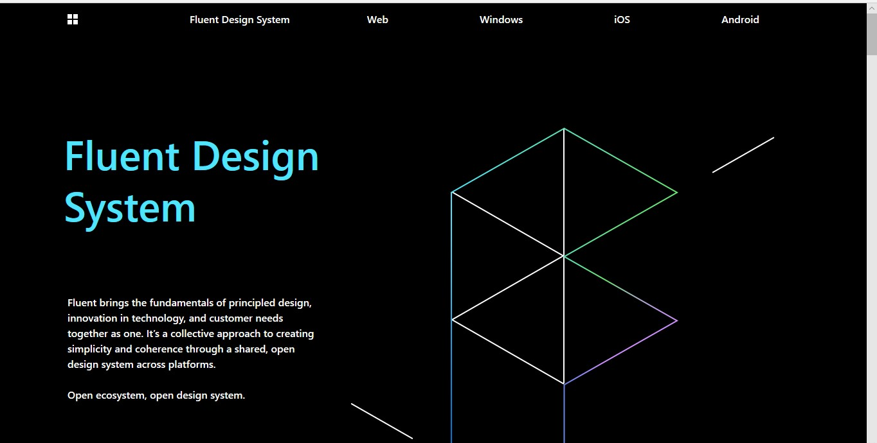

# Minimalist Design

Minimalism in web design is the practice of using minimal elementsm such as simple layouts, typography, and color palletes, to creates a clean uncluttered design. The goal of minimalism in web design is to create a visually pleasing and east to use website that is free from distractions and uncessary elements. Minimalistic websites are often characterized by their simplicity, clean lines, and alack of clutter. [Minimalist Design](https://simonfosterdesign.com/home/)

# Development Process (daw gantt chart pero thru description) *(Daw estimations and progress monitoring)*

Phase 1 – Orientation and Development of Strategic Concept

* Confirm and refine objectives
* Confirm and refine target market
* Establish success criteria
* Establish a preliminary site and page hierarchy
* Develop one or more graphic options
* Present options for evaluation

*Estimated Time: 3 to 7 days depending on the type of data needed in the development process*

Phase 2 – Concept Approval and Initial Development

* Incorporation of feedback and revisions
* Develop site artwork
* Present artwork for approval

*Estimated Time: 2 to 3 weeks depending on the type of design and availability of other technical resources of the website*

Phase 3 – Revisions and final development (approximate time frame)

* Incorporate artwork feedbacks and revisions
* Finalize illustrations and photography
* Online preview
* Revise site if necessary
* Installation and testing
* Go live (date to be determined)

*Estimated Time: 1 to 2 days depending on the type of revisions gathered from the online testing and recommendation*

**Cost Analysis (Assumption)**

# Package A (what you offer to the clients)

|  |  |
| --- | --- |
| Design and Development Cost | Php 30,000.00 |
| File Hosting (Online) | Php 3,000.00 (for one year) |
| Domain Name | Php 2, 500.00 (for one year) |
| Contingency | Php 2, 000.00 |
| Estimated Total Cost | **Php 37, 500.00** |
| ***Note:*** *Other payments include the renewal of the domain name and file hosting for the* | |

*succeeding years. Updates will be given free for the first 2 months of operation.*

# Package B

|  |  |
| --- | --- |
| Design and Development Cost | Php 30,000.00 |
| Multimedia Cost | Php 5,000.00 |
| File Hosting (Online) | Php 3,000.00 (for one year) |
| Domain Name | Php 2, 500.00 (for one year) |
| Contingency | Php 2, 000.00 |
| Estimated Total Cost | **Php 42, 500.00** |
| ***Note:*** *Other payments include the renewal of the domain name and file hosting for the succeeding years. Updates will be given free for the first 2 months of operation.* | |

# Package C

|  |  |  |
| --- | --- | --- |
| Design and Development Cost | | Php 30,000.00 |
| Hardware Specification Computer) | (Desktop | Php 20,000.00 |
| Multimedia Cost |  | Php 5,000.00 |
| File Hosting (Online) |  | Php 3,000.00 (for one year) |
| Domain Name |  | Php 2, 500.00 (for one year) |
| Contingency |  | Php 2, 000.00 |
| Estimated Total Cost |  | **Php 62, 500.00** |
| ***Note:*** *Other payments include the renewal of the domain name and file hosting for the succeeding years. Updates will be given free for the first 2 months of operation.* | | |

# Working Agreement for Estimates (contrata or MOA)

The costs and expenses cited in this proposal are our best estimates given the information provided. They include meetings, consultation time, design, and production time, and a reasonable amount of revisions. If addition information is forthcoming, project specifications change, or the scheduling changes, cost and expense estimates may also change.

The effect of major, additional services and delays cannot be determined until a final design direction has been established. If requirements arise for additional work or scheduling changes not reflected in this estimate, we will provide an updated estimate when the final design direction has been approved.

In terms of ownership, this proposal is for the development and implementation of one strategic idea or concept. All preliminary concepts, ideas, approaches, plans, reports, recommendations, designs, artwork, and electronic files remain the sole property of our group and maybe used in the future at our discretion.

All materials used in the production of this project including the original artwork and computer generated artwork, formats, and electronic code remains the property of our group. Unless otherwise agreed upon, all original photography and illustration are for the sole purpose of the Web site and may not be used in other applications.

Copyright to the web site design will be considered transferred and reproduction rights granted upon receipt of payment in full.

Checked:

**CEDIE E. GABRIEL**

Web Developer

# QUENNIE MAE C. AGRAMON

Quality Assurance and System Analyst