Connecting to BLE router

1. Power up Thingy. Board shall be visible via hcitool lescan command as 00:AA:13:A1:5C:A5 Nordic_AWS_Demo

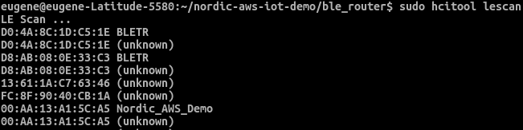

2. Execute ble6_conn.sh. This will create network interface bt0, and will start to ping the board. Wait for 3-4 seconds and execute script again, ping should start and response should present.

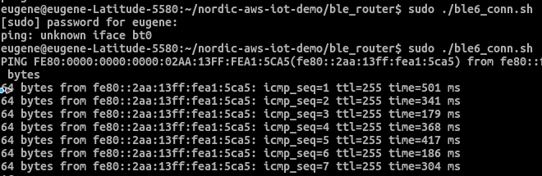

3. Set up local Mosquitto broker by running mos_bro.sh. Kill mosquitto process first if needed. Edit script to use mosquitto.conf file from repository, where PSK file is also located.
4. Set up local Mosquitto subscriber by running mos_sub.sh.
5. Press button on Thingy and connection to broker will be established. Then data from sensors will be sent periodically and displayed by subscriber.

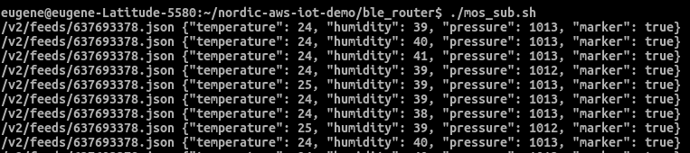

Code highlights

Located in main.c

1. Local broker address shall be set here. Run ifconfig bt0 to find this address

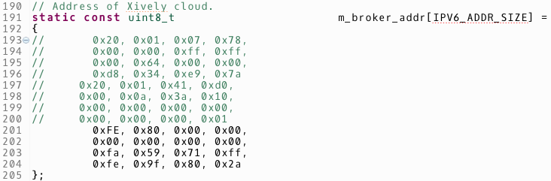
2. Data representation can be changed here, in function app_xively_publish_callback which is executed periodically

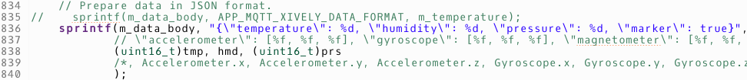
3. Debug output can be seen via Segger RTT (real time terminal)

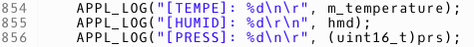

Debugging setup

1. Download and install https://www.segger.com/downloads/jlink/
#J-LinkSoftwareAndDocumentationPack

2. Setup Eclipse IDE for GNU ARM & RISC-V C/C++ Developers. It contains Jlink support. Just create new debug configuration and run it. Board will be flashed and will work even when debug is disconnected.

3. When debug is launched, run JlinkRTTClient to see debug output from APPL_LOG functions

