Parent ->child relation

For explaining this feature we use an example with pigs that need access to 0 to many feed items.

We need to tell feeditems that it can be a child of pigs in the Apism userinterface. We do that by adding <drop>pigs</drop> to the feeditems.xml file under drops:  
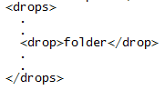

After starting ApismUI again then Feeditems can be drop under Pigs:  
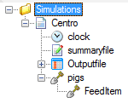

Then add the source code for feeditems in the Visual studio for Pigs:

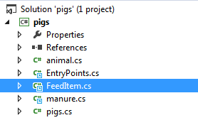

Then you can link to the pig-element as:  


Then iterate trough all pig’s children and accessing FeedItem’s functions as you please. In the example below we are calculating the amount of food each pig have access to:

