An incomplete picture of the farm-xml graph:

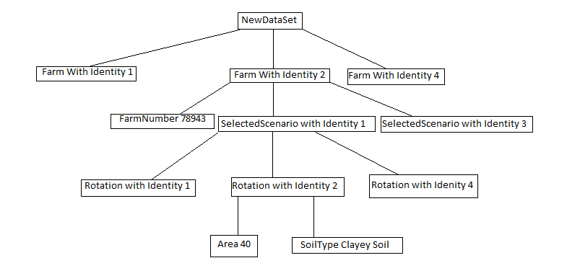

A few examples how to use the file API.

Example nr 1 (Get number of sections that contains rotations)

Fist sthet call ‘setPath’ with ‘Farm(2).selectedScenario(1).Rotation’ as an arguments. Then call getSectionNumber where the first paramter would be the lowest Identety and the 2th parameter is the highest Identity. In the above case then the getSectionNumber would return 1 and 4.

Since there can be gap (in the above case 3 is missing) then one should use doesIDExist(ID) to check if a rotation is there.

Example nr 2 (Getting the area for all roations)

We can use ‘setPath’ for first rotation with using this argrument Farm(2).selectedScenario(1).Rotation(1)

When the first paths has been created then the list called PathNames contains <Farm, selectedScenario, Rotation > and Identity will contain <2,1,1>.

When accessing the 2 rotation then one can do as above or manipulate Identity direcly so it will be <2,1,2> or <2,1,4>for the last Rotation.

When the path has been created then we should called getItemString(“Area”) or getItemInt(“Area”).

Rekursiv seach:

Many of the search mechanisms within the fileInformation is using recursion (eg calling one self unto an enstate has uccuret. So with this path Farm(2).selectedScenario(1).Rotation(1) and asking for getItemString(“Area”), then it will start at the top (newDataSet) and find a Node call Farm with Identety 2. Then it will use that subtree for the next seach that would be a node that is called selectedScenario with Identety 1. And it will continue so unto the end of that path has been reached. That means that the path can have a dynamic length.