(Note: It was actually not presented in this particular way on GDC 2012.
Instead, more emphasis on cool stuff happening on screen was chosen, e.g. fighting HumanGrunt1 with console variable bst_debug_ai=HumanGrunt1.)
(Estimated time: 22–30 minutes)

Opening
(Estimated time: 1 minute)
Hello. My name is Evgeny Adamenkov. I am an AI Engineer at Crytek.
I would like to demonstrate a few features of the AI System of CryEngine.
Generally, an AI system can be split into three major layers:
- Navigation (or Movement), that is, “How do I move to a given point?”,
- Decision Making, that is, “Where should I move?”, and
- Coordination of individual AI characters.
Let’s take a look at a few examples of CryEngine AI at each of these layers.
As soon as you have questions, don’t hesitate to ask immediately.

Navigation
(Estimated time: 3–5 minutes)
There are actually two navigation systems in CryEngine.
Show a map with triangulation and waypoints. Set console variable ai_DebugDraw to 74.
The first one is based on 2D terrain triangulation. This system is quick and has a small memory footprint but it may need designer assistance for non-trivial maps.
Point at HumanWaypoints.
Let’s place an AI character on the map.
Place a Grunt on the map.
To test navigation when the AI simulation is turned on, you can send a selected character to a given point on the map by clicking the middle mouse button at the desired destination.
Turn on the AI simulation. Send the Grunt somewhere.
You can see an actual path taken by the AI character like this:
Set ai_DrawPath to all. Turn on the AI simulation. Send the Grunt somewhere again.
The second navigation system – multi-layer navigation (MLN) system – automatically captures all walkable areas within a specified shape for a specified character type.
Create a new Navigation Area. Set its property MediumSizedCharacters (to true). Set ai_DebugDrawNavigation to 1.
You can switch between the two systems using the console variable ai_useMNM.
Set ai_useMNM to 1. Move the Grunt to the MLN area. Send him somewhere. Show how he stays within the MLN area.

Individual AI
(Estimated time: 12–15 minutes)
Now let’s take a look at individual AI.
I will be showing cover surfaces, tactical points, behaviors, and behavior trees using the following simple example. Suppose in our game we need a Civilian who is generally idle but runs to cover once the player shoots his weapon near him.

Example
I am placing a Grunt on the map and changing some of his properties to turn the Grunt into a Civilian.
Place a Grunt near cover surfaces. Set his entity property BehaviorSelectionTree to “Civilian”. Set property Faction to “Civilians”.
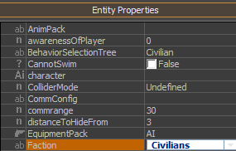
Let’s see it in action.
Enter the game. Demonstrate how the Civilian hides from you once you shoot your weapon.
Now let’s examine the components of this example.

Cover Surfaces
First, let’s visualize Cover Surfaces.
Set console variable ai_DebugDrawCover to 2. Turn [AI/Physics] on to show dynamic cover surfaces. Move a vehicle to show the recalculation of the dynamic cover surface.
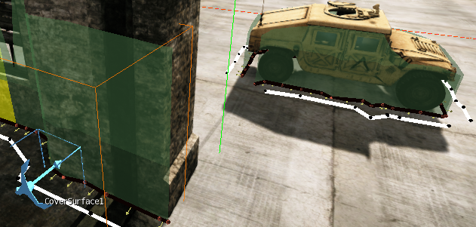
In the past, the designers had to place markers at every place where AI characters should be able to hide. This is now replaced by cover surfaces.
Tweak anchor CoverSurface1 to show how static cover surfaces are recalculated. Move the vehicle to show how dynamic cover surfaces are recalculated.

Tactical Points
These cover surfaces are taken into account when a request for a cover is processed. Cover points are examples of tactical points and to request a cover is to request a tactical point of type “cover”.
In our example, we use the following query:
AI.RegisterTacticalPointQuery({
Name = "Civilian_HideFromEnemy",
{
Generation =
{
cover_from_attentionTarget_around_puppet = 25,
},
Conditions =
{
reachable = true,
},
Weights =
{
distance_to_puppet = -1,
},
},
});
This Lua function call registers a query for a cover from the attention target (in this example, the player), around the puppet (i.e. the AI character who issued the query), within 25 meters. The resulting point should be reachable, that is, a path to it should exist. And from all eligible candidate points, the nearest to the AI character is chosen. This is because for every candidate point its distance to the AI character is negated to come up with the score of this point. The point with minimum distance to the AI character is thus the point of maximum score, which is the result of the query.
This is a simple program for the AI character which uses this query:
<GoalPipe name="Civilian_HideFromEnemy">
<Speed id="Sprint"/>
<TacticalPos name="Civilian_HideFromEnemy"/>
</GoalPipe>

Here we just instruct the AI character to use the query and also make sure he runs really fast to the cover provided.

Behavior Trees
Now let’s examine the behavior of our Civilian. To repeat, he does nothing initially but gets alerted after the player has shot his weapon, which means he tries to find a cover every time he sees the player. After the Civilian hasn’t seen the player for some time, he gets relaxed, i.e. returns to the idle state.
This is achieved by the following behavior tree:
<SelectionTree name="Civilian" type="BehaviorSelectionTree">

<Variables>
<Variable name="alerted"/>
</Variables>

<Priority name="Root">
<Leaf name="CivilianAlerted" condition="alerted"/>
<Leaf name="CivilianIdle"/>
</Priority>

</SelectionTree>

To differentiate between just two behaviors – Idle and Alerted – one Boolean variable is enough.
You can also use the Behavior Selection Tree Editor.
Show the Behavior Selection Tree Editor.
Now let’s take a look at the behaviors themselves.

Idle behavior
local Behavior = CreateAIBehavior("CivilianIdle",
{
OnBulletRain = function(self, entity, sender, data)
AI.SetBehaviorVariable(entity.id, "alerted", true);

entity.AI.hostileId = data.id;
AI.AddPersonallyHostile(entity.id, entity.AI.hostileId);

entity:SelectPipe(0, "Civilian_HideFromEnemy");
end,

OnTPSDestReached = function(self, entity)
entity:SelectPipe(0, "_first_");
end,
});

When the player shoots his weapon near a Civilian, the Civilian gets event “OnBulletRain”. In the given handler, the Civilian
- Sets the behavior variable “alerted” (to true), which will cause the behavior change to Alerted
- Records the entity ID of the shooter
- Marks the shooter as hostile to the Civilian (initially, everyone is neutral to Civilians)
- Assigns to the Civilian the program that instructs him to find a cover and run to it.

Factions
A few words about neutrality and hostility: by default, AI characters can be friendly, neutral, or hostile to other AI characters. This classification has optimization aspects. For example, friends don’t receive the “OnBulletRain” events from each other whereas neutrals do. In turn, neutrals don’t receive perception events, so if we need a Civilian to see the player, we need to explicitly make the player hostile to the Civilian.
Again, the behavior tree and the faction of AI characters are set in their entity properties:
Show Civilian’s entity properties.

Alerted behavior
local Behavior = CreateAIBehavior("CivilianAlerted", "CivilianIdle",
{
Destructor = function(self, entity)
AI.RemovePersonallyHostile(entity.id, entity.AI.hostileId);
end,

OnEnemySeen = function(self, entity)
entity:SelectPipe(0, "Civilian_HideFromEnemy");
end,

OnNoTarget = function(self, entity)
AI.SetBehaviorVariable(entity.id, "alerted", false);
end,
});

Once no perception of the shooter remains in the Civilian – no visual, no sound, no memory – the “OnNoTarget” event is received. In the given example, the handler changes a behavior variable, which triggers the re-evaluation of the current behavior. The Civilian returns to the Idle behavior.
On leaving the Alerted behavior, the Civilian removes the shooter from his list of hostiles.
To make sure the AI characters do what they were intended to, you can use the AI Debugger.
Demonstrate the AI Debugger.

Global AI
(Estimated time: 5–7 minutes)
Now let’s take a look at an example of coordination of AI characters. Suppose that at the start of the game, two AI characters need to meet in a helicopter and fly away.
Make the flowgraph in real time. Explain how each word of the description is translated into flowgraph nodes and their properties. At first, don’t specify who the driver is and who the gunner is.
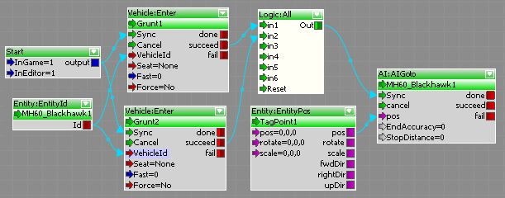
Note that the whole sequence was defined solely by a flowgraph. I haven’t written a single line of code.
Let’s start the game and watch the sequence.
Turn on [AI/Physics]. Watch the sequence fail.
As you can see, it’s not working at the moment, and to figure out why let’s use the flowgraph debugger.
Turn on the signal propagation highlighting. See how the signal doesn’t go beyond the “Vehicle:Enter” flowgraph nodes. Set the breakpoints at their outputs “fail”. Watch them hit.
Aha! An error occurs when the AI characters try to enter the helicopter. This is because there is still some uncertainty in the scenario defined by the flowgraph: it’s not clear which AI character should take which seat.
Assign the seats. Make sure the sequence works as intended.
It is also possible to have flowgraph subroutines so you don’t have to repeat the same flowgraph logic for similar situations.

Conclusion
(Estimated time: 1–2 minutes)
Today we examined the navigation systems of CryEngine and found that even in complex environments the required assistance from the designers is close to zero. You basically need to enclose the required areas by Navigation Area shapes.
Then we examined cover surfaces, both static and dynamic, and an example of how they can be used to provide actual covers (i.e. dynamic tactical points of type “cover”). We also examined a couple of behaviors organized in a behavior tree.
Finally, we saw how flowgraphs allow creating game logic without writing a single line of code.
Thank you for your time. If you have any questions, I will be happy to answer them.

