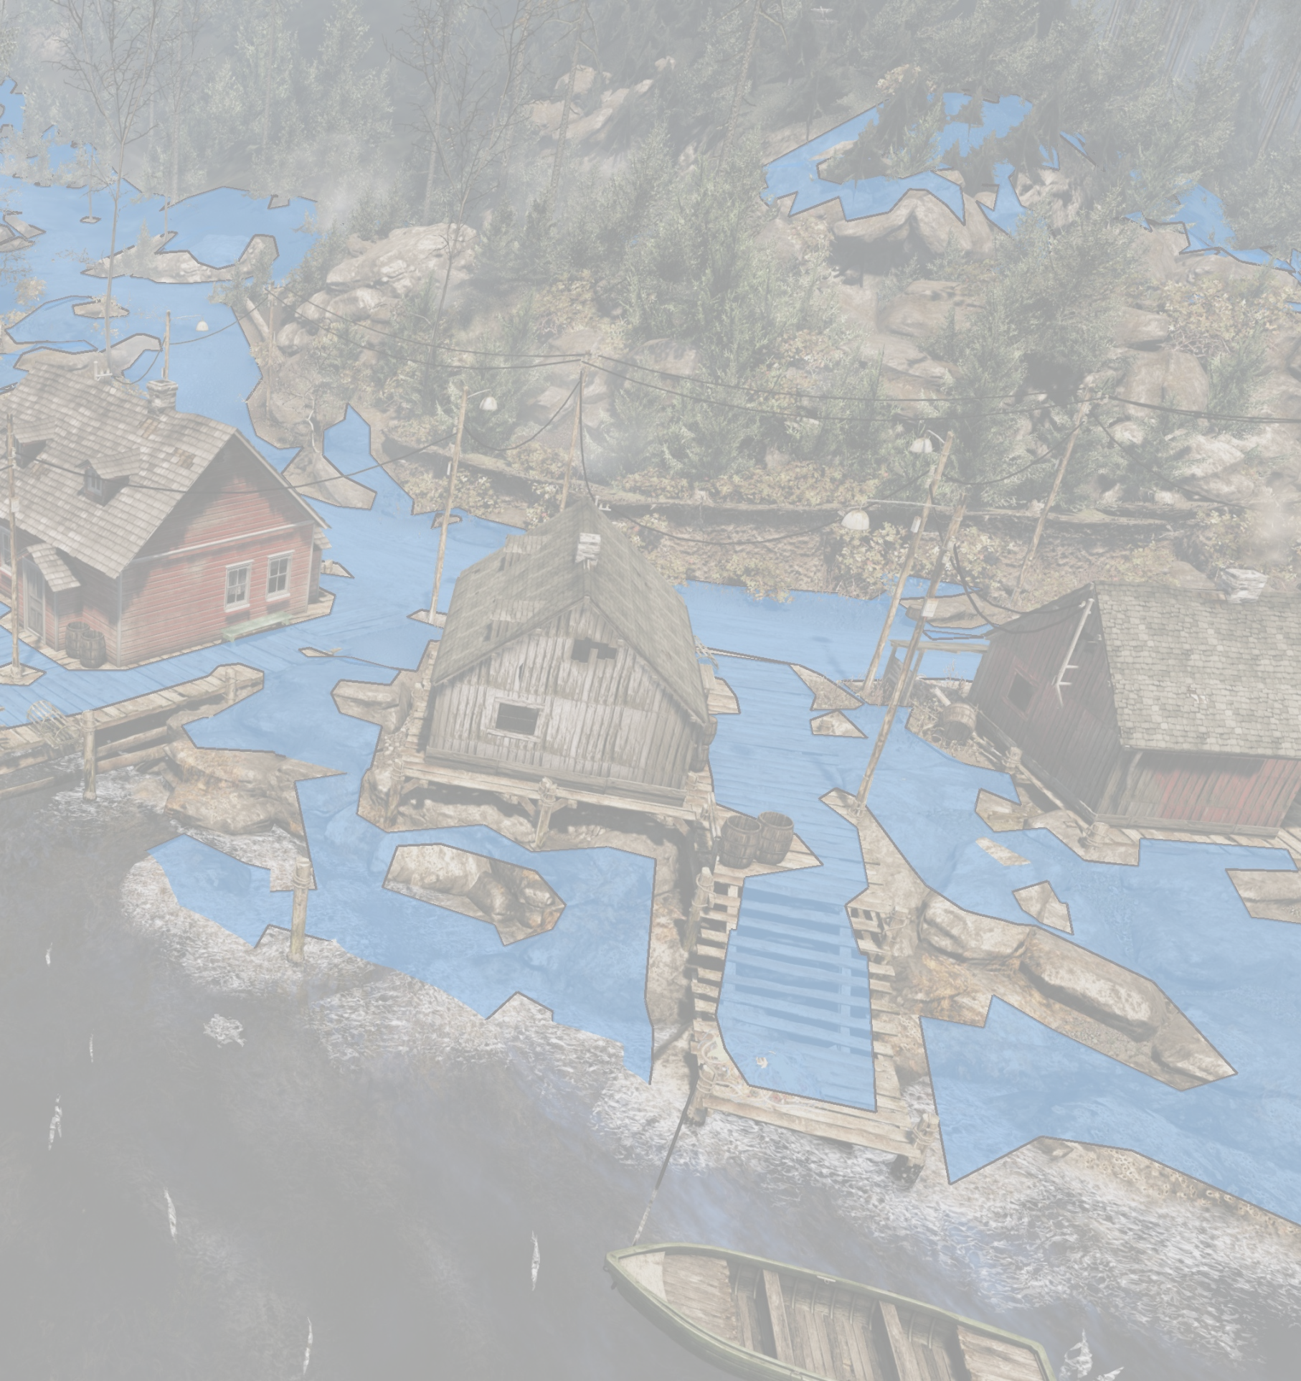
 AI
Universal AI solution for games and simulators

Navigation
- Navigation with little or no assistance from the designers
- Multi-layer, flying, swimming, zero-gravity, or simple 2D navigation
- Smart objects for special navigation or interactions

Individual AI
- Easy-to-use static and dynamic covers (e.g. behind movable vehicles)
- Dynamic tactical points (like cover points, ambush points, patrol waypoints)
- Behavior trees, to select behaviors based on values of Boolean variables
- Customizable perception (like vision, sound, memory, sixth sense)

Group and Global AI
- Group behavior trees, to define group tactics
- Formations, to move AI characters in some orderly fashion
- Factions (like friends, neutrals, enemies)
- Visual flowgraphs of game logic, with macro-nodes for reused sub-flowgraphs

MMO-ready
- Support for streaming big maps

User-friendly
- Visual AI debugger, to log signals, behavior changes, goal changes, user comments
- Behavior tree visual editor
- Visual flowgraph editor and debugger (with visual flow propagation and breakpoints)

mycryengine.com/ai

