**NBI Online Colleague Assistance and Case Progress System in Regional office**

An

Application Development Project

Presented to the Faculty of

**Mindoro State University Calapan City Campus**

Masipit, Calapan City

Oriental Mindoro

In Partial Fulfillment

Of the Requirements for the Degree

Bachelor of Science in Information Technology

By:

**Ang, Shieren Mae**

**Caringal, Kllen Dalemar**

**Garcia, Chester Josiah**

**Miranda, Vhybenica**

October 2024

TITLE PAGE…………………………………………………………………………………………………………………………

TABLE OF CONTENTS………………………………………………………………………………………………………

CHAPTER I. INTRODUCTION

Project Context

Objectives

Scope and Limitation

Definition of Terms

CHAPTER II. REQUIREMENT SPECIFICATIONS

Hardware and Software Requirements

Functional Requirements

Non-Functional Requirements

CHAPTER III. DESIGN AND DEVELOPMENT METHODOLOGIES

System Design

Database Design

Architectural Diagram/ Block Diagram

DFD Level 0

UML Use-case Diagram

Sample Mock-up

Methodology

Phases of Method

Testing

ISO 25010 Evaluation

CHAPTER IV. DEVELOPMENT, TESTING AND EVALUATION RESULT

Presentation of the System Output

CHAPTER V. CONCLUSION AND RECOMMENDATION

Conclusion

Recommendation

**CHAPTER I**

**INTRODUCTION**

**Project Context**

Efficient communication is essential to remaining productive and organized in the demanding and fast-paced work world of today. Constant phone calls can seriously disturb the productivity of National Bureau of Investigation (NBI) secretaries, making it challenging for them to concentrate on job and efficiently manage their time. These calls, which frequently originate from coworkers looking for information or updates, present a constant problem, particularly after work or during breaks.

In order to tackle this problem, we suggest creating the NBI Online Colleague Assistance and Case Progress System in Regional office, an intuitive program that aims to simplify internal correspondence and minimize disturbances. Instead of making repeated phone calls, this system will act as a central location for coworkers to submit questions and requests pertaining to their assignments. The secretary can prioritize and manage requests in an orderly manner, responding to them at the right times without feeling overburdened, particularly during personal or non-working hours, by automating the process of delivering notifications.

In addition, the system enables the secretary to reply to inquiries and give status updates straight within the platform, guaranteeing that every query is answered promptly and openly. This method facilitates straightforward communication and retains a digital record of all exchanges, which makes task tracking and accountability easier. The NBI Online Colleague Assistance and Case Progress System in Regional office facilitates more seamless collaboration by centralizing and digitizing these conversations, giving the secretary greater control over her workload and fewer disruptions. In the end, this increases output and creates a more effective work atmosphere.

**Objectives**

The general objectives of the NBI Online Colleague Assistance and Case Progress System in Regional office are to improve internal communication for the secretary of the National Bureau of Investigation. By providing a centralized platform for staff to submit their inquiries and manage tasks, the system aims to reduce interruptions to the secretary’s workflow. It will help the secretary respond to requests more efficiently, encourage better teamwork, and ensure that all questions are addressed in a clear, organized, and timely manner.

While its specific objectives are:

* Develop a user-friendly and efficient platform for handling staff inquiries.
* Enable the NBI secretary to manage, prioritize, and respond to requests without constant interruptions from phone calls.
* Ensure all communication is documented and easily accessible within the system.
* Track tasks and provide updates in a timely and organized manner.
* Improve overall workflow and productivity through structured task management and efficient communication.

**Scope and Limitation**

The scope of the NBI Online Colleague Assistance and Case Progress System in Regional office is to enhance internal communication within the NBI office by facilitating consistent interactions between colleagues and the secretary. The system streamlines the management and prioritization of inquiries and requests, enabling the secretary to organize their workflow more effectively. By providing timely notifications about incoming queries, the platform reduces disruptive phone calls, allowing the secretary to maintain focus during work hours and personal time. It also enables prompt responses and updates within the application, ensuring transparency and creating a digital record of all communication for future reference. With a user-friendly interface, this system is specifically designed for internal use, fostering a more efficient and organized working environment.

However, the system does have limitations. It is designed solely for internal communication and is not intended for use by external clients or the general public. Furthermore, the scope is restricted to the NBI office in region 4B MIMAROPA, and its features may not be applicable in other regions without customization. The platform's functionality relies on stable internet connectivity, meaning that any disruptions could hinder real-time notifications and responses. While it effectively addresses communication and tracking needs, it does not serve as a comprehensive case management tool for handling investigations or legal processes. Lastly, the system's success depends on user adoption among staff and the secretary, which may require initial training and a period of adaptation to ensure consistent usage.

**Definition of Terms**

Internal Communication Platform - The system's primary function as a centralized hub where NBI colleagues and the secretary can communicate, manage queries, and share updates without relying on phone calls.

Scalability - The system's capability to accommodate an increasing number of users, queries, and case updates as the NBI office's needs grow over time.

Auditability - A feature within the system that ensures all interactions, inquiries, and case updates are logged and can be reviewed for future reference or auditing purposes.

Data Storage - Refers to the system's ability to securely store all communication records and case progress information for up to five years, adhering to NBI policies.

Maintainability - The ease with which the system can be updated and modified to improve functionality or fix issues without causing significant disruptions to the workflow.

Data Privacy - The system’s compliance with data protection laws, such as the Philippines Data Privacy Act, ensuring that all sensitive information handled within the platform is protected.

AES-256 Encryption - The security measure used within the system to protect sensitive case and client data by encrypting it with Advanced Encryption Standard (AES) at a 256-bit level, ensuring confidentiality.

Case Progress Updates - Information and reports entered into the system to track the status of cases handled by the NBI, providing transparency and accountability within the office.

Queries - Questions or requests submitted by NBI colleagues to the secretary via the platform, replacing the need for direct phone calls or in-person inquiries.

**CHAPTER 2**

**REQUIREMENTS SPECIFICATION**

**Hardware and Software Requirements**

TABLE 1. Software Requirements

Table 1 shows the software requirements used in the system along with its minimum, maximum, and a short explanation about the requirements.

|  |  |  |  |
| --- | --- | --- | --- |
| **Requirements** | **Minimum** | **Maximum** | **Explanation** |
| Operating System | Windows Server 2016. | Windows Server 2019 or higher | A stable, long-term support (LTS) OS is necessary to ensure security and performance. |
| Web Server | Apache 2.4 | Apache 2.4.54 or higher | The web server is needed to deliver web pages and handle traffic. |
| Database | MySQL 5.7 | MySQL 8.0 or higher | A modern database version ensures security, speed, and better features. |
| Programming Language | PHP 7.2 or Node.js 10 | PHP 7.4 or Node.js 14 or higher | Newer versions provide better security and performance for backend operations. |
| Backup System | Windows Backup for Windows Server 2016. | Windows Backup for Windows Server 2019 or higher. | Regular backups are essential to avoid data loss. |
| Operating System | Windows 7 | Windows 10/11 | Modern operating systems are more secure and support the latest web technologies. |
| Web Browser | Google Chrome 80, Firefox 75, and Microsoft Edge 80. | Google Chrome 100+, Firefox 100+, and Microsoft Edge 100+. | The system is browser-based, so an up-to-date browser ensures compatibility and security. |
| Internet Connection | 3 Mbps | 5 Mbps or higher for better performance | A stable and fast internet connection is crucial for a smooth experience. |
| Basic Device Specifications | Processor: Intel  RAM: 4 GB.  Storage: 128 GB HDD. | Processor: Intel i5 or higher.  RAM: 8 GB or higher.  Storage: 256 GB SSD or higher. | These specs ensure that users can run the browser and web application without slowdowns. |
| PDF Reader | Adobe Reader 11. | Adobe Reader DC or any up-to-date PDF reader. | PDF readers are useful if the system generates reports or documents in PDF format. |

**Functional Requirements**

**1. User Registration and Login**

- System shall provide a registration form for both admin and user roles, capturing personal information, contact details, and role selection (admin, user).

- System shall validate registration inputs, including ensuring all required fields are completed.

- Upon registration, the system shall send a verification email to the registered email address of the user.

- Users must verify their email by clicking the link in the email to activate their account.

- System shall provide a login form where users can access the system using their verified username and password.

**2. Profile Management**

- System shall allow both admin and users to access their profile page.

- Users shall be able to view, edit, and update their profile information (e.g., name, contact information, role).

- System shall save changes to the user profile in the database upon submission.

**3. Admin and User Role-Based Access**

- System shall differentiate between user and admin roles upon login.

- Users with the admin role (i.e., the secretary) shall have additional permissions, including viewing and managing user-submitted cases and uploading responses.

- Users shall have limited permissions to view and submit cases to the secretary but not access admin-only functions.

**4. Status Indicator for Admin**

- The system shall display the current status of the secretary (admin) account as either "Active" or "Inactive" beside the admin’s profile.

- Status shall be updated automatically based on the admin’s login activity.

**5. File Upload for Case Submission**

- Users shall have the functionality to upload case files for the secretary’s review.

- During file upload, the user shall enter required details, including:

- Case title

- Concern details

- Date submitted

- Date of expected response

- Uploaded files and their corresponding details shall be stored securely in the database.

**6. Case Management and Status Tracking**

- The admin shall have access to view and manage all uploaded cases.

- System shall allow the admin to update the status of each case, with statuses such as "Pending," "In-Progress," and "Resolved."

- Users shall be able to view the current status of their submitted cases.

**7. Case History**

- System shall maintain a history log of all resolved or completed cases.

- Users shall have access to view a history of their submitted cases, including those marked as "Resolved" or "Done."

**8. Activity Logs**

- System shall record login and logout activities for each user.

- Admin shall be able to access and view these activity logs for monitoring purposes.

- Activity logs shall include details such as user ID, timestamp, and action performed (login/logout).

**9. Mobile Compatibility**

- System shall support mobile-responsive design, allowing users to access and interact with the system seamlessly on mobile devices.

**10. User-Friendly Interface**

- System shall have an intuitive and user-friendly interface for easy navigation.

- Interface design shall prioritize ease of use for both technical and non-technical users, with clear labels, prompts, and instructions.

**Non-Functional Requirements**

**Operational Requirements**

Easy to Use - The system will be simple and built-in, so that NBI secretaries and colleagues can use it with minimal training.

Scalable - The system should be scalable to support the addition of new users, queries, and case progress updates.

Maintainability - The system will be designed to allow easy updates without causing major downtime.

**Performance Requirements**

Auditability - The system will keep records of all communication and case updates, so everything can be reviewed later if necessary.

Data Storage - All communication and case records will be kept for up to 5 years, following NBI rules.

**Security Requirements**

**Security** - Sensitive case and client information should be encrypted with AES-256.

**Data Privacy** - Ensure compliance with data protection laws such as the Philippines Data Privacy Act.

**CHAPTER 3**

**DESIGN AND DEVELOPMENT METHODOLOGIES**

**System Design**

**Database Design**

The database design for the NBI Online Colleague Assistance and Case Progress System in the Regional Office is critical for efficiently managing data related to staff inquiries, case progress, and user interactions.

Figure 1. Database Schema

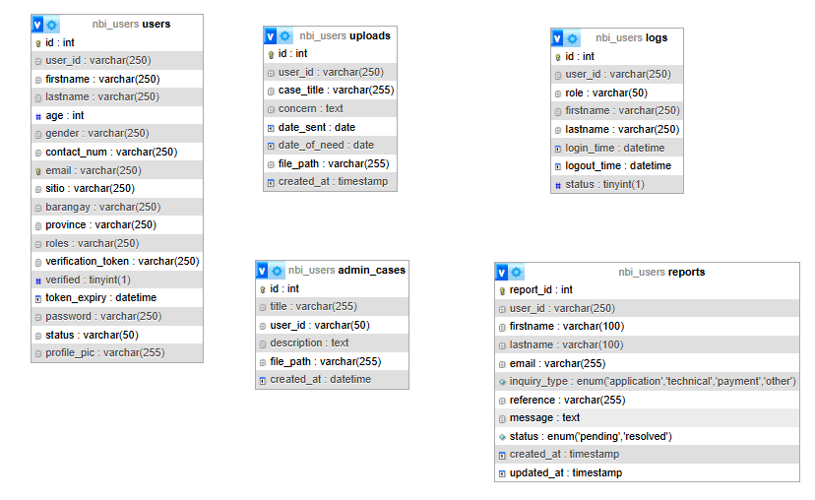

TABLE 1. Field of users

|  |  |  |  |
| --- | --- | --- | --- |
| Field Name | Data Type | Default | Description |
| Id | Int |  |  |
| User_id | Varchar(250) |  |  |
| Firstname | Varchar(250) |  |  |
| Lastname | Varchar(250) |  |  |
| Age | int |  |  |
| Gender | Varchar(250) |  |  |
| Contact_num | Varchar(250) |  |  |
| Email | Varchar(250) |  |  |
| Sitio | Varchar(250) |  |  |
| Barangay | Varchar(250) |  |  |
| Province | Varchar(250) |  |  |
| Roles | Varchar(250) |  |  |
| Verification_token | Varchar(250) |  |  |
| Verified | Tinyint(1) |  |  |
| Token_expiry | datetime |  |  |
| Password | Varchar(250) |  |  |
| Status | Varchar(50) |  |  |
| Profile_pic | Varchar(255) |  |  |

TABLE 2. Fields for Uploads

|  |  |  |  |
| --- | --- | --- | --- |
| Field Name | Data Type | Default | Description |
| Id | int |  |  |
| User_id | Varchar(250) |  |  |
| Case_title | Varchar(255) |  |  |
| Concern | Text |  |  |
| Date_sent | Date |  |  |
| Date_of_need | Date |  |  |
| File_path | Varchar(255) |  |  |
| Created_at | Timestamp |  |  |

TABLE 3. Field of Admin Cases

|  |  |  |  |
| --- | --- | --- | --- |
| Field Name | Data Type | Default | Description |
| Id | int |  |  |
| Title | Varchar(255) |  |  |
| User_id | Varchar(50) |  |  |
| Description | Text |  |  |
| File_path | Varchar(255) |  |  |
| Created_at | Datetime |  |  |

TABLE 4. Field of User Logs

|  |  |  |  |
| --- | --- | --- | --- |
| Field Name | Data Type | Default | Description |
| Id | int |  |  |
| User_id | Varchar(250) |  |  |
| Role | Varchar(50) |  |  |
| firstname | Varchar(250) |  |  |
| lastname | Varchar(250) |  |  |
| Login_time | Datetime |  |  |
| Logout_time | Datetime |  |  |
| status | Tinyint(1) |  |  |

**Architectural Diagram / Block**

The architectural diagram for the NBI Online Colleague Assistance and Case Progress System in the Regional Office visually represents the structure and components of the system. It outlines how different modules interact with each other and the overall flow of data within the system.

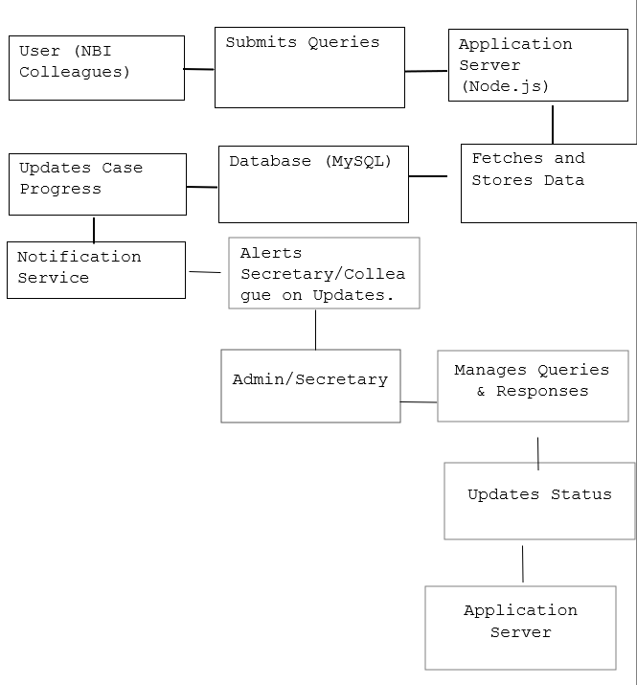

**DFD Level 0**

The Data Flow Diagram (DFD) Level 0, also known as a Context Diagram, provides a high-level overview of the NBI Online Colleague Assistance and Case Progress System in the Regional Office. It illustrates how the system interacts with external entities, the major data flows, and the system's boundary.

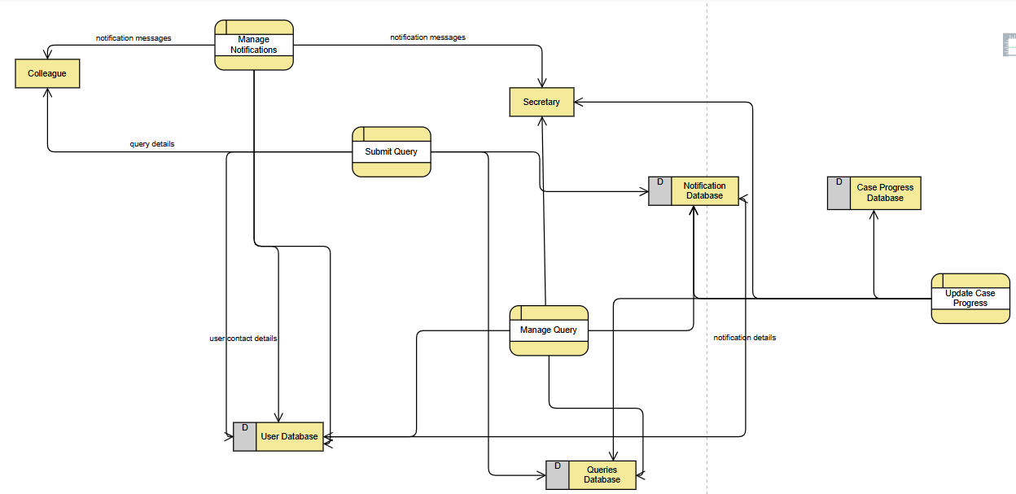

**UML Use-Case Diagram**

The UML Use Case Diagram for the NBI Online Colleague Assistance and Case Progress System in the Regional Office visually represents the system's functional requirements by illustrating the interactions between users (actors) and the system's functionalities (use cases). This diagram helps in understanding the system's operations from a user's perspective.

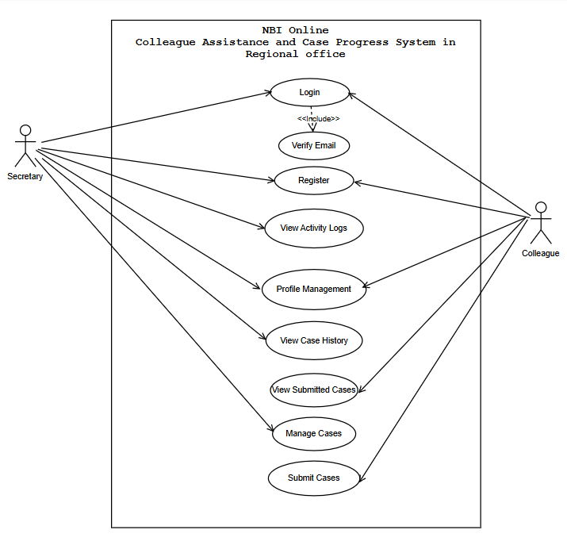

**Sample Mock-up**

Sample mock-up is the visual representation of the website, that shows the layout. It helps improve the user experience by making sure the design is simple, easy to use, and meets what users expect.

**Figure 1. User Interface**

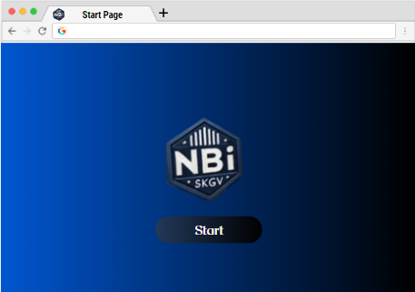

**Figure 2. Login**

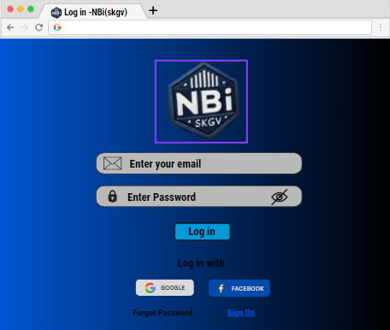

**Figure 3. Register**

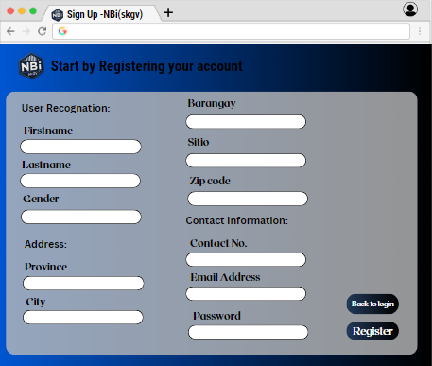

**Figure 4. Homepage for user**

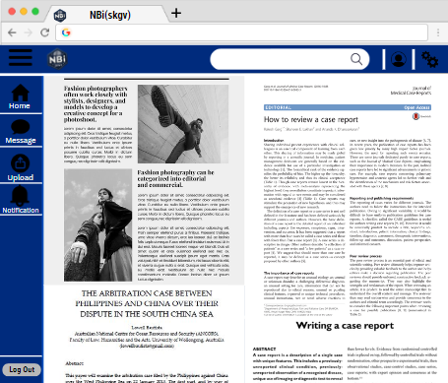

**Figure 5. Message page for user**

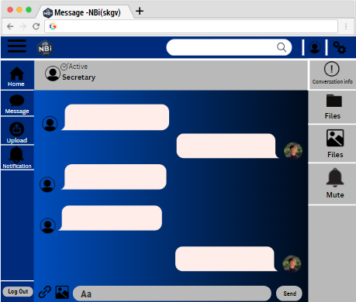

**Figure 6. Upload for user direct to admin**

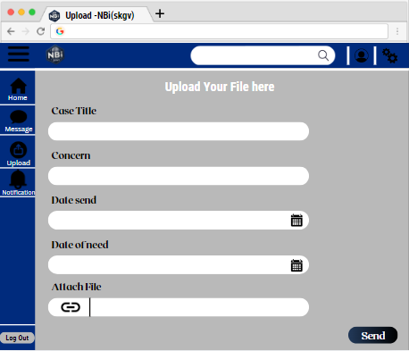

**Figure 6. Notification for user**

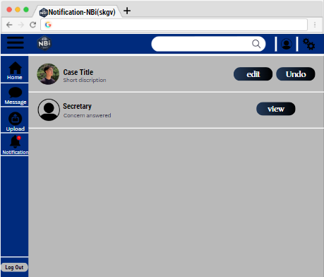

**Figure 7. Settings**

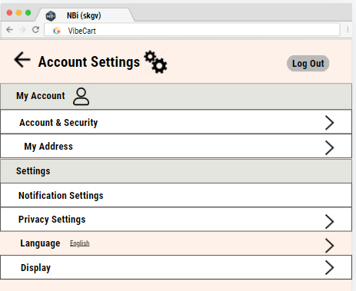

**Figure 6. Admin Interface**

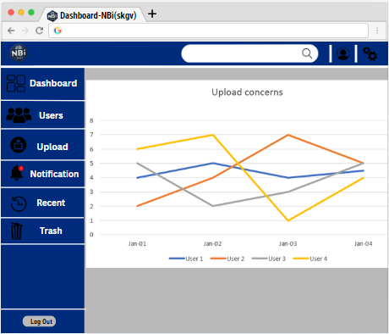

**Figure 7. Admin notification**

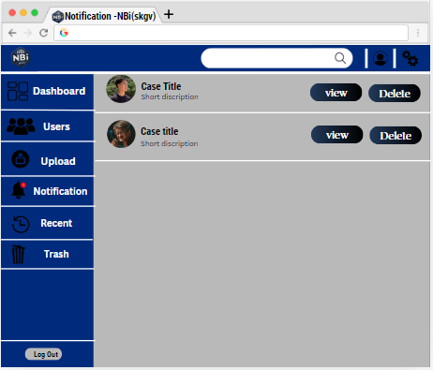

**Figure 8. Admin Users**

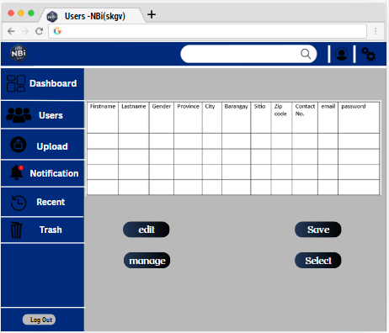

**Project Methodology**

Figure 9. Agile Methodology Phases

Development

Project Planning

Maintenance

Requirements Gathering

Testing

Review Feedback

Design

Deployment

The Agile Development Methodology is an iterative and incremental approach to software development that focuses on delivering functional parts of the system over short development cycles. We chose this method because it offers flexibility and allows us to adapt to changing needs throughout the project. This approach is ideal for the NBI Online Client Assistance and Case Progress System as it ensures the system evolves based on real time feedback from the NBI secretaries and staff. Agile’s iterative process helps deliver key features early, like query management and case tracking, while continuing to refine other areas. It also allows for seamless adjustments in line with evolving security standards, especially for sensitive data like case information. Regular updates and transparent communication are central to Agile, ensuring that the system always aligns with user expectations, while providing the team with the ability to make improvements without causing major disruptions. This method not only keeps the project on track but also ensures the final product is user-friendly, efficient, and secure.

The Agile Manifesto (Fowler et al., 2019) emphasizes the importance of individuals and interactions, working software, customer collaboration, and responsiveness to change. These principles align directly with the needs of the NBI Online Client Assistance and Case Progress System, where the ability to adapt to the needs of secretaries and colleagues in real-time is crucial for improving internal communication and case management.

A recent study by Dikert, Paasivaara, and Lassenius (2019) highlights the success of Agile in environments that require frequent interaction between developers and end-users, ensuring that user feedback is incorporated into the development process. This is particularly relevant in government settings, where projects must evolve based on the practical needs of staff rather than assumptions made during initial planning.

**Phases of Methodology**

Agile development methodology phases in NBI Online Colleague Assistance and Case Progress are:

1. Project Planning - In this phase, the team defines the high-level goals, vision, and scope of the project. Gathering basic requirements, identify the main features, and understand the needs of the NBI secretaries and staff.

2. Requirements Gathering - Detailed requirements are collected. Regular interaction with the NBI secretaries will ensure that the system's features meet their needs, and any new requirements are integrated in future iterations.

3. Design - During this phase, the technical architecture and design of the system are created. This includes planning the user interface (UI) for a user-friendly experience, the database structure for managing case records, and the security mechanisms. The design is kept flexible to allow for future updates or changes.

4. Development - Build the system in short, iterative cycles (sprints), delivering small, functional parts after each sprint.

5. Testing - Both functional and non-functional testing are done here. Functional testing will focus on how the system manages inquiries, while non-functional testing will address performance, security, and scalability.

6. Deployment - Gradually roll out system features, deploying usable parts while continuing development.

7. Review Feedback - Gather feedback at the end of each sprint, making adjustments based on user needs.

8. Maintenance - After deployment, provide ongoing updates, bug fixes, and improvements as needed.

**CHAPTER IV**

**DEVELOPMENT, TESTING AND EVALUATION RESULT**

This chapter presents the system's output, covering the development, testing, and evaluation phases. It highlights key interfaces, their functionalities, and the outcomes of testing to validate system performance against the defined objectives.

**Presentation of the System Output**

**Figure 1. Login Page**

This page is the gateway to the system where users securely input their registered username and password. It includes error handling to validate inputs and prevent unauthorized access, ensuring only verified users can log in.

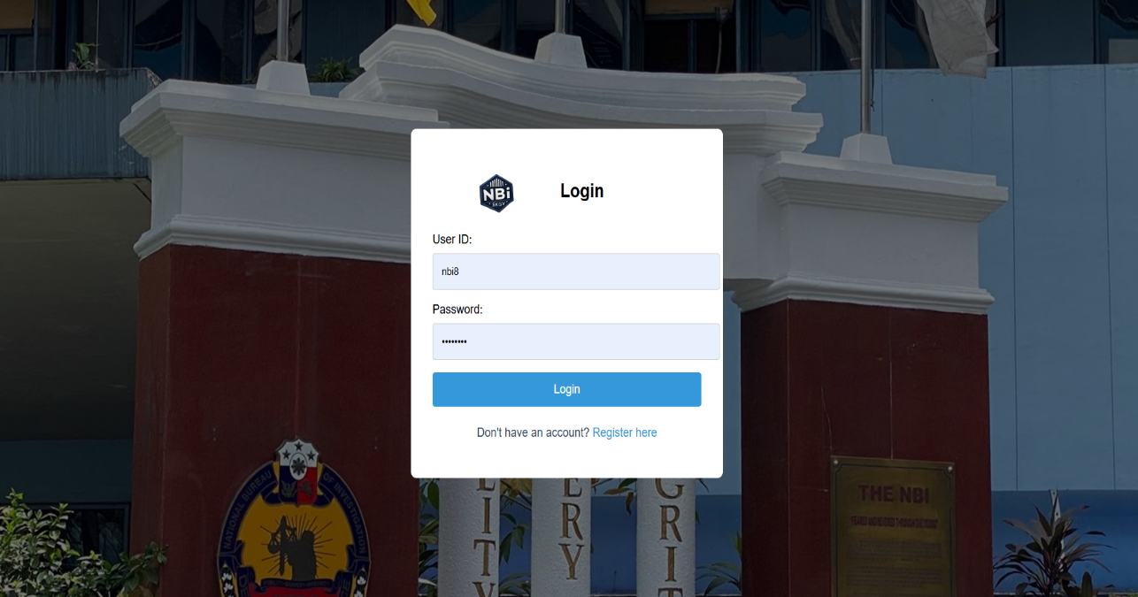

**Figure 2. Registration Page**

New users can create an account by completing fields for their name, email, role, and password. After successful submission, an email verification link is sent to activate the account, adding a layer of security.

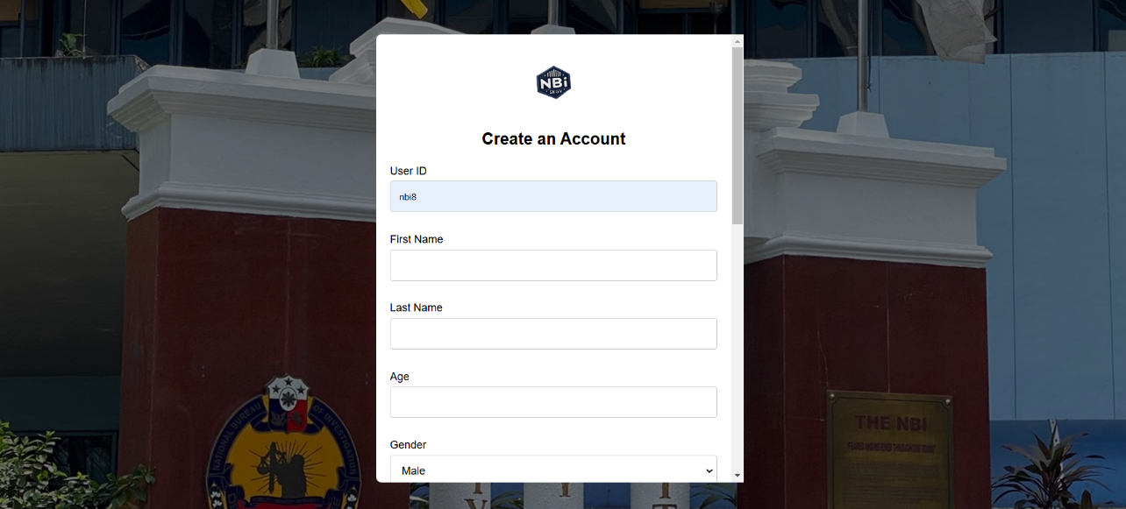

**Figure 3. Admin Dashboard**

The admin dashboard provides a real-time overview of system activity, including active users, pending cases, and submitted queries. It serves as the admin's central hub for monitoring and managing tasks efficiently.

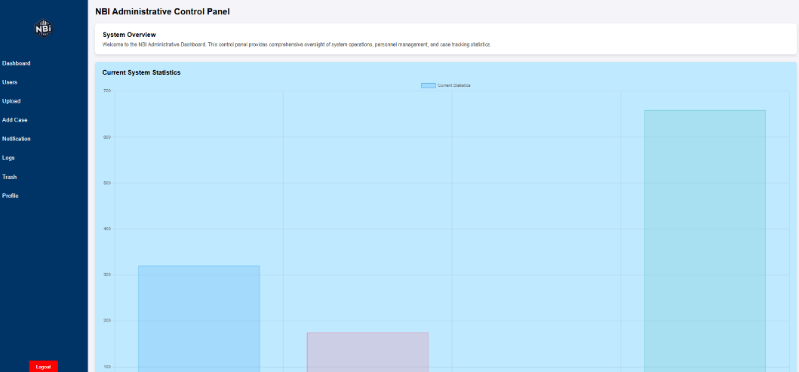

**Figure 4. Admin User View**

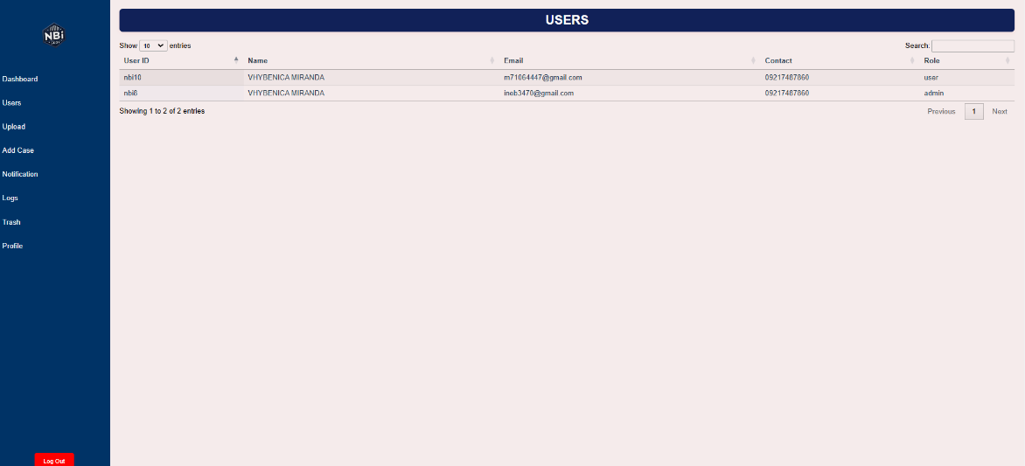 This interface allows the admin to view and manage all registered users, including their profiles, submitted queries, and account statuses. Tools for resolving user-related issues or approving pending requests are also included.

**Figure 5. File Upload for Case Submission**

Users can upload case files with essential details, such as the case title, description, and an expected response date. The interface ensures that all files and information are securely submitted to the admin for review.

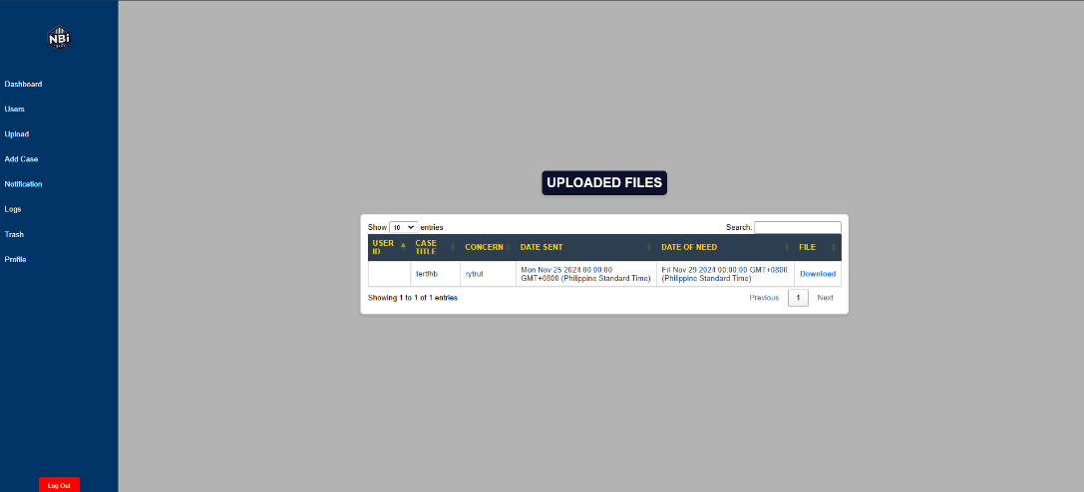

**Figure 6. Add New Cases**

This page allows admin to add new cases with its case title through the user id of the user, and also add a short description about the case along with its pdf file. This will be sent to the user dashboard for users to view the sent case.

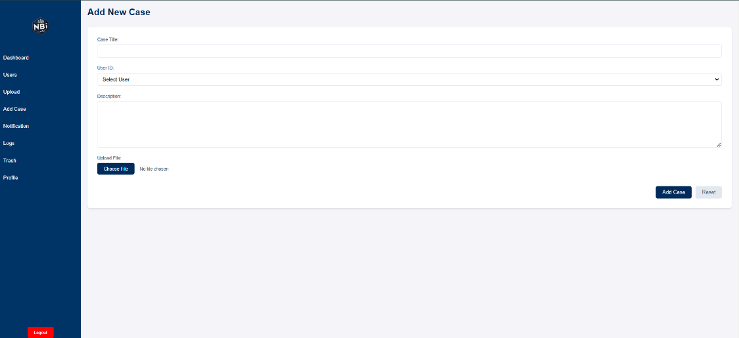

**Figure 7. Administrative Notification**

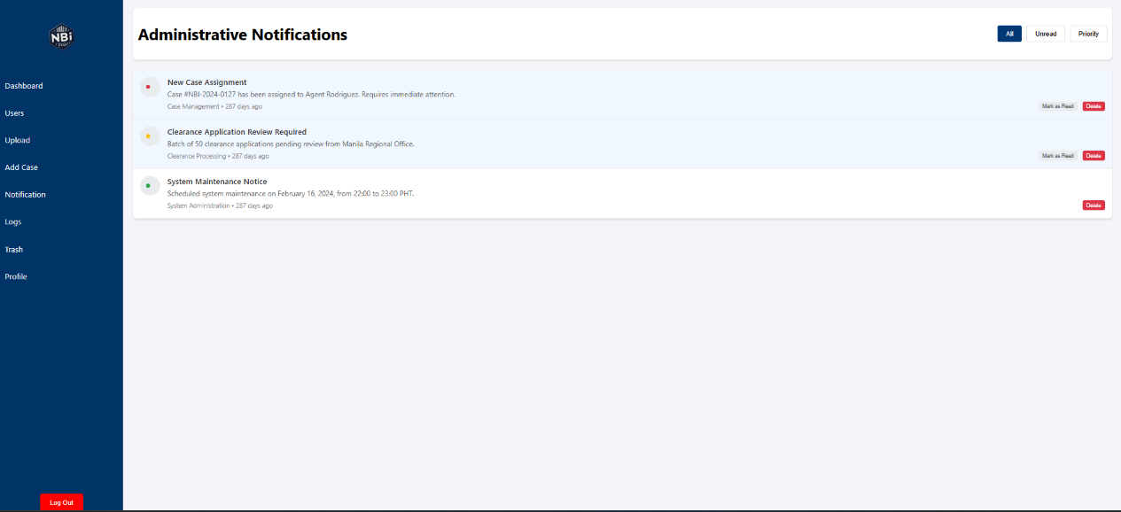 Notifications for the admin are displayed here, alerting them to new case submissions, updates, or urgent system activities. This feature ensures the admin stays informed and can take prompt action when needed.

**Figure 8. Activity Logs**

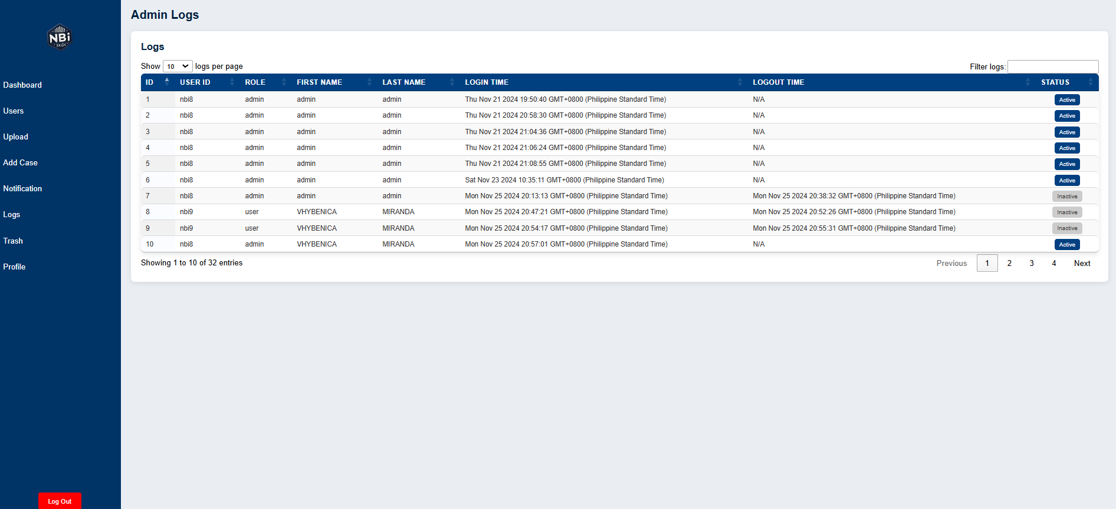 This section records detailed logs of user activities, including login and logout events. It helps admins track system usage patterns and ensures accountability by displaying timestamps and actions performed.

**Figure 9. User Dashboard**

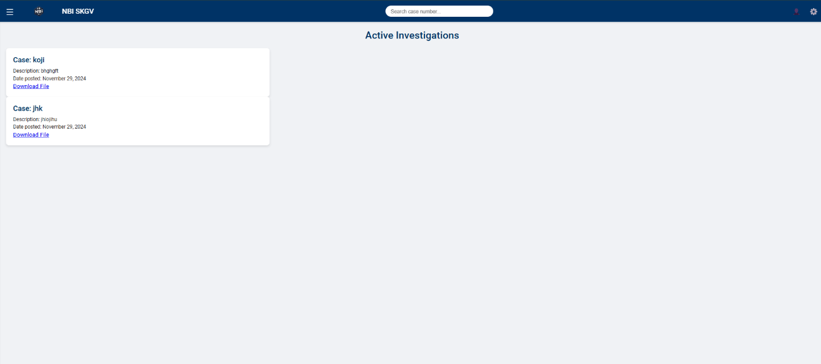The user dashboard provides an overview of the user's activities, such as submitted cases, recent notifications, and system status updates. It simplifies navigation and ensures that users can manage their tasks effectively.

**Figure 10. Settings**

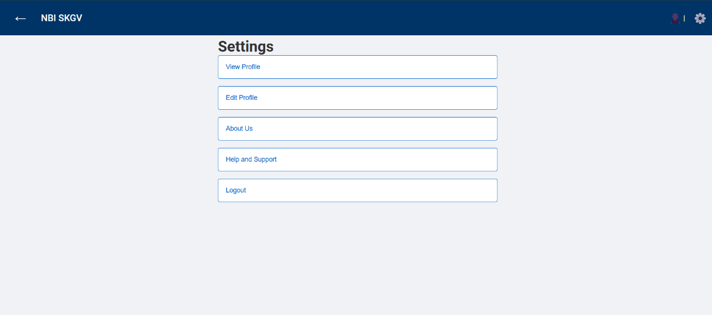 This page enables users to customize their system preferences and update account configurations. It includes options for setting notifications, managing passwords, and adjusting interface settings.

**Figure 11. View Profile**

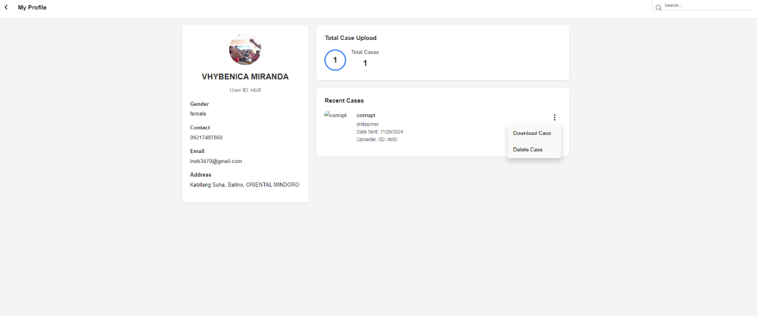 Displays the user’s complete profile information, including their name, role, and contact details. This section provides a clear and organized view of their registered data within the system.

**Figure 12. User Update Profile**

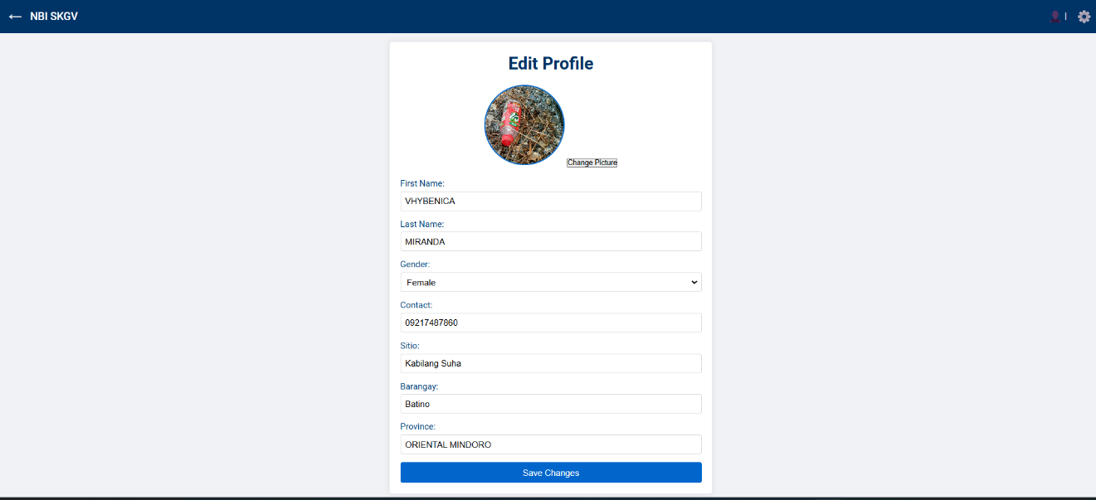 Users can edit their personal information, such as names, emails, and passwords, on this page. Changes are securely saved to the system’s database, ensuring data integrity.

**Figure 13. About Us Page**

This page explains the system's purpose, its development objectives, and introduces the team behind the project. It also outlines how the platform supports efficient communication within the NBI office.

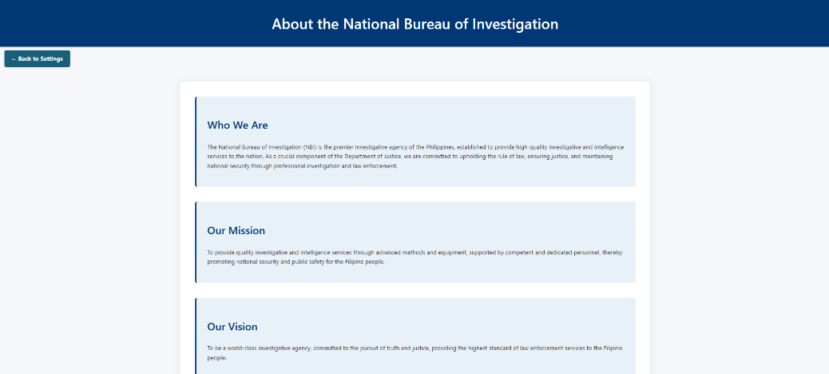

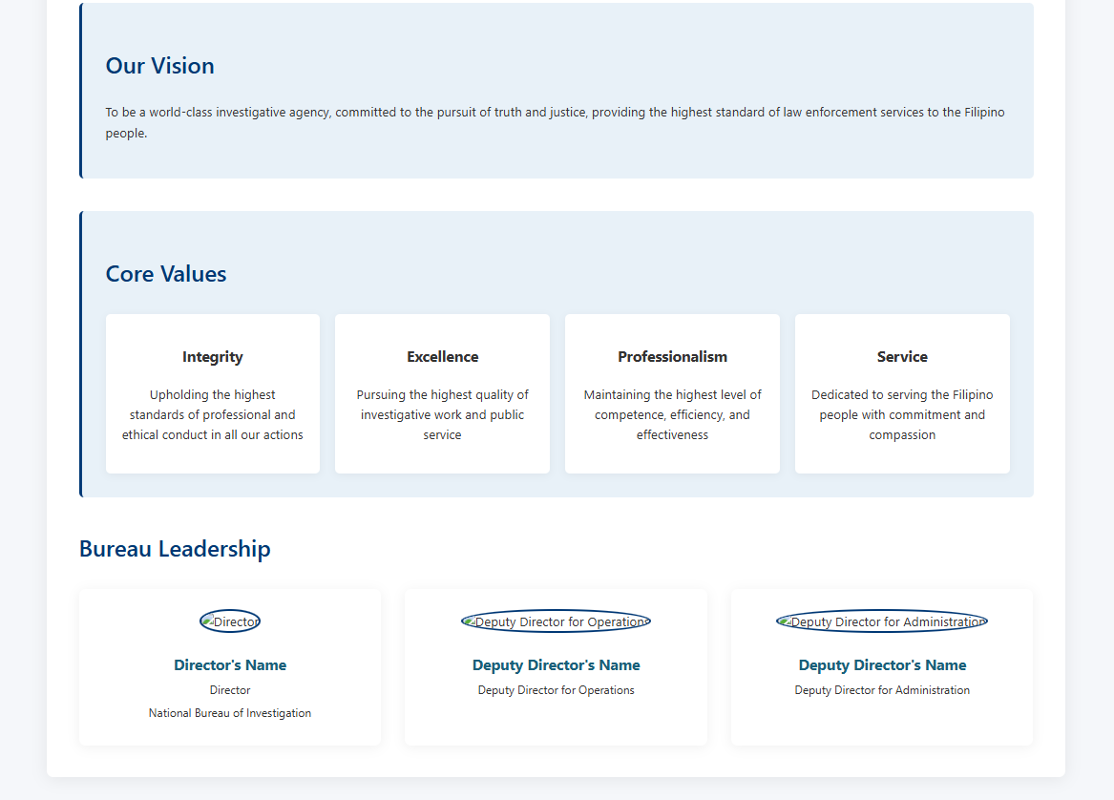

**Figure 14. Help and Support Page**

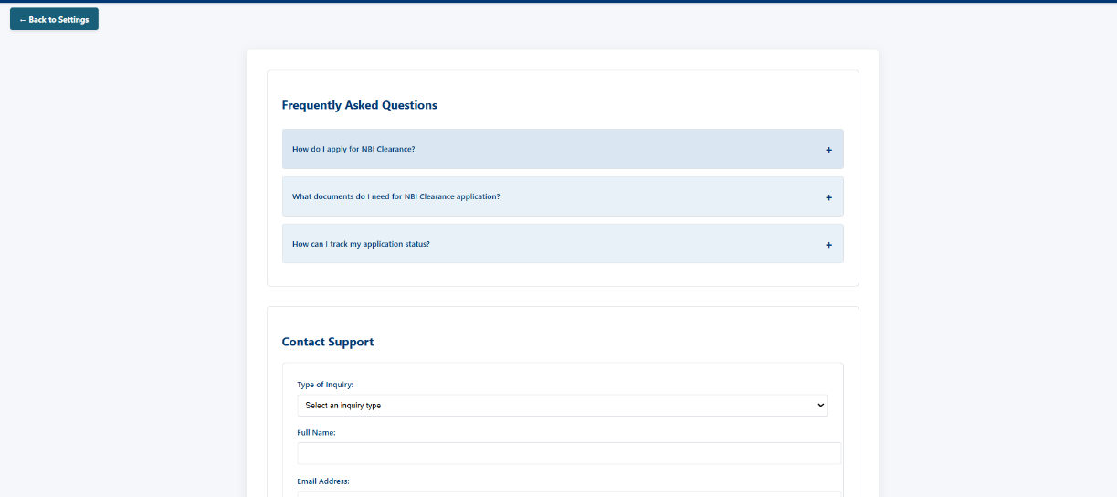A resource center for users, providing guidance on common system functionalities and troubleshooting tips. It includes FAQs and contact options for further assistance.

**Figure 15. User Upload Page**

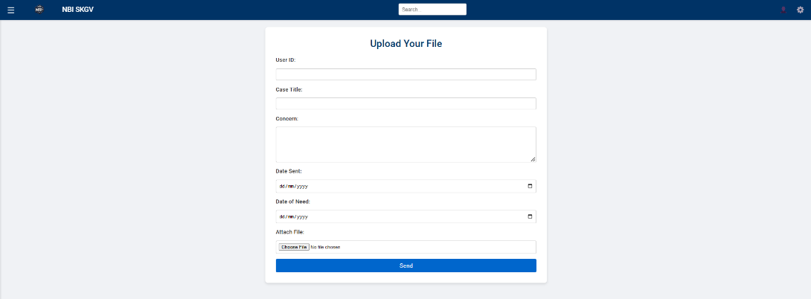 Users can upload files and related case details, such as titles and descriptions, for the admin to review. The process is streamlined, with clear prompts to ensure accurate submission.

**Figure 16. User Notification Page**

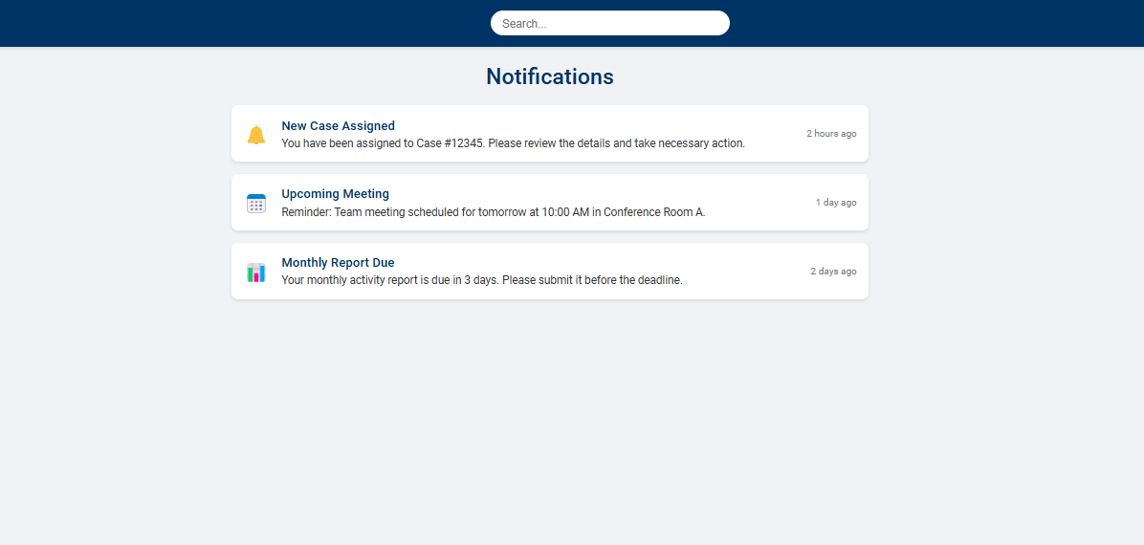 Displays notifications for users, such as case status updates, new responses from the admin, or system announcements. This feature ensures users remain informed about their cases and tasks.

**CHAPTER V**

**CONCLUSION AND RECOMMENDATION**

**Conclusion**

NBI secretaries and employees frequently struggle with interrupted workflows and ineffective communication, which the NBI Online Colleague Assistance and Case Progress System effectively resolves. Utilizing an efficient digital platform to centralize inquiries and requests, the system lessens the need for phone calls, which minimizes disruptions and improves concentration during working hours. Along with creating a more structured and cooperative work environment, the addition of tools like job prioritizing, case monitoring, and automatic notifications has increased accountability and openness in the workplace. Additionally, the design of the system guarantees that secretaries may better organize their work and reply to questions at the right times without feeling overworked. In summary, the system exhibits the ability to refined internal procedures, enhancing output and communication inside the NBI regional office.

**Recommendation**

Comprehensive user training sessions are advised in order to optimize the system's capabilities and guarantee long-term success. By acquainting the secretaries and staff with the functionality of the system, these seminars will facilitate seamless adoption and lower the learning curve. In order to improve its features, fix any technological problems, and add new features that meet the changing demands of the NBI office, the system should also receive regular upgrades based on user feedback. It is also crucial to increase the system's scalability in order to accommodate more regional offices and offer a standardized internal communication solution for the entire company. The system's performance must be regularly monitored and assessed in order to spot usage patterns and areas in need of development. This will support its continued efficacy and relevance. To ensure that sensitive data is protected in accordance with relevant data privacy legislation, including the Philippines Data Privacy Act, strengthening security processes is another top concern. All staff members will find the system easier to use if it is made more accessible by making it mobile-friendly and guaranteeing dependable performance in low-bandwidth settings. Implementing these suggestions will enable the system to accomplish its goals more thoroughly and foster a more modern and effective working environment within the NBI.