**Unit 1 Test for Karen**

**Part 1 Knowledge Questions.**

**i) Solve for x**

$4x^{2} +12x+9 =0$

$64x^{2}-81=0$

$x^{3}-8=0$

$x^{3}+3x^{2}+3x+1=0$

$x^{3}-x^{2}-5x-3=0$

$x^{-2}-{\left(\frac{1}{2x}\right)}^{-1}-3=0$

$\sqrt{\sqrt[2]{1/x}}=10$

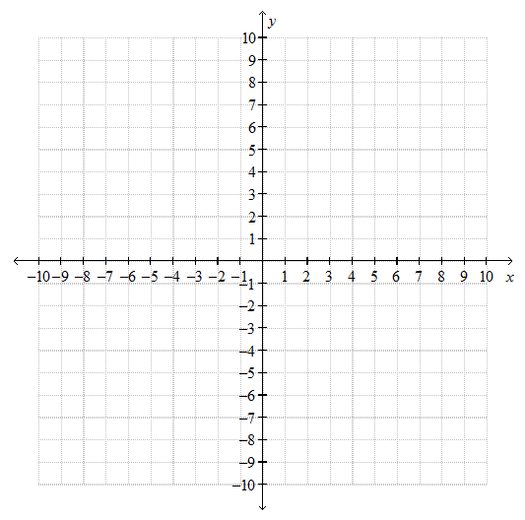**ii) Graph the following equation**

$$y = 2x^{2}- 4x + 5$$

**Part 2 Application Questions.**

Graph the following equation.

$$y=(x^{3}+5x^{2}+8x+4)(x+4)/(x^{2}+5x+6)(x-1)$$

**Part 3 Thinking Problems.**

i) There are cows and chickens in the farm. There are 65 heads and 226 legs. How many chicken are there?

ii) Suggest 3 values for b such that $x^{2}+bx+24$ is factorable

iii) Suggest a possible equation for the following graph.

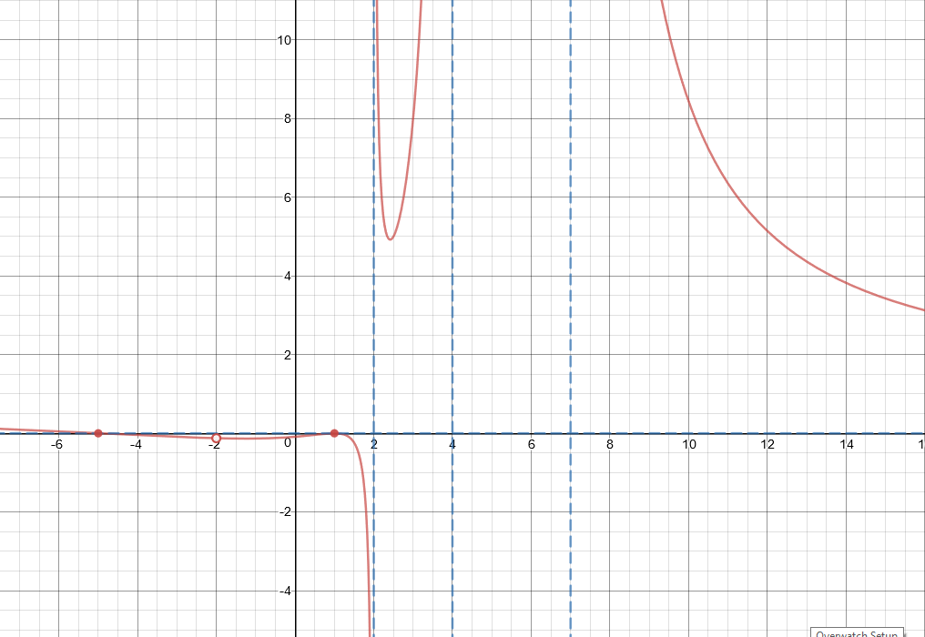

**Part 4 Communication Questions.**

**i) In your own words, explain what is an asymptote. Can a function ever cross an asymptote?**