**New Unit: Slopes and Derivatives.** 

This review is going to be pretty short. The next unit we are going to learn can be simply summed up as “how to find slope?”

It requires you to remember the formula for finding slope.

$$Slope = ∆y/∆x$$

Another way of saying this is the “rate of change of y in respect to x”

Using this equation find the slope of the following graph. Is this slope positive or negative?

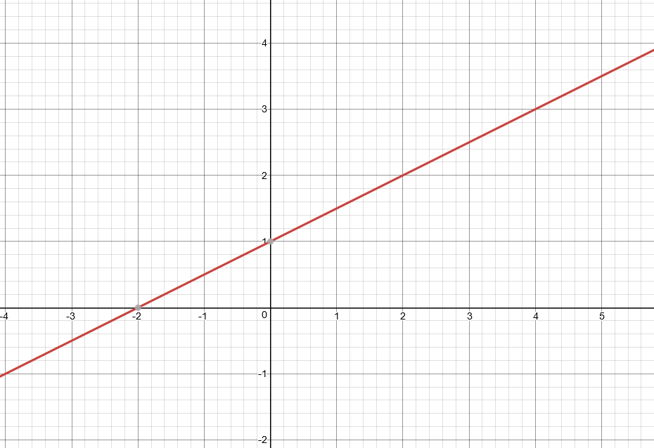

We know how to find slope for a linear equation.

$$y=mx+b$$

Let say I give you two points of a linear equation -> (2, 3) , (3, 4)

Find the slope.

What about these two graphs? What are their slope

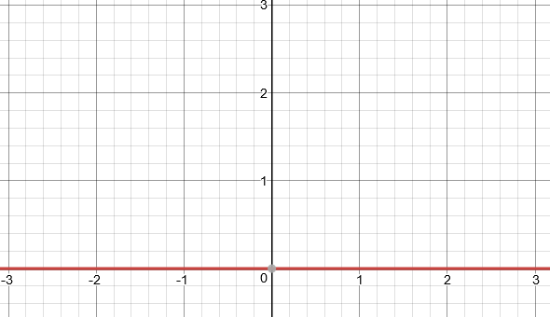

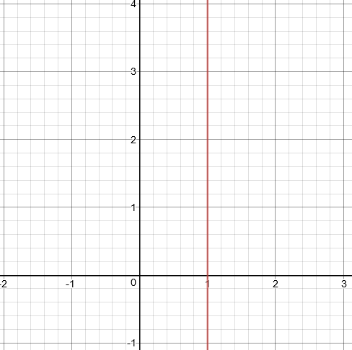

Now we are going to be introduced to how to find slope of a function that is not linear. For example $y=x^{2}$

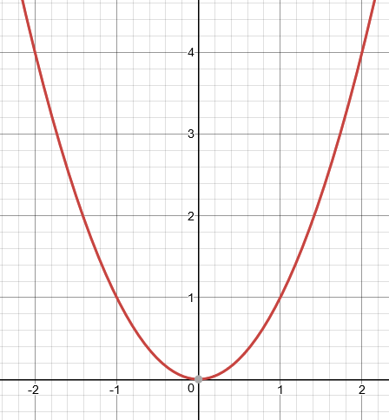

Think about the following questions before the next tutorial.

What is the slope of this equation? Is it Positive? Negative? A constant? Or Is It Changing?

Use this simplified version of the graph below to help you.

