Tutorial: Quick Derivatives Overview.

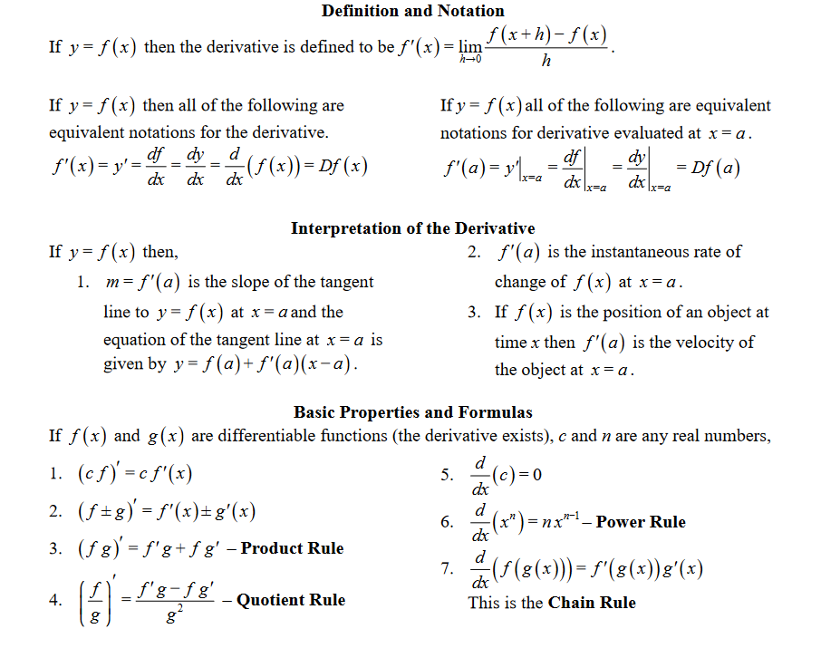

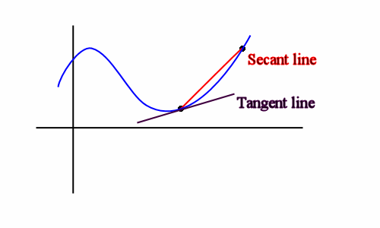

Practice worksheets.

1. Try out this worksheet first. If you are able to correctly complete the problems, move on to the next worksheets. It is using the power rule.

<https://cdn.kutasoftware.com/Worksheets/Calc/03%20-%20Power%20Constant%20and%20Sum%20Rules.pdf>

2. Product rule:

<https://cdn.kutasoftware.com/Worksheets/Calc/03%20-%20Product%20Rule.pdf>

Note for the last question. f◦g is equivalent to saying f(g(x))

3. Quotient rule: You can just use the product rule if you forget the formula for the quotient rule. Either way the quotient rule is quite messy, so be very careful when doing these problems.

<https://cdn.kutasoftware.com/Worksheets/Calc/03%20-%20Quotient%20Rule.pdf>

4. Chain rule:

<https://cdn.kutasoftware.com/Worksheets/Calc/03%20-%20Chain%20Rule.pdf>

………………………………………………………………………………………………………

This will be the worksheets for next week also. So don’t worry if you don’t finish this week, but the majority of derivative unit is just remembering and applying these laws. So make sure you do the worksheets. The next tutorial tomorrow is really going to be just going over all of these rules again, so try to memorize the rules for tomorrow.