**Derivative Part 2 Review.**

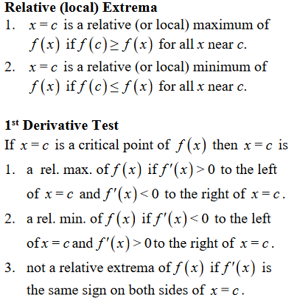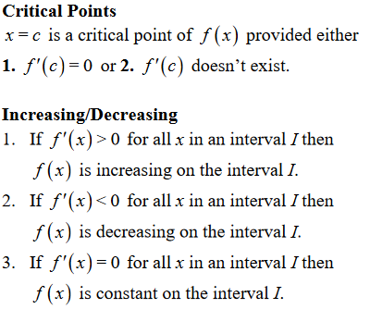

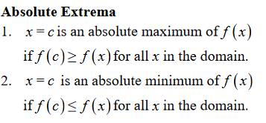

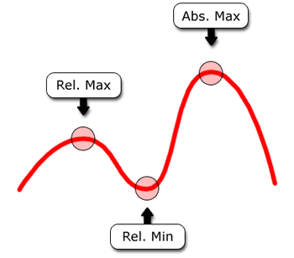

Practice worksheets.

1. More derivative Practice

<http://www.muhlsdk12.org/site/handlers/filedownload.ashx?moduleinstanceid=4027&dataid=3509&FileName=Chapter%203.3%20number%202.pdf>

2. Finding tangent lines. This is from last last tutorial. You use derivative to find the slope of the tangent at that point. Using a slope and a point, create a tangent line.

<https://cdn.kutasoftware.com/Worksheets/Calc/04%20-%20Tangent%20Lines.pdf>

3. Finding relative max and minimums. Try doing these problems using the first derivative test.

<https://cdn.kutasoftware.com/Worksheets/Calc/04%20-%20Relative%20Extrema.pdf>

4. Finding absolute extrema. The idea is that you are trying to compare the Y value of the relative extrema versus the y values of the endpoint. The lower/higher value is then the absolute min/max. Try the worksheet. If you can’t figure out how to do it, don’t worry because we didn’t go in depth into how to find the absolute extrema last tutorial.

<https://cdn.kutasoftware.com/Worksheets/Calc/04%20-%20Absolute%20Extrema.pdf>