**Tutorial #14**

The second derivative test simply enough is another way of determining whether a point is a max or a min. It follows a similar step to the first derivative test.

So you have a critical point x where *f'*(*x*) = 0. If the derivative function *f'*(*x*) is further differentiable, then you can use the 2nd derivative test.

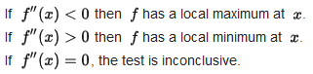

The intuitive reasoning behind it is pretty simple.

So derivative is simply finding the slope of a function. The first derivative test examines the slopes of the function and determines whether the function changes from decreasing to increasing or vice versa. Using that information, we can determine whether it is a max or a min. Similarly, for the 2nd derivative test uses the same idea.

Since a max is when a function changes from increasing to decreasing. The slope of the derivative changes from positive to negative for its derivative. *f'*(*x*) could look something like this. Realize that at x=1 is the critical point in this case, since *f'*(*x*)=0. Now the derivative of the derivative (the 2nd derivative) finds the slope of the derivative. If a function changes from positive to negative. Well, then it is a decreasing function, so a negative slope (a negative 2nd derivative). For this reason, a negative 2nd derivative at the critical point represents a max.

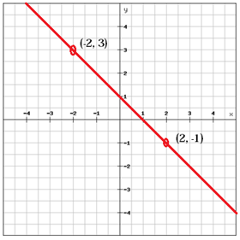

We are going to introduce optimization next lessons and some word problems. To practice the 2nd derivative test you can go back to the relative max and min worksheet from tutorial 13 and just try the problems using the 2nd derivative test.

<https://cdn.kutasoftware.com/Worksheets/Calc/04%20-%20Relative%20Extrema.pdf>

Here are some problems for you to try.

First of all try the problem from last tutorial again (Answer: 15/2)

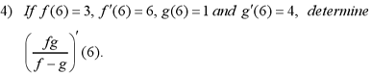

Now try these ones.

1. (*fg*)*'*(6)

2. (*g/f*)*'*(6)

3. (*g+g/ff*)*'*(6)

4. (g+f/f-g)*'*(6)

If I also give you h(6)=1, h*'*(6)=2. Find (*fgh*)*'*(6)

This is a pretty traditional word problem, try it out. (acceleration is the 2nd derivative)

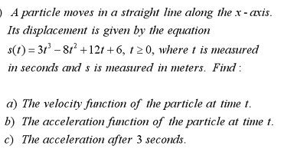

d) Find the minimum speed of the particle. (remember the function is a displacement function, in other words distance)

The other important type of problem is being able to read graphs of the function and infer the derivative or the other way around. Try this worksheet.

<https://cdn.kutasoftware.com/Worksheets/Calc/04%20-%20Comparing%20Function%20and%20Derivs.pdf>