

**Sorry…I was badly organized today : (**

**I will do better on the next Tutorial!**

**From now on, I will also post the next tutorial outline (subjected to change)**

**So Overview of today’s tutorial.**

1. **Factoring.**

**How to factor (the way your teachers taught you, factor by grouping)**

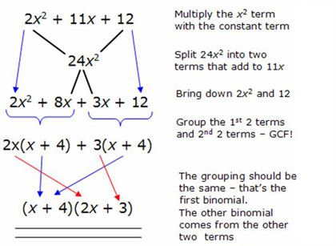

**So you understand this!**

1. **Graphing.**

**Overview of graphing of Quadratics.**

**So you have the form y=A(x+h)+k**

**Method of graphing it.**

**So typically when we graph a parabola, we graph its 5 points. The vertex and the 4 points around it.**

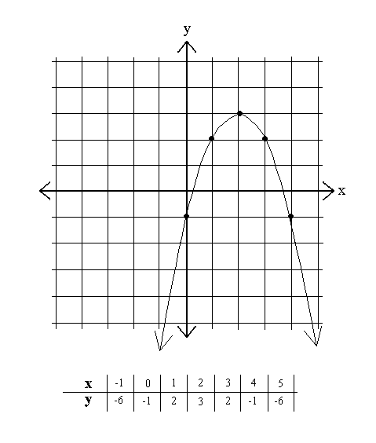

**To plot a quadratic, you must know the basic 5 points of a general quadratic(y=x2)**

|  |  |
| --- | --- |
| **x** | **Y** |
| **-2** | **4** |
| **-1** | **1** |
| **0** | **0** |
| **1** | **1** |
| **2** | **4** |

**So you plot the vertex (0,0) first. You move one right and one up to plot (-1,1), You move one right and three up more to plot (-2, 4). You repeat this for the other side, except you move left instead of right.**

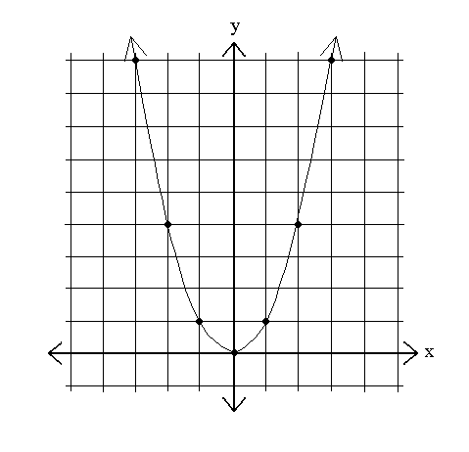

**Know this relationship! You move one right, one up. Plot! Move one right more and three up, Plot! And repeat for the left side.**

**Basic vertex form: y=A(x+h)+k**

**So to plot for example y=-2(x-2)+2**

1. **You plot the vertex (h,k) first, this is how much you translated your original graph (y=x2). In this case you plot (2,2)**
2. **Now you plot the 4 points. If there is no A value, you can just plot the parabola normally. You move one right, one up. Plot! Move one right more and three up, Plot! And repeat for the left side.**
3. **Because there is an A value $≠1$. There is either an expansions or compression. (A>1 there is a compression, 0<A<1 there is an expansion). In this case, the remaining 4 points follow a different relationship. The amount you move vertically is multiplied by a value (positive or negative).**
4. **For example, in this case, you have A=-2. So you originally you were supposed to move one right and one up to plot the first point. Now you move one right and two (1 X -2 = -2) down to plot the first point, and move one right six down (3 X-2 = -6) to plot the second point.**
5. **This is shown here.**

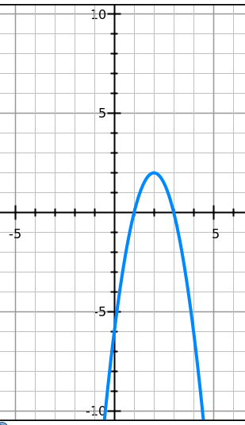

**: ) Now you make sure you label the axis and add the name of the equation.**

1. **We learned how to convert into the vertex form.**

**First let’s review how to complete the square.**

**The idea of completing the square originates form this formula**

**C=x2+2xy+y2 because this formula can be factored into C=(x+y)2, where C is a constant.**

**The idea of completing the square is simply adding the y2 to C=x2+2xy so that it is in the form of C+y2=x2+2xy+y2, and then you can change it into the form of C+y2=(x+y)2**

Here is the shortcuts, Probably the way your teacher taught you. MAKE SURE you understand the concept behind these steps. They are doing the same thing. Adding y2 to complete the formula and factoring it to the form of C+y2=(x+y)2.

Solve 4*x*2 – 2*x* – 5 = 0".

|  |  |
| --- | --- |
| This is the original problem. | 4*x*2 – 2*x* – 5 = 0 |
| Move the loose number over to the other side. | 4*x*2 – 2*x* = 5 |
| Divide through by whatever is multiplied on the squared term.  Take half of the coefficient (don't forget the sign!) of the *x*-term, and square it. Add this square to both sides of the equation.  Convert the left-hand side to squared form, and simplify the right-hand side. (This is where you use that sign that you kept track of earlier. You plug it into the middle of the parenthetical part.) | (x – 1/4)^2 = 21/16 |
| Square-root both sides, remembering the "±" on the right-hand side.  Simplify as necessary. | x – 1/4 = ± sqrt(21)/4 |
| Solve for "*x* =". | x = 1/4 ± sqrt(21)/4 |
| Remember that the "±" means that you have two values for *x*. | x = 1/4 – sqrt(21)/4 and x = 1/4 + sqrt(21)/4 |

**In converting to the vertex form you do a similar thing.**

**Find the vertex of *y* = 3*x*2 + 2*x* – 1**

Follow this and above procedure. There are pros and cons to using this procedure. My issue with these procedures is that they sometimes take an unnecessarily long time. But if you are confused, follow and memorize these procedures for the answer. Again! MAKE SURE you understand the concept behind these steps

|  |  |
| --- | --- |
| This is your original equation. | *y* = 3*x*2 + 2*x* – 1 |
| Move the loose number over to the other side. | *y* + 1 = 3*x*2 + 2*x* |
| Factor out whatever is multiplied on the squared term.  Remember that "factor" does not mean to "make disappear" or "divide off onto the other side"; "factor" means "divide out front". | y + 1 = 3(x^2 + (2/3)x) |
| Create space on the left-hand side, and, if "*a*" is anything other than 1, put a copy of "*a*" in front of this space. You'll need this space and the copy of "*a*" to keep your equation "balanced".  Take half of the coefficient of the *x*-term from inside the right-hand side parentheses (that is, divide it by two, not forgetting its sign). Square the result, and add it to both sides *inside the parentheses*. | y + 1 + 3(1/9) = 3(x^2 + (2/3)x + 1/9) |
| Multiply out the "*a* times the squared coefficient" part on the left-hand side, and convert the right-hand side to squared form. (This is where you use that sign you kept track of earlier, putting that sign in the middle of the squared expression.) | y + 1 + 1/3 = 3(x + 1/3)^2 |
| Simplify some more, as necessary. | y + 4/3 = 3(x + 1/3)^2 |
| Move the loose number back over to the right-hand side. | y = 3(x + 1/3)^2 - 4/3 |
| To be thorough, reformat into vertex form, and read off the vaues of "*h*" and "*k*". | y = 3(x – (–1/3))^2 + (–4/3) |

**Warm Up: Do them Fast!**

**Find y2 so that the equation follows the format x2+2xy+y2**

1. **x2+2x**
2. **4x2+16x**

1. **9x2+6x**

1. **x2-4x**

**Exercise**

**Complete the square and solve**

1. **3 = x2+2x**
2. **9 = 4x2+16x**

1. **8 = 9x2+6x**

1. **5 = x2-4x**

**Find the vertex form**

1. **y = x2+2x+3**
2. **y= 4x2+16x+1**

1. **y = 9x2+6x+1**
2. **y= 2x2-4x+1**

**Plot y = x2+2x+3**

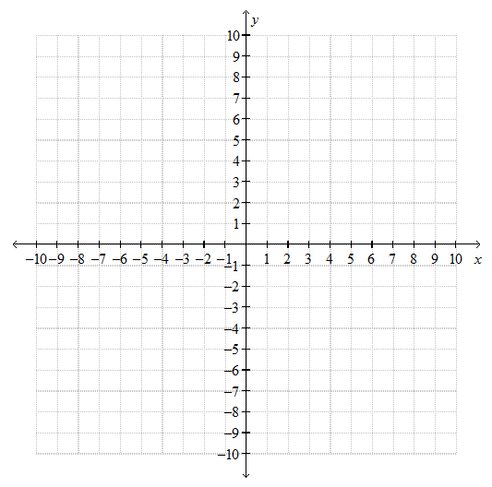

**Plot y = 2x2-4x+1**



Some Review Stuff You will need to memorize for next tutorial

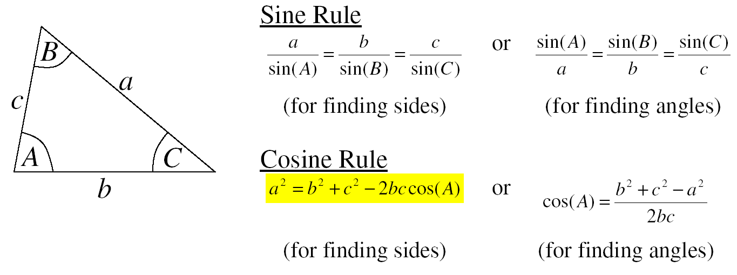

Exercise

Find angle *m*° in the diagram below:  
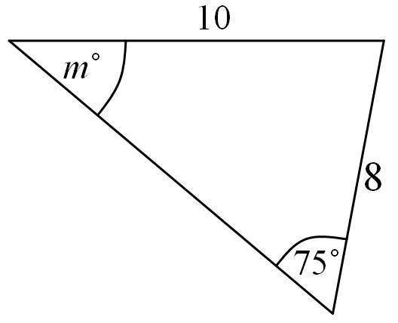

Work out the length of *x* in the diagram below:

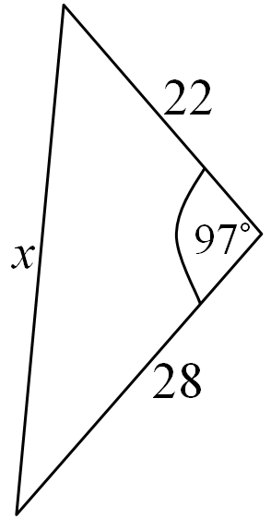

Remember that!

Formula for finding length of a line.

http://www.regentsprep.org/regents/math/geometry/gcg3/Ldista5.gif

Outline for next tutorial

1. Looking over past tests thinking questions.
2. What is a polynomial? and some terms (degrees, standard form, monomial, binomial, trinomial)
3. Sum and difference of cubes
4. Factoring trinomial through long division
5. Different Graphs of Polynomials (even, odd)

------------------------------------------------------------------------------------------

1. Introduction to Derivatives and Applications of it
2. Basic derivative memorization.
3. First and Second derivatives, First and Second differences.

------------------------------------------------------------------------------------------

I’m visiting my friends this week to see if they have their past tests from grade 11 and grade 12. If I do happen to get them, I will change the order of the tutorial topics and methods to reflect them.

**Just for fun: What’s Wrong with this proof?**

Let x=y. Then

x - y + y = y

x - y + y y

--------- = ---

x-y x-y

y y

1 + --- = ---

x-y x-y

1 = 0