

Slightly More Difficult Problems.

Reviews.

Last Tutorial.

1. Radicals Review
2. Exponents.
3. Long Division
4. Little bit about Cubic Functions.

Simple Diagram of Fractional Exponents

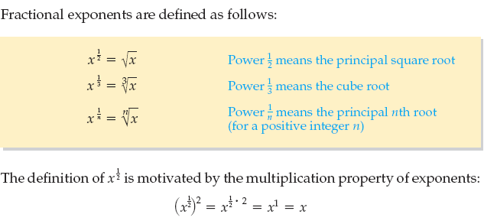

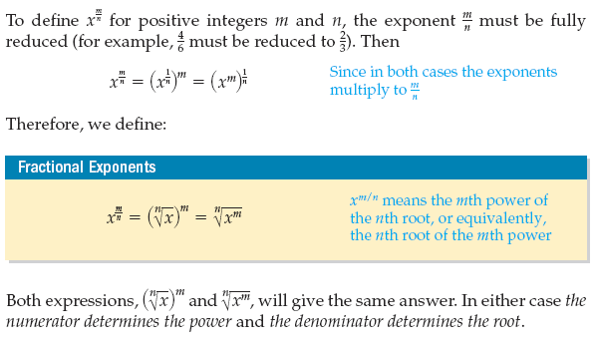

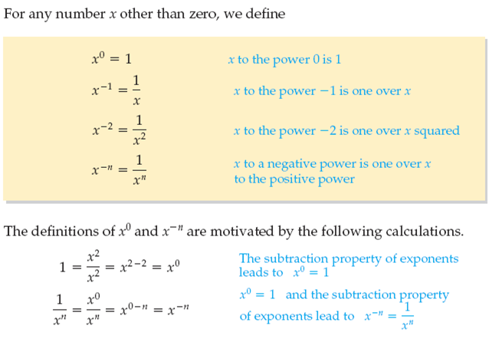

Now some review problems for what we covered so far.

For the questions below, if possible Factor and Simplify. Try A to E First, if not try other ones.

$\sqrt{x^{4}-4x^{3/2}{×x^{3/2}+4x}^{2}}$

$x^{-2}-{(1/2x)}^{-1}-3$

$x^{1/2}-{{2(x}^{\frac{1}{8}})}^{2}y{+y}^{2}$

$x^{1/10}+2x^{1/20}{y^{-15}z^{12}-y}^{-30}z^{24}$

$9x^{4/7}-{4y}^{2/9}$

For the following problems, simplify and put them in exponent form.



$\sqrt{x^{2}x^{5}}$

$\sqrt{\sqrt[4]{1/x}}$

$\sqrt[5]{32x^{-3}}-\sqrt[5]{x^{-3}}- \sqrt{x^{-3}}$

${1/(0.5\sqrt{x})}^{2}- 4\sqrt{x^{-2}}$

${8/(\sqrt{9x})}^{2}÷ 2\sqrt{x^{-2}}$

For the following problems, simplify and put them in radical form

${3x}^{-\frac{1}{2}}-{\left(256x\right)}^{-\frac{3}{8}}÷x^{\frac{3}{16}}$

$y^{3/2}x^{-32/6}$

For the next tutorial, we are plotting and learning more about the cubic function.

So plot the following using a table for the next tutorial.

Plot y = x3

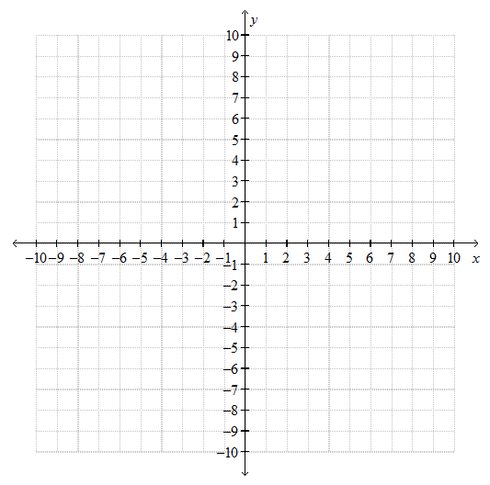

Plot y = - x3+1

