

**WATCH RICK AND MORTY! ITS AWESOME!!!!!**

**This week’s worksheet is very short…but with a lot of graphing…: (**

**Overview For Next Tutorial**

**1. Do the difference of cubes worksheet!**

**Basically Remember This formula**

**a3 + b3 = (a + b)(a2 – ab + b2)**

**a3 – b3 = (a – b)(a2 + ab + b2)**

[**http://www.kutasoftware.com/FreeWorksheets/Alg2Worksheets/Factoring%20A%20Sum+Difference%20of%20Cubes.pdf**](http://www.kutasoftware.com/FreeWorksheets/Alg2Worksheets/Factoring%20A%20Sum+Difference%20of%20Cubes.pdf)

**Remember to CHECK THE SOLUTIONS!**

**2. Review Exponent Laws. Make sure you know this! We are going to use this soon.**

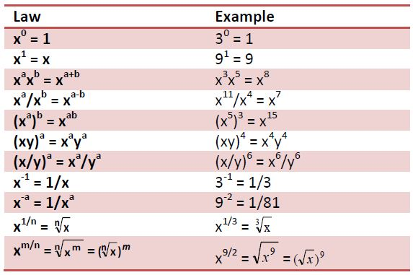

**3. Remember what exactly is a function.**

* A function relates an input to an output. Take a function F(x) = 2x
* The input is x
* The output is 2x
* The function is multiplication of the input by 2
* The input is limited by its domain, which is the possible values that the input can take in the function.
* The output is limited by its range, which is the possible values that the output can take on in this function.
* Next tutorial we will be exploring graphing, domains and functions in depth. No worksheet is needed for this. It will be more of a lecture tutorial.

**But Before that, Remember the tools you have to find properties of a function.**

* **Factoring and Long division -> To Find Zeros**
* **Finding X and Y intercepts**
* **Behaviors of Zeros by examining its exponents.**
* **The end behaviors of functions. What happens to f(x) as it gets very positive and negative.**

**So Take Some Blank Paper and Graph the Following Functions with the above properties. (like in last tutorial, no need to be very precise)**

1. **Y=(-X)2**
2. **Y=X3**
3. **Y=-X3**
4. **Y=(X+1)2(X-1)**
5. **Y=(X+1)3(X-1)**
6. **Y=(X+1)2(X-1) 2**
7. **Y=(X+1) (X-1) (X+2)**
8. **Y=(X+1)3(X-1) (X-3) 2**
9. **Y=(-X+1)2(X-1) <- Careful!**
10. **Y=-(X+1)2(X-1) 2**
11. **Y=(-X+1)3(X-1)**
12. **Y=X4  <- Think about this one!**
13. **Y=X5 <- Think about this one!**
14. **Y=(X+1)5(X-1)**
15. **Y= X3 + 3X2 + 3X +1 <- HINT: LONG DIVISION (TRY SOME NUMBERS!)**
16. **Y= X3 + 3X2 - 3X -1**
17. **Y= -2X3 - 6X2 - 56X**