

**EXAMS…CRY.**

**Review**

**Some Tools You Have to Decipher Polynomials.**

**1. Rules of Exponents to help simplify and solve equations.**

**2. Factoring and Long division to find out zeros of functions.**

**3. Finding Intercepts.**

**4. End Behaviors.**

**5. Odd and Even Functions.**

**So Given these tools you should be able to graph the following functions. Try them.**

**1. F(x) = x3 + 6x2 + 11x + 6. (Factor using long division first. Factor further)**

**2. F(x) = 9x3 + 63x2 + 99x + 45. (Factor using long division first. Factor further)**

**3. F(x) = (-x+2)2(-x-2)**

**4. F(x) = (9x2 + 36) (x-2) 2 (2x2 + 5x -25) (Factor first then Graph)**

**Now, Let’s Reverse that. Create a possible function for the following graphs.**

**a) Try to use the Zeros create the formula. The Y intercept is 0 for this case, what does that mean?** 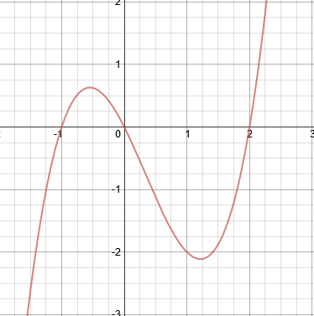

**b) Again. Try to use the Zeros create the formula. Take note of the End behaviors (Even or Odd? Positive or Negative?). The Y intercept is 0.5 in this case, what does that mean?** 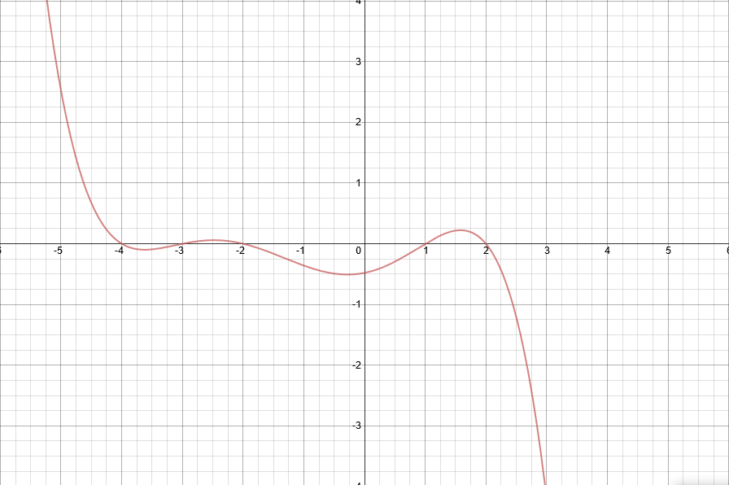

**c)This one is a little bit harder. You have done this problem before in quadratics, you don’t know the zeros, but the three points are on the same line. Try to use the 3 points I have given you to formulate a possible function for this graph.**

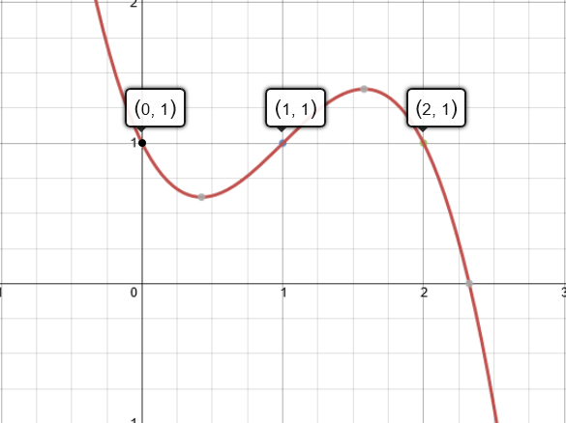

**d) This one covers it all. Look at behaviors of points at each zero.**

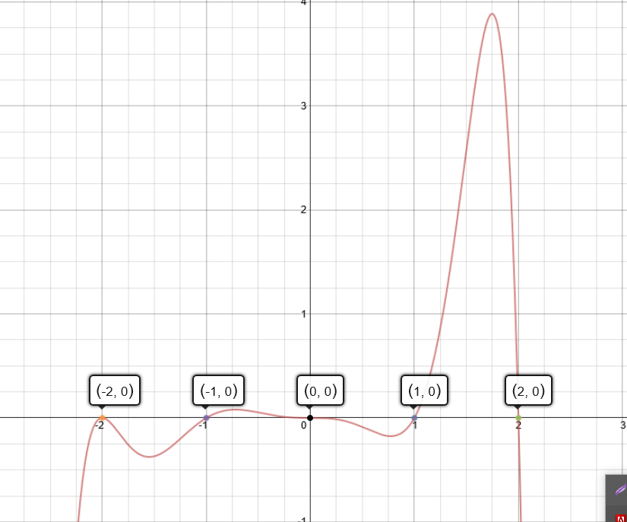

**f) This one is just good practice. Try it, if you don’t get it don’t worry. You technical don’t have to. So this graph is the graph of a cubic function y=x3 transformed, the inflection point occurs at 1,1. Try to remember back to the transformation rules and the five points of the cubic function y=x3 . How did it get to this image.** 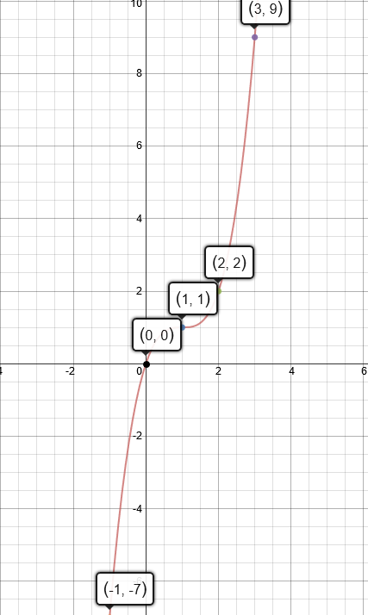

**Next Lesson. We are going to review back the transformation rules and you will also be introduced to a new function. Rational Functions.**

**To start I want to graph the following functions. Try to plot these points for graph 1 and 2.**

**X= -1.5, -1, -0.5, 0, 0.5, 1, 1.5**

**1. F(x) = 1/x 🡪 For this question. What happens as x approaches 0? From the left side? From the Right side? What about when x approaches positive infinity? Or negative infinity?**

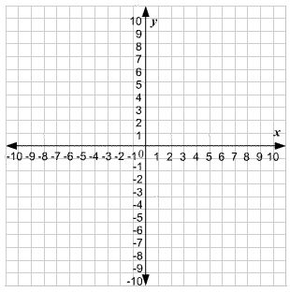

**2. F(x) = -1/x**



**3. F(x) = 1/(x+1) 🡪 For this question. Think about your transformation rules. What do you think happens here? Try these points X= -2.5, -2, -1.5, -1, -0.5, 0, 0.5**

